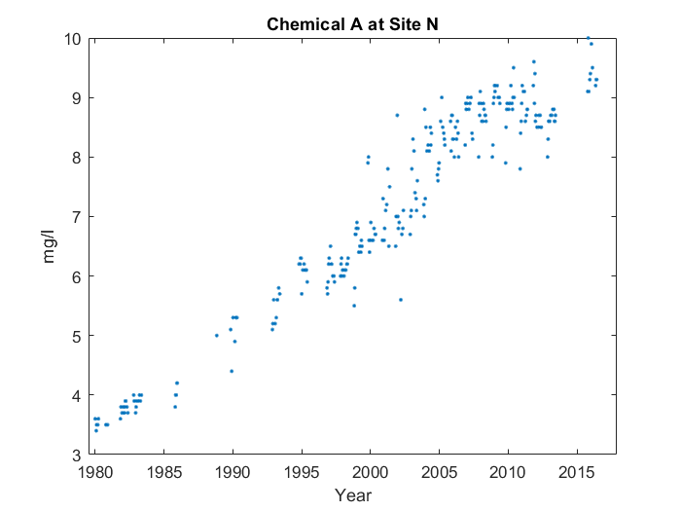

Case 1: Priming, point of interest info

For the whole graph, it goes up in a line starting from 1980, with something interesting happening about three-quarters of the way through. But we'll talk more about that later. You can see the end of the line at 2015. However, the line gets shallower at around 2005. Interestingly, about three-quarters of the way through, at around 2010, the average value for Chemical A at Site N peaks, reaching 8.739 mg/l.

Case 2: No priming, point of interest info

For the whole graph, it goes up in a line starting from 1980. You can see the end of the line at 2015. However, the line gets shallower at around 2005. About three-quarters of the way through, at around 2010, the average value for Chemical A at Site N peaks, reaching 8.739 mg/l.

Case 3: No priming, no point of interest info

For the whole graph, it goes up in a line starting from 1980. You can see the end of the line at 2015. However, the line gets shallower at around 2005.