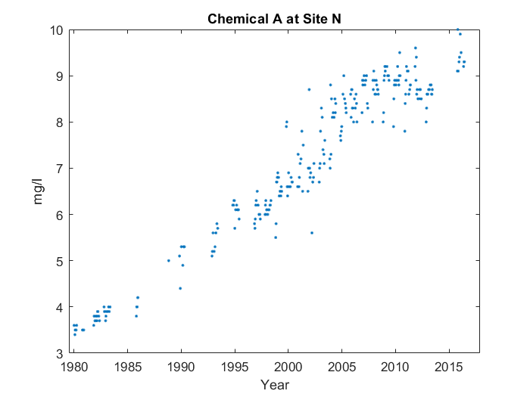

Case 1: Description with critical points and abnormality

For the whole graph, it goes up in a line starting from 1980. You can see the end of the line at 2015. However, the line gets shallower at around 2005.

Case 2: No description

Case 3: Description with critical points, no abnormality

For the whole graph, it goes up in a line starting from 1980. You can see the end of the line at 2015.