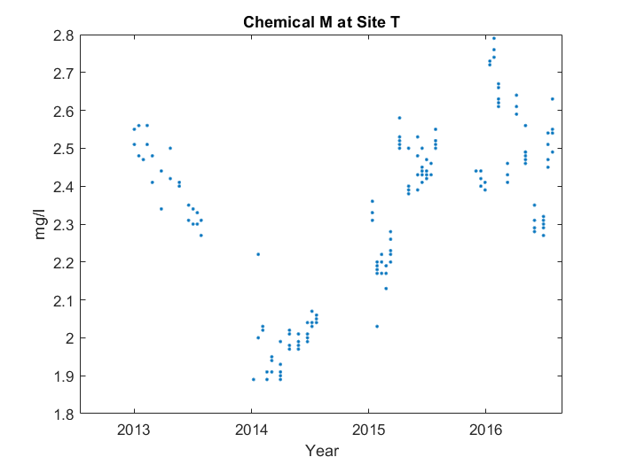

Case 1: Description with critical points and abnormality

First, it makes a 'v' shape starting from 2013. You can see the end of the 'v' at 2016, and the middle at 2014. However, the middle point's too high up. Then, it goes down in a line from 2016 to 2016.

Case 2: No description

Case 3: Description with critical points, no abnormality

First, it makes a 'v' shape starting from 2013. You can see the end of the 'v' at 2016, and the middle at 2014. Then, it goes down in a line from 2016 to 2016.