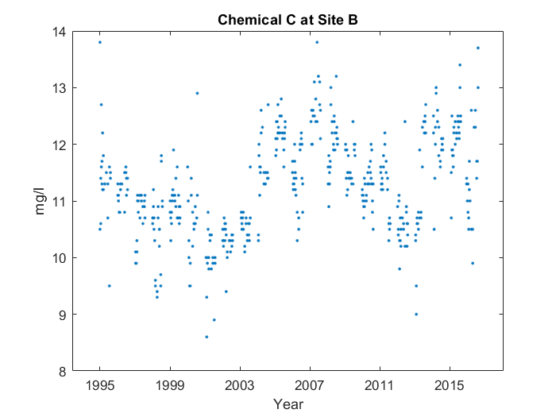

Case 1: Priming, point of interest info

For the whole graph, it makes sort of a 'w' shape from 1995 to 2015, with something interesting happening at the middle. But more on that later. You can see the middle of the 'w' at 2007, and where it reaches the bottom on the right side at 2011. However, on the right side, the bottom's too high, and the middle point's skewed too far to the right. Interestingly, near the middle, at around 2007, the average value for Chemical C at Site B peaks, reaching 12.41 mg/l.

Case 2: No priming, point of interest info

For the whole graph, it makes sort of a 'w' shape from 1995 to 2015. You can see the middle of the 'w' at 2007, and where it reaches the bottom on the right side at 2011. However, on the right side, the bottom's too high, and the middle point's skewed too far to the right. Near the middle, at around 2007, the average value for Chemical C at Site B peaks, reaching 12.41 mg/l.

Case 3: No priming, no point of interest info

For the whole graph, it makes sort of a 'w' shape from 1995 to 2015. You can see the middle of the 'w' at 2007, and the low point after the middle at 2011. However, on the right side, the low point's too high, and the middle point's skewed too far to the right.