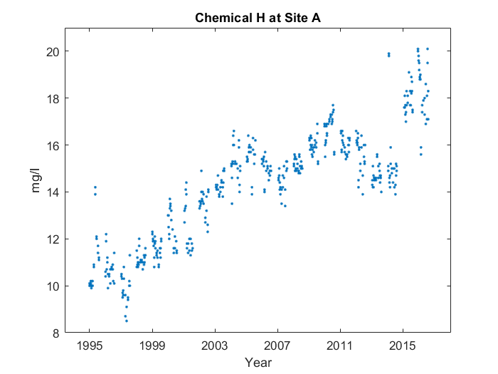

Case 1: Priming, point of interest info

First, it goes up in a line from 1995 to 2003. Then, it makes sort of a 'w' shape, with something interesting happening at the end. But more on that later. You can see where the shape starts and ends at 2003 and 2015. However, on the left side, the top's kind of stunted. Interestingly, near the end, at around 2015, the average value for Chemical H at Site A peaks, reaching 19.18 mg/l.

Case 2: No priming, point of interest info

First, it goes up in a line from 1995 to 2003. Then, it makes sort of a 'w' shape. You can see where the shape starts and ends at 2003 and 2015. However, on the left side, the top's kind of stunted. Near the end, at around 2015, the average value for Chemical H at Site A peaks, reaching 19.18 mg/l.

Case 3: No priming, no point of interest info

First, it goes up in a line from 1995 to 2003. Then, it makes sort of a 'w' shape. You can see where the shape starts and ends at 2003 and 2015. However, on the left side, the first leg's kind of stunted.