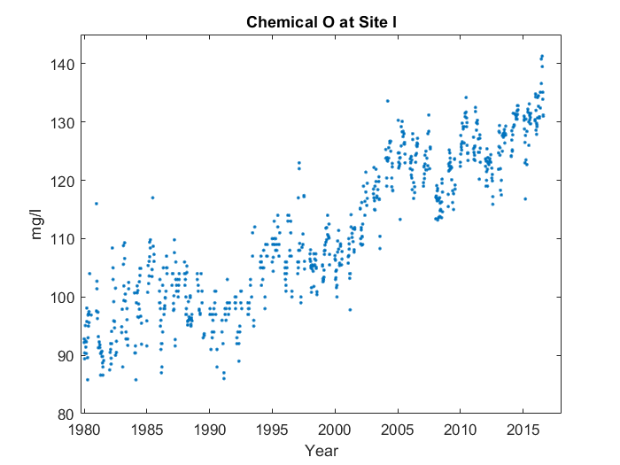

First, it goes up in a line from 1980 to 1986. Then, It looks sort of like a 'w' from 1986 to 2006. Then, it makes sort of a 'v' shape starting from 2006. But around where it ends, something interesting happens. You can see where it ends at 2017, and the middle at 2012. However, on the left side, it's not tall enough, and the middle point's not low enough. It's near where it ends, at around 2017, that the average value for Chemical L at Site G peaks, reaching 132.6 mg/l.