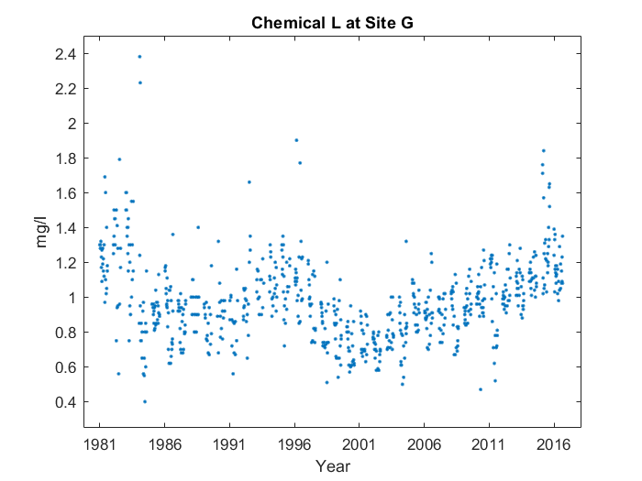

Case 1:

For the whole graph, it makes sort of a 'w' shape up until 2016, with something interesting happening at the start. But more on that later. You can see the start of the 'w' at 1981, and where it reaches the bottom on the left side at 1986. However, on the left side, the bottom's too high, and the middle point's not tall enough. Interestingly, near the start, at around 1981, the average value for Chemical L at Site G peaks, reaching 1.325 mg/l.

Case 2:

For the whole graph, it makes sort of a 'w' shape up until 2016. You can see the start of the 'w' at 1981, and where it reaches the bottom on the left side at 1986. However, on the left side, the bottom's too high, and the middle point's not tall enough. Interestingly, near the start, at around 1981, the average value for Chemical L at Site G peaks, reaching 1.325 mg/l.

Case 3:

For the whole graph, it makes sort of a 'w' shape up until 2016. You can see the start of the 'w' at 1981, and where it reaches the bottom on the left side at 1986. However, on the left side, the bottom's too high, and the middle point's not tall enough.