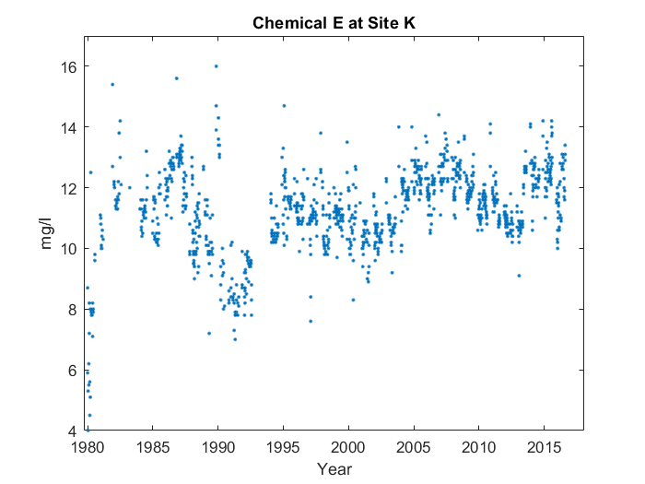

First, it goes up in a line starting from 1980. But near the end, something interesting happens. You can see the end of the line at 1986. However, it's overall steeper than you'd expect. It's near the end, at around 1986, that the average value for Chemical L at Site G peaks, reaching 12.85 mg/l. Then, it looks sort of like a 'w' from 1986 to 2006. Finally, it resembles a 'v' from 2006 to 2017.