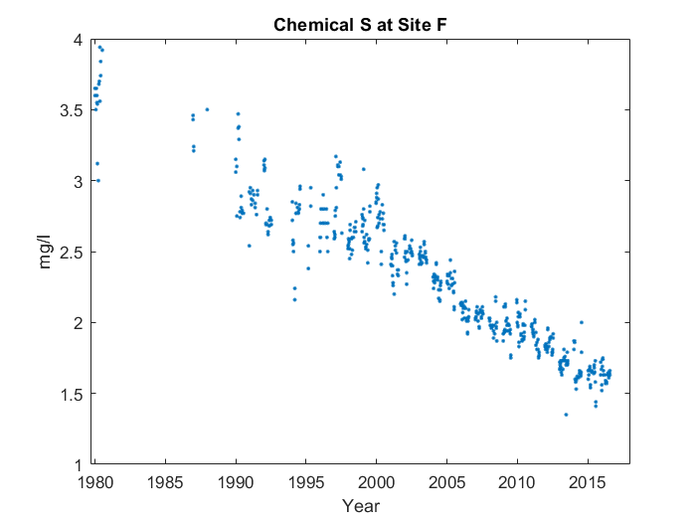

For the whole graph, it goes down in a line up until 2017. But about a quarter of the way through, something interesting happens. You can see the start of the line at 1980. However, near the start, it goes up instead of down for the first time. It's about a quarter of the way through, at around 1986, that the average value for Chemical M at Site T peaks, reaching 3.742 mg/l.