Variables: Secchi Depth, Total Phosphorous, and Chlorophyll A.

Groupings: Yearly, Monthly, and Site.

We will test story variations for individual variables and groupings, as well as one with all three variables. Visualizations and baseline explanations will come from the State Of The Lake report.

Language:

Positive Sentiment: Rise, go up, soar, recuperate, rebound, stabilize, rally, increase, surge.

Negative Sentiment: Lag, decrease, tank, languish, dip, crash, collapse, tumble, fall, sink.

# Total Phosphorous

Seasonal:

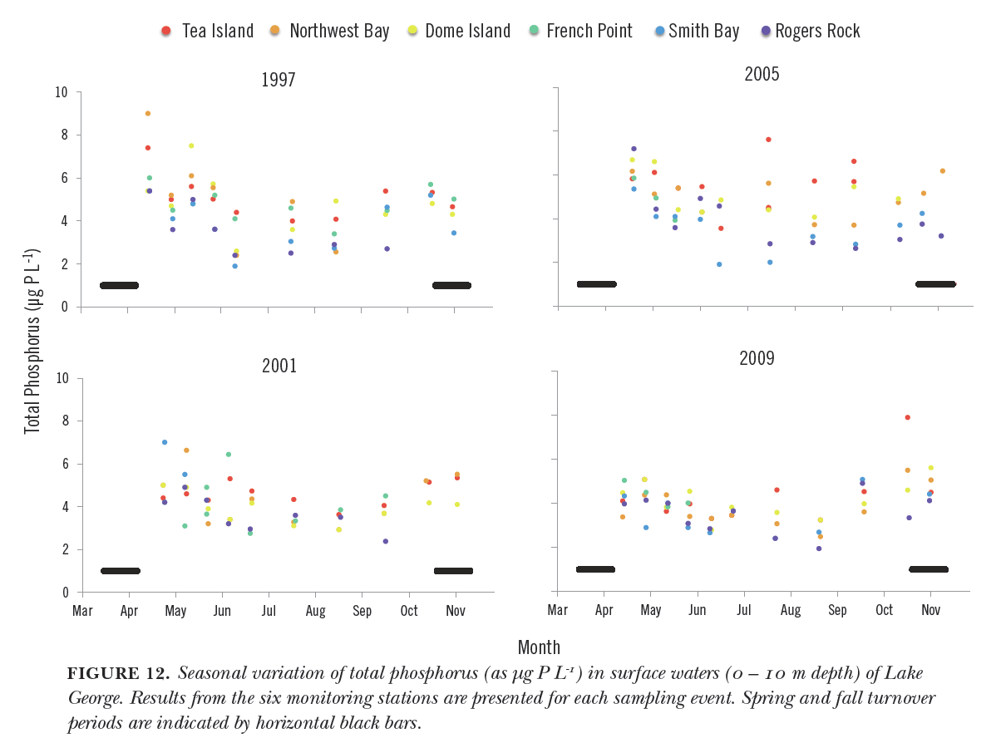

Accompanying text:

Unedited:

Biologically available phosphorus imported to the lake is incorporated into the food web on time scales of days to weeks. Experiments conducted by Eiling (1992) demonstrated that even in the dark, phosphorus released by hypoxic sediments of Lake George stimulated microbial production within about a week. Even faster incorporation would be expected by phytoplankton for biologically available phosphorus imported into the lake. Such rapid incorporation is confirmed by monitoring observations of seasonal depletion of phosphorus showing declines from wintertime maxima to seasonal minima during summer, followed by increases during fall (Fig. 12). While seasonal declines in orthophosphate and total soluble phosphorus often account for most of the observed decline in total phosphorus, this is not always the case, suggesting that some of the particulate phosphorus may be made biologically available through decomposition. Conversely, biological utilization of phosphorus and subsequent loss from the water column from sedimentation only results in depletion of about half the total phosphorus available.

Simplified + shortened:

Biologically available phosphorus imported to the lake is incorporated into the food web on time scales of days to weeks. Experiments have demonstrated that phosphorus released by sediments of Lake George stimulated microbial production within about a week. Even faster incorporation would be expected by phytoplankton for biologically available phosphorus imported into the lake. Such rapid incorporation is confirmed by monitoring observations of seasonal depletion of phosphorus showing declines from wintertime maxima to seasonal minima during summer, followed by increases during fall (Fig. 12).

Trend-only:

Total phosphorous declines from wintertime maxima to seasonal minima during the summer, followed by increases during fall.

Trend-only simplified:

Total phosphorous declines from wintertime highs to seasonal lows during the summer, followed by increases during fall.

Story text:

Story curve explanation:

Have you ever heard of the man-in-a-hole story? It’s the type of tale where things start out fairly well, fall to a low point, then rise back up to be better than before.

Story curve text:

Total phosphorous levels start at a high point in the winter. From there, they sink until they hit their lowest in the summer, then rebound and increase through the fall.

**Test Text A:** Edited human text with trend-only simplified explanation.

Biologically available phosphorus imported to the lake is incorporated into the food web on time scales of days to weeks. Experiments have demonstrated that phosphorus released by sediments of Lake George stimulated microbial production within about a week. Even faster incorporation would be expected by phytoplankton for biologically available phosphorus imported into the lake. Such rapid incorporation is confirmed by monitoring observations of seasonal depletion of phosphorus. Total phosphorous declines from wintertime highs to seasonal lows during the summer, followed by increases during fall.

**Test Text B:** Edited human text with story curve text.

Biologically available phosphorus imported to the lake is incorporated into the food web on time scales of days to weeks. Experiments have demonstrated that phosphorus released by sediments of Lake George stimulated microbial production within about a week. Even faster incorporation would be expected by phytoplankton for biologically available phosphorus imported into the lake. Such rapid incorporation is confirmed by monitoring observations of seasonal depletion of phosphorus. Total phosphorous levels start out strong in the winter. From there, they sink until they hit their lowest in the summer, then rebound and ramp up throughout the fall.

**Test Text C:** Edited human text with story curve explanation and story curve text.

Biologically available phosphorus imported to the lake is incorporated into the food web on time scales of days to weeks. Experiments have demonstrated that phosphorus released by sediments of Lake George stimulated microbial production within about a week. Even faster incorporation would be expected by phytoplankton for biologically available phosphorus imported into the lake. Such rapid incorporation is confirmed by monitoring observations of seasonal depletion of phosphorus. Have you ever heard of the man-in-a-hole type story? It’s the type of tale where things start out fairly well, fall to a low point, then rise back up to be better than before. Total phosphorous levels start out strong in the winter. From there, they languish until they hit their lowest point in the summer, then rebound and ramp up throughout the fall.

**Test Text D:** Edited human text with story curve explanation and trend-only simplified explanation.

Biologically available phosphorus imported to the lake is incorporated into the food web on time scales of days to weeks. Experiments have demonstrated that phosphorus released by sediments of Lake George stimulated microbial production within about a week. Even faster incorporation would be expected by phytoplankton for biologically available phosphorus imported into the lake. Such rapid incorporation is confirmed by monitoring observations of seasonal depletion of phosphorus. Have you ever heard of the man-in-a-hole type story? It’s the type of tale where things start out fairly well, fall to a low point, then rise back up to be better than before. Total phosphorous declines from wintertime highs to seasonal lows during the summer, followed by increases during fall.

**Test Variation 1:** Visualization only.

**Test Variation 2 - 5:** Visualization + Test Text A – D.

**Test Variation 6 – 9:** Test Text A – D only.

Related Questions:

1. Describe the seasonal trend for Total Phosphorous in Lake George.

2. When are Total Phosphorous levels lowest in Lake George?

3. How would you expect Total Phosphorous levels in the summer to compare to those in the fall?

# Chlorophyll A

Seasonal:

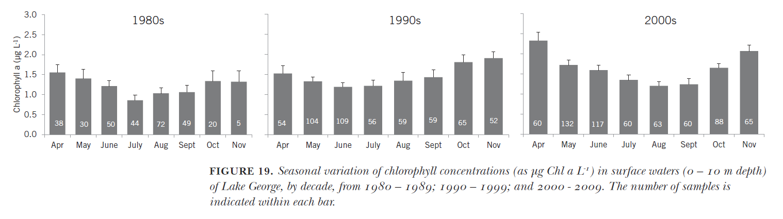

Accompanying text:

Unedited:

In concert with nutrients (see Sec. VII), chlorophyll concentrations show a pronounced seasonal pattern of relatively high concentrations during spring that decline to a mid-summer minimum followed by an increase during fall (Fig. 19). The high concentrations during spring reflect utilization of nutrients from terrestrial snowmelt, augmented by regenerated nutrients sequestered through winter in the hypolimnion until the spring turnover. These conditions produce a spring phytoplankton bloom, followed by a zooplankton bloom which reduces phytoplankton populations through late spring and early summer. The increased zooplankton populations are in turn cropped by second-order consumers including zooplanktivorous fishes, sessile suspension feeders, insect larvae, etc. As the thermocline deepens into early fall, nutrients previously present in the hypolimnion or released by decaying sessile vegetation become available to phytoplankton in the photic zone (Section IX), supporting the observed fall phytoplankton bloom. As clearly shown in Fig. 19, this seasonal cycle has deepened in recent years, superimposed on the long-term trend of increasing chlorophyll concentrations in the lake.

Simplified + shortened:

Chlorophyll concentrations show a pronounced seasonal pattern of relatively high concentrations during spring that decline to a mid-summer minimum followed by an increase during fall (Fig. 19). The high concentrations during spring reflect utilization of nutrients from terrestrial snowmelt, augmented by regenerated nutrients trapped through winter until the spring turnover. These conditions produce a spring phytoplankton bloom, followed by a zooplankton bloom which reduces phytoplankton populations through late spring and early summer. The increased zooplankton populations are in turn cropped by second-order consumers including zooplanktivorous fishes, sessile suspension feeders, insect larvae, etc. Into early fall, nutrients previously present deeper in the lake become available to phytoplankton in the photic zone, supporting the observed fall phytoplankton bloom. As clearly shown in Fig. 19, this seasonal cycle has deepened in recent years, superimposed on the long-term trend of increasing chlorophyll concentrations in the lake.

Trend-only:

Chlorophyll concentrations show a pronounced seasonal pattern of relatively high concentrations during spring that decline to a mid-summer minimum followed by an increase during fall. … As clearly shown in Fig. 19, this seasonal cycle has deepened in recent years, superimposed on the long-term trend of increasing chlorophyll concentrations in the lake.

Story text:

Story curve explanation:

Have you ever heard of the man-in-a-hole type story? It’s the type of tale where things start out fairly well, fall to a low point, then rise back up to be better than before. …

Story curve explanation repeat:

Remember the man-in-a-hole type story? It’s the one where things start out fairly well, fall to a low point, then rise back up to be better than before.

Story curve text:

Chlorophyll begins with decently high concentrations during the spring.

Total phosphorous levels start at a high point in the winter. From there, they sink until they hit their lowest in the summer, then rebound and increase through the fall.

Chlorophyll concentrations show a pronounced seasonal pattern of relatively high concentrations during spring that decline to a mid-summer minimum followed by an increase during fall.