Variables: Secchi Depth, Total Phosphorous, and Chlorophyll A.

Groupings: Yearly, Monthly, and Site.

We will test story variations for individual variables and groupings, as well as one with all three variables. Visualizations and baseline explanations will come from the State Of The Lake report.

Language:

Positive Sentiment: Rise, go up, soar, recuperate, rebound, stabilize, rally, increase, surge, abate, lull, best.

Negative Sentiment: Lag, decrease, tank, languish, dip, crash, collapse, tumble, fall, sink, escalate, worse.

Story curve explanations:

Have you ever heard of a [story type] type story? It’s the type of tale where [story type explanation].

[story type] type stories are ones where [story type explanation].

(Story types from https://arxiv.org/pdf/1606.07772.pdf)

Story type: Rags to riches. Explanation: Things start out poorly. But, over the course of the tale, they rise up to be better than ever.

Story type: Tragedy/Riches to rags. Explanation: Things start out fairly well. But, over the course of the tale, they deteriorate to be worse than ever.

Story type: Man-in-a-hole. Explanation: Things start out fairly well, fall to a low point, then rise back up to be better than before.

Story type: Icarus. Explanation: Things start out poorly, rise to a high point, then fall back down to be even worse.

# Total Phosphorous

Seasonal:

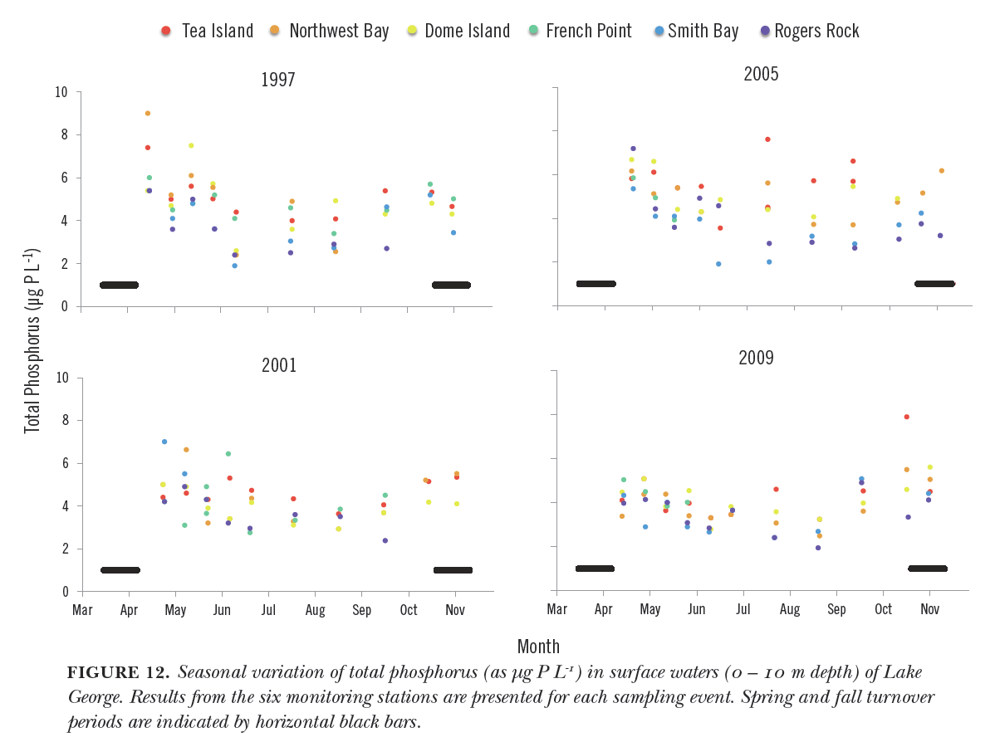

Accompanying text:

Unedited:

Biologically available phosphorus imported to the lake is incorporated into the food web on time scales of days to weeks. Experiments conducted by Eiling (1992) demonstrated that even in the dark, phosphorus released by hypoxic sediments of Lake George stimulated microbial production within about a week. Even faster incorporation would be expected by phytoplankton for biologically available phosphorus imported into the lake. Such rapid incorporation is confirmed by monitoring observations of seasonal depletion of phosphorus showing declines from wintertime maxima to seasonal minima during summer, followed by increases during fall (Fig. 12). While seasonal declines in orthophosphate and total soluble phosphorus often account for most of the observed decline in total phosphorus, this is not always the case, suggesting that some of the particulate phosphorus may be made biologically available through decomposition. Conversely, biological utilization of phosphorus and subsequent loss from the water column from sedimentation only results in depletion of about half the total phosphorus available.

Simplified + shortened:

Biologically available phosphorus imported to the lake is incorporated into the food web on time scales of days to weeks. Experiments have demonstrated that phosphorus released by sediments of Lake George stimulated microbial production within about a week. Even faster incorporation would be expected by phytoplankton for biologically available phosphorus imported into the lake. Such rapid incorporation is confirmed by monitoring observations of seasonal depletion of phosphorus showing declines from wintertime maxima to seasonal minima during summer, followed by increases during fall (Fig. 12).

Trend-only:

Total phosphorous declines from wintertime maxima to seasonal minima during the summer, followed by increases during fall.

Trend-only simplified:

Total phosphorous declines from wintertime highs to seasonal lows during the summer, followed by increases during fall.

Story text:

Story curve explanation:

Have you ever heard of an Icarus type story? It’s the type of tale where things start out poorly, get better up to a good point, then back to be worse than before.

Sentiment explanation:

For total phosphorous, higher levels mean larger algael blooms, which could decrease the clarity of the water. Instead, we want lower total phosphorous levels.

Story curve text:

Total phosphorous levels are at their steepest in the winter. From there, they abate until they hit a lull in the summer, then rebound and escalate throughout the fall.

Full story text:

Have you ever heard of an Icarus type story? It’s the type of tale where things start out poorly, get better up to a good point, then go back to being worse than before. For total phosphorous, higher levels mean larger algael blooms, which could decrease the clarity of the water. Instead, we want lower total phosphorous levels. Total phosphorous levels are at their steepest in the winter. From there, they abate until they hit a lull in the summer, then rebound and escalate throughout the fall.

**Test Text A:** Edited human text with trend-only simplified explanation.

Biologically available phosphorus imported to the lake is incorporated into the food web on time scales of days to weeks. Experiments have demonstrated that phosphorus released by sediments of Lake George stimulated microbial production within about a week. Even faster incorporation would be expected by phytoplankton for biologically available phosphorus imported into the lake. Such rapid incorporation is confirmed by monitoring observations of seasonal depletion of phosphorus. Total phosphorous declines from wintertime highs to seasonal lows during the summer, followed by increases during fall.

**Test Text B:** Edited human text with story curve text.

Biologically available phosphorus imported to the lake is incorporated into the food web on time scales of days to weeks. Experiments have demonstrated that phosphorus released by sediments of Lake George stimulated microbial production within about a week. Even faster incorporation would be expected by phytoplankton for biologically available phosphorus imported into the lake. Such rapid incorporation is confirmed by monitoring observations of seasonal depletion of phosphorus. Total phosphorous levels are at their steepest in the winter. From there, they abate until they hit a lull in the summer, then rebound and escalate throughout the fall.

**Test Text C:** Edited human text with full story text.

Biologically available phosphorus imported to the lake is incorporated into the food web on time scales of days to weeks. Experiments have demonstrated that phosphorus released by sediments of Lake George stimulated microbial production within about a week. Even faster incorporation would be expected by phytoplankton for biologically available phosphorus imported into the lake. Such rapid incorporation is confirmed by monitoring observations of seasonal depletion of phosphorus. Have you ever heard of an Icarus type story? It’s the type of tale where things start out poorly, get better up to a good point, then go back to being worse than before. For total phosphorous, higher levels mean larger algael blooms, which could decrease the clarity of the water. Instead, we want lower total phosphorous levels. Total phosphorous levels are at their steepest in the winter. From there, they abate until they hit a lull in the summer, then rebound and escalate throughout the fall.

**Test Text D:** Edited human text with story curve + sentiment explanations and trend-only simplified explanation.

Biologically available phosphorus imported to the lake is incorporated into the food web on time scales of days to weeks. Experiments have demonstrated that phosphorus released by sediments of Lake George stimulated microbial production within about a week. Even faster incorporation would be expected by phytoplankton for biologically available phosphorus imported into the lake. Such rapid incorporation is confirmed by monitoring observations of seasonal depletion of phosphorus. Have you ever heard of an Icarus type story? It’s the type of tale where things start out poorly, get better up to a good point, then go back to being worse than before. For total phosphorous, higher levels mean larger algael blooms, which could decrease the clarity of the water. Instead, we want lower total phosphorous levels. Total phosphorous declines from wintertime highs to seasonal lows during the summer, followed by increases during fall.

**Test Variation 1:** Visualization only.

**Test Variation 2 - 5:** Visualization + Test Text A – D.

**Test Variation 6 – 9:** Test Text A – D only.

Related Questions:

1. Describe the seasonal trend for Total Phosphorous in Lake George.

2. When are Total Phosphorous levels lowest in Lake George?

3. How would you expect Total Phosphorous levels in the summer to compare to those in the fall?

# Chlorophyll A

Seasonal:

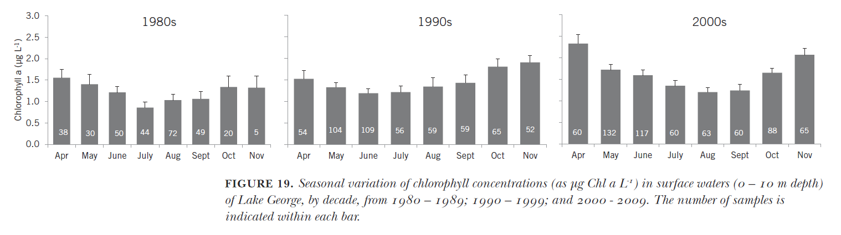

Accompanying text:

Unedited:

In concert with nutrients (see Sec. VII), chlorophyll concentrations show a pronounced seasonal pattern of relatively high concentrations during spring that decline to a mid-summer minimum followed by an increase during fall (Fig. 19). The high concentrations during spring reflect utilization of nutrients from terrestrial snowmelt, augmented by regenerated nutrients sequestered through winter in the hypolimnion until the spring turnover. These conditions produce a spring phytoplankton bloom, followed by a zooplankton bloom which reduces phytoplankton populations through late spring and early summer. The increased zooplankton populations are in turn cropped by second-order consumers including zooplanktivorous fishes, sessile suspension feeders, insect larvae, etc. As the thermocline deepens into early fall, nutrients previously present in the hypolimnion or released by decaying sessile vegetation become available to phytoplankton in the photic zone (Section IX), supporting the observed fall phytoplankton bloom. As clearly shown in Fig. 19, this seasonal cycle has deepened in recent years, superimposed on the long-term trend of increasing chlorophyll concentrations in the lake.

Simplified + shortened:

Chlorophyll concentrations show a pronounced seasonal pattern of relatively high concentrations during spring that decline to a mid-summer minimum followed by an increase during fall (Fig. 19). The high concentrations during spring reflect utilization of nutrients from terrestrial snowmelt, augmented by regenerated nutrients trapped through winter until the spring turnover. These conditions produce a spring phytoplankton bloom, followed by a zooplankton bloom which reduces phytoplankton populations through late spring and early summer. The increased zooplankton populations are in turn cropped by second-order consumers including zooplanktivorous fishes, sessile suspension feeders, insect larvae, etc. Into early fall, nutrients previously present deeper in the lake become available to phytoplankton in the photic zone, supporting the observed fall phytoplankton bloom. As clearly shown in Fig. 19, this seasonal cycle has deepened in recent years, superimposed on the long-term trend of increasing chlorophyll concentrations in the lake.

Trend-only:

Chlorophyll concentrations show a pronounced seasonal pattern of relatively high concentrations during spring that decline to a mid-summer minimum followed by an increase during fall.

Story text:

Story curve explanation:

Have you ever heard of the man-in-a-hole type story? It’s the type of tale where things start out fairly well, fall to a low point, then rise back up to be better than before.

Sentiment explanation (NOTE: This part is a lie, the opposite is actually true, just wanted to have a man-in-the-hole example):

Higher levels of Chlorophyll indicate more plant life in the lake. This is a good thing, as it indicates that the lake is healthy.

Story curve text:

Seasonally, chlorophyll begins with decently high concentrations during the spring. From there, they languish and tumble to their lowest point in the summer. However, afterwards, chlorophyll concentrations rally and surge throughout the fall.

Full story text:

Have you ever heard of the man-in-a-hole type story? It’s the type of tale where things start out fairly well, fall to a low point, then rise back up to be better than before. Higher levels of Chlorophyll indicate more plant life in the lake. This is a good thing, as it indicates that the lake is healthy. Seasonally, chlorophyll begins with decently high concentrations during the spring. From there, they languish and tumble to their lowest point in the summer. However, afterwards, chlorophyll concentrations rally and surge throughout the fall.

# Secchi Depth, Chlorophyll, and Total Phosphorous

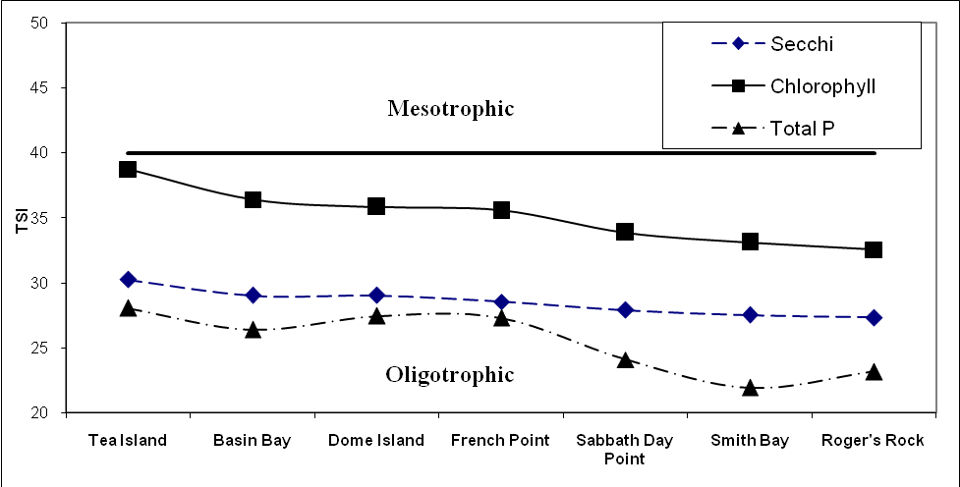

Accompanying text:

Unedited:

Seasonal trends observed in dissolved nutrients and other essential constituents can be attributed in many cases to primary production among the phytoplankton.  Soluble nutrients have shown maximum concentrations in past years following snowmelt episodes and the resulting terrestrial runoff.  Heavy rains in October of 2010, causing widespread erosion, affected the composition of various components in the water column, particularly when coupled with Fall overturn.  This in turn can affect other biological and chemical qualities of the water.  For example, chlorophyll and phosphorus distributions throughout the water column might be elevated for a longer period of time in the spring due to the runoff caused by the increased precipitation.  Higher phosphorus levels provide more nutrients for the algae.  This in turn can affect zooplankton populations, and so on up the food chain.  Differences in overall water quality were observed between the north and south basins of Lake George in 2010.  Principle among the observed differences were:

* Less clarity in the south basin as measured by secchi disk and photometry,
* More chlorophyll, phosphorus, nitrogen and salts in the south basin, and
* Less deep-water (hypolimnetic) dissolved oxygen in the Caldwell (Tea Island) sub-basin of the south basin.

Simplified + shortened:

Seasonal trends observed in dissolved nutrients and other essential constituents can be attributed in many cases to primary production among the phytoplankton.  Soluble nutrients have shown maximum concentrations in past years following snowmelt episodes and the resulting terrestrial runoff. Heavy rains in October of 2010, causing widespread erosion, affected the composition of various components in the water column. This in turn can affect other biological and chemical qualities of the water. For example, chlorophyll and phosphorus distributions throughout the water column might be elevated for a longer period of time in the spring due to the runoff caused by the increased precipitation. Higher phosphorus levels provide more nutrients for the algae. This in turn can affect zooplankton populations, and so on up the food chain.  Differences in overall water quality were observed between the north and south basins of Lake George in 2010. Principle among the observed differences were less clarity in the south basin as measured by secchi depth, and more chlorophyll, phosphorus, nitrogen and salts in the south basin.

Story text:

Story curve explanation:

Have you ever heard of a rags-to-riches type story? It’s the type of tale where things start out poorly. But, over the course of the tale, they rise up to be better than ever.

Sentiment Explanation:

Secchi depth is a measure of how deep you can see into a lake. Higher secchi depth is good, as it indicates a healthy, clean lake.

Story curve text:

Secchi depth is at its worst at the southmost part of the lake. As you move north, it begins to rally, rising from Tea Island to Basin Bay, experiencing a lull until Dome Island, and soaring afterwards through French Point and Sabbath Day Point to reach its best at Smith Bay.

Full story text:

Have you ever heard of a rags-to-riches type story? It’s the type of tale where things start out poorly. But, over the course of the tale, they rise up to be better than ever. Secchi depth is a measure of how deep you can see into a lake. Higher secchi depth is good, as it indicates a healthy, clean lake. Secchi depth is at its worst at the southmost part of the lake. As you move north, it begins to rally, rising from Tea Island to Basin Bay, experiencing a lull until Dome Island, and soaring afterwards through French Point and Sabbath Day Point to reach its best at Smith Bay.