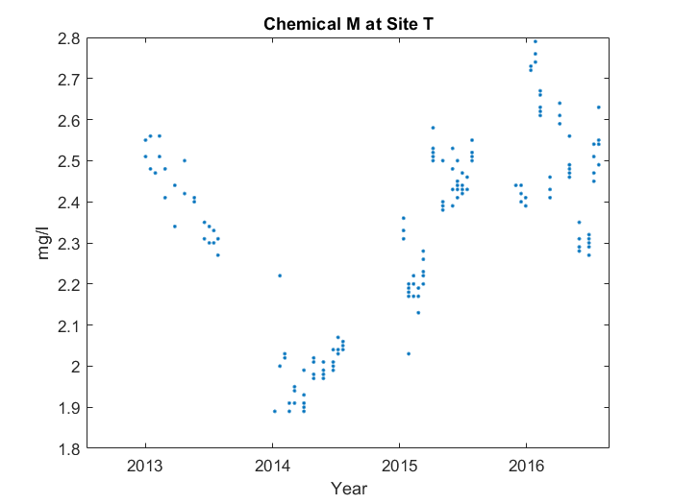

First, it makes sort of a 'v' shape starting from 2013. But around where it ends, something interesting happens. You can see where it ends at 2016, and the middle at 2014. However, the middle point's not low enough. It's near where it ends, at around 2016, that the average value for Chemical M at Site T peaks, reaching 2.588 mg/l. Then, it goes down in a line from 2016 to 2017.