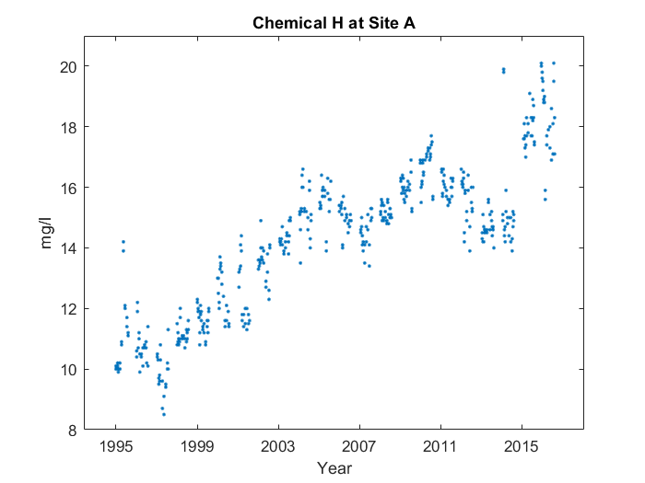

Case 1: Description with critical points and abnormality

First, it goes up in a line from 1995 to 2003. Then, it makes sort of a 'w' shape. You can see where the shape starts and ends at 2003 and 2015. However, on the left side, the first leg's kind of stunted.

Case 2: No description

Case 3: Description with critical points, no abnormality

First, it goes up in a line from 1995 to 2003. Then, it makes sort of a 'w' shape. You can see where the shape starts and ends at 2003 and 2015.