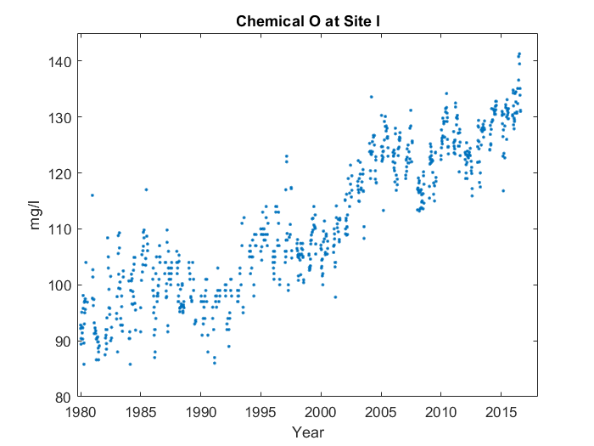

Case 1:

First, it goes up in a line from 1980 to 1985. Then, it looks sort of like a 'w' from 1985 to 2005. Finally, it makes a 'v' shape starting from 2005, with something interesting happening at the end. But we'll get back to that later. You can see the end of the 'v' at 2015, and the middle at 2010. However, on the left side, it's not tall enough, and the middle point's too high up. Interestingly, near the end, at around 2015, the average value for Chemical L at Site G peaks, reaching 132.6 mg/l.

Case 2:

First, it goes up in a line from 1980 to 1985. Then, it looks sort of like a 'w' from 1985 to 2005. Finally, it makes a 'v' shape starting from 2005. You can see the end of the 'v' at 2015, and the middle at 2010. However, on the left side, it's not tall enough, and the middle point's too high up. Interestingly, near the end, at around 2015, the average value for Chemical L at Site G peaks, reaching 132.6 mg/l.

Case 3:

First, it goes up in a line from 1980 to 1985. Then, it looks sort of like a 'w' from 1985 to 2005. Finally, it makes a 'v' shape starting from 2005. You can see the end of the 'v' at 2015, and the middle at 2010. However, on the left side, it's not tall enough, and the middle point's too high up.