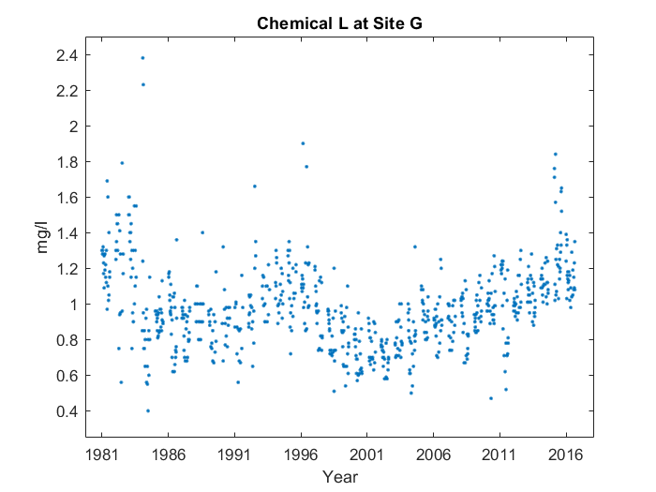

For the whole graph, it makes sort of a 'w' shape up until 2017. But around the start of the 'w', something interesting happens. You can see the start of the 'w' at 1981, and the bottom point to the left at 1986. However, on the left side, the bottom's too high, and the middle point's not tall enough. It's near the start of the 'w', at around 1981, that the average value for Chemical L at Site G peaks, reaching 1.325 mg/l.