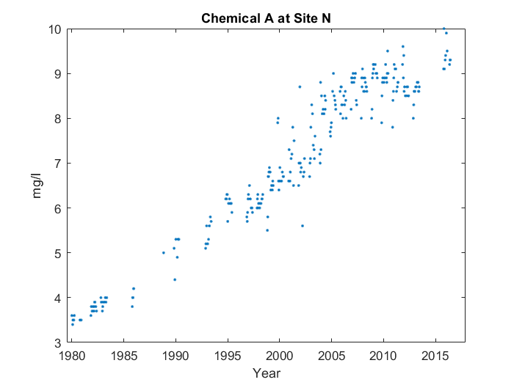

For the whole graph, it goes up in a line starting from 1980. But about three-quarters of the way through, something interesting happens. You can see the end of the line at 2017. However, it starts slowing down at around 2006. It's about three-quarters of the way through, at around 2012, that the average value for Chemical M at Site T peaks, reaching 8.739 mg/l.