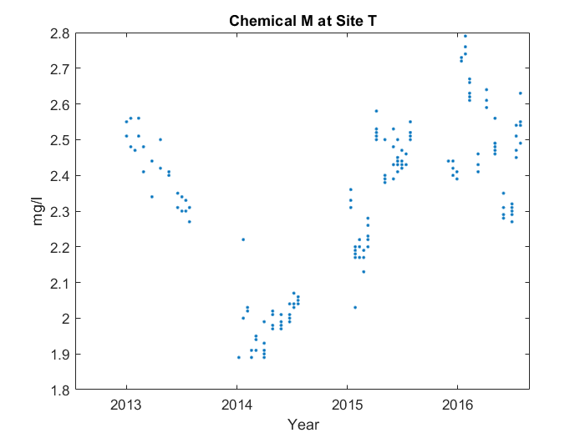

Case 1:

First, it makes a 'v' shape starting from 2013, with something interesting happening at the end. But we'll get back to that later. You can see the end of the 'v' at 2016, and the middle at 2014. However, the middle point's too high up. Interestingly, near the end, at around 2016, the average value for Chemical M at Site T peaks, reaching 2.588 mg/l. Then, it goes down in a line from 2016 to 2016.

Case 2:

First, it makes a 'v' shape starting from 2013. You can see the end of the 'v' at 2016, and the middle at 2014. However, the middle point's too high up. Near the end, at around 2016, the average value for Chemical M at Site T peaks, reaching 2.588 mg/l. Then, it goes down in a line from 2016 to 2016.

Case 3:

First, it makes a 'v' shape starting from 2013. You can see the end of the 'v' at 2016, and the middle at 2014. However, the middle point's too high up. Then, it goes down in a line from 2016 to 2016.