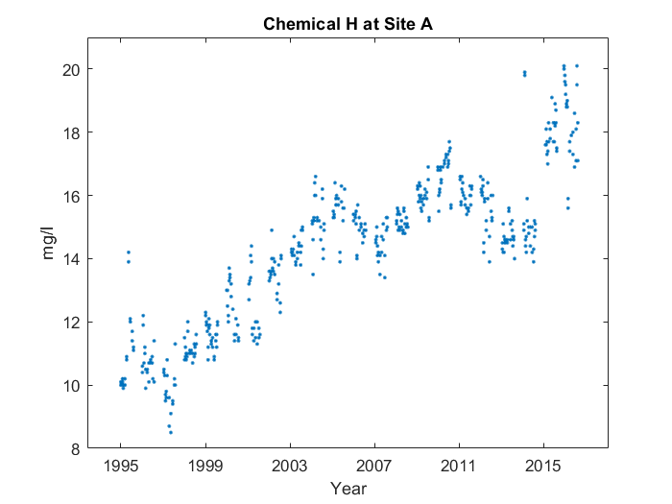

First, it goes up in a line from 1995 to 2005. Then, it makes sort of a 'w' shape. But around the end of the 'w', something interesting happens. You can see where it starts and ends at 2005 and 2017. However, on the left side, the top part's too short. It's near the end of the 'w', at around 2017, that the average value for Chemical H at Site A peaks, reaching 19.18 mg/l.