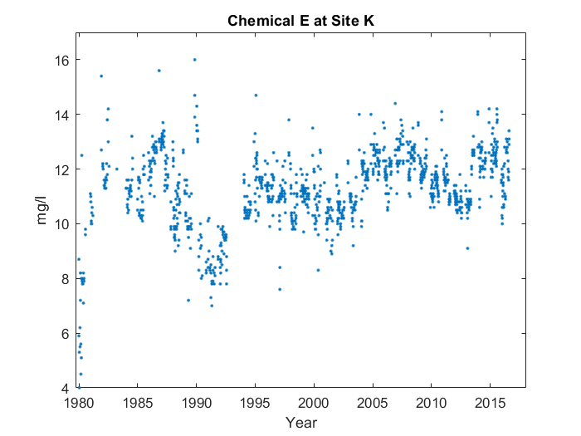

Case 1:

First, it goes up in a line starting from 1980, with something interesting happening near the end, which we'll touch back on later. You can see the end of the line at 1985. However, the whole line's overall steeper than you'd expect. Interestingly, near the end, at around 1985, the average value for Chemical L at Site G peaks, reaching 12.85 mg/l. Then, it looks sort of like a 'w' from 1985 to 2005. Finally, it resembles a 'v' from 2005 to 2015.

Case 2:

First, it goes up in a line starting from 1980. You can see the end of the line at 1985. However, the whole line's overall steeper than you'd expect. Interestingly, near the end, at around 1985, the average value for Chemical L at Site G peaks, reaching 12.85 mg/l. Then, it looks sort of like a 'w' from 1985 to 2005. Finally, it resembles a 'v' from 2005 to 2015.

Case 3:

First, it goes up in a line starting from 1980. You can see the end of the line at 1985. However, the whole line's overall steeper than you'd expect. Then, it looks sort of like a 'w' from 1985 to 2005. Finally, it resembles a 'v' from 2005 to 2015.