Ca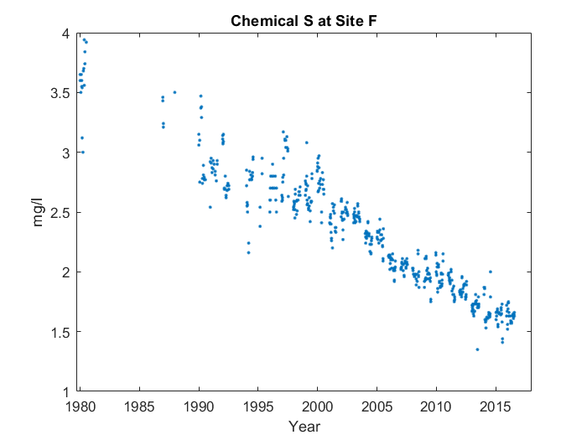

Case 1:

For the whole graph, it goes down in a line up until 2015, with something interesting happening about a quarter of the way through. But we'll talk more about that later. You can see the start of the line at 1980. However, near the start, it goes up instead of down for the first time. Interestingly, about a quarter of the way through, at around 1985, the average value for Chemical M at Site T peaks, reaching 3.742 mg/l.

Case 2:

For the whole graph, it goes down in a line up until 2015. You can see the start of the line at 1980. However, near the start, it goes up instead of down for the first time. About a quarter of the way through, at around 1985, the average value for Chemical M at Site T peaks, reaching 3.742 mg/l.

Case 3:

For the whole graph, it goes down in a line up until 2015. You can see the start of the line at 1980. However, near the start, it goes up instead of down for the first time.