Ca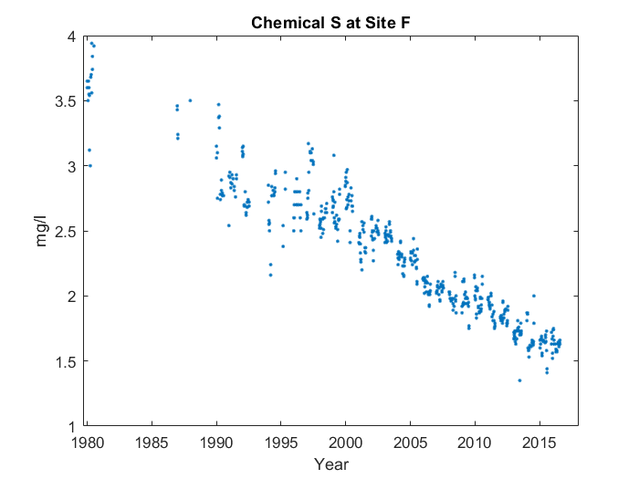

Case 1: Description with critical points and abnormality

For the whole graph, it goes down in a line up until 2015. You can see the start of the line at 1980. However, near the start, it goes up instead of down for the first time.

Case 2: No description

Case 3: Description with critical points, no abnormality

For the whole graph, it goes down in a line up until 2015. You can see the start of the line at 1980.