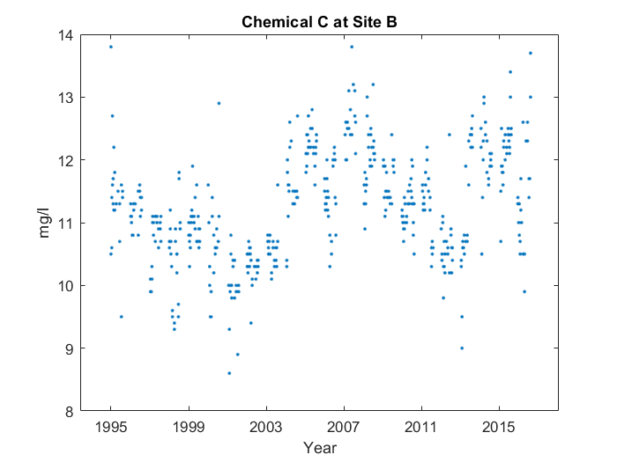

For the whole graph, it makes sort of a 'w' shape from 1995 to 2017. But around the middle point, something interesting happens. You can see the middle point at 2008, and the bottom point to the right at 2010. However, on the right side, the bottom's too high, and the middle point's skewed too far to the right. It's near the middle point, at around 2008, that the average value for Chemical C at Site B peaks, reaching 12.41 mg/l.