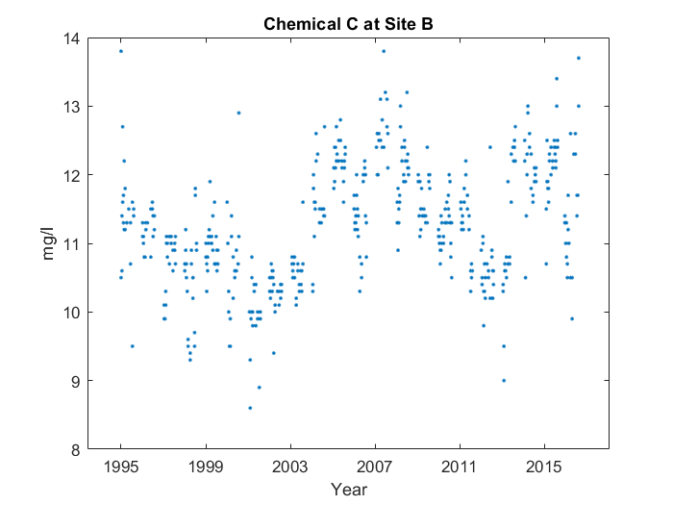

Case 1: Description with critical points and abnormality

For the whole graph, it makes sort of a 'w' shape from 1995 to 2015. You can see the middle of the 'w' at 2007, and the low point after the middle at 2011. However, on the right side, the low point's too high, and the middle point's skewed too far to the right.

Case 2: No description

Case 3: Description with critical points, no abnormality

For the whole graph, it makes sort of a 'w' shape from 1995 to 2015. You can see the middle of the 'w' at 2007, and the low point after the middle at 2011.