## horizontal line

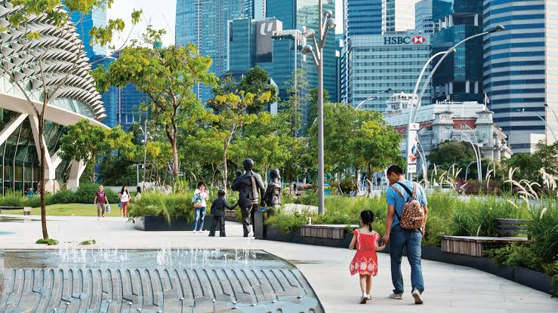

A SMART-CITY REAL ESTATE INVESTMENT PROPOSAL

**Prepared for**

**[Insert Company Name and logo]**

Bamboo Real Estate Ltd

Port Harcourt, Rivers, Nigeria

# Investment Summary

## Silicon Delta (the smart city)

This document relates to Bamboo Real Estate ltd's ("Bamboo") proposed development of the Silicon Delta, a smart city in Rivers state, Nigeria during the course of 2022 - 2030.

## Problem

Nigerian innovators and creatives (especially in tech) are leaving the country at an alarming rate, in search of an environment that works and supports the future of work. Even with this mass emigration, Nigeria has a growing housing deficit of 20,000,000 units.

## Vision

The Silicon Delta is to be a smart city in Nigeria where favourable policies and high tech infrastructure create a future-ready community that drives growth, having amenities of the first world for the growing Nigerian population.

## Project description

Bamboo proposes to acquire 30,587.16 acres of land along the Obiri Ikwerre airport road, Rivers state for the construction of the city.

Silicon Delta will contain one (1) 25-30 storey luxury mixed-use tower; fifty (50) 3-storey smart apartment buildings; one hundred (100) luxury, smart duplexes and terraces; amongst other structures and facilities.

## Market Overview

Rental and purchase rates in the markets for residential and commercial properties in Rivers state have been growing at 25% per annum for the past 3 years.

Residential vacancy rate in the market is currently at 12%. This rate is expected to fall significantly over the next 8 years creating a higher demand for homes in the state.

## Financial analysis

Total estimated capital required = N 300,000,000,000 (NGN)

Expected return on investment = 36.5% P/A

We are proposing that [Insert company name] invest upwards of 10 units (10,000,000 per unit) for 30% return on investment.

DETAILS

# Problem

Nigerian innovators and creatives (especially in tech) are leaving the country at an alarming rate, in search of an environment that works and supports the future of work. Even with this mass emigration, due to the rapidly increasing population, Nigeria has a housing deficit of 20,000,000 units.

The World Bank reported in 2020 that International migration is more prevalent in relatively prosperous southern states in Nigeria, which includes Rivers state.

With increasing exit of Nigerian talents from the country, the sustainability of indigenous Tech Corporations is highly questionable.

# Vision

The Silicon Delta is to be a smart city in Nigeria where favourable remote-work policies, high-tech infrastructure and jaw-dropping architecture work together to create a future-ready community that drives economic growth, providing amenities of the first world for the growing Nigerian population.

# Project description

Bamboo proposes to acquire 30,587.16 acres of land along the Obiri Ikwerre airport road, Rivers state for the construction of the city.

Silicon Delta will contain one (1) 25-30 storey luxury mixed-use tower; fifty (50) 3-storey smart apartment buildings; one hundred (100) luxury, smart duplexes and terraces; amongst other structures and facilities.

## Existing Site

Located 14 minutes away from Port Harcourt airport, the site covers 30,587.16 acres of virgin land with an easily accessible road network.

While the city would contain all it's amenities for sustainable living, it is located close to all external desired amenities and the University of Port Harcourt which is 10 minutes away.

## CITY PLANS

| Phase 1 | Finalizing architectural designs | 14 April 2022 |
| --- | --- | --- |
| Phase 2 | Development applications | 30 August 2022 |
| Phase 3 | Construction levels 1 - 3 | 1st December 2022 |
| Phase 4 | Construction levels 4 - 6 | 3rd June 2024 |
| Phase 5 | Construction levels 7 -10 | 13 November 2026 |
| Phase 6 | Construction levels 11 - 12 | 4th December 2027 |
| Phase 7 | Sales | 1st October 2029 |

## GRID PLAN

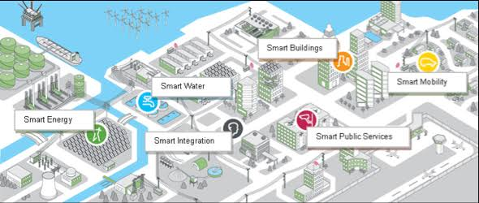

## Renderings of the city

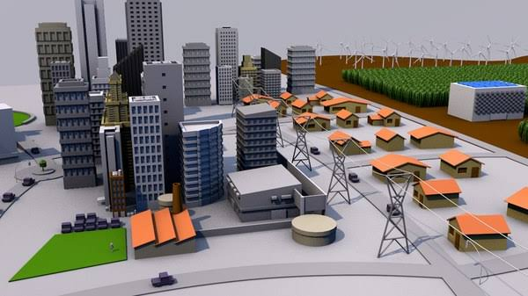

## Proposed facilities of the Silicon Delta

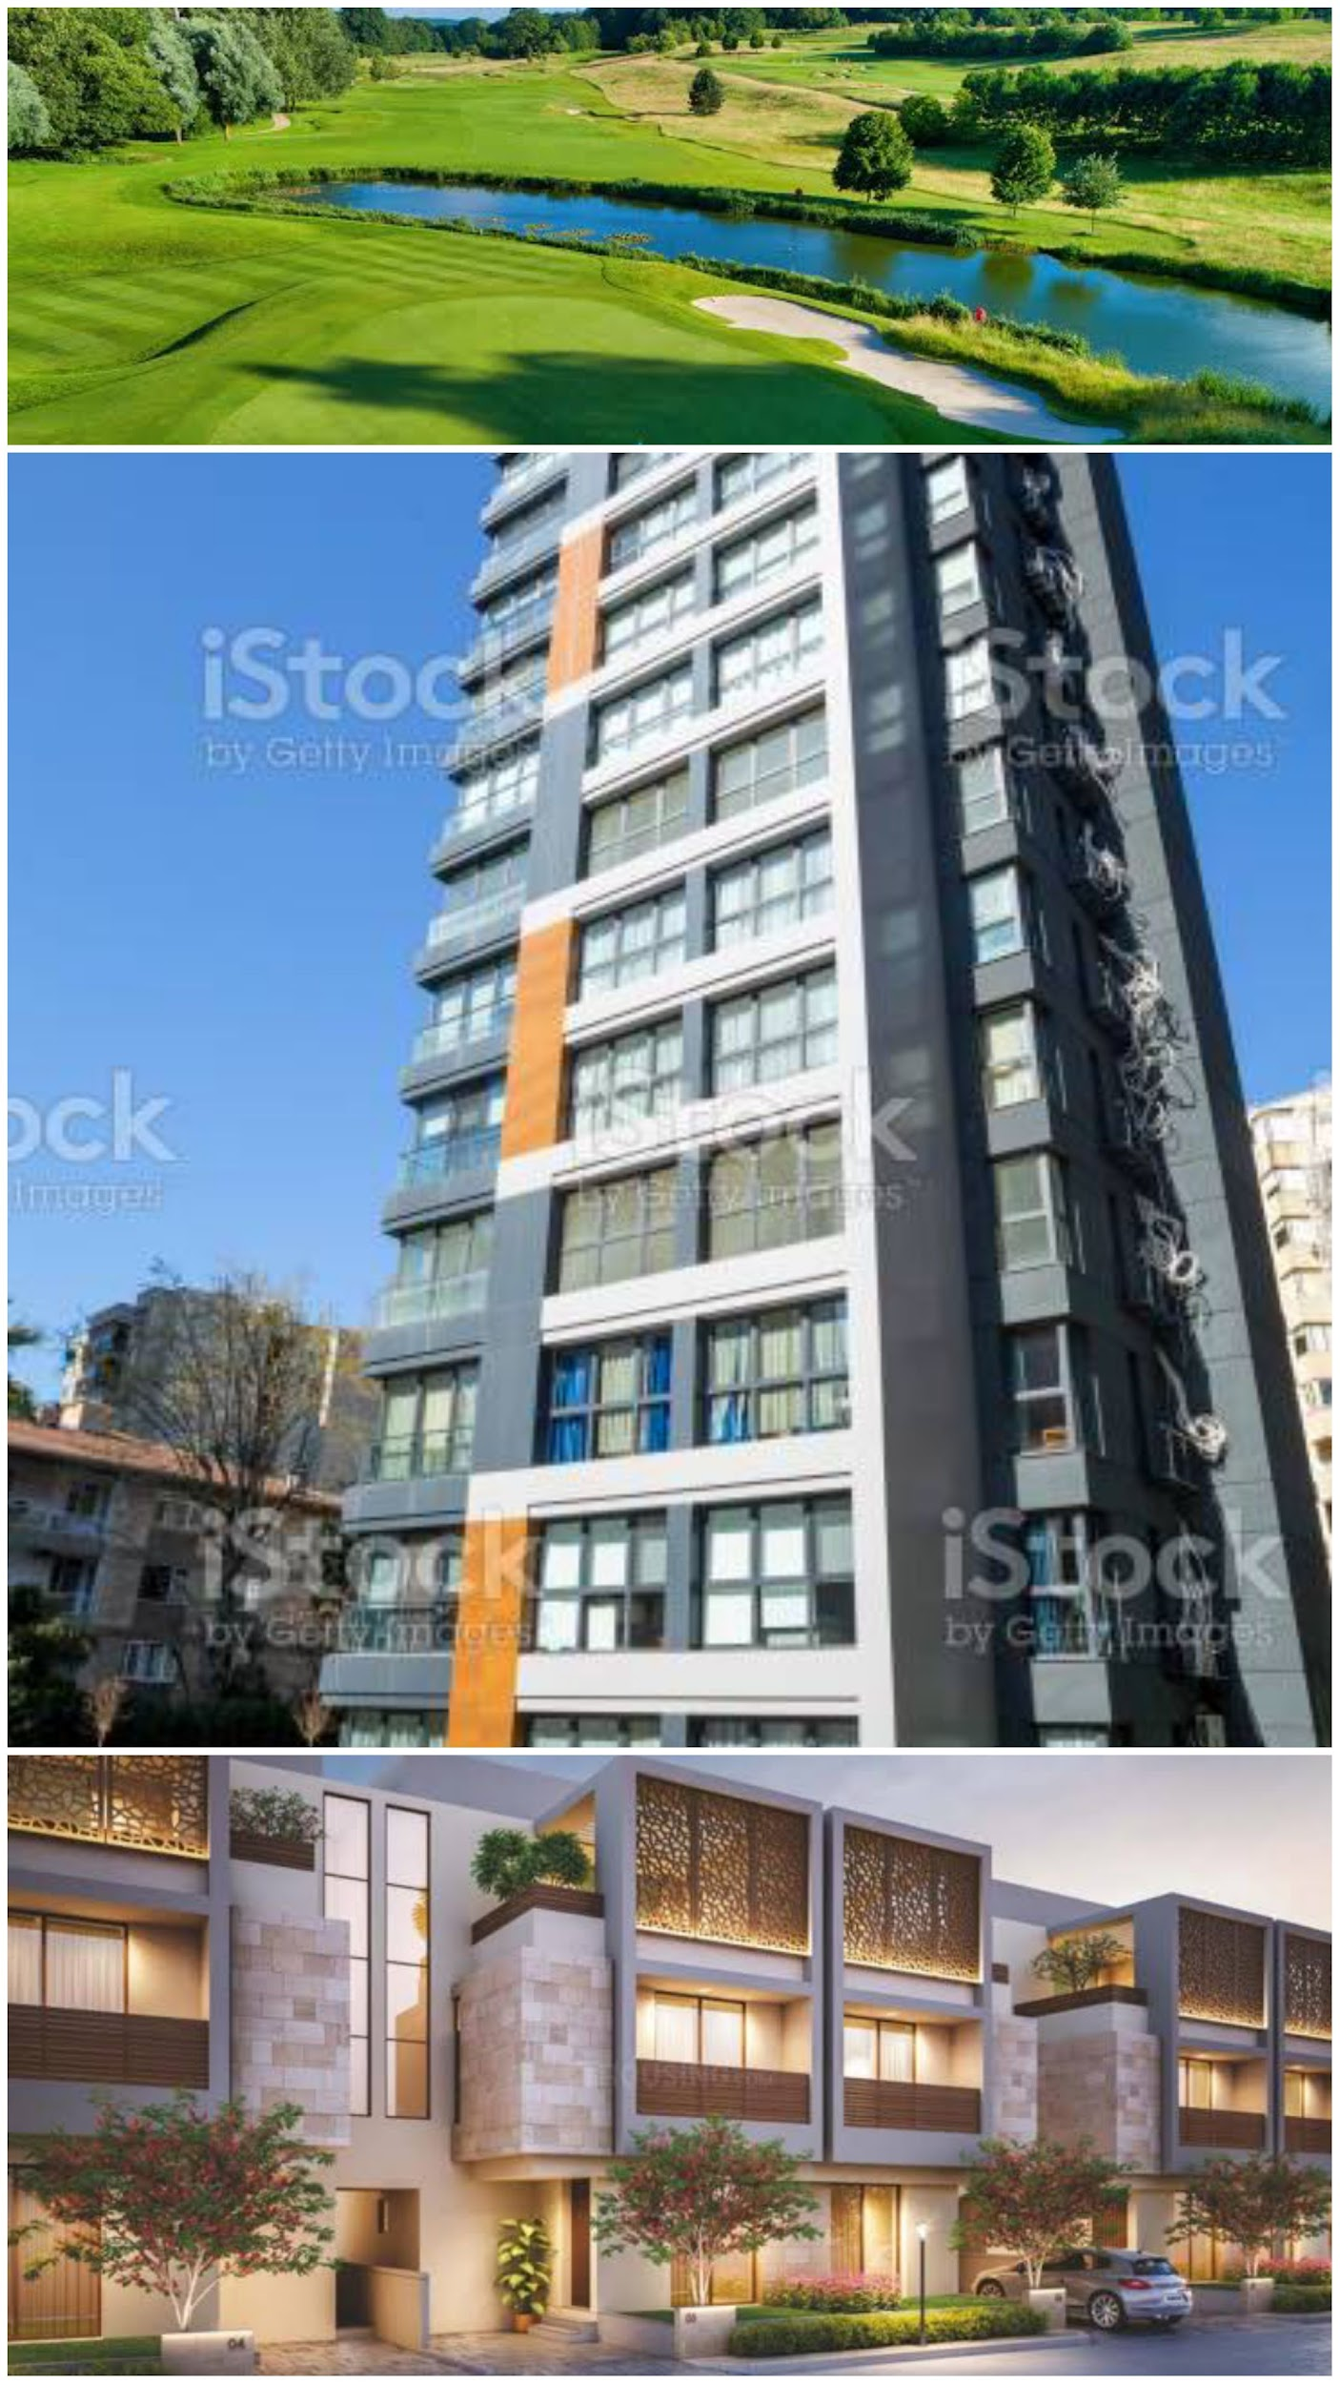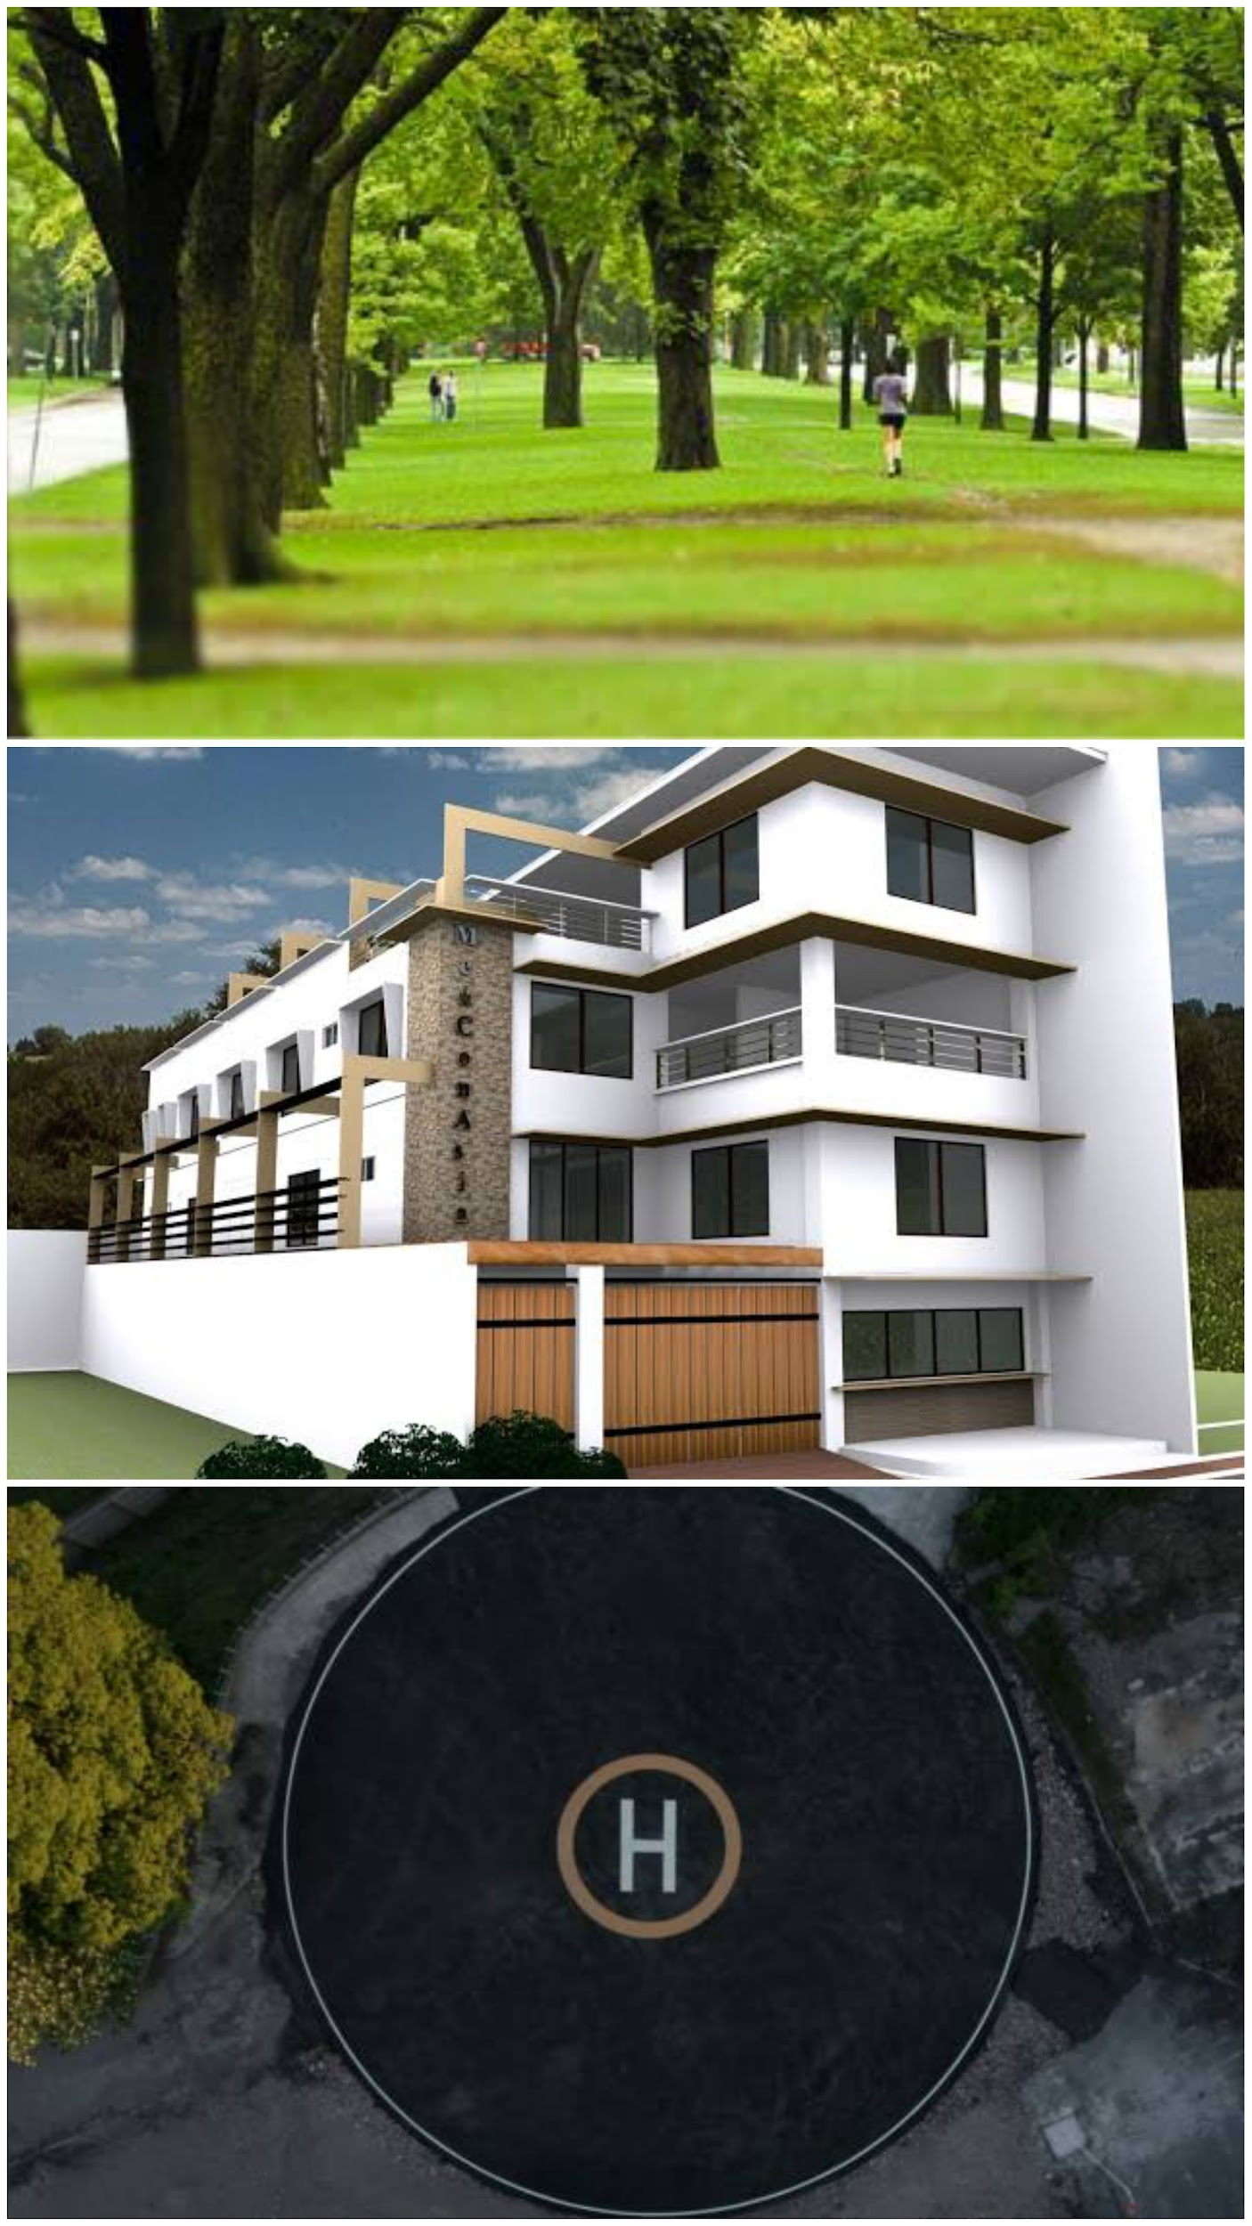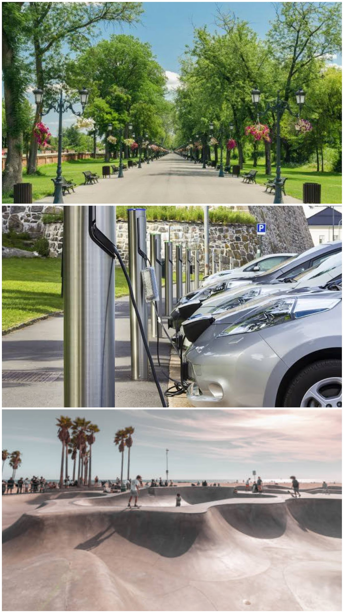

1. The golf course with it's dedicated private lake.
2. The 'Onome' - a 30 storey luxury skyscraper with co-working spaces, luxury apartments and condos.
3. The row of luxury smart duplexes and terraces
4. A million trees to ensure pure, fresh and cool breeze
5. Block of flats – in sets of 2 and 3 storey buildings of 1 - 3 bedroom flats.
6. A Helipad
7. Parks with dedicated pools and other recreational facilities
8. Electric Car charging stations
9. Skateboard rink/park
10. A fully equipped hospital
11. A shopping mall and market
12. Bio-gas plant
13. A multi-curricular primary and secondary school,
14. A mixed-use building
15. An administrative building
16. Banks

## Area Map

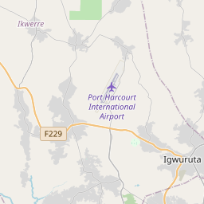

# MARKET OVERVIEW

## Demographics and general market conditions

With the highest literacy rate in the entire South South region of Nigeria, 61% of people living in Rivers state are between the ages of 15 and 64 years.

The population of PortHarcourt is projected by the UN to increase a staggering 46.6% from 3,171,000 in 2021 to 4,650,000 in 2030.

Since 2016, increasing numbers of Port Harcourt city dwellers have moved slightly away from the centre of the city, to the obiri ikwerre airport road. This move is bound to increase with the 46.6% rise in the population of the city. The vast majority of that population are educated millennials.

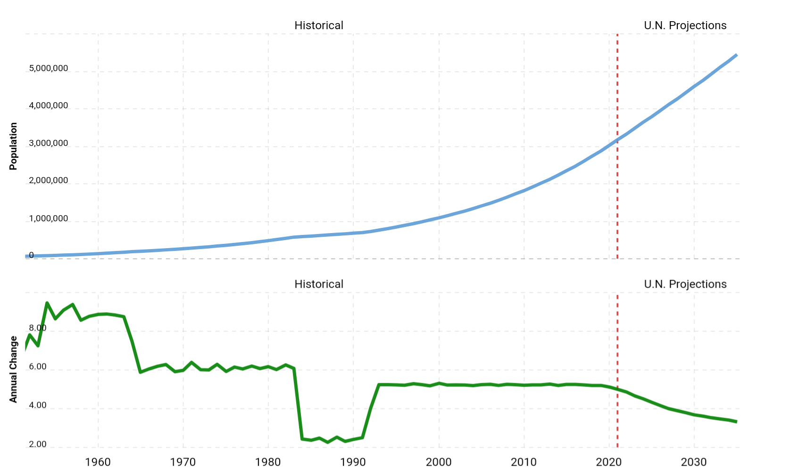

## Neighborhood Analysis

### Transportation

Silicon Delta would be 14 minutes from Port Harcourt Airport.

### Employment

While the Silicon Delta would have office spaces and co-working facilities for remote workers, there are plenty of companies (construction, electrical, petroleum, oil servicing, etc) around the vicinity of the smart city.

### Shopping

Apart from the shopping complex and market facilities that the city would provide, it's location abounds with popular and well stocked markets and shopping malls such as Market square.

### Medical

Medical facilities and hospitals also abound in the vicinity including the University of PortHarcourt teaching hospital (UPTH), not counting that which would be in the Silicon Delta.

### Schools

Obiri ikwerri airport road is home to some of the most prestigious primary and secondary schools in the whole of Rivers state such as Jesuit Memorial, Jephthah comprehensive high school, Charles Dale memorial, amongst others, The university of Port Harcourt is also 10 minutes away. The city would also have its high standard school within the premises.

### Recreation

While available in the proposed surrounding of the city, the silicon Delta will be replete with gyms, parks, skateboard rinks, pools and other recreational facilities.

## Rental and Real estate purchase Rates

Rental and purchase rates in the markets for residential and commercial properties in Rivers state have been growing at 25% per annum for the past 3 years.

Residential vacancy rate in the market is currently at 12%. This rate is expected to fall significantly over the next 8 years creating a high demand for homes in the state.

# Schedule

Construction is expected to commence in December 2022 and to be completed by January 2029. All apartments are expected to be sold by December 2029. The project will be broken down into phases with the following tentative deadlines.

| Phase 1 | Finalizing architectural designs | 14 April 2022 |
| --- | --- | --- |
| Phase 2 | Development applications | 30 August 2022 |
| Phase 3 | Construction levels 1 - 3 | 1st December 2022 |
| Phase 4 | Construction levels 4 - 6 | 3rd June 2024 |
| Phase 5 | Construction levels 7 -10 | 13 November 2026 |
| Phase 6 | Construction levels 11 - 12 | 4th December 2027 |
| Phase 7 | Sales | 1st February 2029 |

## **Capital required: 300,000,000,000**

# Financial Analysis

Residentials

| Facility | Size | Lease per annum | Sale |
| --- | --- | --- | --- |
| Onome (30 storey) | Studio Apartment | 200,000 | 3,000,000 |
| 1 bedroom | 350,000 | 4,500,000 |
| 2 bedroom | 500,000 | 7,000,000 |
| 3 bedroom | 750,000 | 10,000,000 |
| 4 bedroom | 1,000,000 | 13,000,000 |

| Facility | Size | Lease per annum | Sale |
| --- | --- | --- | --- |
| 3 storey Block of flats | Studio Apartment | 200,000 | 3,000,000 |
| 1 bedroom | 350,000 | 4,500,000 |
| 2 bedroom | 500,000 | 7,000,000 |
| 3 bedroom | 750,000 | 10,000,000 |
| 4 bedroom | 1,000,000 | 13,000,000 |

| Facility | Size | Lease per annum | Sale |
| --- | --- | --- | --- |
| Duplexes and terraces | 2 bedroom | 3,800,000 | 65,000,000 |
| 3 bedroom | 5,000,000 | 140,000,000 |
| 4 bedroom | 10,000,000 | 250,000,000 |

Commercial

1,000 SQM goes for 70,000,000 [all calculations are based on this]

## Projected Net income

See below for our project net income analysis over a period of 1 year

| Income | Rentals | Sales |
| --- | --- | --- |
| Onome (30 storey) | 160,000,000 | 10,000,000,000 |
| Block of flats (3 - storey) | 160,000,000 | 10,000,000,000 |
| Duplexes and Terraces | 900,000,000 | 30,000,000,000 |
| Commercial | 800,000,000 | 30,000,000,000 |
| Total | 2,020,000,000 | 80,000,000,000 |
| Expenses | | |
| Construction | 12,000,000 | 12,000,000 |
| Operating  Management | 10,000,000  20,000,000 | 10,000,000  20,000,000 |
| Total | 42,000,000 | 42,000,000 |
| Net Income | 1,978,000,000 | 79,958,000,000 |
| Grand Total | 81,936,000,000 | |

## **In 5 years of operation, Net Income = 409,680,000,000**

## **109,680,000,000 above the capital**

# Investment Fees and returns

| **10,000,000** | **10 units** | **100,000,000** |
| --- | --- | --- |
| **30% return** | **(3,000,000 per unit)** | **30,000,000** |

**For every single unit of N10,000,000 (NGN) [insert company's name] puts in, you get N3,000,000 (NGN) return on investment per annum.**

**Payable till agreement is terminated.**

# About Bamboo Real Estate Ltd

Bamboo is a leading real estate, construction and energy company, we are committed to a culture of excellence, innovation and integrity. We are fully versed in our quest to providing solutions in our core areas through research and development indigenous to the African challenges

Over the years, we have developed several housing estates across Rivers state, Abuja, Lagos and Enugu and have seen a 310% return on investment in 5 years.

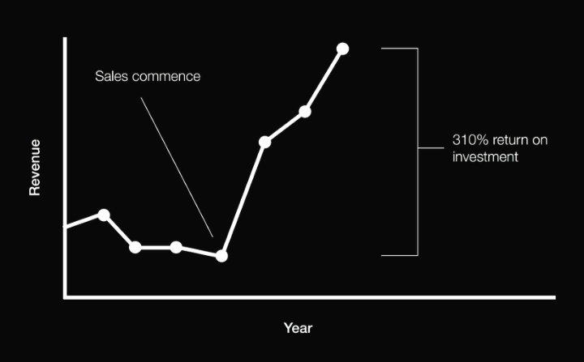

## Our team



**Oseyomon Ighodaloh**

**Founder, CEO**

Ighodaloh is the founder and Chief Executive Officer with 5 years experience in real estate. He has originated and structured transactions in excess of $10 million for a wide range of projects across Africa.

With a degree in Geology and Mining from the University of PortHarcourt, He is the chairman and founder of Undergraduate Alumni foundation (a philanthropy organisation focused on empowering undergraduates across African universities). He sits on the board of several other organisations.

**Chukwu Loveth**

**Chief Financial Officer/ Director**

Loveth is a professional accountant with 7 years of corporate experience and a graduate of Finance from the University of Uyo. She co-founded an accounting and auditing company; Morgate Financial services to assist organisations get their accounting right. She is currently studying for her MBA in fintech at London to further develop herself to take advantage of the Nigerian market.



### **Vincent Inyang**

**Legal**

Vincent is a certified legal practitioner enrolled with the supreme court of Nigeria with over 9 years post-call experience in the legal practice.

He majored in business and corporate law practice and has had his legal practice retained by several reputable companies including Schneider Institute Limited.

LET'S DO BUSINESS TOGETHER

**Call us on: [ insert number]**

**Mail: [insert email]**

**Or visit:** [**www.silicondelta.ng**](http://www.silicondelta.ng)

# TERMS AND CONDITIONS

[To be curated by your legal team]