University of Waterloo

Faculty of Engineering

Department of Electrical and Computer Engineering

Web/Cloud Interface for Medical Device – Nellcor N600x

University of Waterloo  
200 University Avenue West

Waterloo, Ontario, Canada

Prepared by

Adeboye Osuntogun

ID 2035429

Userid: aa2osunt

4B Electrical Engineering

22 April 2015

200 University Avenue West

Waterloo, Ontario, Canada

N2L 3G1

22 April 2015

Sebastian Fischmeister

Electrical and Computer Engineering

University of Waterloo

Waterloo, Ontario

N2L 3G1

Dear Professor:

This report. Entitled “Web/Cloud interface for a medical device – N600x”, was prepared as my 499 project report for the Real-time Embedded Software Laboratory at the University of Waterloo. The report is in fulfillment of the 499 course requirements.

The Real-time Embedded Software Laboratory lab based in the University of Waterloo Campus provides a research on real-time embedded systems specifically at the intersection between software technologies, embedded networking and applied formal methods. The main work I performed was to extract medical data from the Nellcor Oximax N-600x medical data while uploading and persisting the content to a remote database hosted on the cloud with access to a web interface to enable visualization of the medical data in real time. I also had to design the physical cable for the pulse device which involved purchasing and researching the right equipment which met the physical characteristics specified by the manufacturer, I also performed the soldering of the wire and cables needed to receive the signals from the pulse oximeter device.

I would like to thank Professor Sebastian Fischmeister for his guidance in picking a research topic and providing access to the resources at the Real time Embedded Software Laboratory. I would also like to thank Summit Seghal for providing practical assistance in soldering the electrical components of the interface cable and also providing me with access to technical materials that aided the development of the interface to the device. I hereby confirm that I have received no further help other than what is mentioned above in writing this report and that it has not been previously submitted for academic credit at any other academic institution.

Sincerely,

Adeboye Osuntogun

20359429

Table of Contents

Summary 6

Introduction to the device and usage of the N-600 7

Description of Nellcor Control Panel Button and Symbols 7

Description of Control Functions 8

Data extraction N-600 9

Calculating Analog Voltage Output 10

Medical Device Adapter Setup 11

Alternative 1 11

Alternative 2 11

Graphical Data 16

Lessons Learnt and Engineering Principles Applied 17

Conclusion 20

References 21

List of Figures

Figure 1 : Nellcor-600 7

Figure 2 : Data flow Diagram 12

Figure 3 : Physical Setup for extracting data from N-600 13

Figure 4 : BPM spline Graph 14

Figure 5 : Pulse Amplitude spline graph 14

Figure 6 : %SP02 Spline Graph 15

Figure 7 : CSV export table 15

List of Tables

Table 1: Control button and symbols for N-600 7

Table 2 : Data Port Pinout 9

Table 3: Analog Pinout 10

Table 4 : Pros and Con analysis Alternative 1 19

Table 5 : Pros and Con analysis Alternative 2 19

# 

# Summary

The main purpose of this report is to give an overview of the work done in streaming data from a pulse oximeter (N-600) to the cloud that will be used by medical staff to monitor and analyze patient data. The report details the hardware and software setup needed to reproduce the solution. The report also examines the OpenIce network which is created by the MD PnP a non-profit program that wants to improve medical device interoperability by developing widely accepted standards for medical devices. The report shows the concept that were adopted from the OpenIce network in developing this solution. Furthermore it is also contain the schematic of the circuit that was used to extract serial and analog data from the pulse oximeter and how the data were converted into a consumable format on the front end.

The collection of real time medical data from medical devices offer a host of benefits that can improve patient health care and safety it also includes several workflow improvements in health care. These improvements are

* Reduction of errors when reading medical information of device by staff
* A closed loop controlled system
* Safe keeping of patient medical information through storage in databases and other similar services
* Enabling remote monitoring of patient
* Cost reduction in staff and other book keeping activities
* Clinical decision support
* Provides monitoring of the medical device state and performance

# Introduction to the device and usage of the N-600

The oxiMax N-600 pulse oximeter sensor is used as a non-invasive way for an uninterrupted means to monitor the amount of functional oxygen saturation in the blood produced by arterial haemoglobin and pulse rate. The N-600 is intended for use with paediatric, neonatal and adult patients in hospitals and home environments.

## **Description of Nellcor Control Panel Button and Symbols**

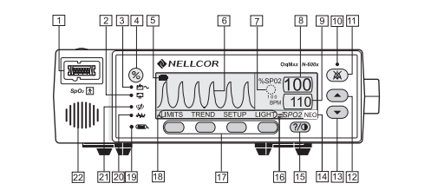

Figure 1 : Nellcor-600

Table 1: Control button and symbols for N-600

|  |  |
| --- | --- |
| 1. SpO2 OxiMax Sensor Port | 12. Adjust Down Button |
| 2. AC Power Indicator | 13. Neonate Mode Indicator |
| 3. On/Standby Button | 14. Contrast Button |
| 4. Low/Battery Indicator | 15. Fast Response Mode Indicator |
| 5. Waveform Display | 16. Softkeys |
| 6. SatSeconds Indicator | 17. Menu Bar |
| 7. %SpO2 Display | 18. Data In Sensor Indicator |
| 8. Pulse rate Display | 19. Interference Indicator |
| 9. Alarm Silence Indicator | 20. Pulse Search Indicator |
| 10. Alarm Silence Button | 21. Speaker |
| 11. Adjust Up Button |  |

## **Description of Control Functions**

On/Standby button – Used to turn the N-600 on or off

Alarm Silence – Used to control the current alarm, if an alarm has been triggered the button is used to silence it, the three alarm indicators are “SENSOR OFF”, “LOW BATTERY”, “SENSOR DISCONNECT”

Adjust UP and DOWN – Increase/Decrease the variable parameters of the N-600

Contrast Button – Used with the Adjust up/Adjust down button to brighten or darken the display screen

Waveform Display – The waveform displayed on the screen is a plethsmographic waveform, it also displays %SpO2 and pulse rate. The blip display on the graph displays SatSecond settings. The blip display includes a pulse amplitude blip bar, measured using %SpO2 and pulse rate limit.

%SPpO2 display – Indicates the amount of haemoglobin oxygen saturation level in the blood, the display flashes when either the Sp02 value is outside or above the allowable pulse limits.

Pulse Amplitude – Displays the relative pulse amplitude, more bars means the pulse from the measured person is becoming stronger.

AC power indicator/Low battery indicator – Indicates when the source power of the Nellcor is AC power and also displays a warning when the battery of the device reaches a low status.

Alarm silence – Lights up continuously till the audible alarm gets silenced.

Interference Indicator – The indicator light flashes on when the N-600 detects a signal degradation quality

Pulse Search Indicator – The indicator lights up continuously prior to the detection of a pulse signal and also when a pulse signal is lost

Data In-Sensor Indicator – The display lights up to signal that the OxiMax-Sensor contains new recorded data from a patient which can be made available for printing or viewing.

SatSeconds Indicator – Detects when the SpO2 reading goes outside the expected range either higher or lower

Fast Response Mode Indicator – Dictates the minimum response time to an abnormal value in the SpO2 reading.

# Data extraction N-600

The Nellcor provides data outside of its port which is used to keep track of the patient data and also record graphical information of medical data (i.e. pleth waveform). The data ports pins on the Nellcor are built on a DB-15 subminiature. The DB-15 sub provides digital data both in RS-232 and RS-422 format, it also provides analog data that represents the voltage level of the pulse rate and SpO2 signal. Displayed in the table below is a table that contains the pinout information of the Nellcor N-600

Table 2 : Data Port Pinout

|  |  |
| --- | --- |
| **Pin** | **Signal Name** |
| 1 | RXD+ (RS-422) [+] input) |
| 2 | RXD_232 (RS-232 input) |
| 3 | TXD_(RS-232 output) |
| 4 | TXD+ (RS-422 [+] output) |
| 5 | Signal Ground (Isolated from Earth ground) |
| 6 | AN_SpO2 (analog saturation output) |
| 7 | Nurse Call Open |
| 8 | Nurse Call closes |
| 9 | RxD- (RS_422 [-] input) |
| 10 | Signal Ground (isolated from Earth Ground) |
| 11 | Nurse Call (RS-422 [-] output) |
| 12 | TxD- (RS-422 [-] output) |
| 13 | AN_PULSE(analog pulse rate output) |
| 14 | AN_PLETH (analog pleth waveform output) |
| 15 | NC_COM (relay closure nurse call, common lead) |

From the above table it is seen that the pin 2, 3, 5 provides data in RS-232 format, the signals provided are the Receiver. Transmit and Ground signal. Pin 1 and 4 provide the differential transmitter data in RS-422 format while Pin 9 and12 provide receiver data in RS-422 format.

The nurse call signal is raised high when an alarm is raised because of an abnormal condition observed in the patient being measured i.e. high/low SpO2, abnormal pulse rate. The N-600 provides the signal through the pin 7, 8 11 and 15. To determine the signal, when there is no alarm condition the voltage level between the data port that contains an alarm signal for instance pin 7 and the ground signal is between -5 and – 12 VDC and when there is an alarm condition the voltage between the data port and the ground is +5 and +12 VDC.

## **Calculating Analog Voltage Output**

The analog port on the N-600 provides access to SpO2, pulse rate and pleth waveform of the measured patient. Analog data is accessed from pin 6, 13 and 14. The parameter ranges for this ports are shown below.

Table 3: Analog Pinout

|  |  |  |
| --- | --- | --- |
| **Pin** | **Parameter** | **Parameter Range** |
| 6 | %SpO2 | 0 – 100% |
| 13 | Pulse rate | 0 – 250 bpm |
| 14 | Pleth waveform | 0 - 255 |

The desired value is determined by measuring the analog value between the ground pin and the desired analog pin. The differential voltage between the ground port and an analog port varies proportionally from 0-1V.

For example if the voltage read from pin 5 is 0.83 volts this corresponds to a %SpO2 value of 83. The pulse rate value varies from 0 - 250 to scale the numbers appropriately since the voltage varies from 0-1V if a voltage value of 0.7V is read from analog pin 13 this corresponds to a pulse rate value of 170 bpm.

Pulse rate = voltage * (1/250)

# Medical Device Adapter Setup

## **Alternative 1**

The first alternative considered for handling the data extracted from the Nellcor was to use a Beagle bone black (BBB) as a device adapter while also integrating the data into the OpenICE environment.

OpenICE is an open source clinical information environment that serves as a middleware device between the medical device and the openICE DDS network. The OpenICE service is written in java which makes it a perfect candidate to run on a variety of platforms since it is platform independent. The required hardware to run the setup include.

1. Beaglebone black running Angstrom Linux distribution
2. A dedicated 5V power supply
3. SD card setup

The medical data is viewable through the OpenICE web interface which consists of streaming medical data over the web to a browser to be viewed by medical personnel. The openICE allows for a “Plug and play” model for medical device interoperability as it supports a broad range of medical devices with an already defined communication protocol between all the devices.

## **Alternative 2**

Due to the continued development of the openICE network and a lack of hardware required to run the network another alternative was considered which was to build a custom solution to extract data from the device. The setup consisted of developing

1. A custom cable to extract digital and analog data out of the nellcor device
2. Sparkfun level shifter to step down the voltage from 5V to 3.3V
3. Arduino mega 2500 to read the serial and analog data from the medical device and interface with a PC
4. NodeJS setup on a PC windows/Mac OS/Ubuntu

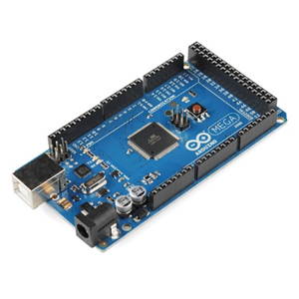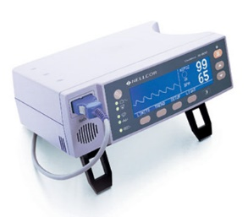

N-600 Arduino Mega 2500



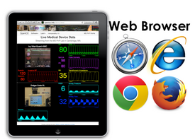

Figure 2 : Data flow Diagram

The serial data port output data in RS-232 format the Arduino reads the data and sends it to the PC for processing. External interrupts were used to read the data from the Arduino mega, the Arduino runs at a clock rate of 9600 Hz and provides functions to read the data. To stream the serial data to the web a NodeJs server is run that reads the serial port of the Arduino and streams the information read at the port to a web browser real time. The data is passed to the web browser using a websocket. Websocket provides a protocol for full duplex communication over a channel using a single instance of a TCP connection.

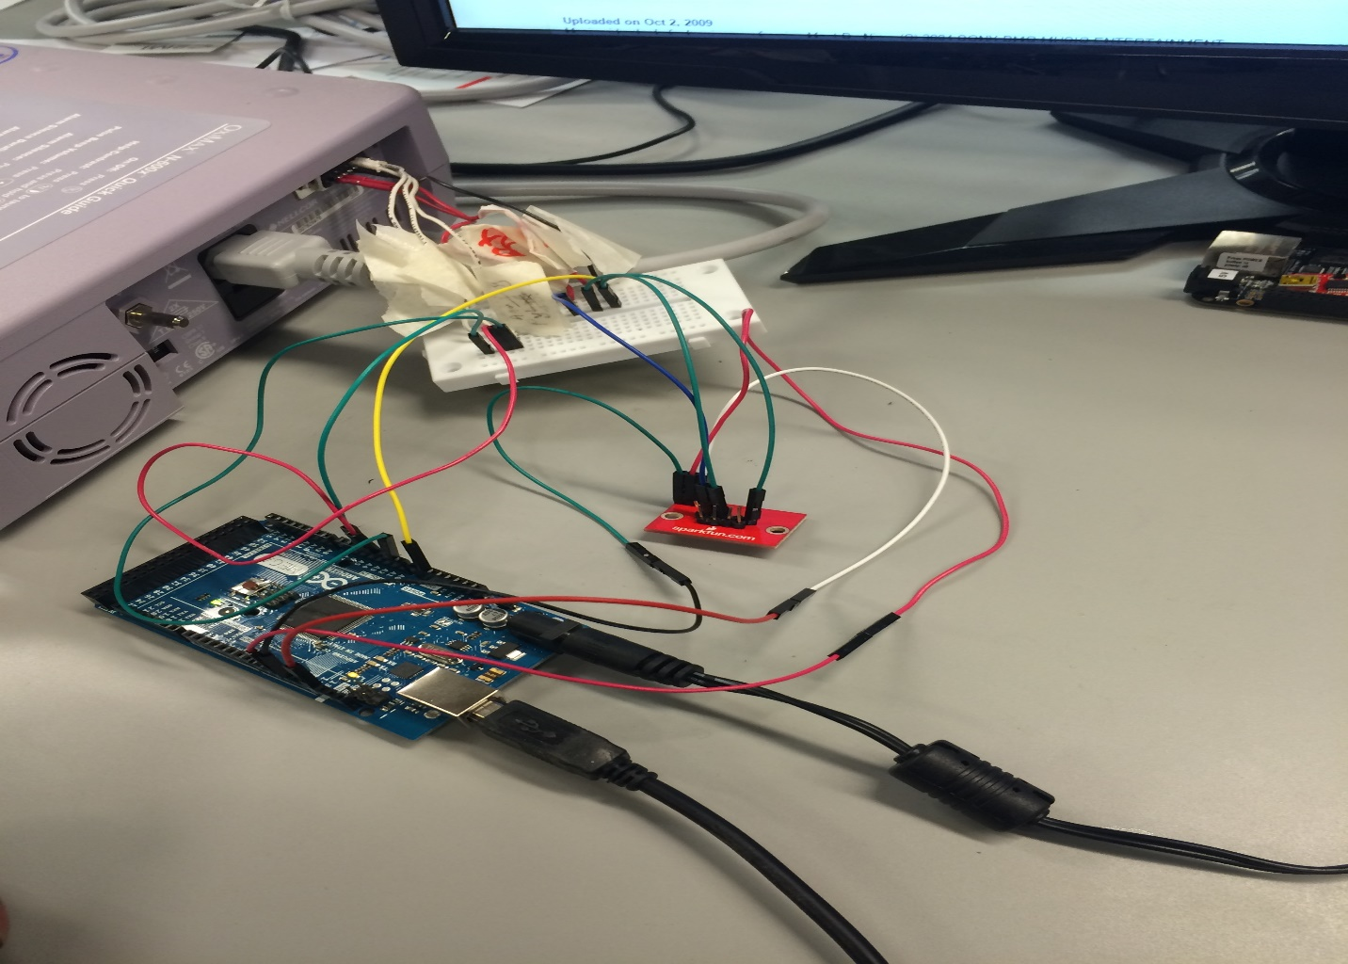

Figure 3 : Physical Setup for extracting data from N-600

The websocket is especially important in this application as it offers a low latency solution to passing data to the browser, a delay in latency cannot be afforded as the data being outputted is expected represent a snapshot of the patient vitals at that particular time.

After the data is received from the socket it is passed into a function that generates a graphical representation of the values in time using a spline chart. The custom module used to achieve this was highchart.js a JavaScript charting module that allows for creation of interactive chart. The chart is fed the corresponding %Spo2/bpm/pulse amplitude value and the current time which are plotted on the y-axis and x-axis correspondingly. The images below show the medical data fed into the web browser.

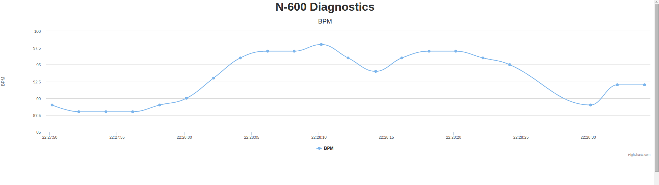

Figure 4 : BPM spline Graph

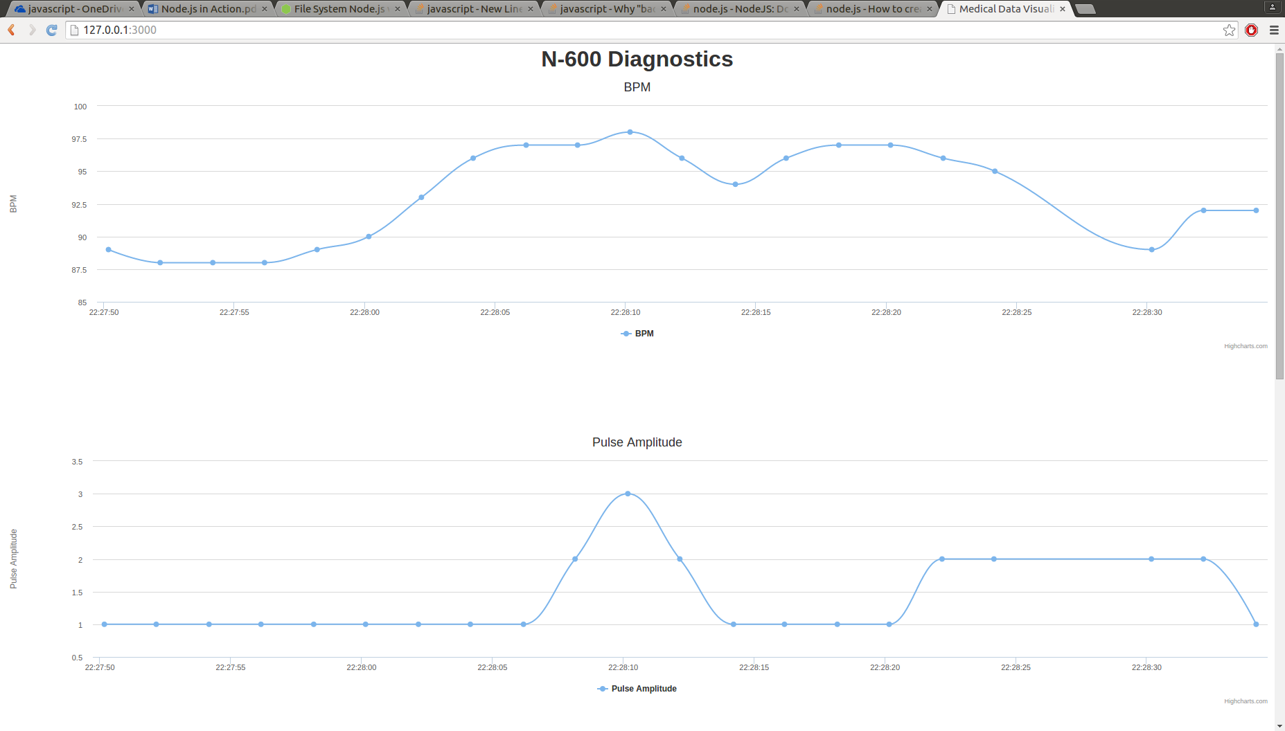

Figure 5 : Pulse Amplitude spline graph

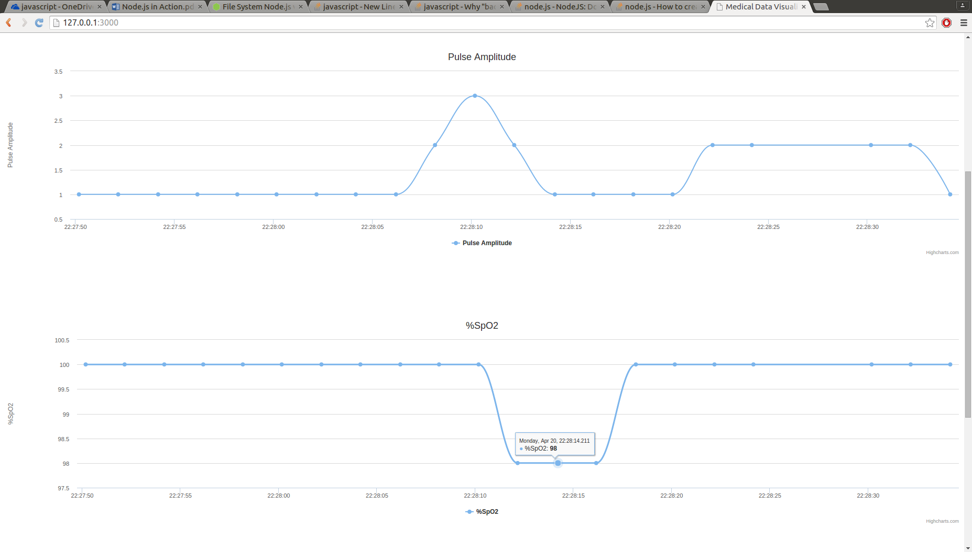

Figure 6 : %SP02 Spline Graph

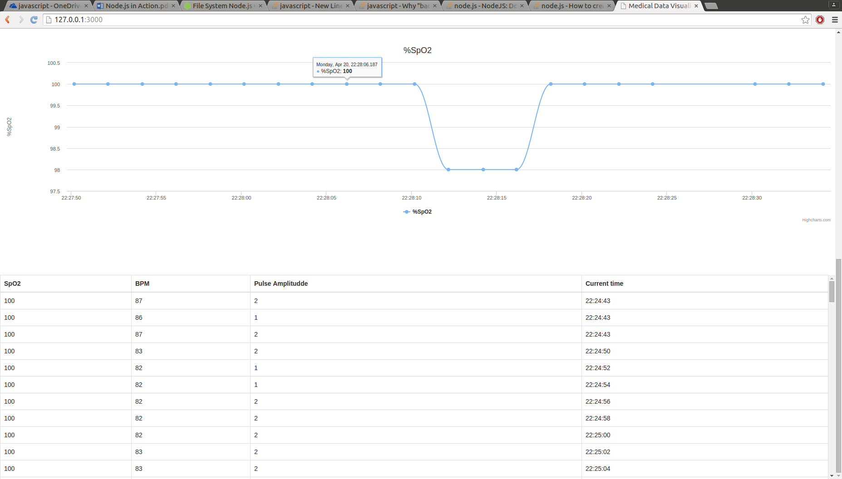

Figure 7 : CSV export table

# Graphical Data

Figure 4 contains the graph showing the values of the BPM, figure 5 displays the pulse amplitude, figure 6 displays the %SPO2 and figure 7 shows the values stored in a table that can be exported as a csv file for reference. The graphical data is very useful because not only does it provide the vitals of the patient but it can also be used to extract trends. A test experiment was run to extract data from a patient running which simulates increase in anaerobic activity in the body. Examining figure 4 at time 22.18 there is an increase in the BPM value which also corresponds to an increase in the pulse amplitude at the same in figure 5 and also a corresponding decrease in the Sp02 value at the same time, this matches with the expected results as physical activity leads to a decrease in oxygen content in the body and an increase in anaerobic respiration. Trends like the above are incredibly useful as medical personnel can use the data to better understand the health of a patient and help in forming an accurate diagnosis, it also helps in archiving medical history of patient has the data is stored for easy retrieval.

# Lessons Learnt and Engineering Principles Applied

During the course of this project I came upon some problems while trying to implement interfacing the Nellcor – Pulse oximeter which led me to seek solutions to achieve the project goals.

A main problem I faced was designing a cable to connect to the pin ports of the nellcor-600 to extract the data. The cable was required to be able to transmit serial data in a RS-232 format. I had no prior experience designing a cable and this project provided a huge learning opportunity in this area. I researched into RS-232 standard and implanted the required control lines including the i.e. RXD, TXD, RTS, Shield Ground signals additionally implementing the logic on the microcontroller to interpret the voltage signals and convert them to logic level.

I also improved my electrical design skills as I had to go through multiple levels of iteration to get a working cable, this involved me ordering the right electrical components for the N-600 for instance I had to ensure the AMP connector on the serial cable met particular standards i.e. the shielding of the wire and also hardware flow control. I ran into problems soldering the cable together as my initial attempts created shorts on the connector so different pins were connected to each other, fixing this problem greatly improved my soldering skills.

Another technique I learnt was finding a way to handle Asynchronous logic in my project. In streaming the data to the browser there was a significant amount of asynchronous functions running and managing them proved to be a challenge i.e. a problem that occurred was an application variable was changing unexpectedly before it was expected to change due to a previously running asynchronous function. To solve this problem I came across flow control which is a method of sequencing groups of asynchronous tasks to ensure application state is kept in the right order. There are two types of flow control serial and parallel. Since I had parallel executing tasks i.e. graphing the SpO2, BPM and pulse amplitude information each handled by different asynchronous function, I used parallel flow control. Parallel flow control involves creating a queue that contains the number of asynchronous tasks that have executed and creating a handler function that increments the number of tasks that have competed and when done remove the task from the queue while repeating the step for new tasks.

Reflecting back on the project requirements, it involved a significant amount of engineering design especially in bringing all the components together and coming up with a unified system. Several engineering principles were used in this project including knowledge of embedded software (ECE 455) in designing the microcontroller code to read serial and analog data from the Nellcor-600x, implementing efficient interrupt handlers to deal with interrupts from the microcontroller, ASCII character decoding and character framing. Additionally concepts learn in (ece 224) helped in understanding and implementing a cable interface for a RS-232 standard. Overall software design skills which I have learn from various software courses I have taken in the university and CooP experience helped in designing a coherent system from top to bottom including the web interface and also ensuring quality by writing multiple test cases to ensure the results that were received were valid.

**Decision Making Tool**

In coming up with a decision for this project a Pros and cons analysis technique was used. The pros and cons list provide a qualitative way to measure advantages and disadvantages of an option. The options are evaluated and the option with the strongest pros and weakest con is chosen as the solution

Table 4 : Pros and Con analysis Alternative 1

|  |  |
| --- | --- |
| Pros | Cons |
| Supports open medical standards e.g. ASTM F2761, ICE | Long development time |
| Supports a full range of medical devices including providing a rich API | Still under development |
| Provides communication network between various medical devices |  |

Table 5 : Pros and Con analysis Alternative 2

|  |  |
| --- | --- |
| Pros | Cons |
| Real time streaming capabilities to GUI using web sockets | Lack of support for multiple medical device interoperability |
| Utilizes chart model to graph data real time data |  |
| Data is archived in database (accessible through csv download) |  |
| Lightweight architecture |  |

# Conclusion

From the report it was demonstrated that medical data from the Nellcor-600 pulse oximeter can be streamed real time to a web environment for monitoring and analysis. This can be scaled further by storing the medical data on a cloud infrastructure to enable remote monitoring capabilities. Further development of the project will involve standardizing the solution to work with the MD PnP openIce network while still maintain the websocket interface created to allow bidirectional communication between a server and a client. Full documentation and test cases of the project can be found at https://github.com/Adeboye/Nellcor-600_webapp.

# References

[1] “OxiMax N-600 Pulse Oximeter Operators Manual”, Tyco Healthcare Group. Pleasanton CA, Nellcor Puritan Bennett Division, 10006478A-1005

[2] J. Goodman. “Medical Devices and Medical Systems — Essential safety requirements for

Equipment comprising the patient-centric integrated clinical environment (ICE)”, April 21 2015