Databases HW 3

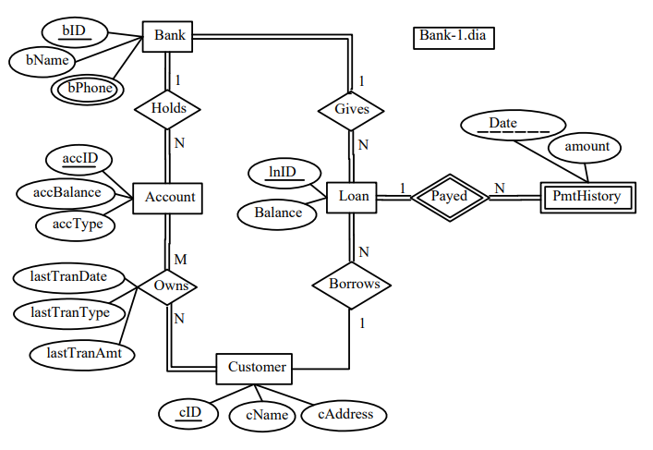

Skeleton relation schema of Bank-1:

Bank(**bID**, bname)  
Account(**accId,** accBalance, accType, bName)

Loan(**InID,** Balance, cID, bID)

Customer(**cID**, cName, cAddress)

PmtHistory(**Date, InID,** amount, InID)

bPhone(**bID, bPhone**)

Owns(**accID, cID,** lastTranAmt, lastTranType, lastTranDate)

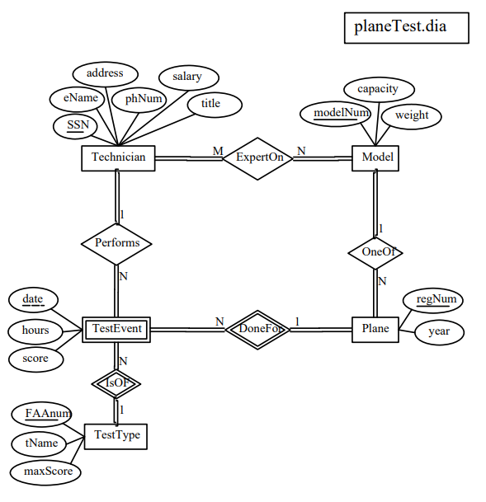

Skeleton relation schema of planeTest:

Plane(**regnum**, year, modelNum)

Model(**modelNum,** capacity, weight)

Technician(**SSN,** eName, address, phNum, salary, title)

TestType(**FAAnum,** tName, maxScore)

TestEvent(**date, FAAnum** hours, score, regnum, SSN)

ExpertOn(SSN, modelNum)