**Surface guided solid**

Développement environnement :

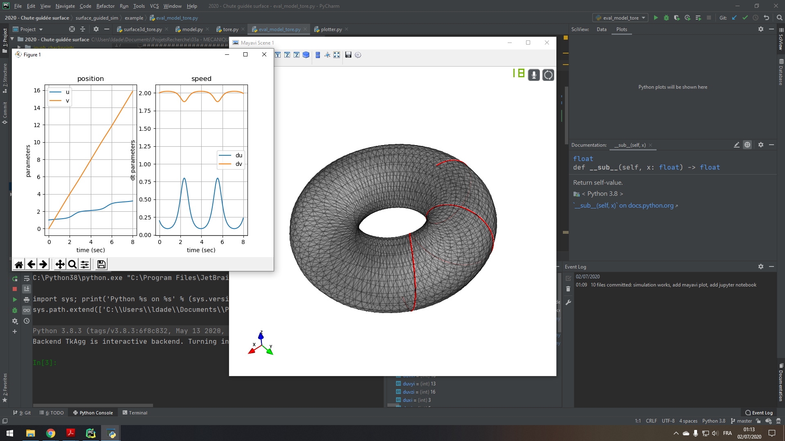

**Comparison of models : Plan-spring model**

We consider the case described in the project :

* ProjetsRecherche\03a - MECANIQUE\Pendule simple - ressort l0 var - ressort rappel - plan incliné

The goal is to compare the results from the mechanical model and the surface guided model.

We consider the following parameters and initial conditions:

|  |  |  |
| --- | --- | --- |
| **Symbol** | **Mechanical model** | **Surface guided model** |
| **Solver configuration** | | |
| Solver | RK4 | RK4 |
| Time-start (s) | 0 | 0 |
| Time-stop (s) | 60 | 60 |
| Delta-time (s) | 0.01 | 0.01 |
| T mesh | 6000 | 6000 |
| **Parameters** | | |
| Mass (kg) | 1 | 1 |
| Plan angle | 0.0 (gravity $⊣$ plan) | 0.0 (gravity $⊣$ plan) |
| Gravity acceleration Z (m/s^2) | -9.81 | -9.81 |
| X | 0.0 | 0.0 |
| Y | 0.0 | 0.0 |
| Spring base length – l0 (m) | 1.0 | 1.0 |
| Spring stiffness (N/m) | 1.0 | 1.0 |
| Spring damping (Ns/m) | 0 | 0 |
| Viscous friction mu (Ns/m) | 0.15 | 0.15 |
| **Initial conditions** | | |
| Distance to spring (m) | 2.0 | $$\sqrt{x^{2}+y^{2}}=2$$ |
| Radial speed (m/s) | 0.0 | 0.0 |
| Angle (rad) | 0.0 | $$\tan{\frac{y}{x}}=0.0$$ |
| Rot speed (rad/s) | 2.0 | 0.0 |

Initial conditions for Surface Guided model:

$$x=2.0 vx=0.0 \\ y=0.0 vy=rdθ=2*2=4$$

Results:

|  |  |
| --- | --- |
| **Mechanical specific model** | **Surface guided model** |
|  |  |

Python code:

