IGP Project Submitted by Ade Adegbola

Git Repository Link: https://github.com/Adedamola29/IGP-Project

Jenkins UI:Code Compile,Test,and Package
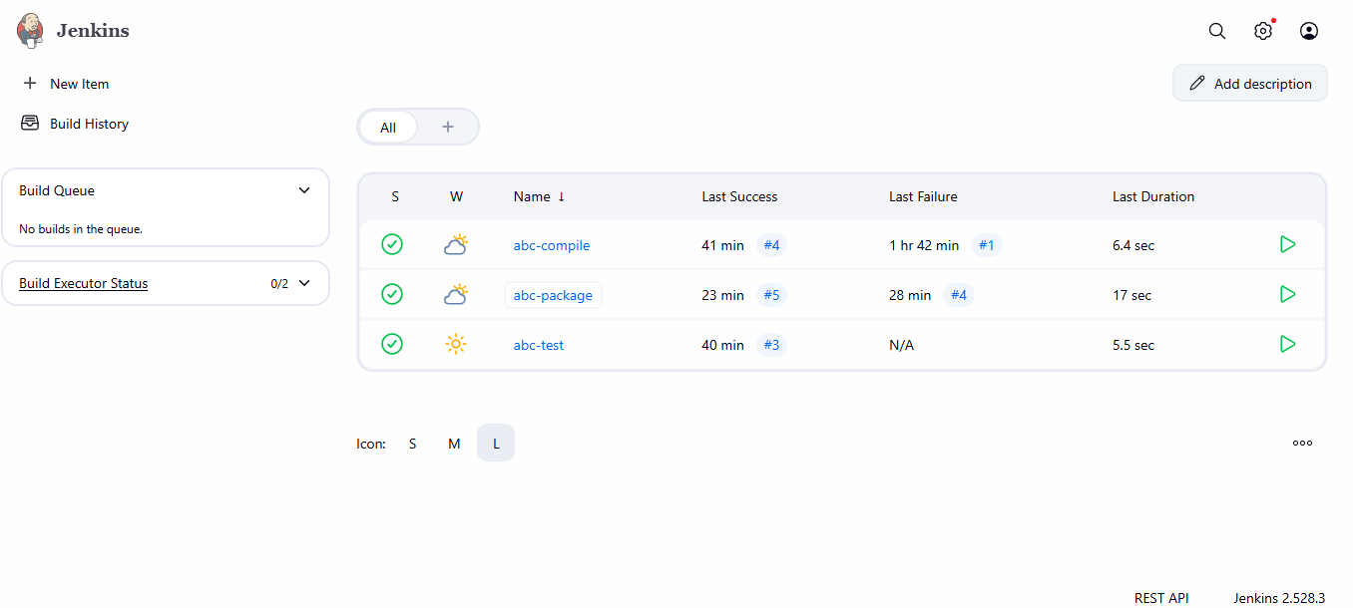
ABC Portal
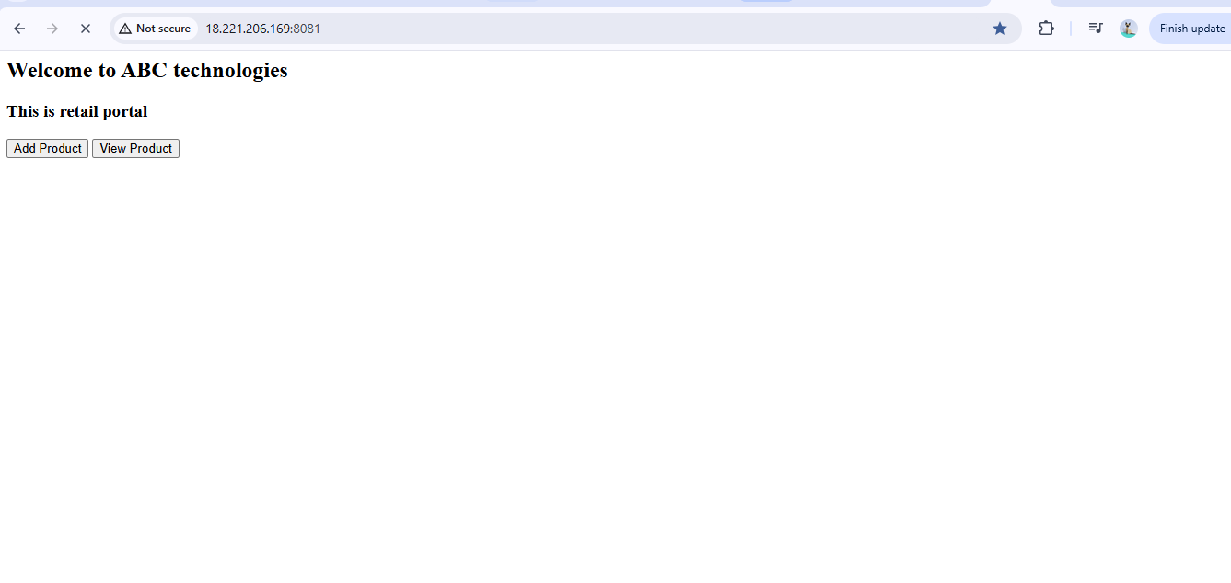

My EC2 Server with all necessary Ports enabled
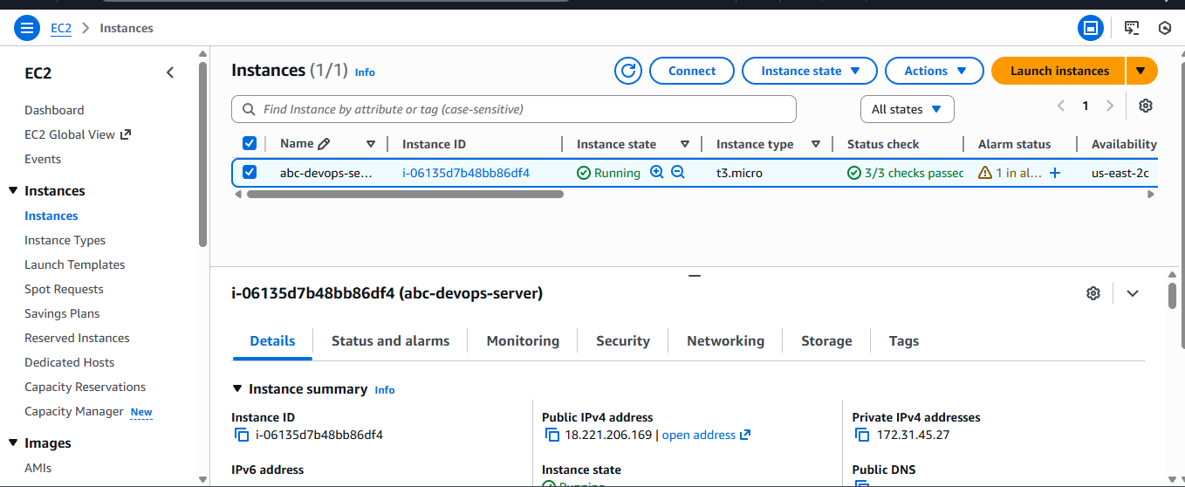

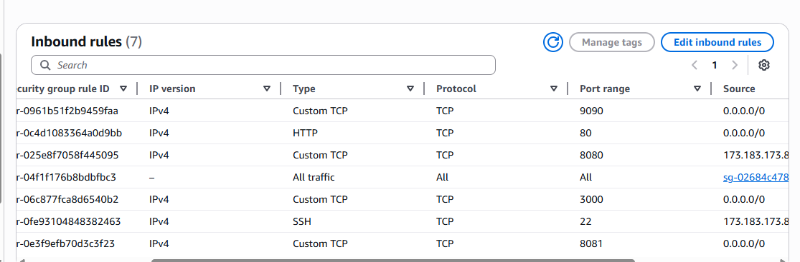

Jenkins successfully compiled, tested, and packaged the application using Maven.
Compile: Success
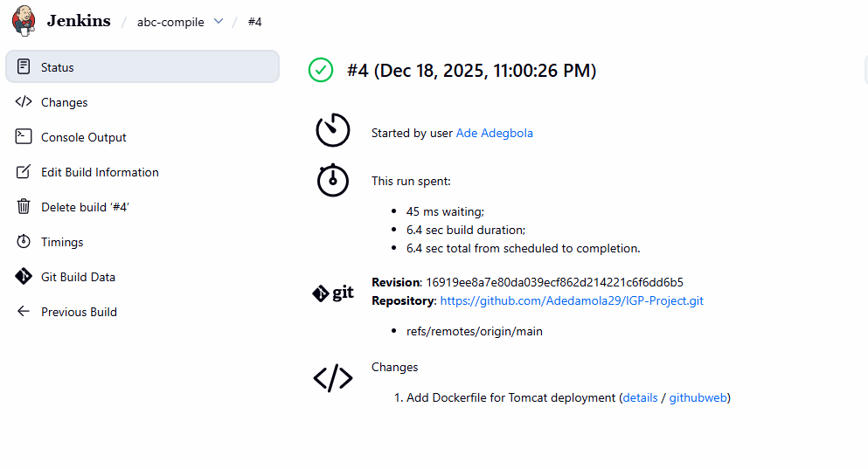
Package: Success

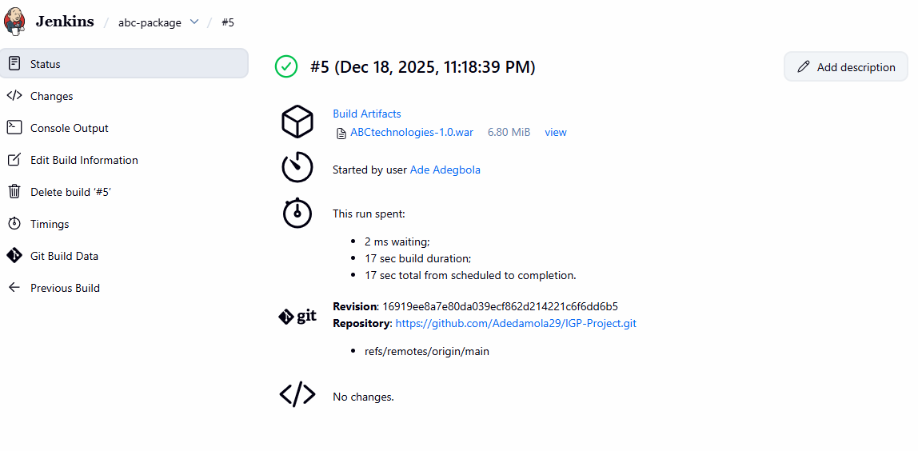

Test: Success
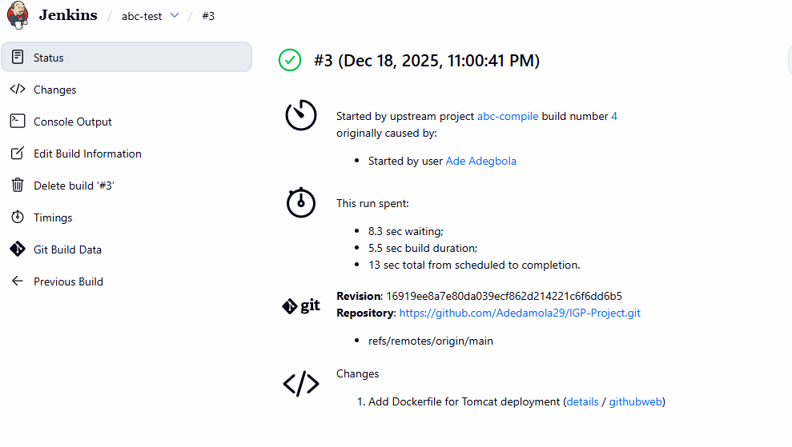
Docker Image:
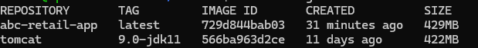

Docker ps:

Ansible:

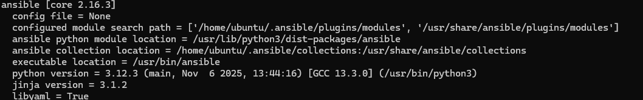

Ansible Playbook:
