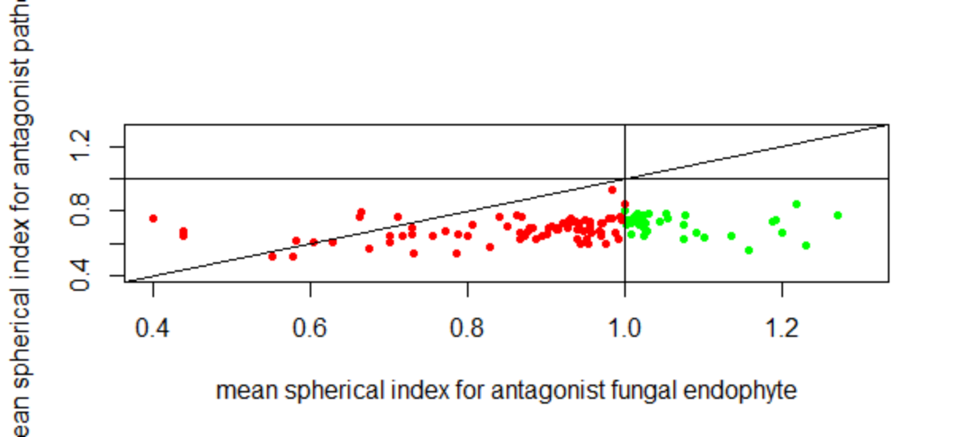

Antagonism Assay

The antagonism assay identified of the 36 root endophytes against the pathogen *H. parviporum* was statistically successful, none of the assayed samples was statistically significant on Day 4, by Day 7 only 3 of the 36 samples was significant, Day 10 4/36 was significant and by Day 14, 3 of the 9 samples was significant. In total 5 of the root endophytes was significant against the pathogen.

|  |  |  |  |  |  |
| --- | --- | --- | --- | --- | --- |
| Sample | Identification | Sampling time (days) | | | |
|  |  | 4 | 7 | 10 | 14 |
| 1 |  |  | Y | Y | Y |
| 2 |  |  | N | N | Y |
| 3 |  |  | N | N | N |
| 4 |  |  | Y | N | N |
| 5 |  |  | N | N | N |
| 6 |  |  | N | N | N |
| 7 |  |  | N | Y | Y |
| 8 |  |  | N | N | N |
| 9 |  |  | N | N | N |
| 10 |  | N | N | N |  |
| 11 |  | N | N | N |  |
| 12 |  | N | N | N |  |
| 13 |  | N | N | N |  |
| 14 |  | N | N | N |  |
| 15 |  | N | N | N |  |
| 16 |  | N | N | N |  |
| 17 |  | N | N | Y |  |
| 18 |  | N | N | N |  |
| 19 |  | N | N | N |  |
| 20 |  | N | N | N |  |
| 21 |  | N | N | N |  |
| 22 |  | N | N | N |  |
| 23 |  | N | N | N |  |
| 24 |  | N | N | N |  |
| 25 |  | N | N | N |  |
| 26 |  | N | N | N |  |
| 27 |  | N | N | N |  |
| 28 |  | N | N | N |  |
| 29 |  | N | Y | N |  |
| 30 |  | N | N | N |  |
| 31 |  | N | N | N |  |
| 32 |  | N | N | N |  |
| 33 |  | N | N | N |  |
| 34 |  | N | N | N |  |
| 35 |  | N | N | N |  |
| 36 |  | N | N | Y |  |