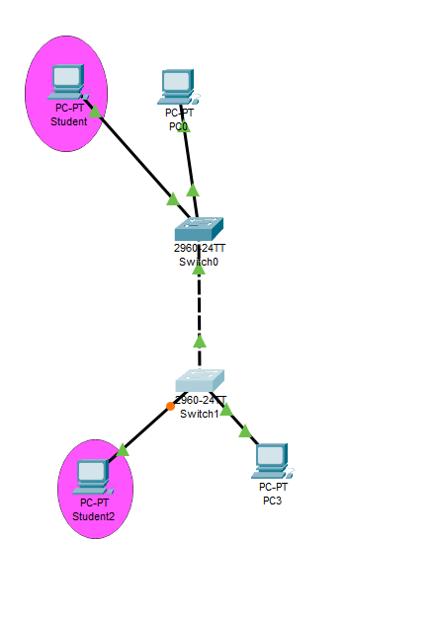

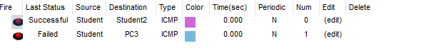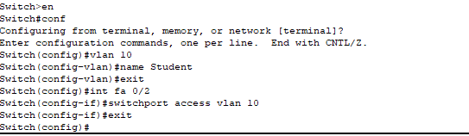

**Enable (previliged password)**



**Phla password:**



**Banner:**



