SMART BUILDING ENERGY
& CARBON PERFORMANCE
INTELLIGENCE
End-to-End Data Engineering & Power BI Analytics Project
By Adeeb M Inamdar
Linkedin : www.linkedin.com/in/adeeb-m-inamdar-35531b2a2
github : https://github.com/AdeebInamdar

PROJECT REPORT
Data source: NYC Open Data | Reporting years: 2022–2024

1. Executive Summary
This project develops an end-to-end business intelligence workflow for exploring building energy use, energy efficiency, greenhouse-gas (GHG) emissions and sustainability indicators. Public building disclosure data from NYC Open Data is extracted through a REST API, ingested with Python, stored in SQL Server, transformed in Power Query, modelled in Power BI and analysed using DAX measures.
The delivered Power BI report contains three pages: Executive Overview, Energy Performance Analysis, and Carbon & Sustainability Analysis. It is designed to help users compare reported building performance across years, boroughs and building types.

2. Project Objectives
- Bring public building energy disclosure data into a structured analytics workflow.
- Compare reported energy consumption across reporting years, boroughs and building categories.
- Explore energy-use intensity (EUI), ENERGY STAR scores and location-based GHG emissions.
- Build reusable measures and a dimensional data model for interactive reporting.
- Communicate results while making data-quality limitations visible.

3. Dataset and Coverage
The project uses the NYC Building Energy and Water Data Disclosure dataset, dataset ID 5zyy-y8am. The API endpoint used for ingestion is:
https://data.cityofnewyork.us/resource/5zyy-y8am.json
The ingestion run completed with 103,259 records across reporting years 2022, 2023 and 2024. The year-level record counts below are the dataset coverage counts observed during project preparation.
Reporting year | Records
2022 | 30,485
2023 | 33,684
2024 | 39,090
Total | 103,259
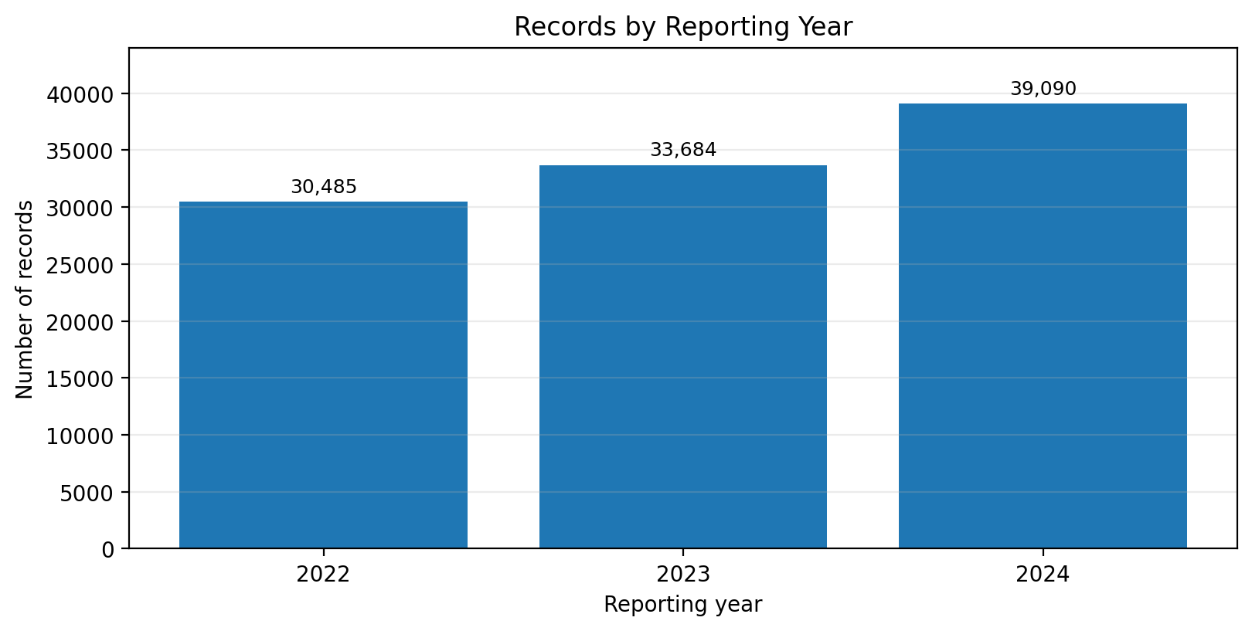
Figure 1. Number of source records by reporting year.
Interpretation: The 2024 reporting-year slice contains the largest number of records in this extract, followed by 2023 and 2022. This chart describes dataset coverage only; it does not indicate that energy consumption or emissions increased.

4. Technology Stack and Responsibilities
Technology | Role in the project
Python | Calls the public JSON API, retrieves the selected fields and loads source records into SQL Server.
REST API / JSON | Provides the NYC Open Data source records.
SQL Server | Stores the ingested source data in dbo.BuildingEnergy_Raw.
Power Query (M) | Performs report-oriented data preparation, including handling invalid values and assigning suitable data types.
Power BI data model | Organises the fact table and dimension tables with one-to-many relationships.
DAX | Defines analytical measures such as totals, averages and year-over-year change.
Power BI Desktop | Builds the interactive three-page report.

5. End-to-End Architecture
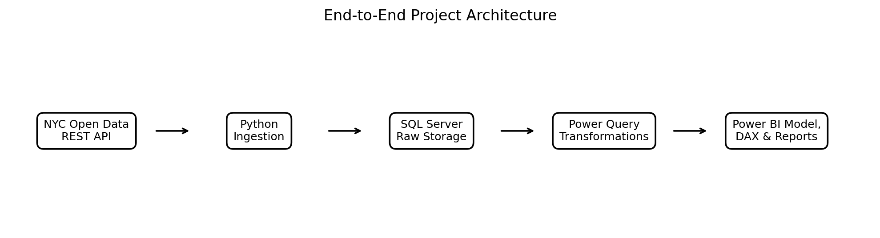
Figure 2. Data flow from the public API to the Power BI report.
The pipeline separates ingestion from reporting transformations. Python is responsible for retrieving and loading source records. SQL Server provides persistent raw storage. Power Query prepares the data for analysis, while the Power BI model and DAX measures support interactive reporting.

6. Data Preparation and Modelling
The main reporting fact table is Fact_BuildingEnergy. The model also contains these dimension tables:
- DimYear — reporting year
- DimBuildingType — primary property type
- DimBorough — borough category
- DimProperty — property-level descriptive attributes
Each dimension table is related to Fact_BuildingEnergy through an active one-to-many relationship with single-direction filtering. The source table retains the imported records; duplicate property-year groups were reviewed rather than automatically removed because some repeated groups contain differing measurements.

7. DAX Measures
Measure | Description
Total Buildings | Distinct count of property IDs.
Total Site Energy | Sum of reported site energy use.
Average EUI | Average of reported site energy use intensity.
Total GHG Emissions | Sum of reported location-based GHG emissions.
Average ENERGY STAR Score | Average of available numeric ENERGY STAR scores.
Energy YoY Change % | Percentage change in total site energy relative to the previous reporting year.

8. Power BI Report and How to Read the Visuals

Page 1 — Executive Overview
KPI cards summarise the selected buildings, site energy, average EUI, GHG emissions and average ENERGY STAR score. The year chart compares reported site energy across reporting years. The building-type bar chart highlights the ten categories with the highest reported site energy. The borough chart compares reported GHG emissions by borough. The ENERGY STAR visual compares average scores across selected building categories. Year, borough and building-type slicers allow the report reader to narrow the view.

Page 2 — Energy Performance Analysis
The year chart supports comparison of reported site energy across years. The building-type chart compares average EUI for the top ten categories under the current filter context. The borough chart compares total reported site energy by borough. Building-type and year slicers make it possible to inspect subsets.

Page 3 — Carbon & Sustainability Analysis
The KPI cards show total reported GHG emissions and average ENERGY STAR score. The year chart compares GHG emissions over time, while the building-type chart identifies categories contributing the largest reported totals. The borough chart compares average ENERGY STAR scores by borough. A data-quality note reminds readers that the source includes missing, estimated and repeated records.
How to interpret the charts: read the axis title and unit first, then compare bars within the same visual. Use slicers to define the year, borough or building-type subset. A change in a filtered total can reflect a change in the selected records, not necessarily a real-world improvement or deterioration.

9. Data Quality, Assumptions and Limitations
- The source includes missing measurements and text placeholders such as 'Not Available'. Invalid measurement values were handled as nulls during Power Query preparation.
- Missing latitude and longitude values were retained as null rather than replaced with artificial coordinates.
- Some property-year groups contain repeated records. Certain repeated rows are identical on inspected fields, while others have different reported measurements. No blanket deduplication was applied.
- Some source values are estimated. The report describes reported records and should not be treated as an independently verified building audit.
- The average EUI and additive totals can be affected by outliers, missing values, estimated values and repeated property-year records. Treat these metrics as exploratory until the duplicate and outlier treatment is formally defined.
- The year-level record-count chart shows reporting coverage, not a trend in energy use or emissions.

10. Project Outcome
The project demonstrates a practical BI workflow spanning public API ingestion, Python automation, SQL Server storage, Power Query transformation, dimensional modelling, DAX calculations and interactive Power BI reporting. It provides a foundation for further work such as validated duplicate-resolution rules, outlier review, documented metric units, scheduled refresh and Power BI Service deployment.

11. Suggested Repository Structure
Smart_Building_Energy_Intelligence/
├── Dataset/
├── powerbi/
│ └── Smart_Building_Energy_Intelligence.pbix
├── python/
│ ├── fetch_data.py
│ ├── inspect_dataset.py
│ ├── inspect_duplicates.py
│ ├── test_sql_connection.py
│ └── load_data_to_sql.py
├── sql/
└── README.md

— End of Report —

