

Analog Circuit Design
Laboratory Report
EEM_WS2025/26

Guided by
FH-Prof. DI Dr. Robert Okorn Stefan Dierer, MSc

Prepared by
Muhammad Adeel Akhtar
Muhammad Rabeet Tahir
01 August 2026

Contents
1 Computer Lab 1
1.1 Stochastic Signals 1
1.2 Noise Analysis with PSpice 3
1.2.1 Task Description 3
1.3 Noise Analysis of a single-stage emitter circuit 3
1.3.1 Schematic of a single-stage emitter circuit 3
1.3.2 Noise voltage spectral density 4
1.4 Noise analysis of a single stage inverting and non-inverting operational amplifier circuit. 4
1.4.1 Task Description 4
1.4.2 Schematic of an inverting and non-inverting amplifier circuit 5
5
2 Active band pass filter 7
2.1 Task Description 7
2.2 Schematic of the 2nd order band pass filter 8
2.3 Calculation of filter components 8
2.3.1 Calculated filter components 8
2.4 Simulation Results 9
2.4.1 Transient Analysis with sine wave input 9
2.4.2 Transient Analysis with unit step input 9
2.4.3 Noise Analysis 10
2.4.4 Monte Carlo Analysis 11
2.5 Measurement Results 13
2.5.1 Frequency Response 13
2.5.2 Pass band gain at center frequency 14
2.5.3 Step response 15
2.6 Comparison of Measured and Simulated Results 16
2.7 Discussion of measured output results 16
3 ADC-driver and anti-aliasing filter 17
3.1 Task Description 17
3.2 Schematic of the ADC-driver with anti-aliasing filter 17
3.3 Calculation of filter components 17
3.3.1 Calculated filter components 18
3.4 Simulation Results 18
3.4.1 Transient Analysis 18
3.4.2 Total output noise 18
3.5 Measurement Results 20
3.5.1 Pass band output signals 20
3.5.2 Step Response 21
3.6 Comparison of Measured and Simulated Results 22
3.7 Calculation of SNR and ENOB on the ADC full-scale input 24
3.8 Discussion of Measured Results 24
4 Switched Capacitor Filter 25
4.1 Task Description 25
4.2 Schematic of switched capacitor filter 25
4.3 Measurement Results 25
4.3.1 Magnitude Response 25
4.3.2 Bode plot comparison 27
4.3.3 Input signal near tuning frequency 29
4.3.4 Switching frequency at output signal 30
4.3.5 Total output noise measurement 32
4.4 Calculation of SNR and ENOB 34
4.4.1 Total Input Noise Voltage 34
4.4.2 Calculation of SNR and ENOB 34
4.5 Discussion on Measurements 35
5 Instrument Device List 36
6 Literature 36
7 Date and Signatures 36
8 Appendix 37
8.1 Active band pass filter components calculations 37
8.2 ADC-driver and anti-aliasing filter components calculations 40

List of Figures
Figure 1: Graphical Diagram 1
Figure 2: autocorrelation 2
Figure 3: Spectral Power Density 2
Figure 4: Cross Correlation 3
Figure 5: Schematic of Single Stage Emitter Circuit 3
Figure 6: Voltage Noise Spectral Voltage Density (in red) and Total Output Noise (in blue) 4
Figure 7: Schematic of inverting and non-inverting amplifier 5
Figure 8: Noise Spectral Voltage Density (Non-Inverting Amplifier) 5
Figure 9: Noise Spectral Voltage Density (Inverting Amplifier) 6
Figure 10: Resistance change effect on Noise Spectral Voltage Density (On Inverting Amplifier) 6
Figure 11: Schematic of the second order band pass filter (Butterworth) 8
Figure 12: Sine Wave Transient Analysis 9
Figure 13: Unit Step Response 9
Figure 14: Noise Density in ‘V²/Hz’ 10
Figure 15: Total Output Noise Voltage in ‘V’ 10
Figure 16: 3dB Bandwidth 11
Figure 17: Center Frequency 12
Figure 18: Gain Variation in dB 12
Figure 19: Pass Band Gain (at center frequency) 14
Figure 20: Step Response of the filter 15
Figure 21: Comparison between Measured and Calculated Responses 16
Figure 22: Schematic of the ADC-driver with anti-aliasing filter. 17
Figure 23: Time domain simulation with sine wave input 18
Figure 24: Noise Power Density (V2/Hz) 19
Figure 25: Integrated differential output-noise voltage for V(Uout+,Uout−), integrated from 1 Hz to 10 MHz. 19
Figure 26: Pass band signals 21
Figure 27: Step-Response of the Filter 22
Figure 28: Differential magnitude and phase responses of the ADC driver with anti-aliasing filter (Wrapped Phase). 23
Figure 29: Differential magnitude and phase responses of the ADC driver with anti-aliasing filter (Unwrapped Phase). 23
Figure 30: Schematic of the switched-capacitor filter with pre-amplifier stage. 25
Figure 31: Magnitude response of SC-filter with 500 kHz and 1 MHz tuning frequencies (Wrapped Phase) 27
Figure 32: Magnitude response of SC-filter with 500 kHz and 1 MHz tuning frequencies (Unwrapped Phase) 28
Figure 33: Input and aliased output signals for an input frequency near the switching frequency. 29
Figure 34: Switching frequency visibility at the output 30
Figure 35: Switching Frequency 31
Figure 36: Measurement of the total output noise of the circuit with the pre-amplifier and SC filter and an additional second stage amplifier. The input signal was connected directly to GND. 32
Figure 37: Total Output Noise with R_{g} = 51ohm 33
Figure 38: Total Output Noise with R_{g} = 100kohm 33
Figure 39: Schematic of the first-stage multi-feedback band pass filter. 37

List of Tables
Table 1: Calculated values for Butterworth filter 8
Table 2: Frequency Response Data 13
Table 3: Calculated and implemented resistor and capacitor values for the ADC Driver with anti-aliasing filter. 18
Table 4: Measured frequency response of the ADC-driver and anti-aliasing filter (𝐕𝐂𝐂=+5V, 𝐕𝐄𝐄=0V). 20
Table 5: Measured magnitude response of the SC-filter with 500 kHz tuning frequency (VCC​=+5V, VEE​=−5V). 25
Table 6: Measured magnitude response of the SC-filter with 1 MHz tuning frequency (VCC​=+5V, VEE​=−5V). 26

Computer Lab

Stochastic Signals

Value used for given simulations
- Number of Samples = 1000
- Amplitude = 8.2
- f / Hz = 5
- Standard deviation = 5
- Demsion size = 100

Graphic Diagram
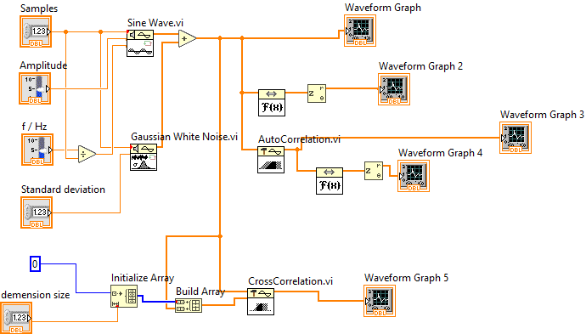
Figure 1: Graphical Diagram

Auto-Correlation

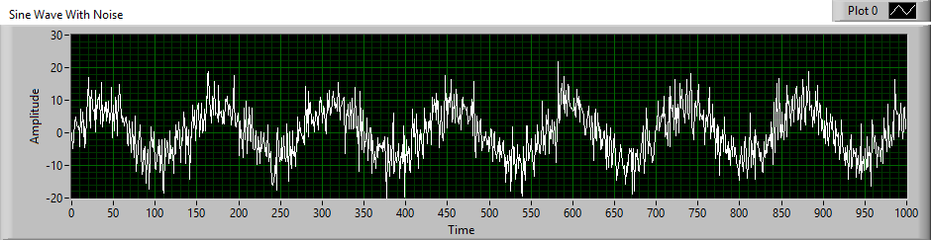
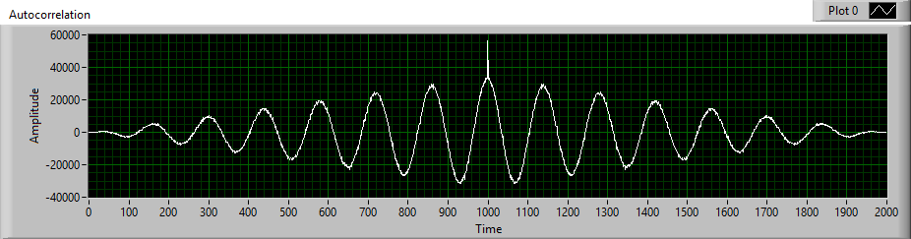
Peak at zero lag position (1000, where shifted version of signal exactly matches with original signal) which shows period nature of sine wave as well. For the noise signal, the autocorrelation rapidly decayed to zero for increasing time delay, indicating that the noise signal was random and uncorrelated over time.
Figure 2: autocorrelation

Spectral Power Density

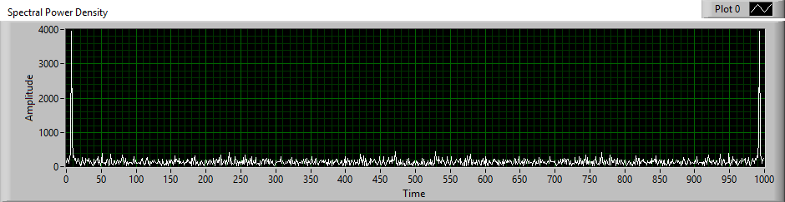
The resulting spectrum showed a distinct peak at the sine wave frequency (5 cycles per 1000 samples) so peak is around 5 and 995 because of symmetry property, representing the deterministic component of the signal. In addition, a continuous wide band noise was observed across the frequency range, caused by the noise component.
Figure 3: Spectral Power Density

Cross Correlation

For the two sine wave signals, the cross-correlation showed a clear peak at a specific time delay, indicating a strong correlation between the signals. For the two noise sources, no significant correlation peak was observed, confirming that the noise signals were uncorrelated and random.

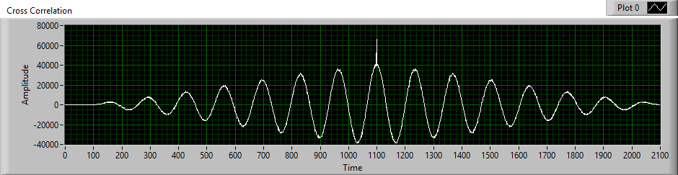
As dimension size is 100, cross correlation peak at 100 samples delayed as compared to auto correlation.
Figure 4: Cross Correlation

Noise Analysis with PSpice

Task Description

Noise analysis is the key aspect in designing and analyzing op-amp circuits to get familiar with non-ideal output. It ensures circuits performance, stability, and functionality in real-time circuits where signals are distributed by external noise sources. Noise analysis is used in evaluation of unwanted electrical signals that disturb the operation of electrical circuits. Noise analysis deals with the fluctuation in the voltages or current flowing through the operational amplifier because of noise sources. OrCAD PSpice is used to evaluate and verify the circuit’s noise voltage spectral density in this task.

Noise Analysis of a single-stage emitter circuit

Schematic of a single-stage emitter circuit

In this part single stage emitter circuit is designed using BC547C bipolar junction transistor as an amplifier circuit.
Figure 5: Schematic of Single Stage Emitter Circuit

Noise voltage spectral density
Figure 6: Voltage Noise Spectral Voltage Density (in red) and Total Output Noise (in blue)

Noise spectral voltage density V(ONOISE) in $V/√Hz$ and SQRT(S(NTOT(ONOISE)) is Integrated Total RMS Noise in $V$.

- At low frequencies R5 and C1 function as high pass filter so noise density is low
- At mid band range, noise is flat (white noise) mostly due to thermal noise of Resistors.
- At high frequencies noise density drops because of amplifier bandwidth is limited.

Noise analysis of a single stage inverting and non-inverting operational amplifier circuit.

Task Description
In this task, an inverting and non-inverting amplifier is designed and simulated on PSpice to see the noise spectral voltage density of the circuit. Figure 7 displays the schematic of amplifier’s circuit and figures 8, 9 and 10 show the noise voltage spectral density (non-inverting), noise voltage spectral density (inverting), and resistance change effect on inverting amplifier respectively.

Schematic of an inverting and non-inverting amplifier circuit
Figure 7: Schematic of inverting and non-inverting amplifier

Figure 8: Noise Spectral Voltage Density (Non-Inverting Amplifier)

Figure 9: Noise Spectral Voltage Density (Inverting Amplifier)
Both results look similar because resistor values are equal to achieve almost same gain.

R8 changed from 10K to 5k so noise density also decreased.
Figure 10: Resistance change effect on Noise Spectral Voltage Density (On Inverting Amplifier)

Noise Spectral Voltage Density for inverting and non-inverting amplifier is shown above.
Noninverting Amplifier Noise Spectral Voltage Density ($V/√Hz$ )
- At low frequencies noise density is high because of flicker noise
- From range 100Hz to 500kHz flat noise density because of thermal noise
- At Higher frequencies noise density rolls off is due to limited gain bandwidth of AD823an Opamp.
- $GBW=Acl×f_{BW}=11×1.31×{10}^{6}=14.4MHz$ (f_{BW} calculated from bode plot in simulation)
- Rolls off start after 14.4Mhz onwards as we move to higher frequencies.

Active band pass filter

Task Description
In this task a second order active band pass filter with the dual Op-Amp AD823an/AD is designed, by cascading two staggered tuned first order band pass filters by using the multi feedback topology (MFB) to build the two filter stages. Filter has following specifications
- Passband: 4000 Hz - 5000 Hz
- Gain: 20 dB
- Response Type: Butterworth

The design process began with the calculation of key parameters, including the damping factor (α). In order to calculate the components of filters the equation of α is solved by using Wolfram Alpha and then values of capacitors and resistors are calculated by using filter equations.
The circuit is simulated in OrCAD PSpice, and the following analyses are conducted:
- Transient analysis using unit-step and sine wave inputs
- AC analysis to generate Bode plots
- Noise analysis (noise density, total output noise voltage)
- Monte Carlo analysis with component tolerances histograms (for 3dB bandwidth, center frequency, gain variation).

Next step is implementation on the breadboard, following steps are performed.
- Assemble circuit using Op-Amp AD823an/AD with supply voltages of +5V and-5V
- Measure frequency response using oscilloscope’s ratio and phase measurement function.
- Measure pass band gain (at center frequency)
- Measure 3dB corner frequencies
- Measure step-response of the filter
Final step is to compare the simulated and measured values using Bode Diagram

Schematic of the 2nd order band pass filter
Figure 11: Schematic of the second order band pass filter (Butterworth)

Calculation of filter components

To calculate value of components we need transfer function of above filter, complete calculations and derivations are written in Appendix 8.1.

Calculated filter components

Table 1: Calculated values for Butterworth filter
Component | Calculated  Ω | Used  Ω
R1 | 5440 | 5600
R2 | 48820 | 51000
R3 | 321 | 300
R4 | 4650 | 4700
R5 | 41790 | 43000
R6 | 274 | 270
C1 = C2 = C3 = C4 | 10nF

Simulation Results

In this section, transient analysis of a second order active band pass filter with the dual Op-Amp AD823an/AD, by cascading two staggered tuned first order band pass filters by using the multi feedback topology is done with sine wave and unit step input.

Transient Analysis with sine wave input

V_{IN(P)} = 306 mV, V_{OUT(P)} = 3.5175 V, Freq = 4.5kHz, Gain = 21.21dB
Figure 12: Sine Wave Transient Analysis

Transient Analysis with unit step input

V_{IN} = 1V, as step contains all frequencies, band pass only allows certain range of frequencies.
Figure 13: Unit Step Response

Noise Analysis

Noise density

Spectral power density of noise G(f) is maximum around 4.5499kHz (center frequency)

G(f)_{max} = 15.696p $V^{2}/Hz$
Figure 14: Noise Density in ‘V²/Hz’

Total output noise voltage

Total Output noise voltage (integrated noise over frequency) of this filter is

V_{noise (RMS)} = 129.940uV (At Nominal Temperature (Pspice) TNOM = 27.0°C)

Figure 15: Total Output Noise Voltage in ‘V’

Monte Carlo Analysis
For all given histogram Analysis following values are used.

- Number of runs = 100
- Distribution = Uniform
- Random Seed Number = 2048
- Tolerance of Components = 1%

Monte Carlo analysis with histogram for 3 dB bandwidth

According to design mean is at 0.9kHz bandwidth.

Figure 16: 3dB Bandwidth

Center frequency

Mean is at 4.485kHz which is our expected center frequency.
Figure 17: Center Frequency

Gain Variation

Mean of samples is at 20.95dB and deviations are because of tolerance in components.
Figure 18: Gain Variation in dB

Measurement Results

Frequency Response

The Butterworth filter's frequency response, including magnitude and phase, is measured by supplying sine wave to the circuit with the help of function generator and using the oscilloscope’s ratio and phase functions covering frequencies from 3.4 kHz to 6 kHz, as shown in Table 2.

Table 2: Frequency Response Data
Frequency in Hz | Magnitude in dB | Phase in degree
f/Hz | G/ dB | Φ/ ˚
3400 | -0.1 | 151
3500 | 1.4 | 149.8
3600 | 3.1 | 145.3
3700 | 4.9 | 142.1
3800 | 6.8 | 135.5
3900 | 8.8 | 128.2
4000 | 11.0 | 120.5
4100 | 13.3 | 110.6
4270(f_{L}) | 16.9 | 81.3
4300 | 17.4 | 76.7
4400 | 18.7 | 57.6
4500 | 19.5 | 37.5
4700(f_{c}) | 19.9 | -1.09
4750 | 19.9 | -10
4800 | 19.8 | -18.3
4900 | 19.5 | -34.5
5000 | 18.9 | -50.3
5100 | 17.9 | -66.7
5190(f_{H}) | 16.9 | -78.4
5300 | 15.5 | -92.5
5400 | 14.1 | -102.8
5500 | 12.6 | -110.4
5600 | 11.2 | -117
5700 | 9.9 | -122.8
5800 | 8.6 | -127.3
5900 | 7.4 | -133.2
6000 | 6.2 | -135.3

Pass band gain at center frequency

- Gain at center frequency, f_{c} = 4.7kHz
- Channel 1(in yellow) is Output Voltage (2.85V_{p})
- Channel 2(in green) is Input Voltage (306mV_{p})

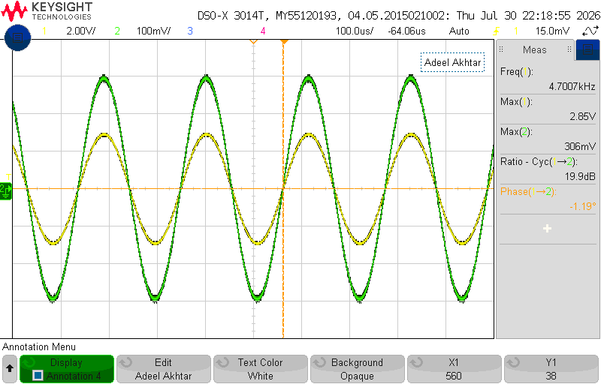
Figure 19: Pass Band Gain (at center frequency)

Step response

- Channel 1(in green) is Input Voltage
- Channel 2(in yellow) is Output Voltage

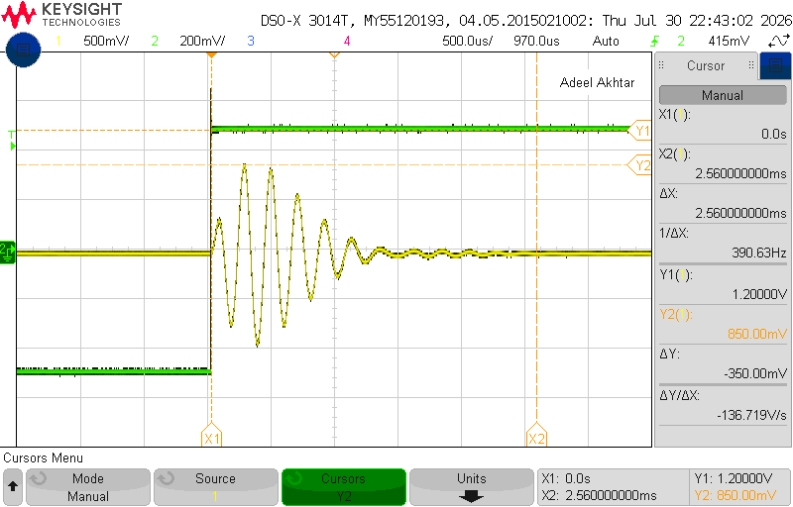
Figure 20: Step Response of the filter

Comparison of Measured and Simulated Results

Measurement results are close to simulation results; deviation occurs because of tolerance in components and effect of parasitic (inductance of jumping wires.)
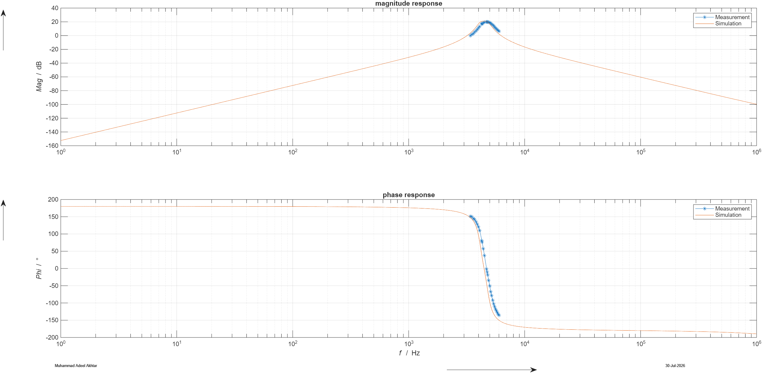
Figure 21: Comparison between Measured and Calculated Responses

Discussion of measured output results
In this task, a second-order bandpass filter was designed using the OpAmp AD823an/AD. The design was based on the properties of a Butterworth filter, and a multi-feedback architecture was implemented with the OpAmp. The filter’s characteristics were simulated in the PSpice environment. Following the simulation, the circuit was constructed on a breadboard, and the filter’s behavior was measured. An overlap was observed between the simulated and measured values. The small shifts in the center frequency and the 3 dB cutoff frequencies are reasonable and can be explained by the tolerances of the components.

Summary of Measured Results:
- Center frequency: 4.7 kHz with 19.9 dB gain
- Lower 3dB cutoff frequency: 4.27 kHz with 16.9 dB gain
- Upper 3dB cutoff frequency: 5.19 kHz with 16.9 dB gain
How could the output noise be measured?
To measure the output noise of the Butterworth filter, the input can be grounded, and a high-gain amplifier circuit can be connected to the output. This amplifier will amplify the noise, making it visible and measurable. The noise can then be observed and quantified using RMS (Root Mean Square) function on an oscilloscope.

ADC-driver and anti-aliasing filter

Task Description
In the task, a single single-ended to differential driver is designed with the help of second order active low pass filter for the AD7626 ADC by using the AD823an/AD dual Op-Amp. The cutoff for the lowpass should be 40kHz and additionally a high pass with a cutoff frequency of 100Hz had to be added. The total differential gain is supposed to be 20 and a DC offset must be provided for the ADC signal (2.5V on both differential outputs).

Schematic of the ADC-driver with anti-aliasing filter

Figure 22: Schematic of the ADC-driver with anti-aliasing filter.

Calculation of filter components
In this circuit, C 1 and C 2 were predefined as part of the design specifications. The filter was implemented using a Multiple-Feedback (MFB) topology for a low-pass response. A detailed description of the general formulas and calculations for the derivation of the component values can be seen in appendix 8.2.

Calculated filter components

All resistors’ values are in ohm(Ω) and capacitors in farad(F).

Table 3: Calculated and implemented resistor and capacitor values for the ADC Driver with anti-aliasing filter.
Component | Calculated value | Implemented value
R₁ | 852 | 910
R₂ | 8519 | 9100
R₃ | 2635 | 2700
R₄ | 1000 | 1000
R₅ | 1000 | 1000
C₁ | 150p | 150p
C₂ | 4.7n | 4.7n
C₃ | 1.85u | 2u
C₄ | 100n | 100n
C₅ | 10u | 10u

Simulation Results

Transient Analysis

Both outputs are (180°) out of phase with equal magnitude.
- Uout+ is output of first Opamp (inverts input with gain of -10) in blue
- Uout- is output of second Opamp (inverts Uout+ with gain of 1) in red
- Uin = 100mV_{p}, Freq = 10k

Figure 23: Time domain simulation with sine wave input

Total output noise

Figure 24: Noise Power Density (V²/Hz)

The noise-analysis output variable is defined as $V(Uout+,Uout-)$. Therefore, the plotted integrated noise represents the RMS differential noise voltage directly across the ADC inputs, rather than the noise at only one output.
Figure 25: Integrated differential output-noise voltage for V(Uout+,Uout−), integrated from 1 Hz to 10 MHz.

Measurement Results

Table 4: Measured frequency response of the ADC-driver and anti-aliasing filter (𝐕𝐂𝐂=+5V, 𝐕𝐄𝐄=0V).
Frequency in Hz | Magnitude in dB | Phase in degree | Unwrapped Phase
f/Hz | G/ dB | Φ/ ˚ | Φ/ ˚
50 | 17.3 | -118.7 | -118.7
100 | 21.3 | -136.8 | -136.8
200 | 23.4 | -155.2 | -155.2
500 | 24.2 | -168.3 | -168.3
1000 | 24.4 | -175.4 | -175.4
2000 | 24.5 | 178.6 | -181.4
5000 | 24.7 | 170.4 | -189.6
10000 | 24.7 | 159.8 | -200.2
20000 | 24.7 | 136.0 | -224.0
30000 | 23.9 | 108.1 | -251.9
40000 | 22.0 | 83.8 | -276.2
60000 | 16.6 | 52.7 | -307.3
80000 | 11.9 | 34.6 | -325.4
100000 | 8.0 | 23.8 | -336.2

Pass band output signals

This measurement is performed under following conditions

- Result taken at Uin = 209mV_{pp}, Freq = 1kHz
- Channel 1 (in yellow) is Uout+
- Channel 2 (in green) is Uout-
- Channel 3 (in blue) is Uin
- Math trace M1 (in pink) represents $(U_{\text{out}+}-U_{\text{out}-})$.
- Both single-ended outputs are centered at approximately $2.5\text{ V}$, which provides the required ADC common-mode voltage for single-supply operation.
- $Gain =24.4dB$
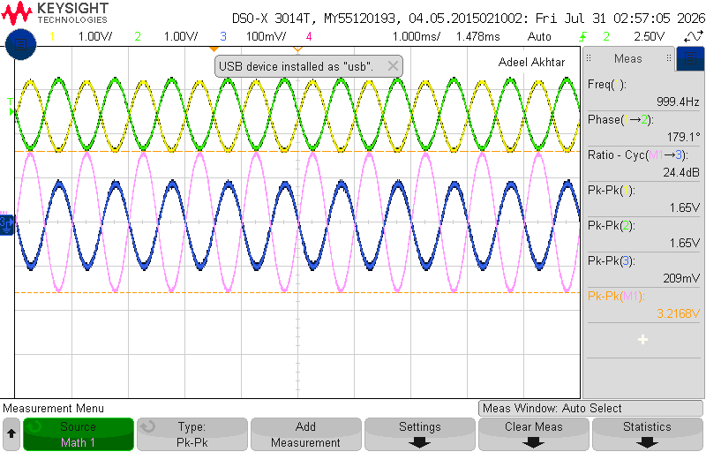
Figure 26: Pass band signals

Step Response
This measurement is performed under following conditions
- V_{IN(P)} = 200mV (in blue)
- Uout- (in green)
- Uout+ (in yellow)

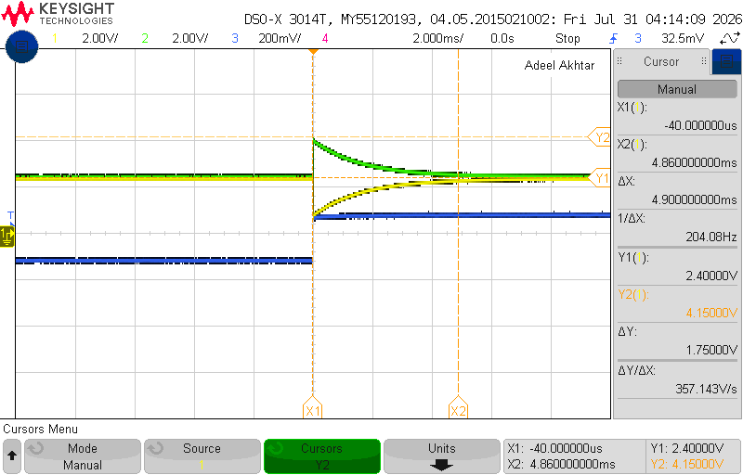
Figure 27: Step-Response of the Filter

Comparison of Measured and Simulated Results
The measured gain response closely follows the simulated behavior, with only a slight deviation in values at the lower frequency range. The transient simulation produced the differential gain of approximately ($26.02\text{ dB}$), whereas the maximum measured pass-band gain was $24.7 \text{dB}$.
In the phase response, fluctuations were observed at certain points, primarily due to variations in oscilloscope readings.
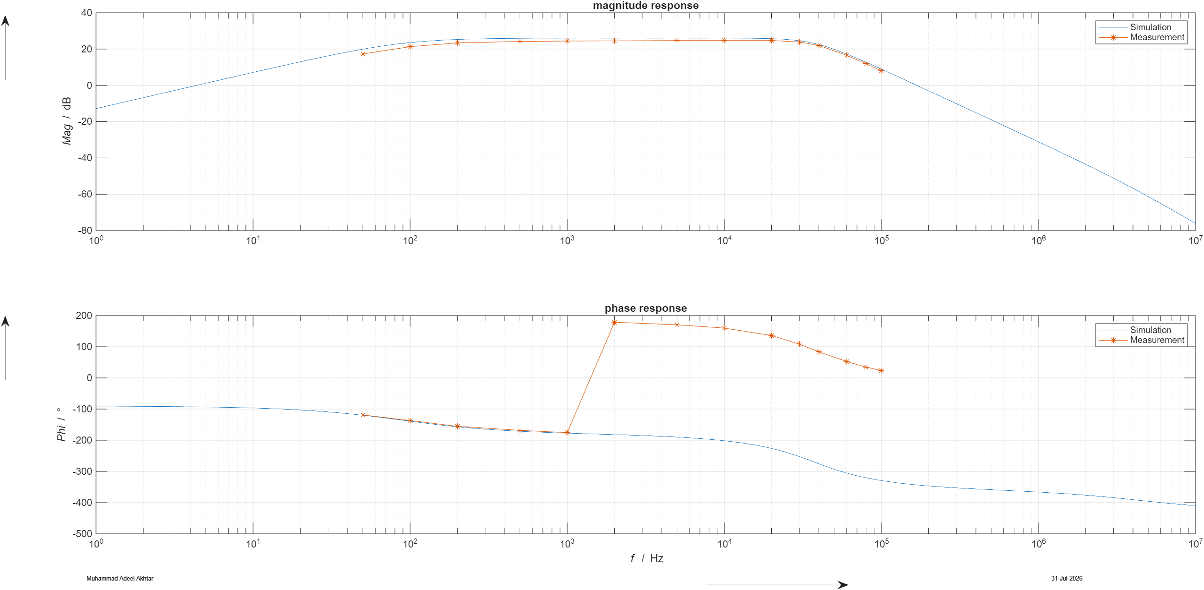
Figure 28: Differential magnitude and phase responses of the ADC driver with anti-aliasing filter (Wrapped Phase).
The oscilloscope gives phase values within the principal range from $-{180}^{∘}$to $+{180}^{∘}$.The actual phase became more negative than $-{180}^{∘}$, the displayed value wrapped to a positive angle. To obtain a continuous phase response for comparison with the PSpice simulation, ${360}^{∘}$is subtracted from the wrapped positive phase values.

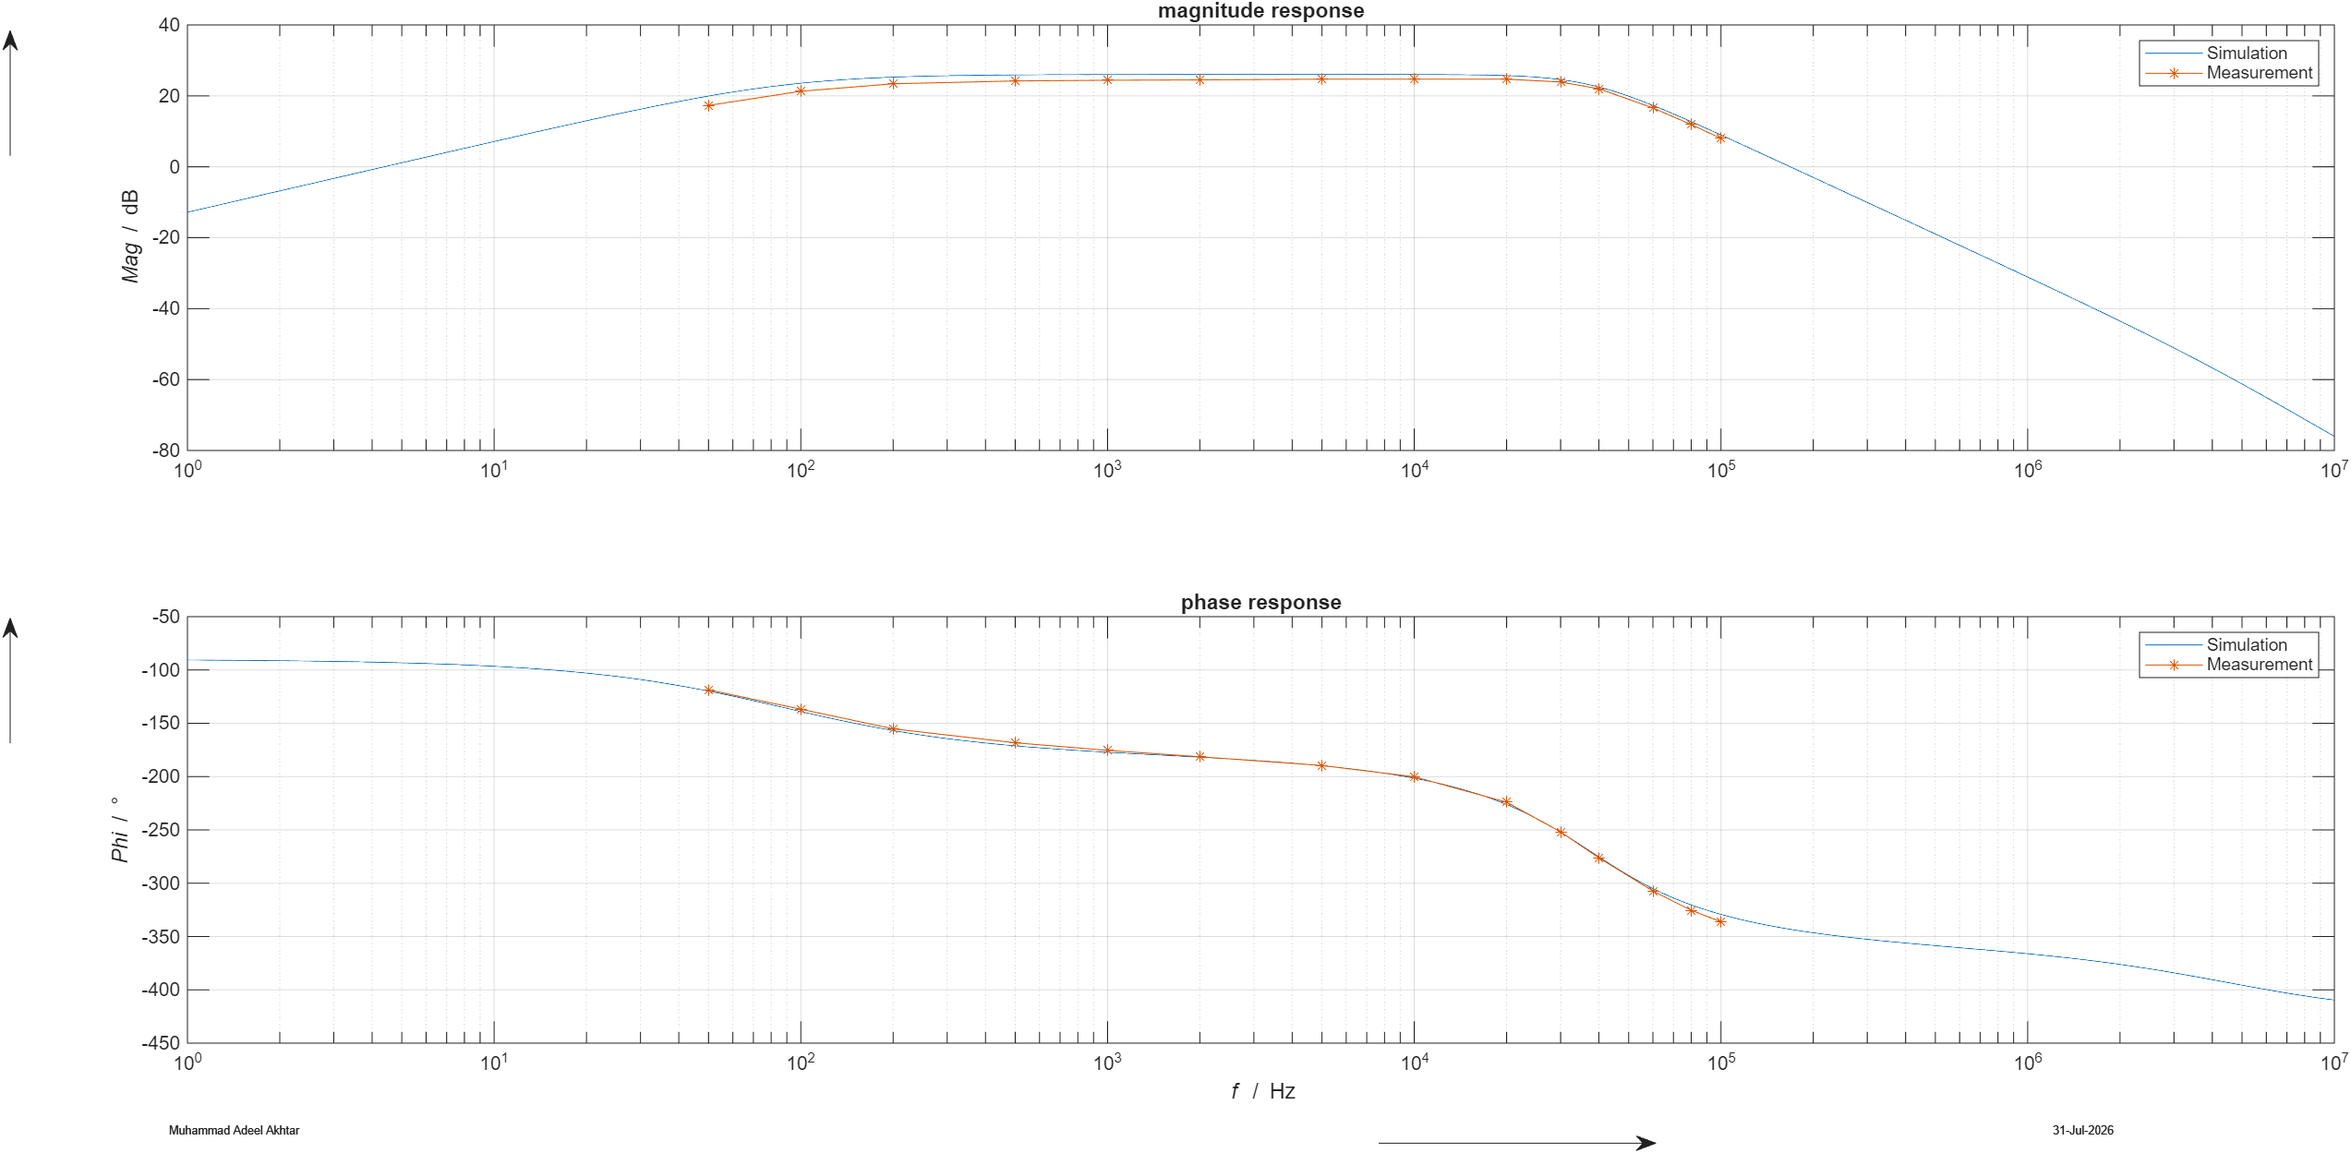
Figure 29: Differential magnitude and phase responses of the ADC driver with anti-aliasing filter (Unwrapped Phase).

Calculation of SNR and ENOB on the ADC full-scale input

The total noise for calculating the SNR was found by performing the PSpice simulation which is 165.411µV(approx.) (from fig25). The output noise was integrated up to 10 MHz to represent the selected system bandwidth used for the SNR calculation.
$V_{FS,PP}$ is twice of 8.192V because of (+- 4.096V)

$$V_{sig,rms}= \frac{V_{(FS,pp)}}{2\sqrt{2}}= \frac{8.192}{2.828}=2.896V$$

$$SNR_{dB}=20{log⁡}_{10}\left(\frac{V_{sig,rms}}{V_{n},rms}\right)= 20{log⁡}_{10}\left(\frac{2.896}{165.411*{10}^{-6}}\right)= 84.87dB$$

$$ENOB=\frac{SNR_{dB}-1.76}{6.02}=\frac{84.87-1.76}{6.02}=13.80 bits$$

Discussion of Measured Results

To prevent aliasing, we used anti-aliasing filters at the ADC input, in accordance with Nyquist’s sampling theorem. These filters ensured that the input signal frequency remained below half the sample rate. Consequently, unnecessary sampling data was avoided. The measured results closely matched the calculated values.

Switched Capacitor Filter

Task Description
The 8th-order switched capacitor (SC) filter was designed, tested, and analyzed using the MAX295 integrated device, paired with a non-inverting pre-amplifier stage built with the AD823an/AD operational amplifier. The circuit was configured with the following specifications:
- Implement a clock-tunable SC filter.
- Integrate a pre-amplifier stage with a gain of 100 before the SC filter.
- Supply Voltage: ±5V dual supply.
- Tuning Frequencies: 1 MHz and 500 kHz.

Schematic of switched capacitor filter

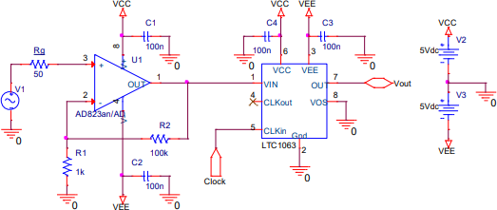
Figure 30: Schematic of the switched-capacitor filter with pre-amplifier stage.

Measurement Results

Magnitude Response
Table 5: Measured magnitude response of the SC-filter with 500 kHz tuning frequency (VCC​=+5V, VEE​=−5V).
Frequency in Hz | Magnitude in dB | Phase in degree | Phase (Unwrapped)
f/Hz | G/ dB | Φ/ ˚ | Φ/ ˚
4000 | 39.2 | -122.3 | -122.3
5000 | 39.1 | -155.2 | -155.2
6000 | 39.2 | 170.6 | -189.4
7000 | 39.2 | 135.1 | -224.9
8000 | 39.0 | 93.8 | -266.2
9000 | 38.4 | 49.2 | -310.8
10000 | 36.6 | -2.4 | -362.4
11000 | 32.8 | -54.6 | -414.6
12000 | 27.6 | -92.5 | -452.5
13000 | 22.2 | -125.1 | -485.1
14000 | 17.00 | -149.4 | -509.4
15000 | 12.1 | -170.4 | -530.4
16000 | 7.4 | 178.8 | -541.2
17000 | 2.9 | 162.5 | -557.5
17300 | 1.6 | 152.4 | -567.6
17500 | 0.8 | 151.0 | -569.0
Note: 1) DC-offset = 0 V, V_{in} = $50 {\text{mV}}_{pp}$

Table 6: Measured magnitude response of the SC-filter with 1 MHz tuning frequency (VCC​=+5V, VEE​=−5V).
Frequency in Hz | Magnitude in dB | Phase in degree | Phase (Unwrapped)
f/Hz | G/ dB | Φ/ ˚ | Φ/ ˚
4000 | 39.3 | -62.9 | -62.9
5000 | 39.3 | -77.8 | -77.8
6000 | 39.3 | -94.5 | -94.5
7000 | 39.3 | -110.7 | -110.7
8000 | 39.3 | -125.6 | -125.6
9000 | 39.3 | -143.6 | -143.6
10000 | 39.3 | -159.8 | -159.8
11000 | 39.3 | -176.4 | -176.4
15000 | 39.1 | 108.9 | -251.1
20000 | 36.4 | -9.5 | -369.5
21000 | 34.8 | -33.9 | -393.9
22000 | 32.7 | -60.1 | -420.1
24000 | 27.5 | -102.4 | -462.4
25000 | 24.8 | -118.9 | -478.9
26000 | 22.0 | -132.5 | -492.5
27000 | 19.4 | -145.7 | -505.7
30000 | 11.8 | -178.5 | -538.5
32000 | 7.1 | 164.4 | -555.6
35000 | 0.4 | 144.2 | -575.8
Note: 1) DC-offset = 0 V, V_{in} = $50 {\text{mV}}_{pp}$

Bode plot comparison
Figure 31 illustrates the measured magnitude response of a switched-capacitor (SC) filter at two different tuning frequencies, 500 kHz and 1 MHz. At lower frequencies, both configurations maintain a stable gain of approximately 39.3 dB. As the frequency increases, the gain remains constant until reaching the cutoff region, where it starts to decline sharply.

A key observation is that the cutoff frequency shifts higher with the increased tuning frequency. The 500 kHz tuning results in an earlier roll-off, meaning it attenuates signals at a lower frequency compared to the 1 MHz tuning, which extends the passband before attenuation begins. This confirms that the SC filter’s cutoff frequency is directly proportional (ratio = f_{clk}⁄f_{c} = 50 ) to the tuning frequency.

Both configurations exhibit a steep roll-off beyond their respective cutoff points, characteristic of high-order SC filters. The higher tuning frequency (1 MHz) allows for a wider passband, making it suitable for applications requiring higher-frequency signal processing. The lower tuning frequency (500 kHz) is effective for narrower bandwidth applications, providing stronger attenuation beyond the cutoff.

Overall, the results validate the frequency-dependent nature of switched-capacitor filters and demonstrate their tunability through clock frequency adjustments.

Shift in phase response is because of wrapping effect, oscilloscope jumps phase from -180° to +180. Therefore, the measured phase values were unwrapped in MATLAB by subtracting ${360}^{∘}$after each phase discontinuity.
$$ϕ_{adjusted} = ϕ_{measured} - 360°$$

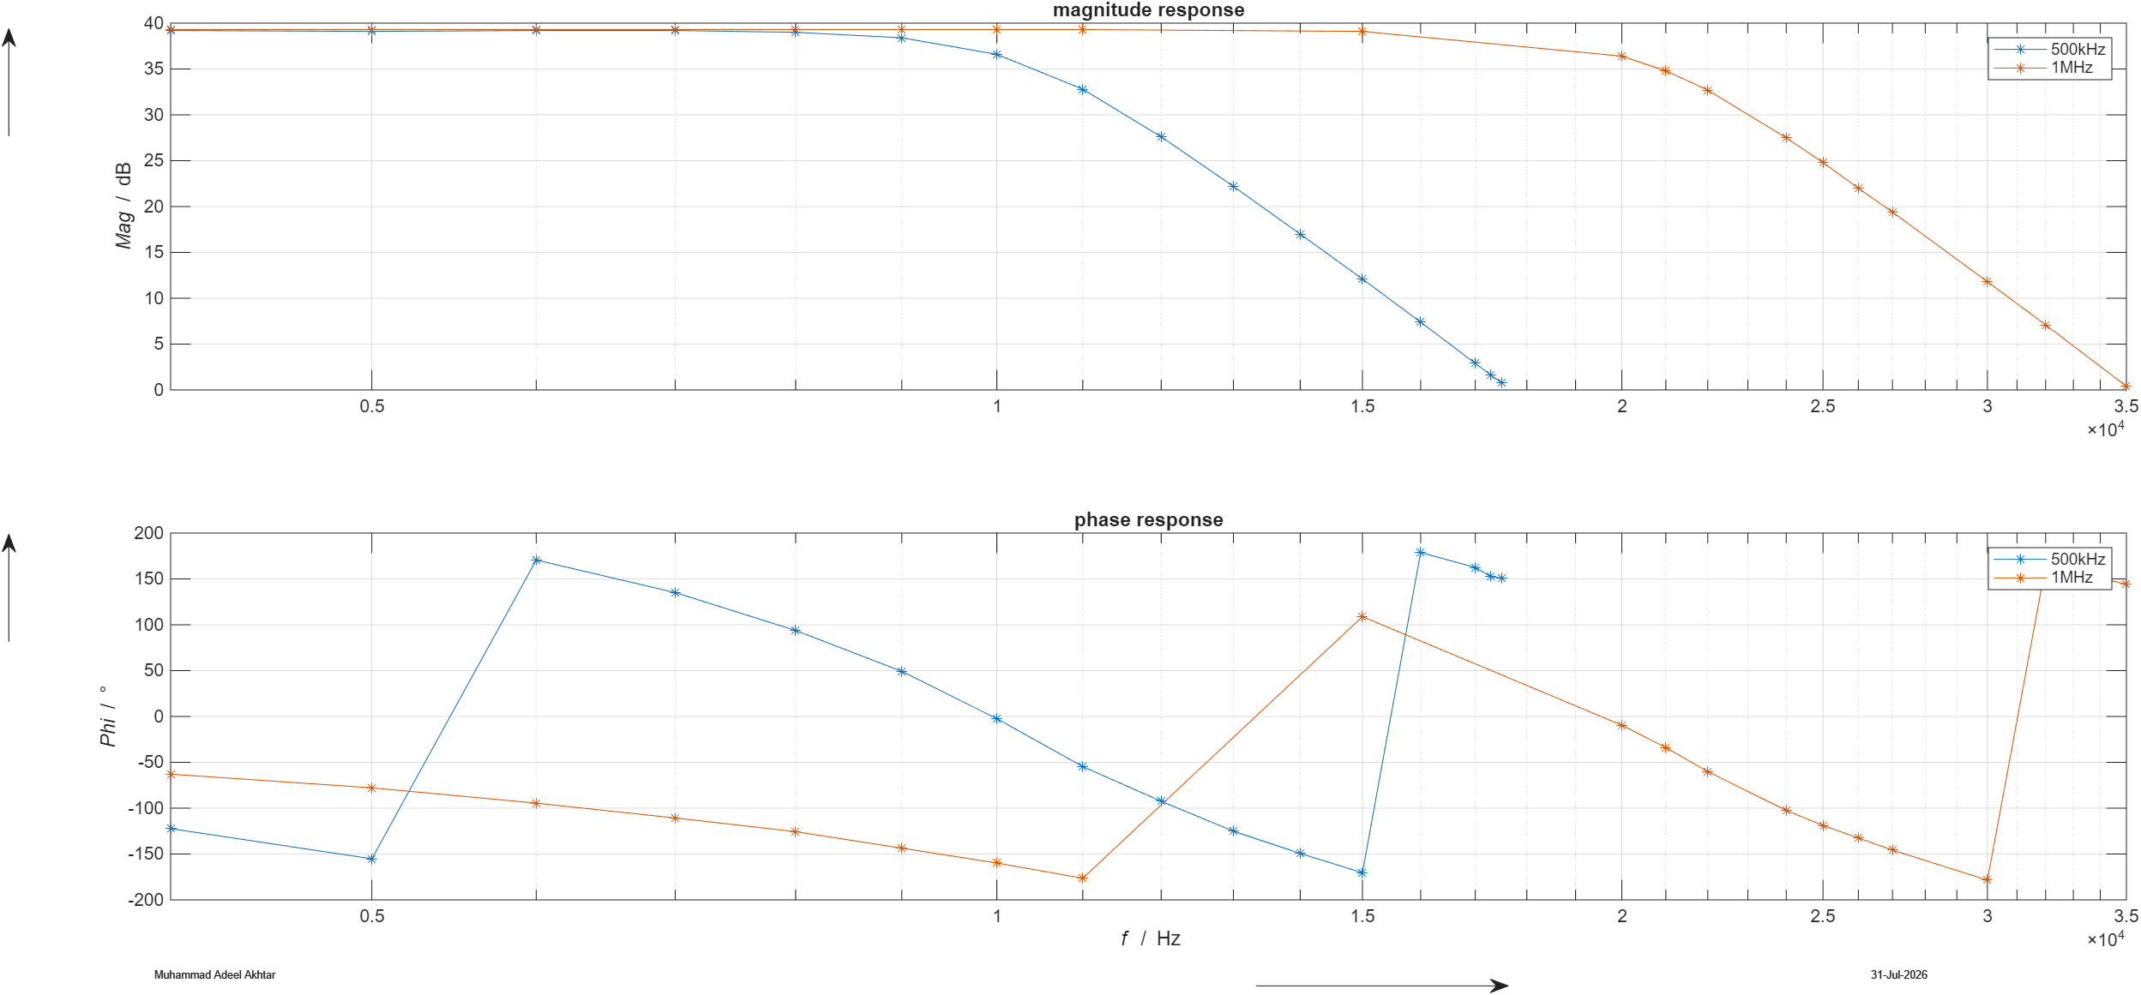
Figure 31: Magnitude response of SC-filter with 500 kHz and 1 MHz tuning frequencies (Wrapped Phase)

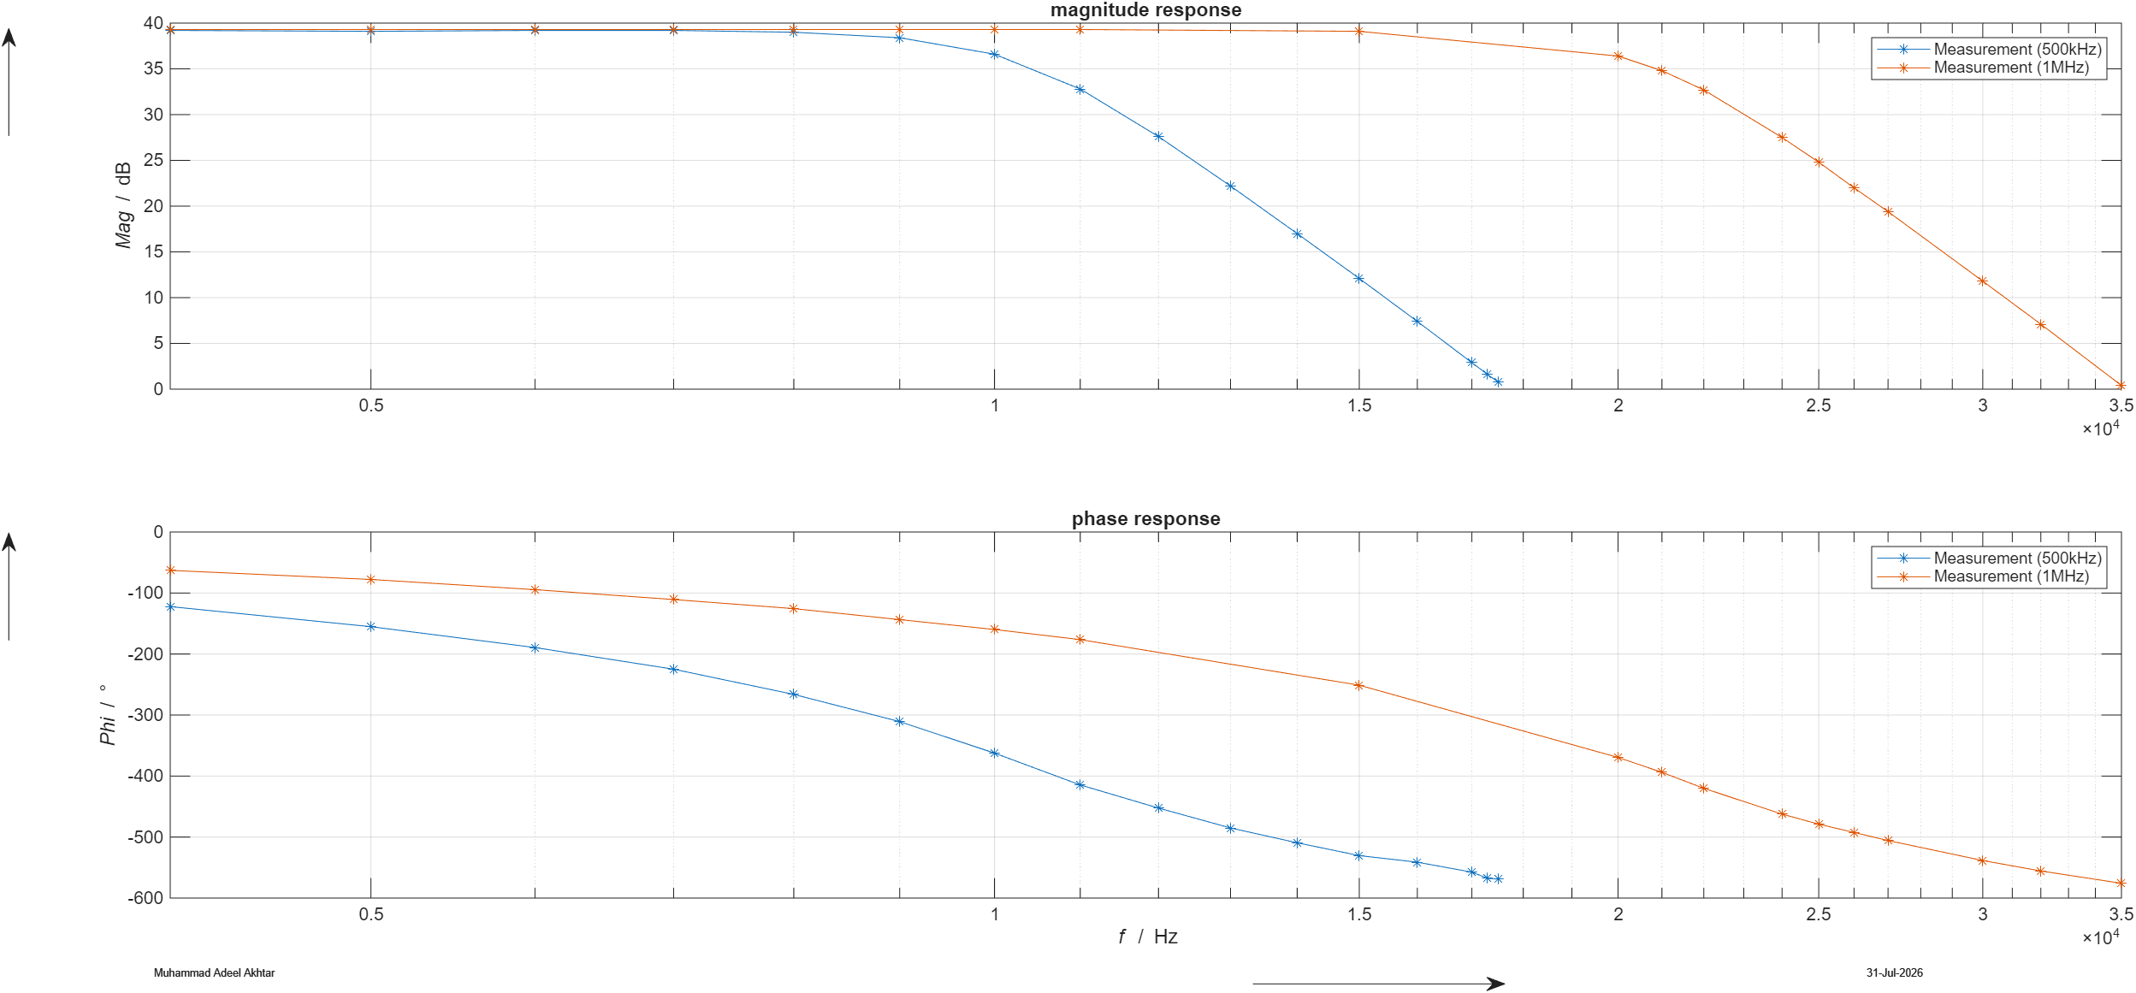
Figure 32: Magnitude response of SC-filter with 500 kHz and 1 MHz tuning frequencies (Unwrapped Phase)

Input signal near tuning frequency

Aliasing occurs when input signal frequency approaches the sampling frequency, as demonstrated in given figure.
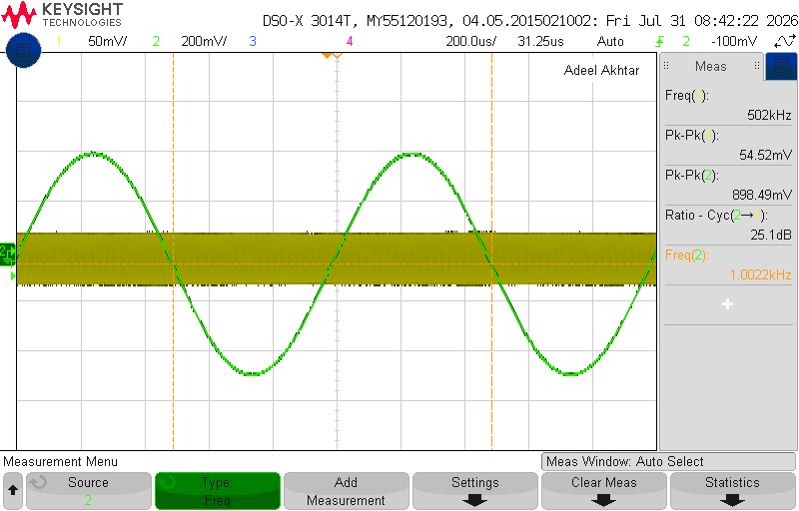
Figure 33: Input and aliased output signals for an input frequency near the switching frequency.

Waveform Description:

Yellow Trace (Channel 1): Represents the signal near 500kHz tuning frequency.

Green Trace (Channel 2): Shows the aliased output sine wave visible on the output of the SC filter.

Switching frequency at output signal

The presence of periodic high-frequency spikes in the output signal (green trace), synchronized with the 500 kHz clock signal, indicates the occurrence of clock crosstalk.

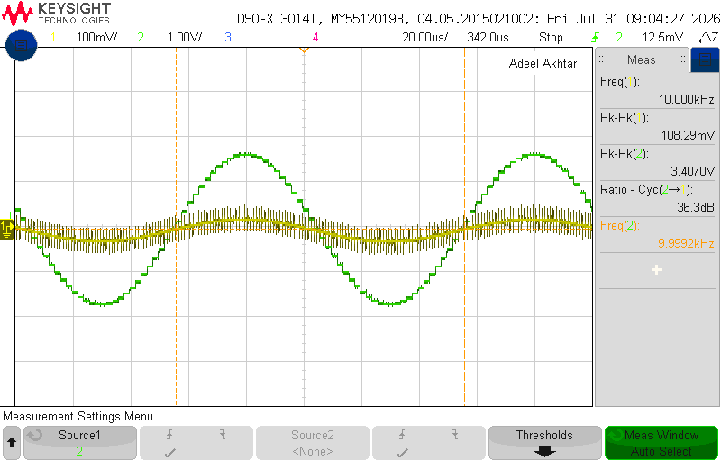
Figure 34: Switching frequency visibility at the output

Traces:

Yellow Trace (Channel 1): Displays the input signal 10kHz.

Green Trace (Channel 2): Shows the output signal.

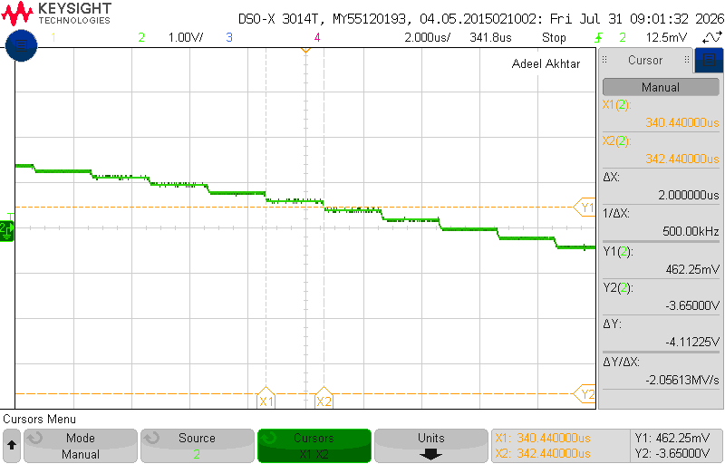
Figure 35: Switching Frequency

- Time base: 2 µs/div
- Cursor spacing: ΔX = 2.000 µs

Therefore:
$$\frac{1}{ΔX}=500\text{ kHz}$$
which matches the 500 kHz switching clock.

Total output noise measurement

An additional low-pass filter and inverting amplifier were connected to the SC-filter circuit's output to measure the total output noise voltage.
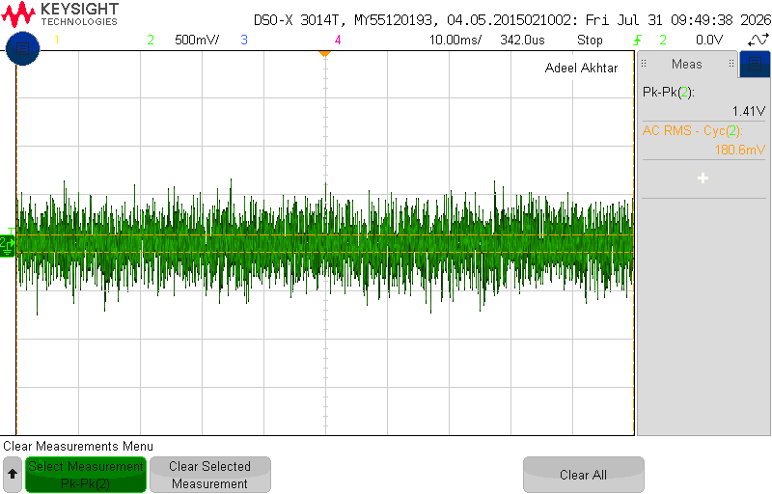
Figure 36: Measurement of the total output noise of the circuit with the pre-amplifier and SC filter and an additional second stage amplifier. The input signal was connected directly to GND.

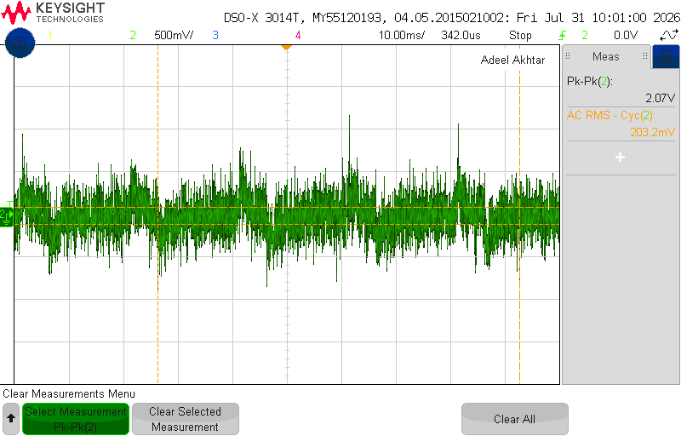
Figure 37: Total Output Noise with R_{g} = 51ohm

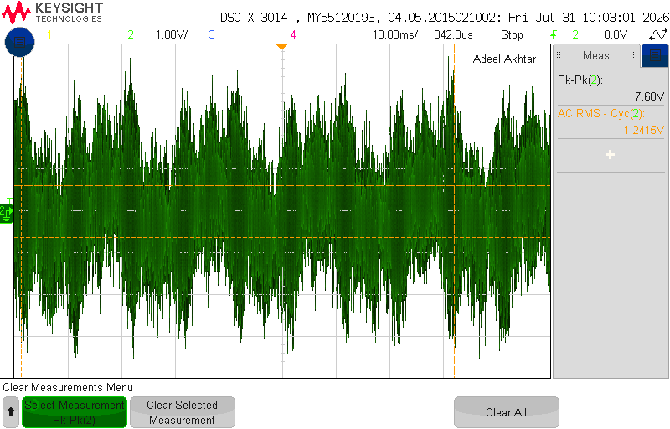
Figure 38: Total Output Noise with R_{g} = 100kohm

Calculation of SNR and ENOB

Total Input Noise Voltage

For R_{g} = 100kΩ, SC output noise voltage:
$A_{meas}$ corresponds to two additional noise-measurement amplifier stages
$$U_{n,SC-out} = \frac{U_{n-meas} (Rg = 100kΩ)}{A_{meas}}$$
$$= \frac{1.2415}{1000}$$
$$= 1.2415 mV$$
Noise referred to the input before the preamplifier:
$$U_{n-in}(Rg = 100kΩ) = \frac{U_{n,SC-out} (Rg = 100kΩ)}{A_{pre} (preamplifier gain= 101)}$$

$$= \frac{1.2415}{101}$$
$$= 12.29 µV RMS$$
Similarly, for R_{g} = 51Ω, SC output noise voltage
$$U_{n,SC-out =}=\frac{203.2m}{1000}=203.2µV$$
Noise referred to the input before the preamplifier:
$$U_{n-in}=\frac{203.2µ}{101}=2.02µV RMS$$

Calculation of SNR and ENOB

Noise voltage for R_{g} = 100kΩ
$$U_{n,RMS}=\frac{1.2415\text{ V}}{1000}=1.2415\text{ mV}$$
The corresponding mean-square noise voltage is:

$$U_{n}^{2}={\left(1.2415×{10}^{-3}\right)}^{2}=1.5413×{10}^{-6} {\text{V}}^{2}$$
Noise voltage for R_{g} = 51Ω
$$U_{n,RMS}=203.2 μ\text{V}$$
The corresponding mean-square noise voltage is:

$$U_{n}^{2}={\left(203.2×{10}^{-6}\right)}^{2}=4.1290×{10}^{-8} {\text{V}}^{2}$$
Signal voltage for full scale sine wave
For this calculation, $5 {\text{V}}_{pp}$was selected as the datasheet-based reference full-scale sine-wave level because the MAX295 harmonic-distortion characteristics are specified using a $5 {\text{V}}_{pp}$sine-wave input.

$$V_{FS,pp}=5\text{V}$$
For a sinusoidal signal:
$$V_{s,RMS}=\frac{V_{s,pp}}{2\sqrt{2}}=\frac{5}{2\sqrt{2}}=1.768\text{ V}$$
The mean-square signal voltage is:
$$V_{s}^{2}={\left(1.768\right)}^{2}=3.126 {\text{V}}^{2}$$With R_{g} = 100kΩ

SNR
$${SNR}_{dB}=10\log_{10}\left(\frac{V_{s}^{2}}{V_{n}^{2}}\right) \\ {SNR}_{dB}=10\log_{10}\left(\frac{3.125}{1.5413×{10}^{-6}}\right)$$
$${SNR}_{dB}=63.07dB$$

ENOB
$$ENOB=\frac{{SNR}_{dB}-1.76}{6.02}$$
$$ENOB=\frac{63.07-1.76}{6.02}=10.18 bits$$
With R_{g} = 51Ω
$${SNR}_{dB}=10\log_{10}\left(\frac{3.125}{4.1290×{10}^{-8}}\right) \\ SNR=78.79\text{ dB}$$
The equivalent ENOB is:
$$ENOB=\frac{78.79-1.76}{6.02}$$
$$ENOB=12.80\text{ bits}$$

Discussion on Measurements
Aliasing effects occur near the tuning frequency but can be avoided by sampling at a frequency greater than half the signal bandwidth. Additionally, the output noise is relatively high in this case.

Instrument Device List
Hardware:
- TTi PL303QMD QUAD-MODE DUAL POWER SUPPLY (9949263)
- KEYSIGHT 34450A 5-1/2 Digit Multimeter (9949726)
- KEYSIGHT 33500B Series TRUEFORM WAVERFORM GENERATOR (9949715)
- KEYSIGHT InfiniiVision DSOX3014T (9949705)
- Agilent U1233A True RMS Multimeter (EL03)

Software:
- OrCAD Pspice 25.1
- MATLAB R2025b
- Wolfram Alpha

Literature
- R. Okorn, Analog Circuit Design Lecture Script V3.13, Graz, 2024.
- R. Okorn, Analog Signal Processing Course Script, Graz, 2021.
- S. Dierer, Noise Analysis with Pspice Handout Part II for OrCAD Capture, Graz, 2024.
- R. Mancini, Op Amps for Everyone, 2002.
- U. Tietze and C. Schenk, Electronic Circuits, Springer Verlag, 2008.
- Maxim Integrated Products, 8th-Order, Lowpass, Switched-Capacitor Filters, Sunnyvale, 1996.
- Texas Instruments, AD823an/AD Dual High-Performance, High-Fidelity Audio Operational Amplifier, Dallas, 2022.

Date and Signatures

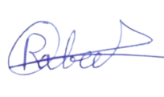

01.08.2026
……………..…..
Date

Adeel Akhtar
……………………....…..
Name
Rabeet Tahir
……………………....…..
Name

Appendix

Active band pass filter components calculations
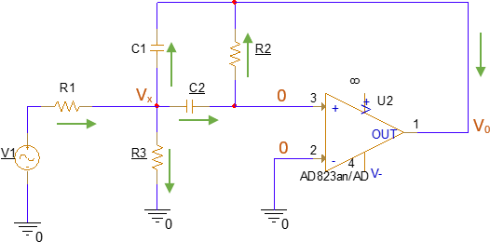
Figure 39: Schematic of the first-stage multi-feedback band pass filter.

Transfer Function

Applying KCL at the first node
$$\frac{V_{1} - V_{x}}{R_{1}} = \frac{V_{x} - V_{0}}{\frac{1}{sC_{1}}} + \frac{V_{x} - 0}{\frac{1}{sC_{2}}} + \frac{V_{x} - 0}{R_{3}}$$
$$\frac{V_{1} - V_{x}}{R_{1}} = \frac{V_{x} - V_{0}}{\frac{1}{sC_{1}}} + \frac{V_{x}}{\frac{1}{sC_{2}}} + \frac{V_{x}}{R_{3}} (1)$$
At node 2:
$$\frac{V_{x} - 0}{\frac{1}{sC_{2}}} = \frac{0 - V_{0}}{R_{2}} (2)$$
$sC_{2}V_{x} = \frac{-V_{0}}{R_{2}}$
$$V_{x} = \frac{-V_{0}}{sR_{2}C_{2}} (3)$$
Replacing the value of Vx/(1/sC₂) in equation (1) from equation (2).
$$\frac{V_{1} - V_{x}}{R_{1}} = \left(V_{x} - V_{0}\right)sC_{1} - \frac{V_{0}}{R_{2}} + \frac{V_{x}}{R_{3}} (4)$$
Putting the value of Vₓ from equation (3) into equation (4):
$$V_{1} - V_{x} = \left(V_{x} - V_{0}\right)sC_{1}R_{1} - \frac{V_{0}R_{1}}{R_{2}} + \frac{V_{x}R_{1}}{R_{3}}$$
$$V_{1} = \left(V_{x} - V_{0}\right)sC_{1}R_{1} - \frac{V_{0}R_{1}}{R_{2}} + \frac{V_{x}R_{1}}{R_{3}} + V_{x}$$
$$V_{1} = -V_{0}\frac{sC_{1}R_{1}R_{3} + s^{2}R_{2}C_{2}C_{1}R_{1}R_{3} + R_{1}R_{3}C_{2}s + R_{1} + R_{3}}{sR_{2}C_{2}R_{3}}$$
Transfer function H(s) = V₀ᵤₜ / Vᵢₙ :
$$\frac{V_{0}}{V_{1}} = -\frac{sR_{2}C_{2}R_{3}}{s^{2}R_{2}C_{2}C_{1}R_{1}R_{3} + s(C_{1}R_{1}R_{3} + R_{1}R_{3}C_{2}) + R_{1} + R_{3}}$$

• Low Pass to Band Pass and Comparison of Coefficients
$$A(s) = \frac{A_{0}}{1 + a_{1}s + b_{1}s^{2}}$$
For converting a low pass filter into a band pass filter, we replace s with:
$$s = \frac{1}{Δω_{n}}\left(s + \frac{1}{s}\right)$$
After substitution and expansion (shown step by step):
$$A(s) = \frac{A_{0}Δω_{n}^{2}s^{2}}{b_{1} + s^{2}\left(Δω_{n}^{2} + 2b_{1}\right) + Δω_{n}^{3}sa_{1} + a_{1}Δω_{n}s + b_{1}s^{4}}$$
Dividing by b₁:
$$A(s) = \frac{\frac{A_{0}Δω_{n}^{2}s^{2}}{b_{1}}}{1 + \left(\frac{a_{1}Δω_{n}}{b_{1}}\right)s + \left(\frac{Δω_{n}^{2} + 2b_{1}}{b_{1}}\right)s^{2} + \left(\frac{Δω_{n}a_{1}}{b_{1}}\right)s^{3} + s^{4}}$$
• Calculation of α
$$H(P) = \frac{\frac{P^{2}H_{0}{\left(Δω_{n}\right)}^{2}}{b_{1}}}{1 + \frac{a_{1}}{b_{1}}Δω_{n}P + \left[2 + \frac{{\left(Δω_{n}\right)}^{2}}{b_{1}}\right]P^{2} + \frac{a_{1}}{b_{1}}Δω_{n}P^{3} + P^{4}}$$
To implement this filter with 2 cascaded first-order band-pass filters, divide the transfer function:
$$H(P) = \frac{\frac{P^{2}H_{0}{\left(Δω_{n}\right)}^{2}}{b_{1}}}{\left[1 + \frac{αP}{Q_{i}} + {\left(αP\right)}^{2}\right]\left[1 + \frac{1}{Q_{i}}\left(\frac{P}{α}\right) + {\left(\frac{P}{α}\right)}^{2}\right]}$$
Where:
α = Coefficient of comparison
Qᵢ = Quality factor
Solving and comparing coefficients gives:
$$\frac{α}{Q_{i}} + \frac{1}{Q_{i}α} = \frac{a_{1}}{b_{1}} ·Δω_{n}$$
$$2 + \frac{Δω_{n}^{2}}{b_{1}} = \frac{1}{α^{2}} + \frac{1}{{Q_{i}}^{2}} + α^{2}$$
With Butterworth coefficients a₁ = 1.4142, b₁ = 1, solving gives the α equation:
$$α^{8} - 0.0499α^{6} - 1.999α^{4} - 0.0499α^{2} + 1 = 0$$
Solved using MATLAB, two values of α:
$$α_{1} = 0.9239, α_{1} = 1.082$$

• Calculation of Resistors
Using α₁ = 1.082. Centre frequency:
$$fₘᵢₙ = 4000 Hz, fₘₐₓ = 5000 Hz$$
$$f_{o} = f_{m} = \sqrt{fₘᵢₙ · fₘₐₓ} = \sqrt{4000 · 5000} = 4472.1 Hz$$
Normalized Bandwidth:
$$Δω_{n} = \frac{fₘₐₓ - fₘᵢₙ}{f_{o}} = \frac{5000 - 4000}{4472.1} = 0.2236$$
$${fₘ}_{1} = \frac{f_{m}}{α} = \frac{4472.136}{1.082} = 4137.036 Hz$$
$${fₘ}_{2} = f_{m} · α = (4472.136)(1.082) = 4834.38 Hz$$
$$Q = \frac{f_{m}}{B} = \frac{4472.136}{1000} = 4.472$$
$$Q_{i} = \frac{4.472 \left(1 + {\left(1.082\right)}^{2}\right) (1)}{(1.082)(1.4142)} = 6.3438$$
$${Aₘ}_{i} = \frac{Q_{i}}{Q}\sqrt{\frac{A_{m}}{b_{1}}} = \frac{6.3438}{4.472}\sqrt{\frac{10}{1}} = 4.485$$
Filter 1:
$$R_{2} = \frac{Q_{i}}{π fₘ₁ C} = \frac{6.3438}{(3.1416)(4137.036)(10 nF)} = 48.82 kΩ$$
$$R_{1} = \frac{R_{2}}{-2Aₘᵢ} = \frac{48.82 × 10³}{-2 × -4.485} = 5.44 kΩ$$
$$R_{3} = \frac{-Aₘᵢ R₁}{2{Q_{i}}^{2}+ Aₘᵢ} = \frac{(4.485)(5.44 × 10³)}{2{\left(6.343\right)}^{2}- 4.485} = 321.11 Ω$$
Filter 2:
$$R_{5} = \frac{Q_{i}}{π fₘ₂ C} = \frac{6.3438}{(3.1416)(4834.38)(10 nF)} = 41.79 kΩ$$
$$R_{4} = \frac{R_{5}}{-2Aₘᵢ} = \frac{41.79 × 10³}{-2 × -4.485} = 4.65 kΩ$$
$$R_{6} = \frac{-Aₘᵢ R₄}{2{Q_{i}}^{2} + Aₘᵢ} = \frac{(4.485)(4.65 × 10³)}{2{\left(6.343\right)}^{2}- 4.485} = 274.48 Ω$$

ADC-driver and anti-aliasing filter components calculations

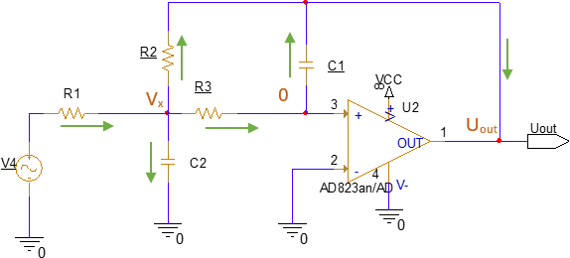
Figure 46. Schematic for 2nd order multi-feedback low pass filter.

At node Vₓ
$$\frac{V_{4} - V_{x}}{R_{1}} = \frac{V_{x} - 0}{R_{3}} + \frac{V_{x} - 0}{\frac{1}{sωC_{2}}} + \frac{V_{x} - U_{out}}{R_{2}}$$

$$\frac{V_{4} - V_{x}}{R_{1}} = \frac{V_{x}}{R_{3}} + sωC_{2}V_{x} + \frac{V_{x} - V_{out}}{R_{2}}$$
At node 0
$$\frac{V_{x} - 0}{R_{3}} = \frac{0 - U_{out}}{\frac{1}{sω_{c}C_{1}}}$$
$$\frac{V_{x}}{R_{3}} = -sω_{c}C_{1}U_{out}$$
$$V_{x} = -sω_{c}C_{1}R_{3}U_{out} (2)$$

Replacing the value of Vₓ in equation (1):

$$\frac{V_{4} + sω_{c}C_{1}R_{3}U_{out}}{R_{1}} = \frac{-sω_{c}C_{1}R_{3}U_{out}}{R_{3}} + sω_{c}C_{2}\left(-sω_{c}C_{1}R_{3}U_{out}\right) + \frac{-sω_{c}C_{1}R_{3}U_{out} - U_{out}}{R_{2}}$$

$$\frac{V_{4} + sω_{c}C_{1}R_{3}U_{out}}{R_{1}} = -sω_{c}C_{1}U_{out} - s^{2}{ω_{c}}^{2}C_{1}C_{2}R_{3}U_{out} - \frac{sω_{c}C_{1}R_{3}U_{out} + U_{out}}{R_{2}}$$
$$V_{4} + sω_{c}C_{1}R_{3}U_{out} = -sω_{c}C_{1}R_{1}U_{out} - s^{2}{ω_{c}}^{2}C_{1}C_{2}R_{1}R_{3}U_{out} - \frac{sω_{c}C_{1}R_{3}R_{1}U_{out} + U_{out}R_{1}}{R_{2}}$$
$$V_{4} = -sω_{c}C_{1}R_{3}U_{out} - sω_{c}C_{1}R_{1}U_{out} - s^{2}{ω_{c}}^{2}C_{1}C_{2}R_{1}R_{3}U_{out} - \frac{sω_{c}C_{1}R_{3}R_{1}U_{out} + U_{out}R_{1}}{R_{2}}$$
$$V_{4} = -sω_{c}C_{1}R_{3}U_{out} - sω_{c}C_{1}R_{1}U_{out} - s^{2}{ω_{c}}^{2}C_{1}C_{2}R_{3}R_{1}U_{out} - \frac{sω_{c}C_{1}R_{1}R_{3}U_{out} + U_{out}R_{1}}{R_{2}}$$

$$V_{4} = -U_{out}\left(sω_{c}C_{1}\left(R_{3} + R_{1} + \frac{R_{1}R_{3}}{R_{2}}\right) + \left(C_{1}C_{2}R_{1}R_{3}\right)ω_{c}^{2}s^{2} + \frac{R_{1}}{R_{2}}\right)$$
$$\frac{U_{out}}{V_{4}} = -\frac{1}{\left(C_{1}C_{2}R_{1}R_{3}\right) s²ω_{c}^{2} + \left(R_{3} + R_{1} + \frac{R_{1}R_{3}}{R_{2}}\right) sω_{c}C_{1} + \frac{R_{1}}{R_{2}}}$$
Dividing numerator and denominator by R₁/R₂:
$$\frac{U_{out}}{V_{4}} = -\frac{\frac{R_{2}}{R_{1}}}{\left(C_{1}C_{2}R_{3}R_{2}\right)ω_{c}^{2}s^{2} + sω_{c}C_{1}\left(R_{3} + R_{2} + \frac{R_{3}R_{2}}{R_{1}}\right) + 1}$$
Comparing with the standard form A(s) = A₀ / (1 + a₁s + b₁s²):
$$A_{0} = -\frac{R_{2}}{R_{1}}$$
$a_{1} = ω_{C}C_{1}\left(R_{3} + R_{2} + \frac{R_{3}R_{2}}{R_{1}}\right)$ Eq(a1)
$$b_{1} = ω_{c}^{2}C_{1}C_{2}R_{3}R_{2}$$
From the above equations:
$$R_{1} = -\frac{R_{2}}{A_{0}}$$
$$R_{3} = \frac{b_{1}}{ω_{c}^{2}C_{1}C_{2}R_{2}}$$
Putting R₁ and R₃ in the ‘a1’ equation and solving the quadratic for R₂:
$$ω_{c}^{2}C_{1}C_{2}{R_{2}}^{2} - a_{1}ω_{c}C_{2}R_{2} + (1 - A_{0})b_{1} = 0$$
Using the Quadratic Formula:
$$R_{2} = \frac{a_{1}C_{2} ± \sqrt{{a_{1}}^{2}{C_{2}}^{2} - 4b_{1}C_{1}C_{2}\left(1 - A_{0}\right)}}{4π f_{c}C_{1}C_{2}}$$
$$R_{1} = -\frac{R_{2}}{A_{0}}$$
$$R_{3} = \frac{b_{1}}{4π²f_{c}^{2}C_{1}C_{2}R_{2}}$$
Values calculated using MATLAB:
$$R_{1} = 851.98 Ω$$
$$R_{2} = 8.519 kΩ$$
$$R_{3} = 2.635 kΩ$$
$$R_{4} = R_{5}$$
Since:
$$A_{0} = \frac{-R_{5}}{R_{4}} = -1$$

