Event loop in JS

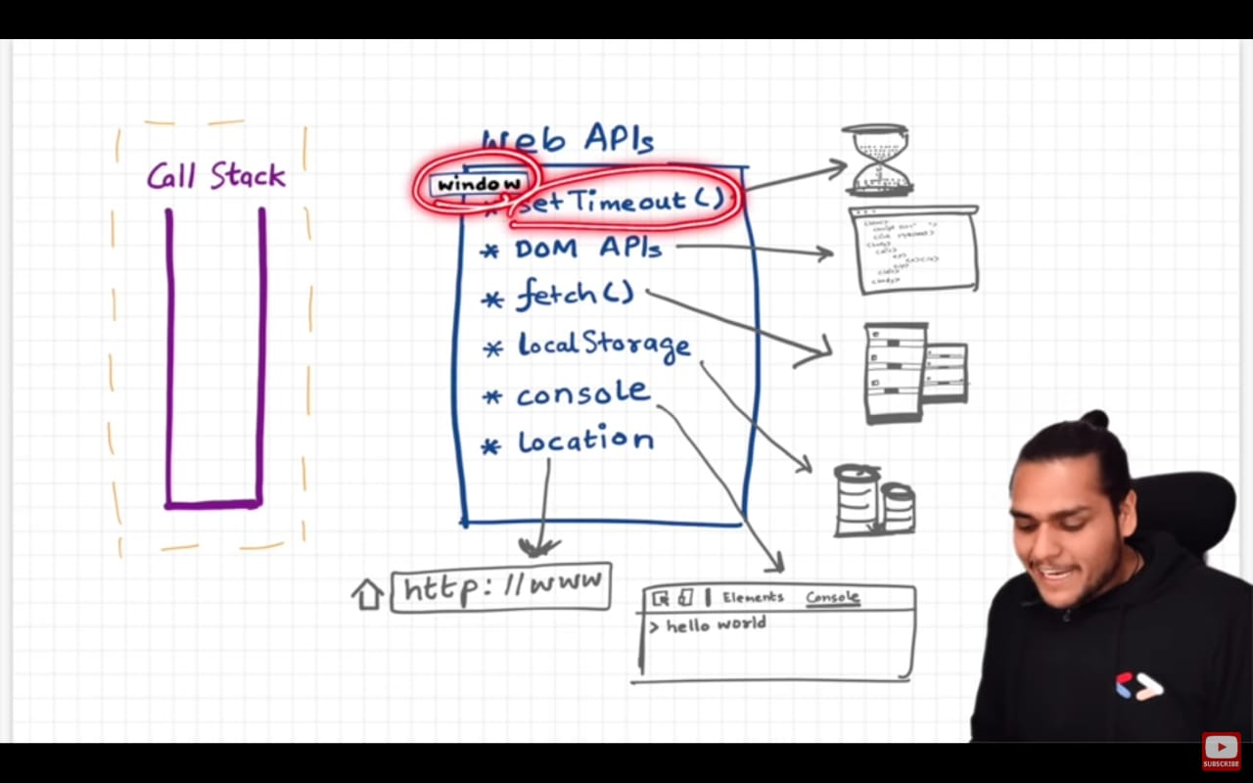

Now the concept is heavy, All the event listeners and calls and DOM manipulations they are not JS part, rather Browers provide them and that is some messed up thing now really the language is not powerful rather the browser is

