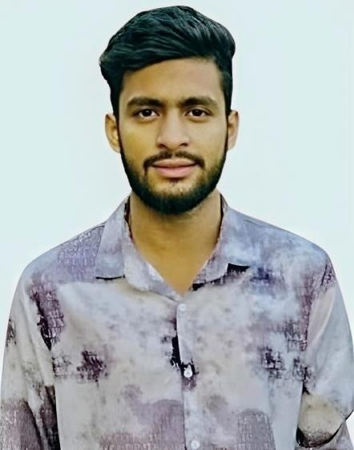

PROFILE:
My Name Is Hamza Ashraf. I Am a Passionate Candidate. Seeking Challenge, Responsibility and
Dynamic Positive renowned
Organization where all me
Energies can be used. My Favorite Sport Is Cricket and badminton, and I Am Quite Good at It. I Like Travelling and going to different places. My Strength is I am a Quick Learner and Self-motivated.
CONTACT:
0310-4166587
0326-5836100
EMAIL:
Rh0621419@gmail.com Address:
Wandala Road Zamindar
Colony, Shahdara Lahore

HAMZA ASHRAF
EDUCATION
- Intermediate (2020-2022) from Govt. Postgraduate Degree Lahore
- Matric (2018-2020) from Govt. Boys high school Chhota Gown Shahdara, Lahore
EXPERIENCE
- Call Center
- Office work in Trex
- Cashier in Lahore Basket
INTEREST
- Poetry
- Sports
- Learning
- Speaking English
SKILLS
- Problem Solving
- Management
- Team Management
- Proficient Communicator
HOBBIES:
- Book Reading
- Poetry
- Music
- Photography
LANGUAGES
- English
- Urdu

