Final Year Project Report
Project Name

Project Advisor:

Submitted By:
- Names and IDs of Students
Name | Student ID
MAHIBAH ZUBAIR | F2022266080
MISHAM MALAIKA | F2022266084
MUHAMMAD DANISH | F2022266094
MUHAMMAD HAMZA | F2022266095

Session

University of Management and Technology
C-II Johar Town Lahore Pakistan

Dedication

Final Approval

- Head of Department ______________________
Department of Informatics & Systems
School of Systems & Technology
UMT Lahore

- Director (Final Year Projects-CS) ______________________
Department of Computer Science.
School of Systems & Technology
UMT Lahore

- Supervisor ______________________
- Department of Informatics & Systems.
- School of Systems & Technology
UMT Lahore

- Co-Supervisor ______________________

Acknowledgment

Project Title: AI Based Stray Dog Injury Detection (Using CCTV and LSTM-Based Deep Learning)
Objective

Undertaken by

Supervised by
Starting Date

Completion Date

Tools Used
Operating System
Documentation

Plagairism Report
Abstract

The automated Stray Dog Injury Detection System presented in this study aims to close the gap between animal distress and prompt rescue. Stray dogs in urban settings frequently have unreported illnesses and accidents that cause them to suffer for a long time or even die. Our technology uses computer vision and artificial intelligence (AI) to track real-time CCTV footage.
The YOLO (You Only Look Once) object identification framework is used by the system's core to recognize stray canines and examine them for obvious physical wounds or blood. In order to identify unusual movement patterns, such limping, which frequently point to internal or invisible trauma, the system also uses behavioral analysis.

The device instantly transmits an Emergency Alert to an NGO Operator dashboard upon correctly detecting an injury, delivering the precise location and video evidence needed for a rescue effort. In addition, the incident is automatically recorded in a master database. By making the surveillance process fully automatic, this solution eliminates the need for human involvement, provides constant surveillance coverage, and enables much faster response times for animal welfare groups, thus saving more lives through effective use of technology.

Revision Chart
This chart contains a history of this document’s revisions. The entries below are provided solely for illustration purposes. Those entries should be deleted until the revision/s they refer to have actually been created.
The document itself should be stored in revision control, and a brief description of each version should be entered in the Revision Control System. A brief description can be repeated in this section. Revisions need not be described elsewhere in the document, unless they explain the document.

Version | Primary Author(s) | Description of Version | Date Completed
Draft | TBD | Initial draft created for distribution and review comments | (To be decided) TBD
Preliminary | TBD | Second draft incorporating initial review comments, distributed for final review | TBD
Final | TBD | First complete draft, which is placed under change control | TBD
Revision 1 | TBD | Revised draft, revised according to the change control process and maintained under change control | TBD
Revision 2 | TBD | Revised draft, revised according to the change control process and maintained under change control | TBD
Etc. | TBD | TBD | TBD

Contents
New paragraphs formatted as Heading 1, Heading 2, and Heading 3 will be added to the table automatically. To update this table of contents in Microsoft Word, put the cursor anywhere in the table and press F9. If you want the table to be easy to maintain, do not change it manually.
Contents 1
Definitions and Acronyms 3
List of Figures 4
List of Tables 5
1. Introduction 6
1.1 Motivations 6
1.2 Project Overview 6
1.3 Problem Statement 6
1.4 Objectives 6
2. Domain Analysis 7
2.1 Customer 7
2.2 Stakeholders 7
2.3 Affected Groups with social or economic impact 7
2.4 Dependencies/ External Systems 7
2.5 Reference Documents 7
2.5.1 Related Projects 7
2.5.2 Feature Comparison 8
3. Requirements analysis 9
3.1 Requirements 9
3.2 List of Actors 10
3.3 List of use cases 10
3.4 System use case diagram 10
3.5 Extended use cases 10
3.6 User interfaces (mock screens) 12
4. Data flow diagram (optional) 13
4.1 Data Flow Diagram Level 0 13
4.2 Data Flow Diagram Level 1 13
4.3 Data Flow Diagram Level 2 13
5. System Design 15
5.1 System Architecture Diagram 15
5.2 Class Diagram 16
5.3 Collaboration Diagrams 17
5.4 Other UMLs 18
5.5 ERD 18
5.6 Data Dictionary 18
6. Implementation details 19
6.1 Development Setup 19
6.2 Deployment setup 19
6.3 Algorithms 19
6.4 Constraints 19
6.4.1 Assumptions 19
6.4.2 System constraints 19
6.4.3 Restrictions 19
6.4.4 Limitations 19
7. Testing 20
7.1 Extended Test Cases 20
7.2 Decision Table 20
7.2.1 Code snippet 20
7.2.2 Decision coverage table 20
7.3 Traceability Matrix 21
7.3.1 RID vs UCID (requirements vs use cases) 21
7.3.2 Prototypes (RID vs PID) 22
7.3.3 Test Cases (RID vs TID) 22
7.3.4 Coverage (UCID vs TID) 22
8. Results/Output/Statistics 23
8.1 %completion 23
8.2 %accuracy 23
8.3 %correctness 23
9. Conclusion 24
10. Future work 25
11. Bibliography 26
11.1 Books 26
11.2 Journals 26
11.3 Articles 26
11.4 Research papers 26
11.5 Other References 26
12. Appendix 27
12.1 Glossary of terms 27
12.2 Pre-requisites 27

Definitions and Acronyms
Below is the table of acronyms and definition:

Table 1: table of acronyms and definitions
Acronym | Definition
DFD | Data Flow Diagram
UML | Unified Modeling Language
AI | Artificial Intelligence
YOLO | You Only Look Once (A real-time object detection algorithm)
CCTV | Closed-Circuit Television
NGO | Non-Governmental Organization
UI/UX | User Interface / User Experience
API | Application Programming Interface
CNN | Convolutional Neural Network (Used for image processing)
Gait Analysis | The study of animal locomotion (used here to detect limping)
Inference | The process of an AI model making a prediction on new data
Metadata | Data that provides information about other data (e.g., location/time of a wound)

Introduction
The presence of stray dogs in major cities such as Lahore is a serious issue related to animal welfare as well as health. Most stray dogs are physically injured due to accidents, territorial disputes, or human abuse. At present, the only way to spot an injured dog is if a human happens to notice it and report it to an NGO. This project proposes an AI-powered automated surveillance system that uses existing CCTV cameras to monitor the city. The proposed system uses Deep Learning techniques such as Convolutional Neural Networks (CNNs) and Long Short-Term Memory (LSTM) networks to identify physical distress, such as limping, in real-time.
MOTIVATIONS:
T The main reason for undertaking this project is the increasing concern for animal welfare. Stray dogs are frequently hit by vehicles or suffer from diseases, resulting in serious injuries such as limping or fractures, wounds, blood, and injuries. In a crowded city like Lahore, such animals languish for days because:
- Lack of Reporting: People tend to pass by injured animals or do not know whom to turn to for help
- Delayed Response: Manual observation of the streets is impossible, resulting in delayed medical assistance.
- Human Safety: Injured dogs may become aggressive because of pain and endanger residents. Applying AI to automate this issue ensures that technology is used for a good cause and fills the gap between injured animals and rescue teams.
- Technological Innovation: Using AI to solve problems of the local community problems.

Project Overview
The purpose of this project is to design an intelligent real-time surveillance system capable of detecting and alerting injured stray dogs in urban areas. By leveraging existing CCTV infrastructure, the system automates the process of animal welfare monitoring, which is currently dependent on random manual reporting.
The system utilizes a multi-staged Deep Learning pipeline: it first localizes stray dogs using a high-speed Object Detection framework, then extracts skeletal landmarks through Animal Pose Estimation, and finally classifies movement patterns using LSTM (Long Short-Term Memory) networks to detect injury-induced limping. This also detects wound/blood injury if any.

Problems or Overview Statement
Injuries in stray dogs, especially those caused by road accidents, often go unnoticed for an extended period of time, resulting in unnecessary suffering and death. It is impossible to monitor the entire city's camera feed manually. This project will automatically detect limping dogs and alert rescue teams instantly.
Customers:
The system is meant for those who have a concern in urban governance and animal welfare.
1)Animal Welfare NGOs: The main users of the dashboard, such as Todd's Welfare and ACF, use it to dispatch the rescue team to the location of the animal and get notifications in real-time..
2)City Surveillance Authorities: Organizations (such as Safe City) that manage CCTV cameras and use them to identify areas that are prone to accidents.
3)Veterinary clinics: Secondary users who utilize the system’s recorded video snippets to perform a preliminary medical assessment before the animal arrives for treatment.

Goals
- Automated Monitoring: To overcome the need for constant human monitoring of CCTV cameras.
- High Sensitivity Detection: To detect the difference between a normal gait and an asymmetric limp through temporal analysis.
- Response Time Reduction: To enable rescue teams to reach the animal in the shortest possible time through real-time alerts.
- Data-Driven Welfare: To provide a digital map of injury hotspots to help authorities design better safety infrastructure (such as speed bumps in high injury areas).
System Functions
- Real-Time Dog Localization: Scanning video streams for the purpose of locating stray dogs.
- Biomechanical Pose Extraction: Locating key joints (shoulders, hips, paws) to construct a digital skeleton of the animal.
- Gait Analysis: Analyzing skeletal movement patterns using LSTM to identify patterns of physical distress or limping.
- Wound Detection: Sees if there is any wound on body then it detects the wound.
- Automated Alerting: Generating instant notifications on a web dashboard with embedded location coordinates and video snippets.
- Database Management: Archiving all detected cases with timestamps for historical analysis.
System Attributes
- Accuracy: High accuracy in gait analysis to avoid "false positives" triggered by dogs playing or running.
- Latency: Low latency processing to ensure alerts are sent within seconds of detection.
- Scalability: The system is scale-able from a single camera to a whole city.
- Robustness: The system is robust and can function well in different lighting conditions (day/night) and angles of the camera.

Problem Statement
The stray dogs in urban settings are extremely vulnerable to road accidents and physical injuries, leading to mobility-related injuries such as limping and injuries such as wounds. At present, these animals are dependent on random public reporting, which is irregular and, in most cases, too late for any effective medical attention. Manually tracking thousands of CCTV cameras to locate injured animals is not humanly possible or efficient.
This issue is tackled by this project through the creation of an automated AI-powered surveillance system. Through the use of Object Detection and Animal Pose Estimation, skeletal gait patterns are derived from video streams. Starting with these patterns, an LSTM network checks for signs of limping or strange movement. When something off shows up, rescue crews get alerts on the spot - complete with where it happened. Speed picks up because of this setup, turning city animal care into something shaped by live information.

Objectives
The proposed project will help in achieving the following specific outcomes after completion:
- Automated Real-Time Dog Detection: Develop a robust system that can track stray dogs in different CCTV settings, irrespective of the complexity of the background and lighting conditions.

- Automated Wound Detection: Develop a customized deep learning module that can detect physical injuries such as open wounds, bleeding, or skin abrasions on the dog’s body through high-resolution image analysis.

- Wound Localization & Mapping: Employ YOLO-based localized bounding boxes to pinpoint the location of the injury on the dog’s body to assist rescuers in initial assessment.

- Biomechanical Gait Extraction: Develop an Animal Pose Estimation module to extract skeletal keypoints (joints) from video frames for accurate movement analysis.

- Intelligent Motion Classification: Use LSTM (Long Short-Term Memory) networks to analyze the temporal patterns of joint movements to classify between healthy walking and limping due to injury.

- Custom Dataset for Animal Injury: Develop a labeled dataset of healthy and injured dog movement patterns to train and test the deep learning models.

- Real-Time Alert & Notification System: Develop an automated reporting system that can send high-confidence injury alerts, along with video clips and location information, to a centralized dashboard.

- Reduction in Response Time: Allow animal rescue teams to receive real-time notifications, thus reducing the time gap between an accident and medical response.

- Urban Hotspot Mapping: Offer data-driven insights by logging the frequency and location of injuries to help authorities identify high-risk traffic zones for animals.

Domain Analysis

Customer
1. Primary Customers (The End-Users)
These are the people who will actually operate the system and interact with the frontend dashboard.
- Animal Rescue Organizations (NGOs):
Role: They are the main users. They keep track of the dashboard to get real-time notifications..
Action: Action: In cases of injury, they provide ambulances and veterinarians to the location pointed out by the system.
- City Monitoring & Surveillance Departments (e.g., Safe City Authorities):
Role: Since they already manage the CCTV infrastructure, they use the system as an "add-on" to their existing monitoring.
Action: They help in locating regions with high risk levels where many injured animals are discovered.

Stakeholders
Stakeholders: A few people might never touch the software, yet their goals tie into whether it works out. Success matters to them just the same, even from afar. List is given below:
Table 2: list of stakeholders
Stakeholders | Roles in System
Local Government & Municipal Corporations (e.g., MCL) | Role: Policy and funding.  Impact: They are interested in public health. They help by reducing the chances of rabies or aggressive animal behavior in public areas by treating the injured dogs.
Veterinary Professionals | Role: Medical support.  Impact: They get to know the kind of injury the dog has by using the "Injury Report" produced by the AI, which has a video clip, before the dog even reaches the clinic.
The General Public (Citizens of Lahore) | Role: Beneficiaries.  Impact: Residents living in areas where the system is operational feel safe and humane knowing that the stray animals in their area are being taken care of.
Project Supervisors & University (FYP Evaluation Committee) | Role: Academic Oversight.  Impact: They ensure the technical integrity of the project and evaluate its feasibility and social impact.

Affected Groups with social or economic impact
The following social and economic areas will be significantly impacted by the implementation of the AI-based injury identification system:

- NGOs and Animal Rescue Teams: By automating the street feed monitoring, the system will significantly lessen their human workload. In keeping with our goal of Real-Time Alerting, it enables them to maximize their fuel and medical resources by only deploying when an injury is confirmed, which improves resource management and has a beneficial economic impact.

- Safe City Authorities & City Surveillance: These authorities will receive data-driven information on accident-prone regions as part of our Urban Hotspot Mapping goal. This has an effect on society since it makes roadways safer for people and animals alike by enabling the installation of safety features like speed breakers and improved lighting.

- Commuters and the General Public: Animals with injuries on the road may become aggressive out of pain or cause unexpected traffic accidents. By accomplishing the goal of Rapid Response, the system contributes to the prompt removal of injured animals from public areas, guaranteeing a safer environment and lowering the likelihood that citizens may be involved in secondary traffic incidents.

- Local Municipalities: From an economic perspective, it assists in reducing the costs associated with the management of untreated, diseased, or severely disabled stray animals by providing early-stage medical interventions.

Dependencies/ External Systems
The completion and functionality of this AI-based system depend on the following external systems and platforms:
- CCTV Infrastructure (Input Source) The project is heavily dependent on the availability of real-time video streams, either live video streams, from city surveillance motion capture sources (e.g., Safe City Authorities), where the quality of video streams is critical to the accuracy of the constructed detection, prediction, and estimation models.

- Pre-trained Deep Learning Repositories (Model Hubs): The external model architecture, for example, Ultralytics for YOLO series, MMPose, or DeepLabCut, serves as the foundation for our application. These have been preloaded with the initial weights for animal object detection as well as keypoint extraction.

- Cloud Computing/GPU Resources (Training Platforms): Due to the high computational requirements of training CNNs and LSTMs on video data, this project depends on high-performance GPU environments such as Google Colab or NVIDIA CUDA enabled local systems for model training and inference.

- Firebase / Google Maps API (Alerting & Mapping): the application is dependent on the Firebase service to allow for real-time data synchronization between the AI engine and the user interface dashboard. Additionally, we need to include the Google Maps API to enable the "Urban Hotspot Mapping" feature to work properly to translate camera IDs into geographical coordinates displayed on heatmaps.

- Python Libraries and Frameworks: The underlying logic is based on the Python libraries, where we can execute our model either through PyTorch or TensorFlow, whereas video frame handling is achieved through the OpenCV library.

Reference Documents

Related Projects
Here is the sheet including all the research sheets we have gone through for this project:

https://docs.google.com/spreadsheets/d/1LTFnx7Vptn-l7SJsdLGKDUG071CB8wQOAIOCZ99u_7U/edit?usp=sharing

Feature Comparison

Table 3: table of feature comparison
Technical Feature | Streetdog | Pawsitive | IndieCare.ai | BooAI | Our App
Input Source | Mobile Camera (Manual) | Static Video/Photos | Manual Image Upload | Home Video(Smart Phone) | Live CCTV (RTSP Stream)
Automation Level | Manual Reporting | semi-automated | User Reporting | User-controlled recording | Fully Autonomous
Core Goal | Manual Reporting & Adoption | Behavior & Mood Analysis | Medical Records / ID | Vet Diagnostics | Emergency Rescue Alert
Limp Detection | No (Only visible wounds) | No (Focus on behavior) | No | Yes(Controlled enviroments) | Yes (Asymmetrical Gait)
Processing Logic | Human Eye / Basic AI | Pose Classification | Manual Data Entry | Markerless Pose Estimation | Gait Analysis
Reporting Interface | Social Feed | Research Dashboard | Digital Registry | Mobile-based Vet Report | NGO Dashboard
Historical Mapping | Limited | None | Statistical Mapping | None | Automated Hotspot Mapping

Requirements analysis

Requirements
Below are the detailed requirements(functional ,non-functional ,data constraint) given:

Table 4: table of FR and NFR
RID | description | Category | Attribute | Details & Boundary Constraints
R1.1 | The system shall provide distinct login interfaces for Super Admins and NGO users. | Functional | Security | Role-Based Access Control (RBAC) to separate system settings from rescue alerts.
R1.2 | The system shall identify and track stray dogs in real-time CCTV video streams. | Functional | Accuracy | Detection confidence score must exceed 80% to minimize false positives.
R1.3 | The system shall utilize LSTM to analyze skeletal sequences for injury detection. | Functional | Reliability | Requires a minimum temporal window of 30 consecutive frames to confirm a limp.
R1.4 | Gait analysis | Functional | Reliability / Predictive Accuracy | The LSTM must process a temporal sequence of 30–60 consecutive frames. It must achieve a classification accuracy of >75% in distinguishing between a normal walk and a limp
R1.5 | The system shall trigger instant visual and sound alerts on the web dashboard. | Functional | Timelines | Alerts must be dispatched within 5 seconds of injury confirmation.
R1.6 | The system shall generate a heatmap of injury locations to identify danger zones. | Functional | Visualization | Integration with Google Maps API to visualize "Urban Hotspots."
R1.7 | The system shall maintain high-speed video processing for real-time monitoring. | Non-Functional | Throughput | Must achieve a minimum inference speed of 15-20 Frames Per Second (FPS).
R1.8 | The monitoring dashboard must be accessible to rescue teams at all times. | Non-Functional | Availability | Target uptime of 99.9% through cloud-based hosting.
R1.9 | The dashboard interface must be intuitive for non-technical NGO personnel. | Non-Functional | Usability | Must allow users to acknowledge and resolve alerts with a maximum of 3 clicks.
R1.10 | The system should maintain operational stability under varying weather conditions. | Non-Functional | Robustness | The system must continue logging data even if detection accuracy drops due to low light or fog.
R1.11 | System works almost all the time (≥99% uptime). | Non-Functional | Reliability | The system must work all the time for safety purposes.
R1.12 | The system shall archive injury metadata, including timestamps and camera IDs. | Data | Persistence | Data must be stored in a NoSQL database (e.g., Firebase) for historical retrieval.
R1.13 | The system shall record and upload a 4-second video snippet of the identified injury | Data | Storage | Snippets must be compressed (MP4) to optimize cloud storage bandwidth.
R1.14 | The system must be developed using Python and Deep Learning frameworks. | Constraint | Techstack | Development is restricted to PyTorch/TensorFlow and OpenCV libraries.
R1.15 | GPU-Dependent Inference | Constraint | Performance | The system requires a CUDA-enabled NVIDIA GPU with a minimum of 4GB VRAM for real-time video processing.

List of Actors
The system boundary includes the AI Processing Pipeline, the Database, and the Web Dashboard. The following actors interact with this system:

- Super Admin: This person takes care of the system infrastructure, including CCTV camera integrations, providing users with accounts for NGOs, etc.

- NGO Operator: This person is the representation of the rescue team, who monitors the dashboard, receives notifications of injuries, etc., taking care of the rescue operations at the scene of the accident.

- AI Processing Engine (Internal Actor): This robot is solely responsible for performing the major technical activities, including dog, pose, and gaits of the dog detected through LSTM techniques.

- CCTV Surveillance System (External Actor): This external system provides information that pertains to the raw video and camera metadata needed to perform detection.

- Veterinary Specialist: This person uses archived injury vids to make a first assessment before the animal comes to the clinic.

List of use cases
The following use cases describe the primary interactions between the actors and the system:
- User Login: Allows Admins and NGO Operators to provide credentials and access their respective restricted monitoring dashboards.

- Manage Camera Feeds: Allows the Admin to add, remove, or edit the RTSP links and location data for the urban CCTV network.

- Process Video Stream: The AI Engine continuously captures video frames to identify dogs and extract skeletal keypoints.

- Analyze Gait (Detect Injury): The LSTM model processes keypoint sequences to classify movements as healthy or injured (limping).

- Trigger Injury Alert: Generates a real-time notification on the dashboard containing the location and confidence score of a detected injury.

- View Hotspot Map: Allows users to view a geographic heatmap showing areas with high frequencies of animal accidents.

- Update Rescue Status: Allows NGO Operators to mark an alert as "In-Progress" or "Resolved" once a dog has been rescued.

- Archive Event Data: Automatically saves the injury metadata and a short video snippet into the database for future reference.

- Generate Reports: Allows the Admin to export monthly data regarding total detections and rescue success rates.

System use case diagram

Below is the Usecase Diagram for dog injury detection system:

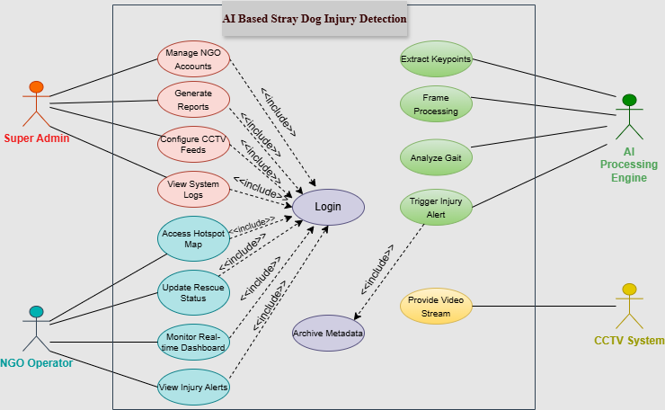
Figure 1: use case diagram with explanation

Explanation:
The Use Case Diagram for the AI-Based Stray Dog Injury Detection System provides a high-level functional overview of the system. It defines the boundary between the internal automated processes and the external entities (actors) that interact with it.

1.3.1 System Boundary
The rectangle represents the System Boundary. All functions (ovals) inside this box are part of the software application, while the actors outside represent human roles or external hardware/software that exchange data with the system.

1.3.2 Actors and Their Roles
The diagram identifies four key actors:

- Super Admin (Primary Human Actor):The one responsible for mnaging NGO accounts_(adding,deleting,udating), can see all reports and have control on system.

- NGO Operator (Primary Human Actor): NGO Operator (Primary Human Actor): The end-user who tracks the dashboard for real-time notifications, identifies the geographical injury hotspots, and maintains the status of the rescue operations on the ground.

- AI Processing Engine (Automated Actor): Symbolises the logic (YOLO, and LSTM). It detects video data to detect the injury of dogs without any human aid.

- CCTV Surveillance System (External Actor): The hardware infrastructure that provides the raw video stream required for analysis.

Analysis of Use Cases and Relationships

1. Core Functionality (The Main Flow)
Process Video Feed & Analyze Gait: These are the heart of the system. The AI Engine continuously captures frames to identify dogs and uses temporal skeletal analysis to detect limping.

Trigger Injury Alert: Once an injury is confirmed by the AI, an alert is generated. This use case <<includes>> Archive Metadata, ensuring that every detected injury is automatically logged into the database for record-keeping.

2. Security and Access (Include Relationships)

The Login use case is a mandatory requirement for both the Super Admin and the NGO Operator.
All functional use cases such as Manage NGO Accounts, View Injury Alerts, and Update Rescue Status point to Login with an <<include>> arrow. This signifies that the system enforces strict authentication; no user can access sensitive data or perform actions without a verified session.

3. Operational Management

Update Rescue Status: This provides a feedback loop. When an NGO team rescues a dog, they update the system, closing the lifecycle of that specific alert.

View Hotspot Map: This use case visualizes archived data on a map, helping NGOs identify areas where accidents are frequent, allowing for better resource allocation.

Table 5: table explaining sprints
Sprint | Phase | Status | Key Deliverables / Tasks
Sprint 1 | Foundation | ✅ Done | Requirement gathering and SRS documentation.
Sprint 2 | Design | ✅ Done | Creating DFDs, Collaboration Diagrams, and Abstract.
Sprint 3 | Frontend | ✅ Done | Developing UI mock screens for NGO dashboards.
Sprint 4 | Computer Vision I | ✅ Done | Implementing Dog Detection and Joint/Pose Estimation.
Sprint 5 | Data Engineering | 🕒 Next | Saving joint coordinates (x, y) into CSV/JSON for Gait analysis.
Sprint 6 | AI Logic (LSTM) | 🕒 Pending | Training LSTM model to classify "Normal" vs "Limping" movement.
Sprint 7 | Vision II (Wounds) | 🕒 Pending | Training YOLO for physical wound and blood detection.
Sprint 8 | Integration | 🕒 Pending | Connecting AI Backend (Python/Flask) with the Frontend UI.
Sprint 9 | Alert System | 🕒 Pending | Implementing real-time notifications and Database logging.
Sprint 10 | Finalization | 🕒 Pending | System testing, performance optimization, and final report.

Extended use cases
All extended use cases are given below:
USECASE-1:
Authenticate User

Use Case ID: | UC-00
Use Case Name: | Authenticate User
Created By: | Misham Malaika |  | Last Updated By:
Date Created: | 28-1-2026 |  | Last Revision Date:
Actors: |  | The actors are given below:  - NGO Operator/Admin(primary)  - Database(secondary)
Description: |  | This usecase tells that a person must be logged in with authenticate credentials so he/she may manipulate/view the system as per the permission granted to their roles.
Trigger: |  | The user opens the app and tries to perform an action
Preconditions: |  | Preconditions are given below:  - User must be already in the database.  - User must have valid credentials
Post conditions: |  | The post-condition is given below:  - User has the access to dashboard and is logged in successfully.  - User fails to login due to invalid credentials and asked by the system to “try again”
Normal Flow: |  | The normal flow is given below:  - The user enters the password and registered email address on the login page. .  - The user presses the "Login" button.  - The user record for the email is obtained by the system from the USER table.  - The password is verified by the system (preferably by a hash).  - The role of the user (NGO_Operator or Super_Admin) is determined by the system.  - The user is redirected to the respective dashboard by the system.  - A SYSTEM_LOGS login record is created by the system.
Alternative Flows:  [Alternative Flow 1 – Not in Network] |  | The alternative flow is given below:  4a)If user forgets the password then he clicks “Forgot password?” and then system manages the password recovery process.
Exceptions: |  | The exception is given below:  - User not found/invalid password  - If in step 3 , username is not in database, System displays error message saying”invalid email or password”  - Usecase may resume from step1
Includes: |  | None(as this is the foundation of all other)
Frequency of Use: |  | Everytime a user starts a new session
Special Requirements: |  | Login must take less than 2 seconds.
Assumptions: |  | - The user has a working keyboard and a compatible web browser.  - The database connection is active.  - There must be an internet connection.
Notes and Issues: |  | - The system is locked temporarily after 5 invalid attempts.

USE-CASE 2:
Monitor Live Feed

Use Case ID: | UC-01
Use Case Name: | Monitor Live Feed
Created By: | Misham Malaika |  | Last Updated By:
Date Created: | 28-1-2026 |  | Last Revision Date:
Actors: |  | The actors are given below:  - NGO Operator(primary)  - CCTV Cameras(secondary)
Description: |  | This allows NGO Operator to watch CCTV Footages(real-time) to anytime(assigned to the specific organization), so that the operator is aware of the situations going on.
Trigger: |  | The operator has to select the camera in order to watch live-feed from dashboard.
Preconditions: |  | Preconditions are given below:  - User must be login as admin or NGO Operator.  - Camera must be active and RTSP URL must be valid.
Post conditions: |  | The post-condition is given below:  - Live CCTV footage is successfully running on the screen.
Normal Flow: |  | The normal flow is given below:  - The user accesses the NGO dashboard.  - A list of the designated cameras is shown by the system.  - The user clicks on a particular camera position.  - The camera hardware's RTSP stream is requested by the system.  - The video feed is rendered on the user's screen by the system.
Alternative Flows:  [Alternative Flow 1 – Not in Network] |  | The alternative flow is given below:  4a)If RTSP stream fails to connect, the system must show the message as “Camera Offline” and notifies them.
Exceptions: |  | The exception is given below:  4a).System denies access if the user who is not assigned by NGO tries to access dashboard.
Includes: |  | Authenticate User(UC-00)
Frequency of Use: |  | This may be used continuously or on-demand.
Special Requirements: |  | Video latency should be less than 500ms, so that user can experience effective monitoring.
Assumptions: |  | - Stable Network: It is assumed that the NGO office and the camera location have a reliable internet connection with sufficient bandwidth to enable RTSP streaming.  - .User Training: The NGO Operator is presumed to be familiar with the basic camera setup of their designated region and to be able to browse a web dashboard.  - Active Power Supply: During monitoring hours, we presume that the cameras are powered on and that there are no local power outages.
Notes and Issues: |  | - Bandwidth Consumption: The NGO's local network may become slower if several operators watch multiple HD feeds at once.  - Night Vision Quality: Nighttime clarity of the feed could be a major issue. Also, the effectiveness of monitoring and AI detection will be compromised if the IR range of the camera is low.  - Browser Compatibility: Without a middle-layer "transcoder" (such as the VLC plugin or WebRTC), some browsers (such as earlier versions of Chrome or Safari) have difficulty playing RTSP streams directly.

USE-CASE 3:
Manage NGO Profiles

Use Case ID: | UC-02
Use Case Name: | Manage NGO Profiles
Created By: | Mahibah Zubair |  | Last Updated By:
Date Created: | 31-1-2026 |  | Last Revision Date:
Actors: |  | The actors are given below:  - Admin(primary)  - Database(secondary)
Description: |  | This is a use case that would permit the Super Admin to add/update/activate/deactivate/delete NGOs profile within the system. Each NGO profile is a animal welfare organization which receives alerts for injuries and does rescue. Super Admin can manage access, allocate regions/cameras and ensure only verified NGOs are operating in the platform.
Trigger: |  | After entering the Admin Dashboard, the Super Admin clicks on “Manage NGO Profiles”.
Preconditions: |  | Preconditions are given below:  - Super Admin must be successfully authenticated.  - Database connection must be active.  - Super Admin must have administrative privileges.
Post conditions: |  | The post-condition is given below:  - The NGO profile is successfully created, updated, deactivated, or deleted.  - The users and camera associations are also updated accordingly.  - A log entry is created for system activity.
Normal Flow: |  | The normal flow is given below:  - 6.The Super Admin logs into the Admin Dashboard.  - The system shows the list of registered NGOs.  - The Super Admin chooses an action:  - Add New NGO  - Edit Existing NGO  - Deactivate NGO  - Delete NGO  - The Super Admin enters or edits NGO information (name, contact details, assigned regions, status).  - The system checks the input information.  - The system updates the NGO information in the database.  - The system shows the successful completion of the action.  - The system records the action in System Logs.
Alternative Flows:  [Alternative Flow 1 – Not in Network] |  | The alternative flow is given below:  5a)If there is an existing NGO with the same name or email, the system will show an error message and ask for correction.  3a)If there are active rescue records for the NGO, the system will suggest deactivation rather than deletion.
Exceptions: |  | The exception is given below:  - Invalid or missing NGO information.  - Database write failure.  - Unauthorized access attempt rescue records for the NGO, the system will suggest deactivation rather than deletion.
Includes: |  | Authenticate User (UC-00)  Log System Activity (UC-03)
Frequency of Use: |  | Occasional (used when onboarding new NGOs or updating system configuration).
Special Requirements: |  | - Creation/updating of NGOs should be completed within 2 seconds.  - Deactivated NGOs should cease receiving alerts immediately
Assumptions: |  | - Super Admin has verified NGO credentials externally.  - Internet connectivity is stable.  - Database integrity constraints are enforced.
Notes and Issues: |  | - Incorrect NGO deactivation can lead to alert routing problems.  - Future enhancement may involve NGO performance analysis.

USE-CASE 4:
Login System Activity

Use Case ID: | UC-03
Use Case Name: | Login System Activity
Created By: | Mahibah Zubair |  | Last Updated By:
Date Created: | 31-1-2026 |  | Last Revision Date:
Actors: |  | The actors are given below:  - System(Internal Process)  - Admin(Secondary)  - Database(secondary)
Description: |  | This use case automatically records all important activities of the system, such as user login, changes in NGO profiles, alert messages, rescue updates, and system errors. All these activities are recorded in the form of logs.
Trigger: |  | Any major system or user activity takes place.
Preconditions: |  | Preconditions are given below:  - The system is running normally.  - The database is accessible.  - A valid system event has occurred.
Post conditions: |  | The post-condition is given below:  - The details of activities are stored in a secure manner in the System Logs table.  - The logs are accessible to the Super Admin for viewing.
Normal Flow: |  | The normal flow is given below:  - A user or system process undertakes an activity.  - The system determines the type and origin of the activity.  - The system retrieves the relevant metadata (date, user ID, type of activity, IP address, affected module).  - The system enters the log record into the database.  - The log is made viewable through the Admin Dashboard.
Alternative Flows:  [Alternative Flow 1 – Not in Network] |  | The alternative flow is given below:  3a)n the case of low-priority events, the system maintains a minimum log detail to optimize storage space.
Exceptions: |  | The exception is given below:  - 10.Failure in connecting to the database.  - Error in writing the log due to storage constraints
Includes: |  | Authenticate User (UC-00)
Frequency of Use: |  | Continuous (runs in the background during the entire system operation).
Special Requirements: |  | - Logging should not impact system performance.  - The log files should be tamper-proof and read-only for non-admin users.
Assumptions: |  | - The server clock is now synchronized.  - The storage capacity is adequate for log retention.
Notes and Issues: |  | - High volumes of logs might need periodic archiving.  - Future version could have anomaly detection in logs using AI.

USE-CASE 5:
Detect & Record Injury

Use Case ID: | UC-04
Use Case Name: | Detect & Record Injury
Created By: | Muhammad Hamza
Date Created: | 31-01-2026
Actors: | The actors are given below:  - AI Processing Engine (Primary – Automated System Actor)  - CCTV Surveillance System (Secondary – External Actor)  - Database / Metadata Archive (Secondary)
Description: | This use case describes the completely automated process that the AI Processing Engine uses to continuously analyze live CCTV video feeds for injured stray dogs. The system detects irregular gaits (such as limping) or visible injuries using deep learning techniques. After the injury is detected, the system records the event by storing metadata and a video clip in the database and prepares the data for alert notification.
Trigger: | This use case is triggered when a live CCTV video stream is received by the AI Processing Engine.
Preconditions: | The preconditions are given below:  - CCTV camera must be active and streaming video.  - AI Processing Engine must be running normally.  - Deep learning models (YOLO, Pose Estimation, LSTM) must be loaded.  - Database connection must be available.
Post Conditions: | The post-condition is given below:  - An injured dog is successfully detected.  - Injury metadata (camera ID, location, timestamp, confidence score) is stored.  - A 4-second injury video snippet is archived.  - Injury detection status is marked as “Confirmed”.
Normal Flow: | The normal flow is given below:  - The CCTV Surveillance System sends a live video stream to the AI Processing Engine.  - The AI Engine extracts frames from the video stream.  - The system detects the presence of a stray dog using an object detection model.  - Skeletal keypoints of the dog are extracted using pose estimation.  - Temporal gait data is analyzed using the LSTM model.  - The system identifies abnormal gait or visible injury patterns.  - Injury confidence score exceeds the defined threshold.  - The system records injury metadata and video snippet in the database.  - The system flags the event for alert generation.
Alternative Flows:  [Alternative Flow 1 – False Detection] | 6a) The system ignores the outcome and keeps monitoring if the level of confidence in gait irregularity is below the threshold.
[Alternative Flow 2 – Poor Video Quality] | 3a) The system records a low-confidence event but does not begin recording if the video quality is poor (blurring, inadequate illumination).
Exceptions: | - CCTV stream unavailable.  - AI model inference failure.  - Database write error.  In such cases, the system logs the error and resumes monitoring when possible.
Includes: | - Archive Event Data  - Log System Activity (UC-03)
Frequency of Use: | - Continuous (runs automatically 24/7).  - Special Requirements:  - Injury confirmation must occur within 5 seconds.  - Minimum inference speed of 15 FPS.
Assumptions: | - Cameras provide sufficient resolution.  - GPU resources are available.  - Network latency is within acceptable limits.
Notes and Issues: | - Occluded views may reduce accuracy.  - Night-time detection may be less reliable depending on IR quality.

USE-CASE 6:
Update Rescue Status

Use Case ID: | UC-05
Use Case Name: | Update Rescue Status
Created By: | Muhammad Hamza
Last Updated By: | -
Date Created: | 31-01-2026
Last Revision Date: | -
Actors: | The actors are given below:  - NGO Operator (Primary – Human Actor)  - Database / Metadata Archive (Secondary)
Description: | This use case allows the NGO Operator to update the status of an injury alert after receiving it on the dashboard. The operator can mark the rescue operation as “In Progress”, “Rescued”, or “Closed” once the injured dog has been attended to. This completes the rescue lifecycle and ensures accurate record-keeping.
Trigger: | The NGO Operator selects an injury alert from the dashboard.
Preconditions: | The preconditions are given below:  - NGO Operator must be authenticated.  - At least one active injury alert must exist.  - The NGO Operator must be assigned to the camera region.
Post Conditions: | The post-condition is given below:  - Rescue status is successfully updated.  - Alert lifecycle is completed.  - Database reflects the latest rescue outcome.  - System logs the status update.
Normal Flow: | The normal flow is given below:  - The NGO Operator logs into the dashboard.  - The system displays a list of active injury alerts.  - The operator selects a specific injury alert.
Theoperator chooses a rescue status: | - In Progress  - Rescued  - Closed  - The operator submits the update.  - The system saves the updated status in the database.  - The system logs the action for audit purposes.  - The alert is visually updated on the dashboard.
Alternative Flows:  [Alternative Flow 1 – Rescue Delayed] | 4a) If rescue cannot be performed immediately, the operator keeps the status as “In Progress” with optional remarks.
Exceptions: | - Database connection failure.  - Unauthorized update attempt.  - Alert already marked as closed.  In such cases, the system displays an error message and prevents changes.
Includes: | Authenticate User (UC-00)  Log System Activity (UC-03)
Frequency of Use: | - On-demand (used whenever a rescue operation is performed).  - Special Requirements:  - Status update should be completed within 2 seconds.  - Maximum of 3 clicks to update status.
Assumptions: | - NGO Operator has confirmed rescue physically.  - Internet connectivity is stable.  - Operator is trained to use the dashboard.
Notes and Issues: | - Incorrect status updates may affect reporting accuracy.  - Future enhancement may include photo upload after rescue.

User interfaces (mock screens)
Initial mockup screens (even hand drawn drafts) will be inserted here. Each screen will be given an appropriate prototype id.e.g.
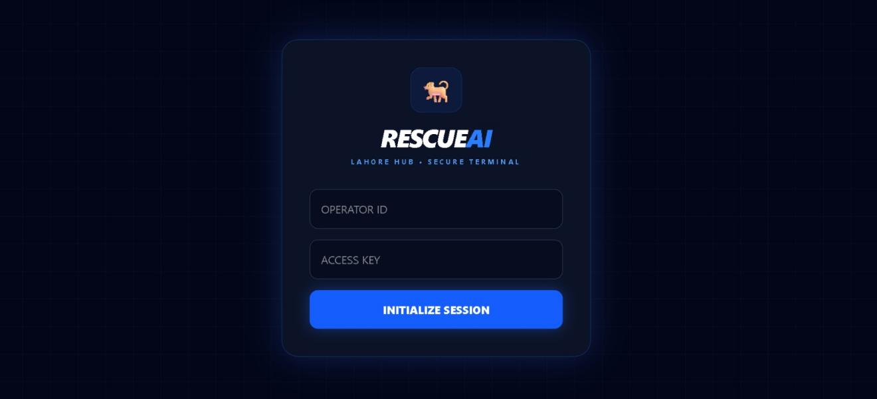
Prototype1: (P1) Admin and NGO Operator login Page

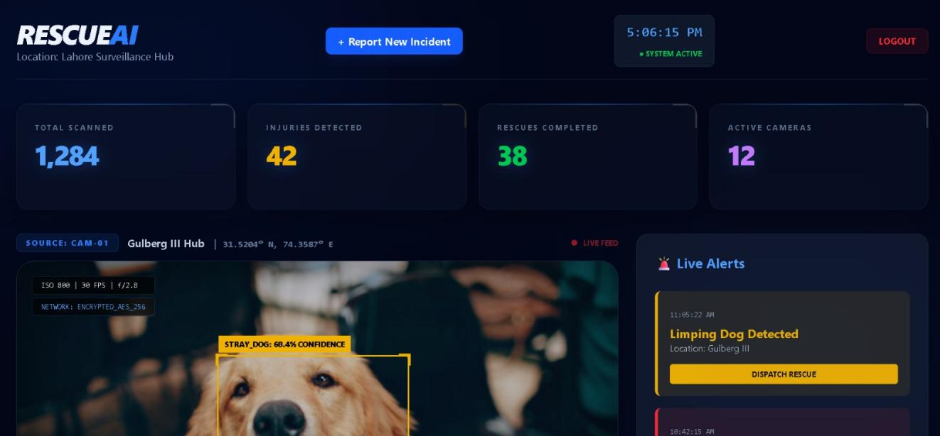
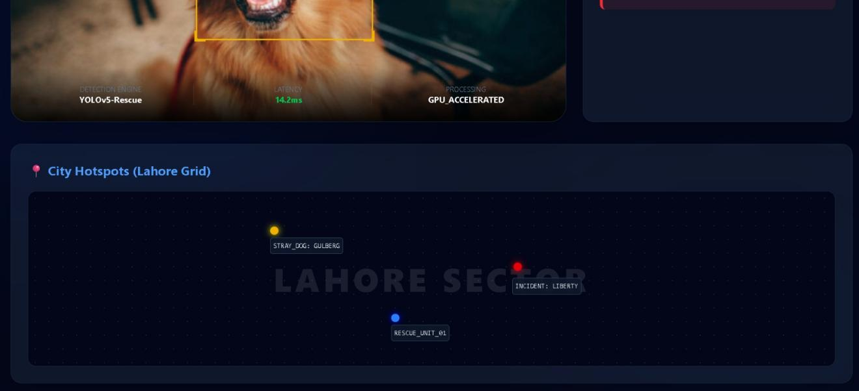
Prototype2: (P2) Real-time Dashboard Page

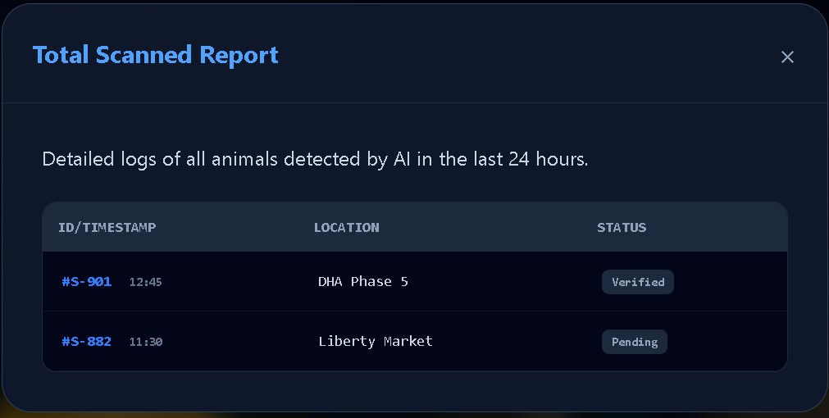
Prototype3: (P3) Scanned Report Page

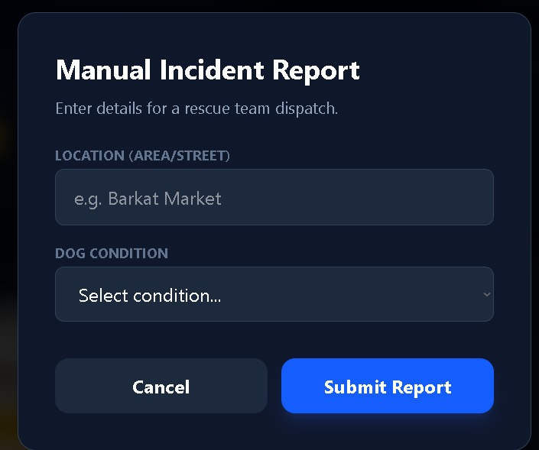\
Prototype4: (P4) Team Dispatch Report Page

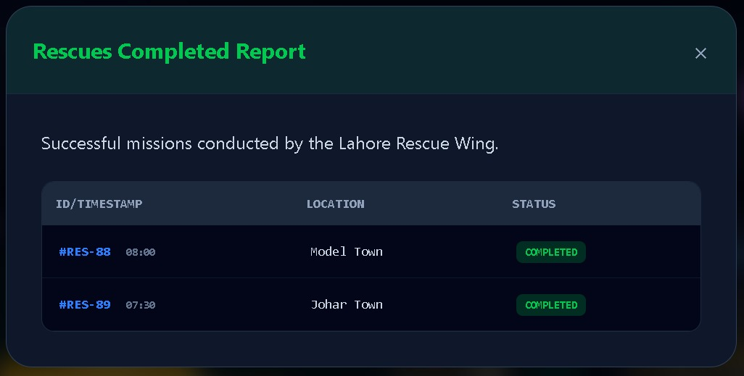
Prototype5: (P5) Rescues completed Report Page

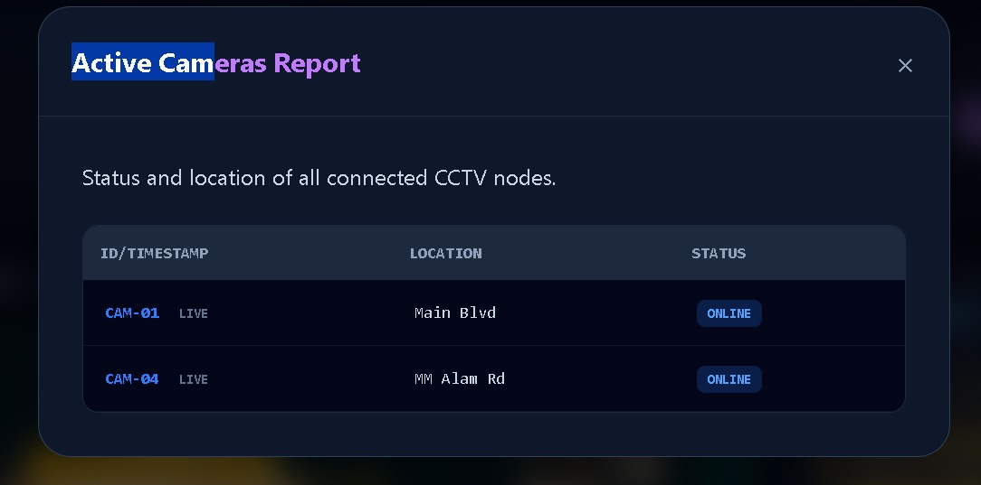
Prototype6: (P6) Active Cameras Report Page

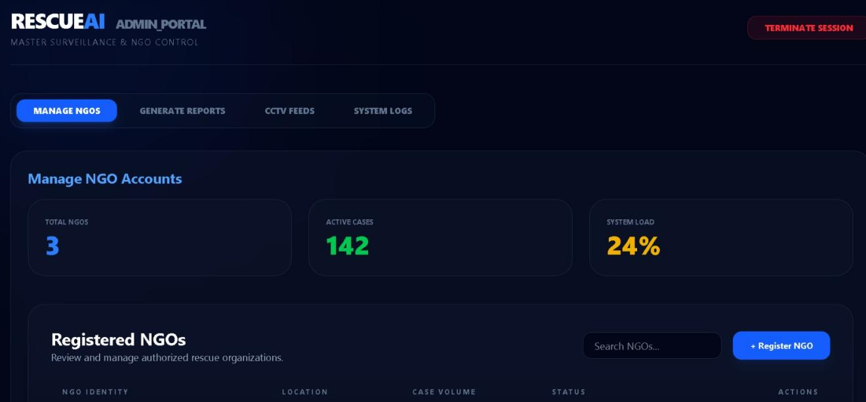
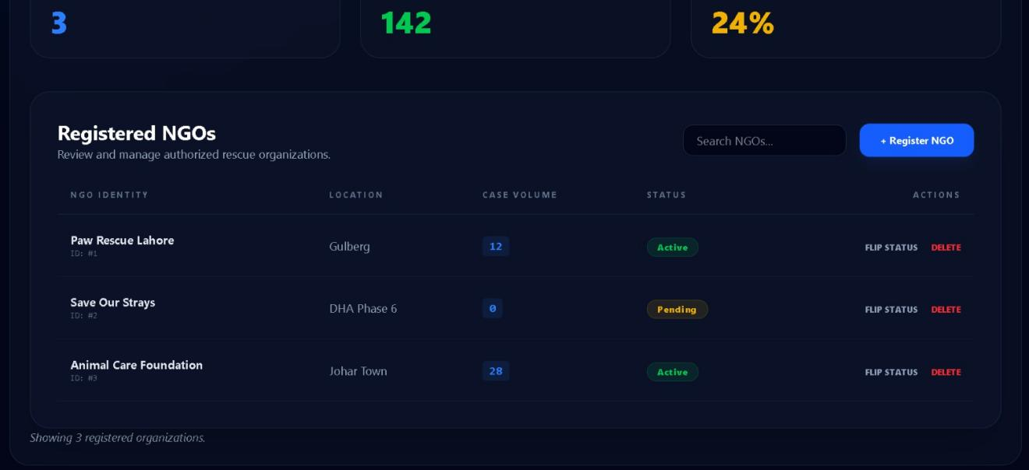
Prototype7: (P7) Admin’s Dashboard Page

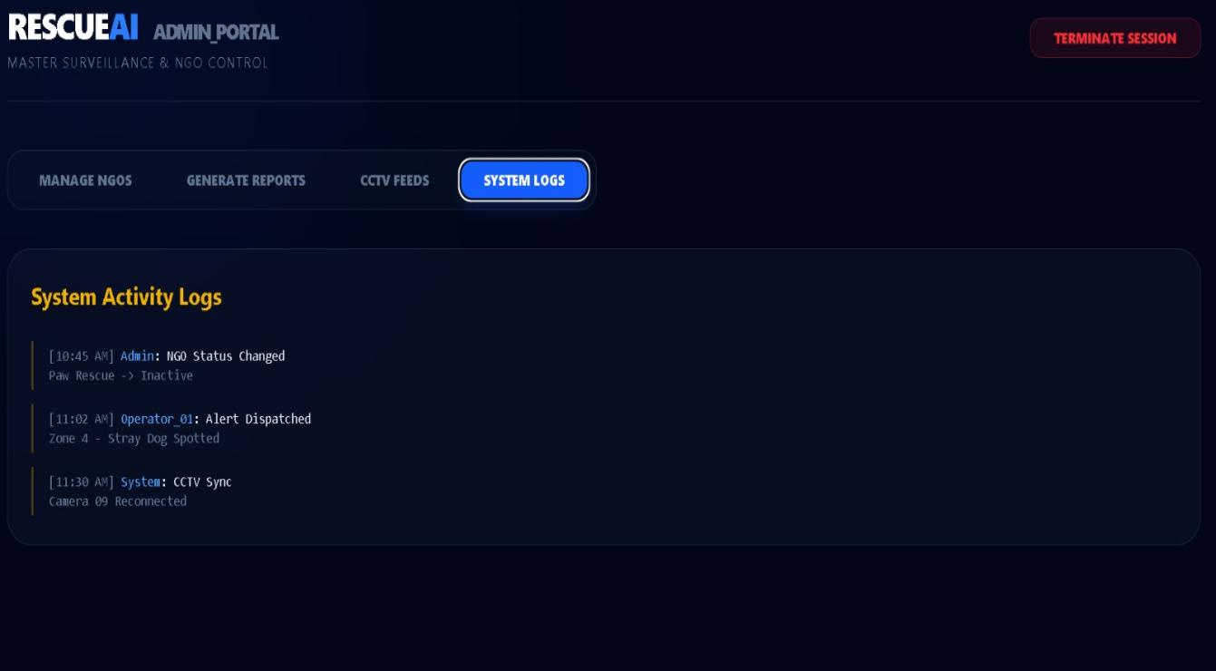
Prototype8: (P8) Admin’s System logs Page

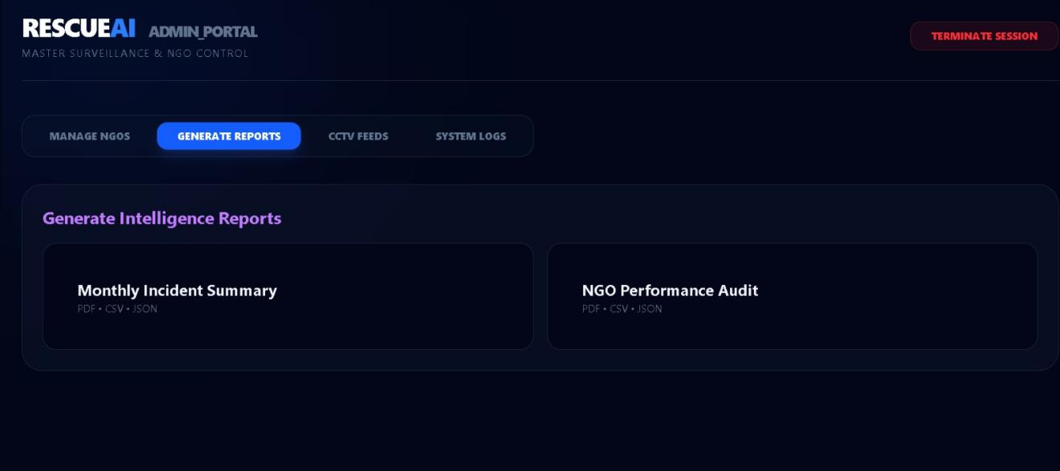
Prototype9: (P9) Admin’s Generate Reports Page

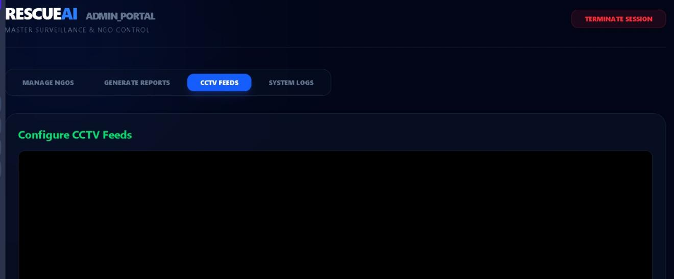
Prototype9: (P9) Admin’s Config CCTV Feeds Page

Data flow diagram

Data Flow Diagram Level 0

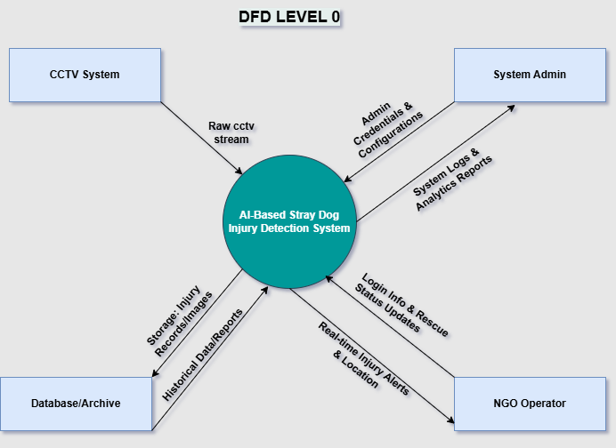
Figure 2: DFD level 0 diagram with explanation

DFD Level 0: Context Diagram Explanation
This provides an overview of the Stray Dog Injury Detection System and its interaction with external entities:
- CCTV System: It is the primary input source, which gives live video stream so that AI can analyze.
- NGO Operator: Provides Login Credentials to the system and receives Real-time Emergency Alerts regarding injured dogs for immediate rescue.
- System Admin: Manages the system via Configurations and receives System Logs/Reports to monitor performance.
- Database/Archive: Serves as the storage hub where the system Saves and Retrieves wound metadata, images, and detection history.

Data Flow Diagram Level 1

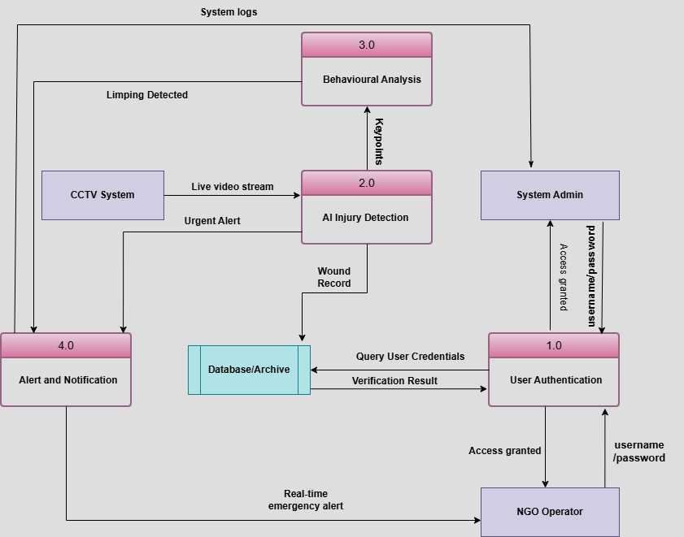
Figure 3: DFD level 1 diagram with explanation

DFD Level 1: System Decomposition
The Level 1 Diagram breaks down the main system into four core processes to show internal data flow:
- 1.0 User Authentication: Validates NGO/Admin credentials against the Database to grant secure system access.
- 2.0 AI Injury Detection: Processes the CCTV stream using YOLO models to detect visual wounds and blood.
- 3.0 Behavioral Analysis: Analyzes motion patterns from the AI engine to identify limping or abnormal gait.
- 4.0 Alert & Notification: Consolidates detection signals and sends Real-time Emergency Alerts to the NGO Operator and System Logs to the Admin.
- Database/Archive: Central storage for saving Wound Records and retrieving user data for validation.

Data Flow Diagram Level 2

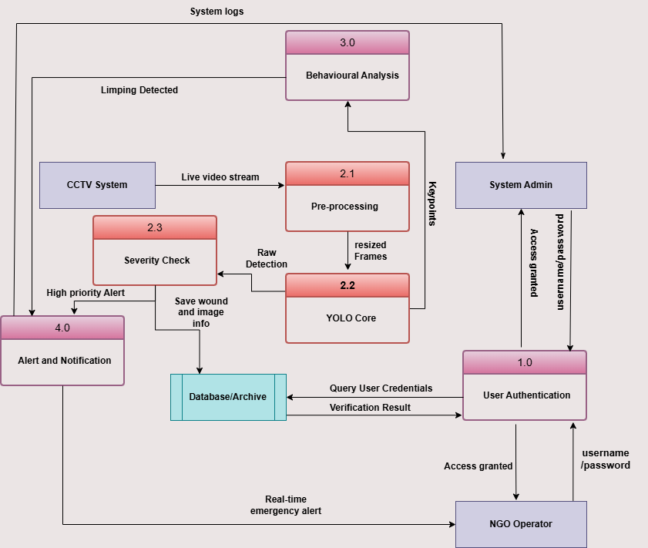
Figure 4: DFD level 2 diagram with explanation

DFD Level 2: AI Pipeline Decomposition
This Diagram "zooms in" on the AI Injury Detection (Process 2.0) and shows the specific steps of the machine learning pipeline:
- 2.1 Pre-processing: Raw video is converted into the format compatible for model.
- 2.2 YOLO Core: The primary AI engine that detects dog and injury and draws box over it
- 2.3 Severity Check: Validates the detection results to filter out false positives and determines the urgency of the injury.
- Data Integration: * To Database: Saves Wound Images and Metadata for history.
  - To 4.0 Notification: Triggers a High Priority Alert if a severe injury is confirmed.
  - To 3.0 Behavioral: Sends processed frames for further Gait Analysis.

System Design

System Architecture Diagram
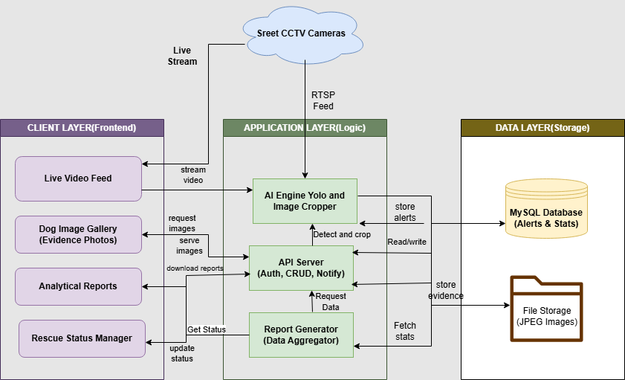
Figure 5: System architecture diagram with explanation

System Architecture (The Big Picture)
Your system follows a classic 3-Tier Architecture that separates user interaction from the heavy AI logic and data storage.
- Client Layer (Frontend): This is where the NGO Operator and Super Admin interact with the system. Responsible for handling real-time video feeds, displays analytical reports, and also allows users to manipulate its rescue statuses.
- Application Layer (Logic): Works as "brain" of the project. Receives RTSP Feed from CCTV cameras. The AI Engine (YOLO) detects dogs and crops images for evidence, API Server handles authentication (Login) and notifications, while the Report Generator aggregates data for the frontend.
- Data Layer (Storage): A dual-storage approach. A MySQL Database stores structured data like alerts, user credentials, and statistics, while File Storage holds the actual JPEG evidence photos of injured dogs.

CLASS DIAGRAM

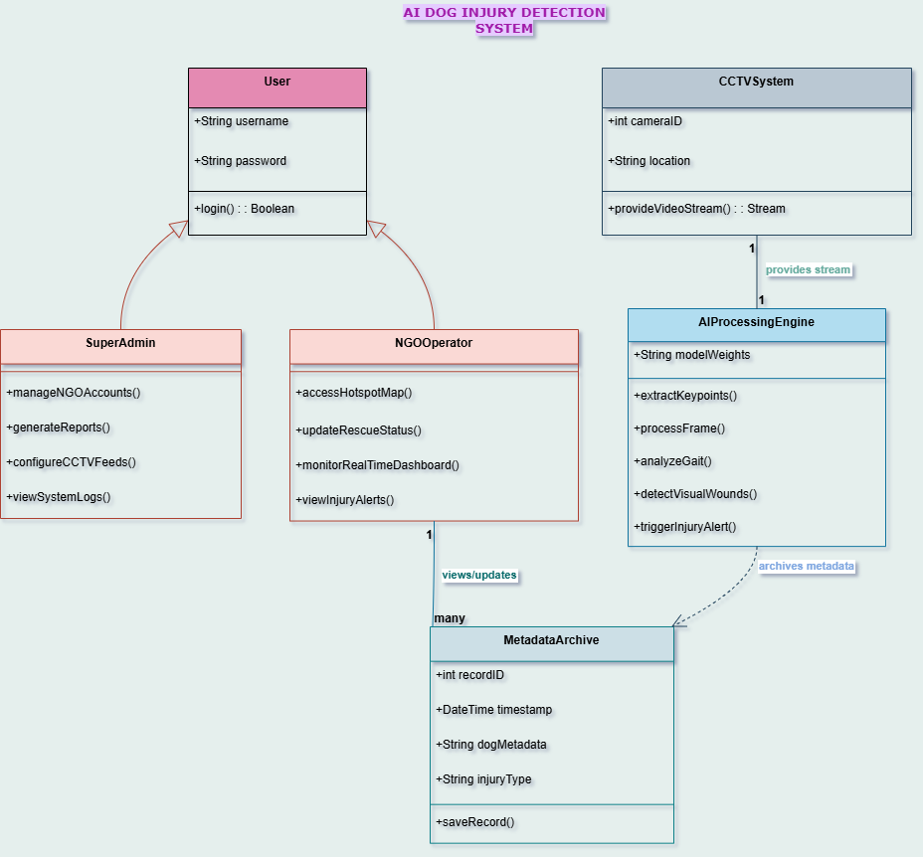
Figure 6: Class diagram with explanation

Explanation:

Inheritance in User
Firstly, we have User class as it is the base class for all.
- User Class: Contains common attributes like username and password and the login() method.
- Super Admin: Inherits from User. This class manages the system's infrastructure, such as NGO accounts, CCTV configurations, and system logs.
- NGO Operator: Inherits from User. This class is the primary "end-user" who monitors the Real-time Dashboard, views Hotspot Maps, and updates the Rescue Status of detected dogs.

2. AI Processing Engine (The System Intelligence)
This is the most critical class in your project. It represents the YOLO-based logic.
- Methods:
  - processFrame(): Breaks down the video stream into individual images.
  - extractKeypoints() & analyzeGait(): Handles the motion-based detection for limping.
  - detectVisualWounds(): Specifically scans for blood and open injuries.
  - triggerInjuryAlert(): The decision-making function that sends a signal when a threshold is met.

3. CCTV System (Data Input)
This class represents the hardware/source layer.
- It has a 1-to-1 relationship with the AI Processing Engine. This means each live stream is mapped to a dedicated processing instance to ensure real-time speed and no lag.
- Attributes: Includes cameraID and location to identify exactly where an injured dog was spotted.

4. Metadata Archive (The Database)
This class handles the storage of all detected events.
- Dependency Relationship: The AI Engine has a dotted arrow pointing to this class. This shows that the Engine depends on the Archive to save the results of an alert.
- Attributes: It stores the timestamp, dogMetadata (details about the dog), and the injuryType (whether it was a wound or a gait issue).

Sequence Diagrams

Sequence Diagram 3: Pose Estimation & Gait Analysis

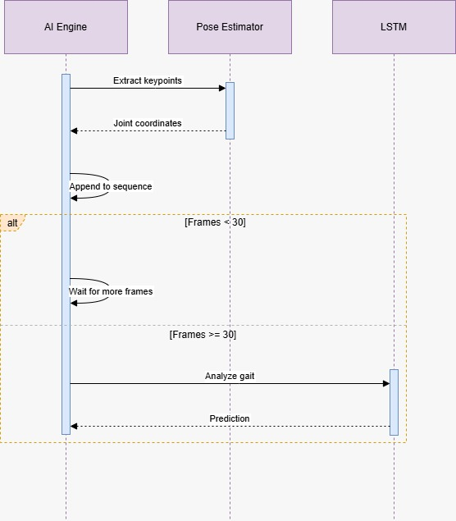
Figure 7: Pose Estimation & Gait Analysis diagram with explanation

Sequence Diagram 4: Injury Decision Logic

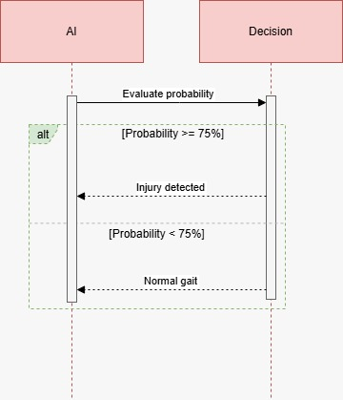
Figure 8: Injury Decision Logic with explanation

represents the ultimate if-else decision that determines whether movement is considered normal or damaged depending on probability criteria.

Sequence Diagram 5: Alert Generation

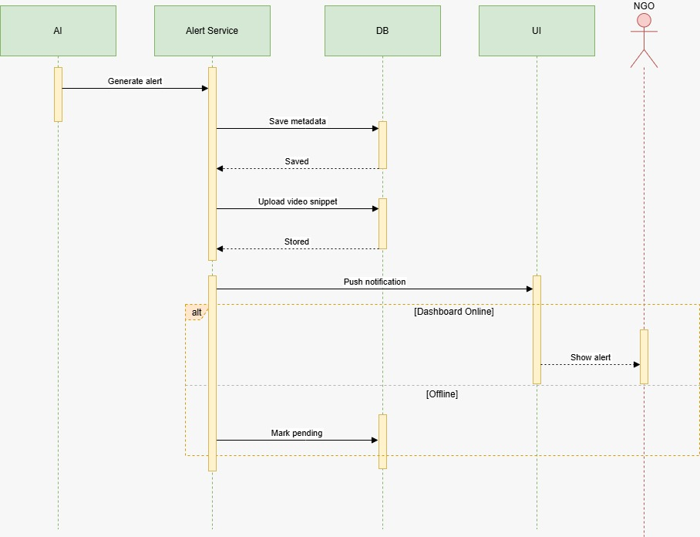
Figure 9: Alert Generation with explanation

demonstrates how the dashboard notifies NGO operators, archives relevant data, and generates an injury alarm.

Collaboration Diagrams
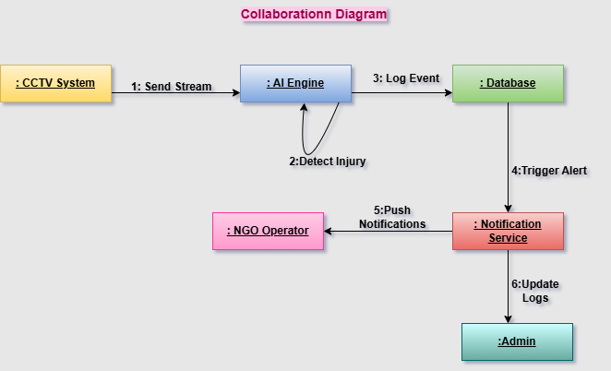
Figure 10: Collaboration diagram with explanation

Collaboration Diagram Explanation
The Collaboration Diagram, also called the Communication Diagram, illustrates how the various parts of the system work together in a certain sequence to detect a stray dog's injury and notify the appropriate authorities.
- 1: Send Stream: The AI Engine receives a live video stream from the CCTV system.
- 2: Detect Injury: The AI Engine processes the frames internally using YOLO models to identify injuries or wounds.
- 3: Log Event: Once an injury is detected, the AI Engine sends the metadata (images and location) to the Database for permanent storage.
- 4: Trigger Alert: The Database (or AI Engine) signals the Notification Service that a valid emergency has been recorded.
- 5: Push Notifications: The Notification Service sends a real-time alert to the NGO Operator’s dashboard or mobile device for immediate rescue action.
- 6: Update Logs: The Notification Service simultaneously updates the Admin with system logs to ensure the event is tracked at a supervisory level.

Other UMLs
This is optional. You may include any other UML to support your system.

ERD

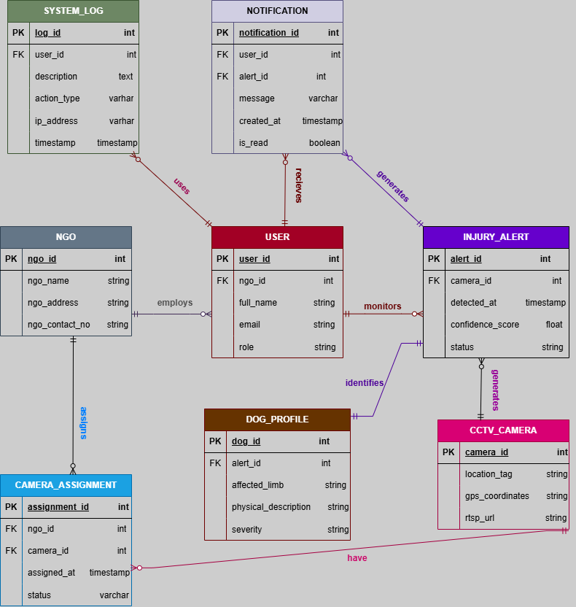
Figure 11: ERD with explanation

Explanation
This ERD defines the structural backbone of your AI-based rescue system. It is organized into four logical clusters:
1. Administrative Core (NGO & USER)
The system starts with the NGO table, which stores organization profiles. Each NGO employs multiple USERS (NGO Operators) who manage the rescue operations. The SYSTEM_LOG table tracks every action these users take for security auditing.

2. Monitoring of Camera and Assignment
The hardware specifications and live stream links ($RTSP$) are kept in the CCTV_CAMERA table. The CAMERA_ASSIGNMENT database serves as a bridge, connecting particular cameras to the NGOs in charge of those regions because not every camera is owned by every NGO.

3. Alert and Profile Logic(AI DETECTION)
When the AI detects an injured dog, it creates an INJURY_ALERT linked to that specific camera. To provide medical context, the DOG_PROFILE stores specific details like the affected limb and injury severity. It helps rescuers as they can take right medications for the injured ones.

4. Notification
As soon as the alert is triggered, the system looks at the assignment logic and populates the NOTIFICATION table. This automatically generates a real-time dashboard alert for the concerned USER, making sure that none of the detections are missed.

Data Dictionary
Below is the data dictionary given:

Table 6: Data Dictionary table
Element Name | Type | Validation | Mandatory | Remarks
UserID / Email | Text Field | Alphanumeric / Email | Yes | Login credentials for both Admin and NGO.
Password | Password | Min 8 chars | Yes | Masked entry for secure access.
Total Scanned | Metric | Numeric | No | Cumulative count of dogs processed by AI.
Injuries Detected | Metric | Numeric | No | Total count of detected wounds/limps.
Rescues Completed | Metric | Numeric | No | Total incidents marked as 'Rescued'.
Active Cameras | Metric | Numeric | No | Number of connected live CCTV streams.
Total NGOs | Metric | Numeric | No | (Admin) Count of registered rescue organizations.
Active Cases | Metric | Numeric | No | (Admin) Total ongoing incidents across all hubs.
System Load | Percentage | 0% - 100% | No | (Admin) AI Engine server performance monitor.
Live Feed Player | Video Stream | RTSP / 30 FPS | Yes | Displays real-time feed with AI Bounding Boxes.
Bounding Box | Overlay | Float (x, y, w, h) | Yes | Highlights dog with confidence score (e.g., 68.4%).
Live Alerts List | Sidebar | List (Temporal) | Yes | Real-time queue of "Limping Dog Detected".
Dispatch Rescue | Button | Action | Yes | Sends notification to field team for a specific dog.
Register NGO | Button | Action | Yes | (Admin) Form to add new NGO accounts to the portal.
Terminate Session | Button | Action | Yes | Logs out user and secures the portal.

AI Processing Pipeline & Technical Workflow
The heart of the RescueAI solution is a complex computational pipeline that aims to identify physical injuries in stray dogs via real-time gait and posture analysis. The technical process is broken down into four major stages:

1. Data Engineering & Preprocessing
The solution utilizes a customized version of the Stanford Dogs Dataset, which is supplemented with customized keypoint annotations. More than 10,000 images were carefully selected, and their joint annotations (paws, knees, hips) were transformed into the YOLO format. This standardization of bounding boxes and coordinates helps to maintain spatial consistency and model generalization capabilities regardless of the image resolution.

2. Spatial Feature Extraction (YOLOv8-Pose)
The solution utilizes the YOLOv8-Pose model for fast spatial analysis. Unlike other detectors, which only output bounding boxes, this model includes Keypoint Estimation.

Bounding Box Localization: This step extracts the region of interest (ROI) containing the dog from the original CCTV footage.

Skeletal Landmark Mapping: This step identifies particular joints in the dog’s anatomy to create a coordinate-based skeletal representation. This information is the essential input for behavioral classification.
3.Temporal Video Processing
OpenCV is used to manage real-time stream handling, enabling frame-by-frame processing. In order to provide a layer for empirical validation of model performance, the pipeline incorporates the visualization modules draw_landmarks and draw_boxes to overlay skeletal analysis onto the live video feed.

4. Behavioral Gait & Injury Classification
The final stage utilizes temporal analysis of extracted keypoints over sequential frames. By calculating the vertical and horizontal displacement of skeletal landmarks over time, the system differentiates between normal locomotion and pathological gaits (limping). This motion analysis is the critical trigger for the system’s automated injury alerting mechanism.

Conclusion
The RescueAI system proves to be a successful implementation of a strong, automated system for the real-time detection and management of stray dog injuries. By incorporating a highly advanced 3-Tier Architecture, the project has successfully bridged the gap between highly advanced AI detection and real-world NGO response. The technical expertise, which incorporates YOLOv8-Pose for skeletal point detection and temporal gait analysis, enables the system to effectively differentiate between healthy and injured conditions, including limping and visible injuries. Furthermore the data must be stored in database for alert purposes ensuring no injured dog go unnoticed. In the end, this project has created a scalable, life-saving for the dogs that go unnoticed despite having injuries.

