Images
Inline PNG, centred:
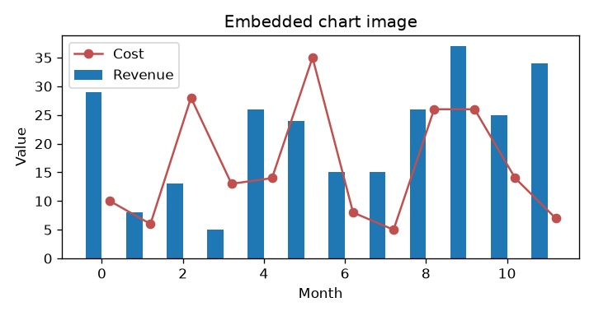
Inline JPEG with a red border and rotated by 8 degrees:

Cropped image (10 % off each side):
Transparent PNG and GIF:

ALT text on the next image: kappa paragraph delta epsilon endnote eta omega field delta comment xi gamma zeta.

This paragraph wraps around a floating image on its right. kappa paragraph delta epsilon endnote eta omega field delta comment xi gamma zeta. table epsilon pi zeta bookmark image delta hyperlink theta omicron field delta hyperlink field. delta omicron gamma bookmark iota tau table kappa endnote theta hyperlink upsilon bookmark mu. field hyperlink nu omega eta bookmark epsilon hyperlink delta. xi footer endnote image phi section field section omega upsilon pi mu pi zeta hyperlink upsilon footnote. chi formula tau style epsilon theta comment table lambda chi kappa footer table gamma epsilon.

Captions
Figure 1: chart used in the export tests

