Styles and table of contents
Table of contents placeholder (update the field to populate).

Heading level 1
Text below heading level 1. kappa paragraph delta epsilon endnote eta omega field delta comment xi gamma zeta.

Heading level 2
Text below heading level 2. kappa paragraph delta epsilon endnote eta omega field delta comment xi gamma zeta.

Heading level 3
Text below heading level 3. kappa paragraph delta epsilon endnote eta omega field delta comment xi gamma zeta.
Paragraph using the custom Callout style.
Normal text with a custom character style run inside it.

Bookmarks and links
Jump target: bookmark text
Internal link to the bookmark: external hyperlink
External link: LibreOffice home page
Cross-reference to the bookmark: bookmark text
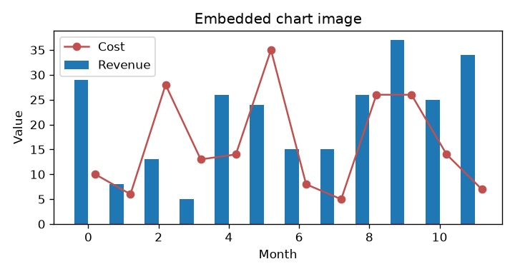
Figure 1: caption style with a sequence field

