**Market Basket Analysis**

In this project, I did the market basket analysis on groceries dataset.

**Data Reading:**

I read the data which was in a csv file using pandas dataframe. It looked like this.

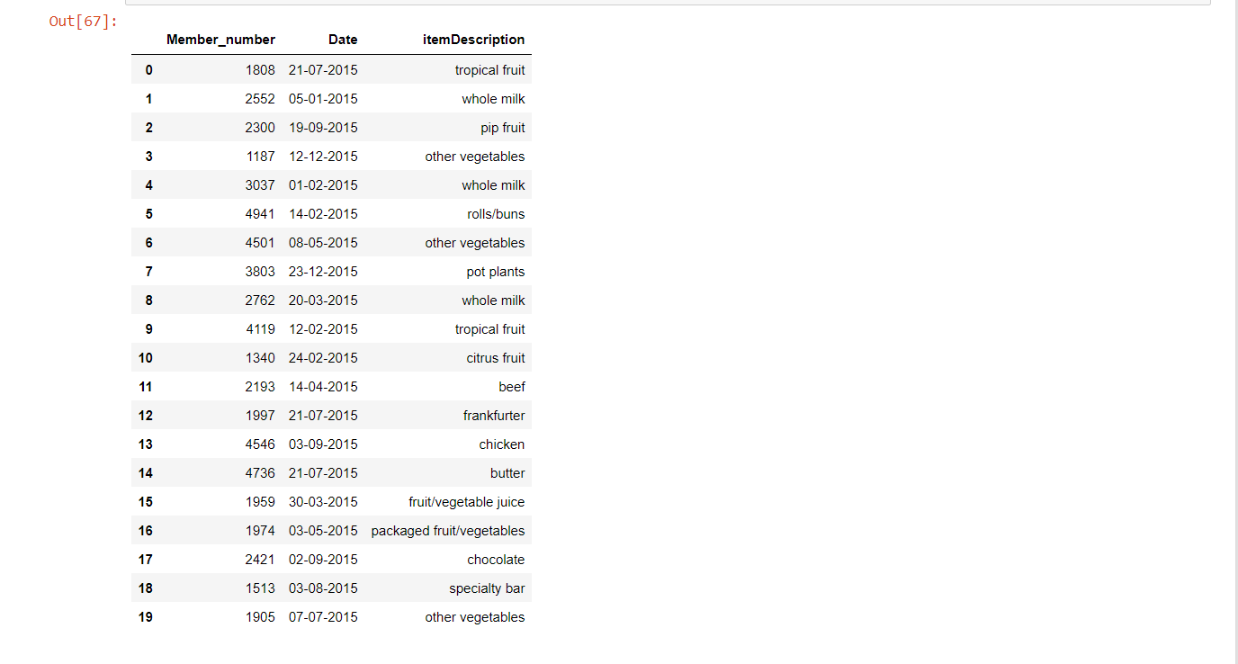

Data consists of three columns Member_number, Date and itemDescription with each 38765 records without a missing record.

**Data Preprocessing:**

Explored the data by finding unique items in each column and counting the frequency of each item in itemDescription. Then I transformed the data into a dictionary of lists combining the records Member_number and Date were the same. After that Data looked like this.

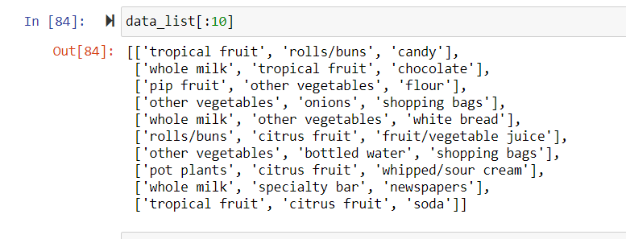

There are 167 unique items in itemDescription. So, I transformed the data into encoded form of size (14963, 167). And converted into a dataframe.

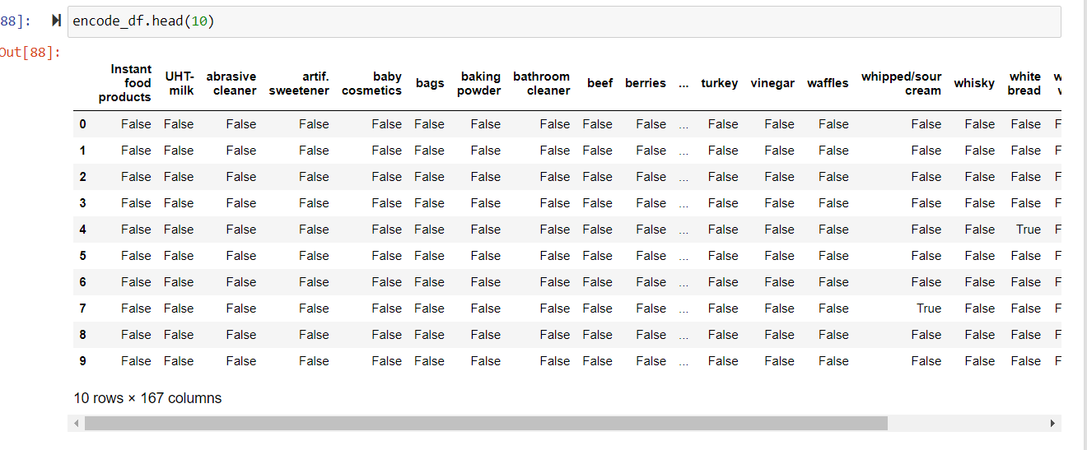

**Model Training:**

Trained the Apriori model on the processed dataframe and got the support of itemsets as below.

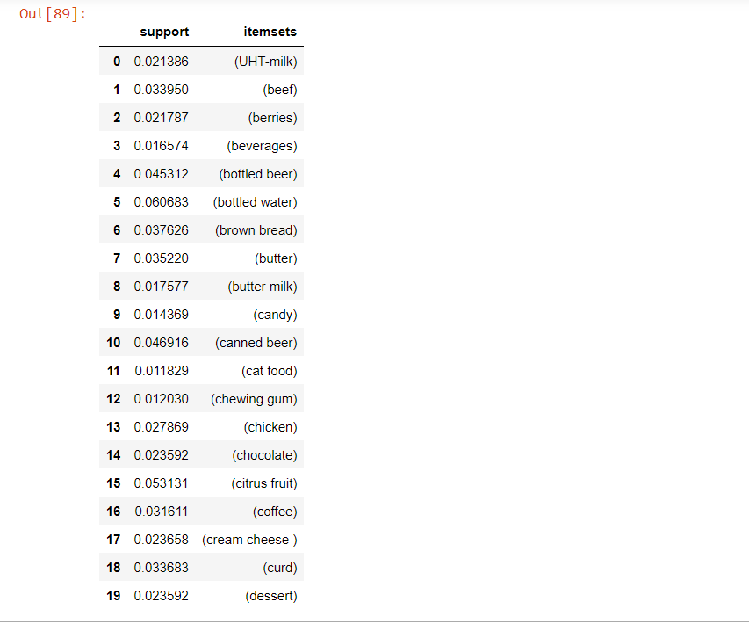

I also trained models of association rules with different metrics.

1- Creating rules (Metric: Confidence) Antecedents ⇒ Consequents

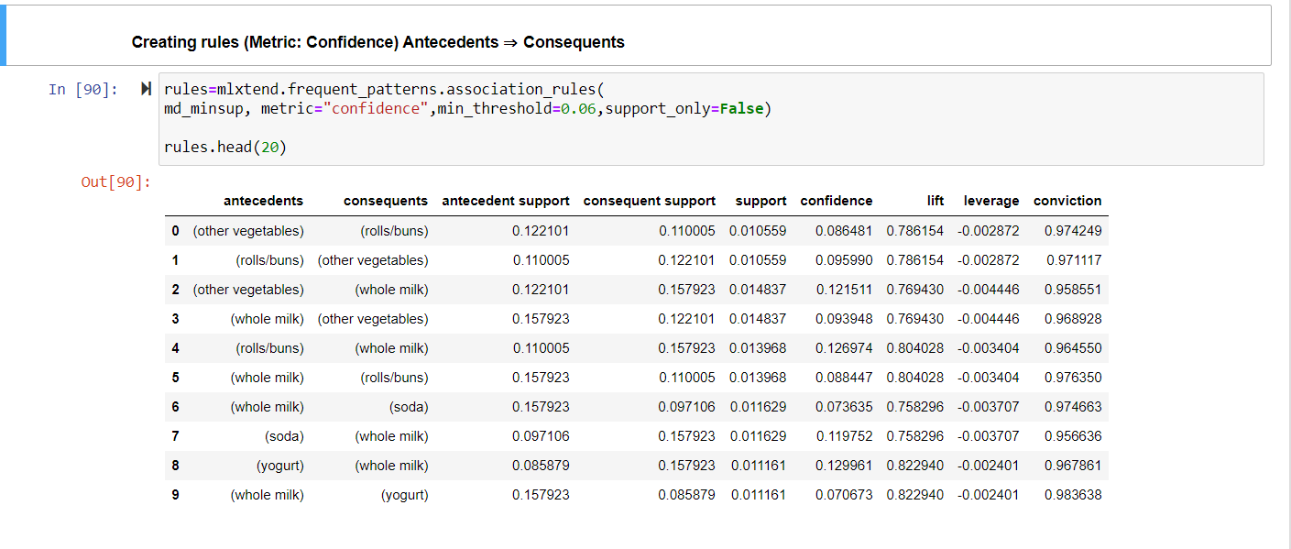

Creating rules (Metric: Lift) Antecedents ⇒ Consequents

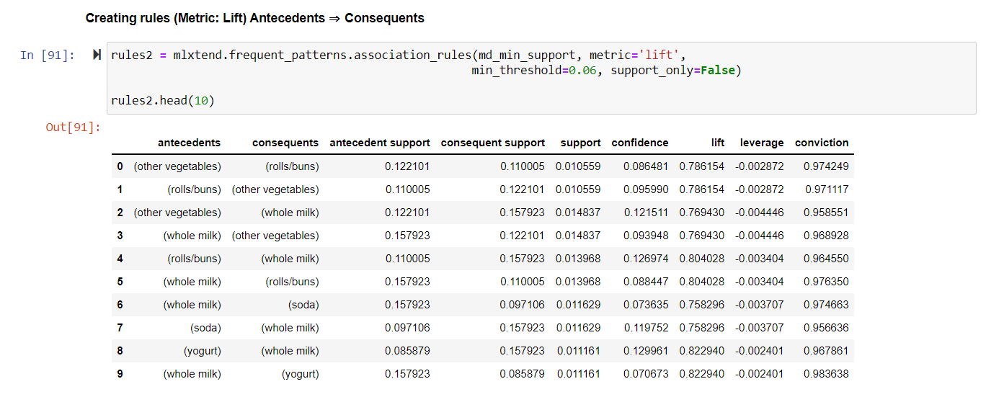

**Conclusion:**

In this project, we used Market Basket Analysis to extract valuable insights from transaction data. It can be used to determine what products to discount. Also it can increase sales and customer satisfaction. It is important to realize that there are many other areas in which it can be applied.