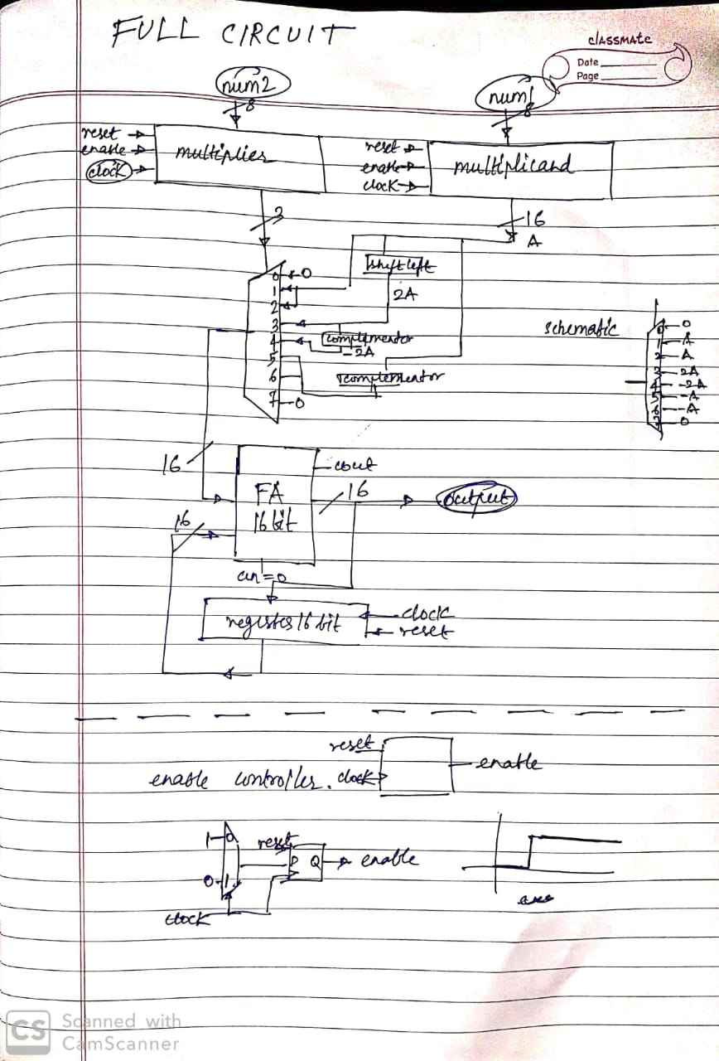

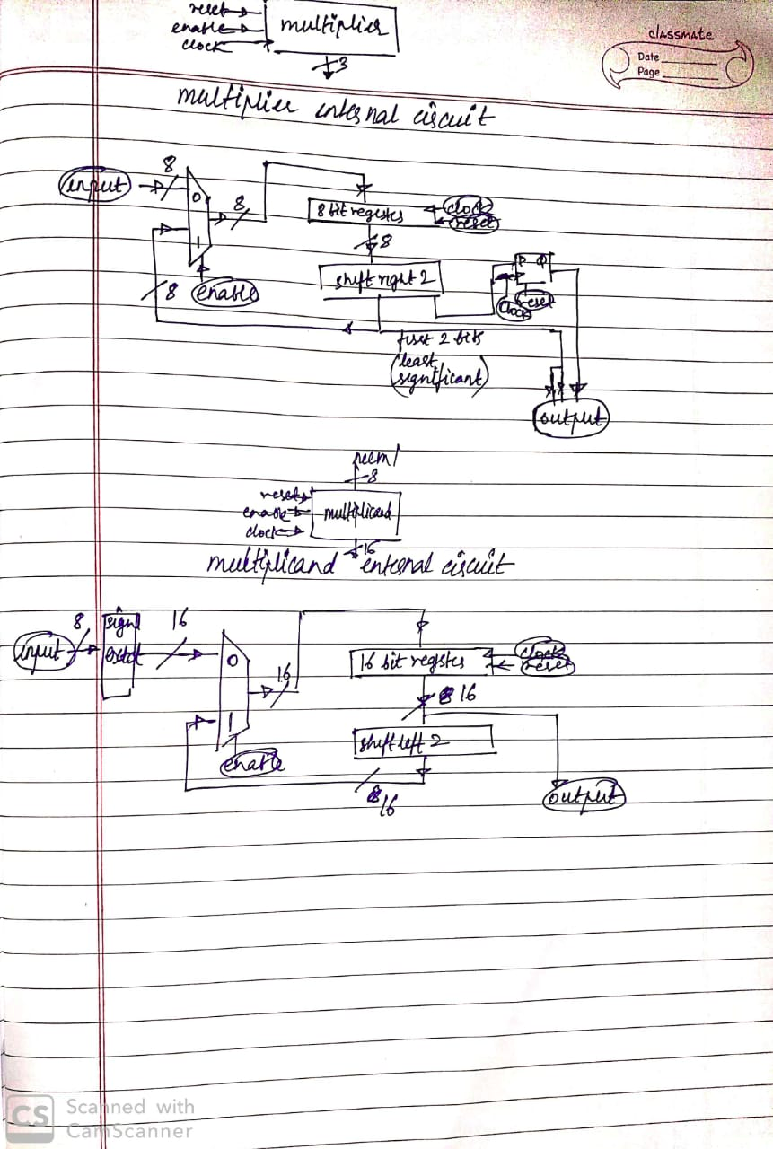

Multiplicand :

Input pins :

Input (8 bit multiplicand),

Reset (sets output to zeros),  
Enable (if enable is 1 then the output shifts left by 2 bits at rising clock edge, else if enable is zero the input shifts to output at rising clock edge),

Clock (goes to the d flip flops of the register).

Output pins :

Output( 16 bit adjusted multiplicand).

Multiplier :

Input pins :

Input (8 bit multiplier),

Reset (sets output to zeros),  
Enable (if enable is 1 then the output shifts right by 2 bits at rising clock edge, else if enable is zero the input shifts to output at rising clock edge),

Clock (goes to the d flip flops of the register).

Output pins :

Output( 3 bit which acts as select for mux in main circuit)

Least significant bit of the output is the output of the d flip flop and the other 2 bits are the 2 least significant bits of the shifted output.

Working of the enable controller :

Before starting num1 and num2 are set to their desired values, clock is connected and reset is set to 1. At the first rising edge, the enable will output 0.

Then the reset is set to 0. At the second rising edge, the inputs are read into the multiplier and multiplicand registers. Now the enable changes to 1 and stays 1 at all the consequent rising edges.

The the consequent rising edges, since the enable is 1, the required shifts take place in the multiplicand and multiplier registers.