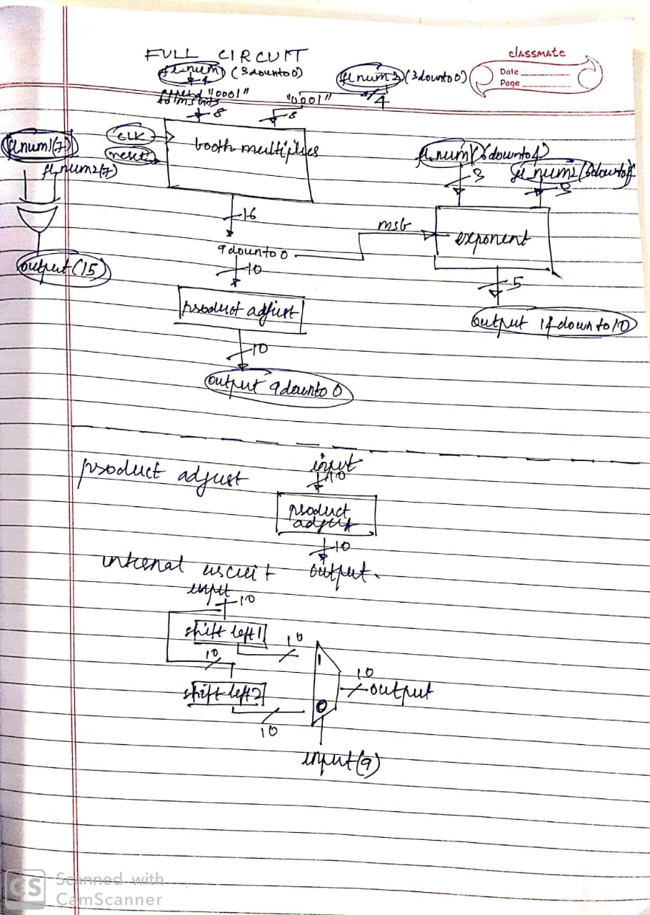

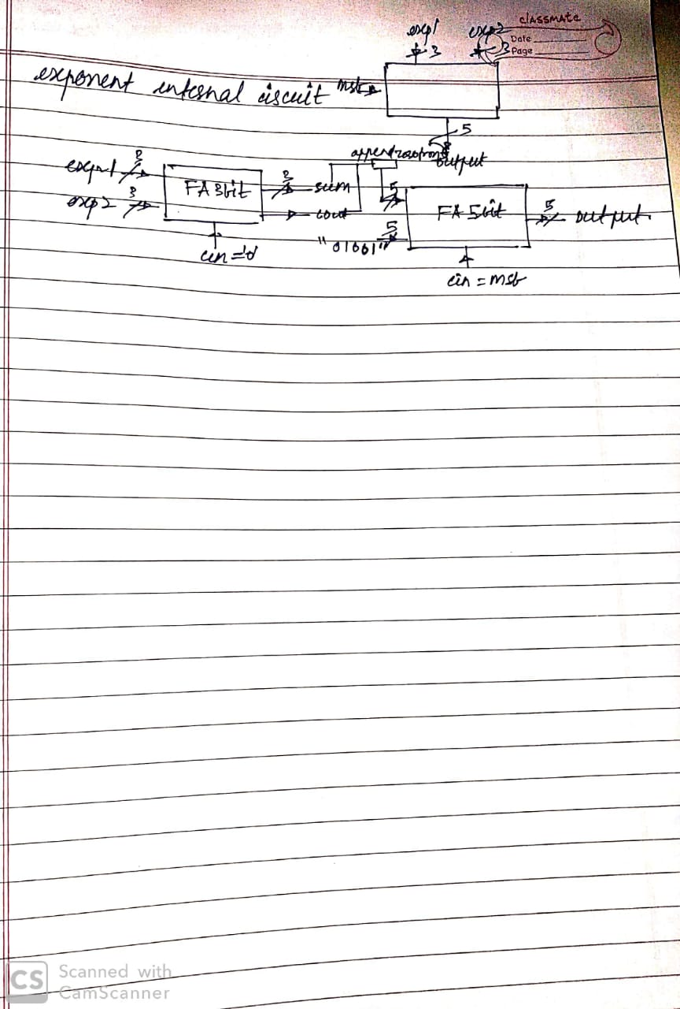

Booth Multiplier:

Input pins :

Num1 and Num2 (4 bit mantissa of our floating point numbers and appended by “0001” to make them 8 bits)

Clock

Reset

Output pins :

Output (16 bit mantissa of our product which is not normalised or truncated to 10 bits)

Product_adjust :

Input pins:

Input (10 most significant bits of the output of the booth multiplier )

Output pins :

Output ( Mantissa of the product floating point number, truncated and normalised)

Brief working :

If the msb of the truncated mantissa is 1 then we need to shift the mantissa 2 bits left(to normalise) and increment one in the exponent. Else if the msb is 0 then we need to shift the mantissa 1 bit left ( to normalise).

Exponent :

Input pins :

Exp1 and Exp2 (3 bit biased exponents of the input floating point numbers)

Msb (most significant bit of the input of the product adjust)

Output pins :

Product_exponent (5 bit biased exponent of the output floating point output)

Brief working :

The exp1 and exp2 3 bit inputs are added using a 3 bit full adder. Now we need to add 9(-3 -3 +15 ) to the sum and produce a 5 bit output. The sum and carryout pins of the 3 bit full adder along with an appended 0 make a 5 bit input of the second full adder which is a 5 bit full adder. The second input of this full adder is nine ie “01001” .