**RESTAURANT MANAGEMENT SYSTEM**

C:\Program Files (x86)\Microsoft Office\MEDIA\OFFICE12\Bullets\BD14514_.gif**C:\Program Files (x86)\Microsoft Office\MEDIA\OFFICE12\Bullets\BD14514_.gifC:\Program Files (x86)\Microsoft Office\MEDIA\OFFICE12\Bullets\BD14514_.gifC:\Program Files (x86)\Microsoft Office\MEDIA\OFFICE12\Bullets\BD14514_.gifC:\Program Files (x86)\Microsoft Office\MEDIA\OFFICE12\Bullets\BD14514_.gifC:\Program Files (x86)\Microsoft Office\MEDIA\OFFICE12\Bullets\BD14514_.gifC:\Program Files (x86)\Microsoft Office\MEDIA\OFFICE12\Bullets\BD14514_.gifC:\Program Files (x86)\Microsoft Office\MEDIA\OFFICE12\Bullets\BD14514_.gifC:\Program Files (x86)\Microsoft Office\MEDIA\OFFICE12\Bullets\BD14514_.gifC:\Program Files (x86)\Microsoft Office\MEDIA\OFFICE12\Bullets\BD14514_.gifC:\Program Files (x86)\Microsoft Office\MEDIA\OFFICE12\Bullets\BD14514_.gifC:\Program Files (x86)\Microsoft Office\MEDIA\OFFICE12\Bullets\BD14514_.gifC:\Program Files (x86)\Microsoft Office\MEDIA\OFFICE12\Bullets\BD14514_.gifC:\Program Files (x86)\Microsoft Office\MEDIA\OFFICE12\Bullets\BD14514_.gifC:\Program Files (x86)\Microsoft Office\MEDIA\OFFICE12\Bullets\BD14514_.gifC:\Program Files (x86)\Microsoft Office\MEDIA\OFFICE12\Bullets\BD14514_.gifC:\Program Files (x86)\Microsoft Office\MEDIA\OFFICE12\Bullets\BD14514_.gifC:\Program Files (x86)\Microsoft Office\MEDIA\OFFICE12\Bullets\BD14514_.gifC:\Program Files (x86)\Microsoft Office\MEDIA\OFFICE12\Bullets\BD14514_.gifC:\Program Files (x86)\Microsoft Office\MEDIA\OFFICE12\Bullets\BD14514_.gifC:\Program Files (x86)\Microsoft Office\MEDIA\OFFICE12\Bullets\BD14514_.gifC:\Program Files (x86)\Microsoft Office\MEDIA\OFFICE12\Bullets\BD14514_.gifC:\Program Files (x86)\Microsoft Office\MEDIA\OFFICE12\Bullets\BD14514_.gifC:\Program Files (x86)\Microsoft Office\MEDIA\OFFICE12\Bullets\BD14514_.gifC:\Program Files (x86)\Microsoft Office\MEDIA\OFFICE12\Bullets\BD14514_.gifC:\Program Files (x86)\Microsoft Office\MEDIA\OFFICE12\Bullets\BD14514_.gifC:\Program Files (x86)\Microsoft Office\MEDIA\OFFICE12\Bullets\BD14514_.gifC:\Program Files (x86)\Microsoft Office\MEDIA\OFFICE12\Bullets\BD14514_.gifC:\Program Files (x86)\Microsoft Office\MEDIA\OFFICE12\Bullets\BD14514_.gifC:\Program Files (x86)\Microsoft Office\MEDIA\OFFICE12\Bullets\BD14514_.gifC:\Program Files (x86)\Microsoft Office\MEDIA\OFFICE12\Bullets\BD14514_.gifC:\Program Files (x86)\Microsoft Office\MEDIA\OFFICE12\Bullets\BD14514_.gifC:\Program Files (x86)\Microsoft Office\MEDIA\OFFICE12\Bullets\BD14514_.gifC:\Program Files (x86)\Microsoft Office\MEDIA\OFFICE12\Bullets\BD14514_.gifC:\Program Files (x86)\Microsoft Office\MEDIA\OFFICE12\Bullets\BD14514_.gifC:\Program Files (x86)\Microsoft Office\MEDIA\OFFICE12\Bullets\BD14514_.gif**

**BY:**

Adeena Shabbir (B16158005)

Bisma Aslam (B16158021)

Areeba Tanveer (B16158013)

* **PROJECT:**

Restaurant Management System

* **OBJECT:-**

Requirement Analysis, Methodologies, Techniques, SDLC’s Phases and their required tools.

* **PROJECT INTRODUCTION:-**

The Restaurant Management system will be able to provide ease for the restaurant manager to manage his/her restaurant with efficiency. This will be done by computerizing meal ordering, billing and backup generating.

* **PURPOSE AND OBJECTIVE:-**

To help the manager make appropriate business decisions for his restaurant. E.g. knowing the amount of customers during a specific time period, the manager could hire waiters and chefs accordingly.

* **FUNCTIONAL REQUIREMENTS:-**
* The system shall provide a login window for the manager to allow the customer to place their orders.
* The system shall take customer credentials for order placement.
* The system shall have dine-in, take away and delivery options.
* The system will display amount in Rs for every individual item along with the total amount for the customer to pay.
* The system will ask for order confirmation.
* The system shall record the customer order along with their credentials and order date and time.
* The system will have an automated cash calculation.
* The orders placed shall be saved in a file for the manager to see.
* **NON-FUNCTIONAL REQUIREMENTS:-**
* The system will be in English language.
* The manager has to login with their username and password in order to access the system.
* The system will be user friendly so it would be easily adaptable.
* The program will run in Microsoft Visual studio (preferably 2010 or newer version).
* 32-bit/64-bit RAM.
* 3 GB Hard Disk space.
* Processor: 1.6 GHz or faster.
* **RESOURCES AND TOOLS AVAILABLE:-**
* Login window.
* Credentials of customers.
* Dine-in, take away and delivery options.
* Menu selections.
* Customer credentials, selected items and quantity saved in file along with order date and time.
* Automatic calculations (tax, cash, change).
* Order confirmation.
* Exception handling.
* **OTHER TECHNIQUES AND METHODOLOGIES USED, EVELUATION METHODS, RESULTS:-**
* New items in the menu can’t be added/deleted during run time.
* We used filing instead of database.
* **IMPORTANT NAMES IN THE FIELD, RESEARCH TEAMS:-**
* Mr. Lam Chi Ching.
* Mr. Leung Fai Tat, Michael.
* Miss Wong Shuk Chun, Prima.
* **RELATED ARTICLES AND BOOKS:**

***Books:-***

* Restaurant owners uncorked by Will Barley.
* Restaurant success by the number by Roger Fields.
* The profit recipe by Cesar Quintero.

**Relevant links:**

* Financesonline.com
* Itvision.com.pk
* Getwisely.com
* **USERS:-**
* Customers
* Manager
* Receptionist
* **PROJECT MANAGEMENT TOOLS:**

**REQUIREMENT ANALYSIS PHASE:-**

**WE USED:**

The tools we used in requirement analysis are Ms Office, Use-Case diagram and Sequence Diagrams. The diagrams helped in understanding the functionalities and structure of the software to be developed in a better, easier and understandable way.

**OTHER TOOLS AND THEIR FUNCTIONALITIES:**

* **PROCESS STREET:**
* 30 day trial
* Can make own requirements
* Keep track of them
* Collaborative workflows
* Not open source
* Can be used for agile development also
* **ANIMBLE:**
* Open source
* Free
* Can make own requirement
* Web based tool
* Supports SDLC workflows

**DESIGN PHASE:-**

**WE USED:**

Visual Paradigm because it is easy to use and works great with visual studio, Netbeans, Intellij etc. Another advantage is that the team can create and post diagrams.

**OTHER TOOLS AND THEIR FUNCTIONALITIES:**

* **MS VISIO:**
* Desktop Application
* Managed and worked individually
* Not easy to use
* Not free

**PROJECT MANAGEMENT PHASE:-**

**WE USED:**

“Microsoft Project”. Through this, activities can be tracked in a couple of different ways by using Gantt chart, Pert chart etc. Even though the software is not free, the crack is available.

**OTHER TOOLS AND THEIR FUNCTIONALITIES:**

* **TRELLO**
* Activities are tracked using cards
* Chat room for co workers
* Real time management
* Used for big projects, organizational
* Not free

**DOCUMENTATION PHASE:-**

**WE USED:**

The platform we chose to do our documentation is Ms Word and Google docs. The main reason to use these platforms is that they are very user friendly, free of cost and are easy to use.

**OTHER TOOLS AND THEIR FUNCTIONALITIES:**

**SHAREPOINT**

* Not free
* Web based application
* For enterprise projects
* For team greater than 1000 person
* Not suitable for small projects
* **UML DIAGRAMS:**

**Use Case Diagram:**

**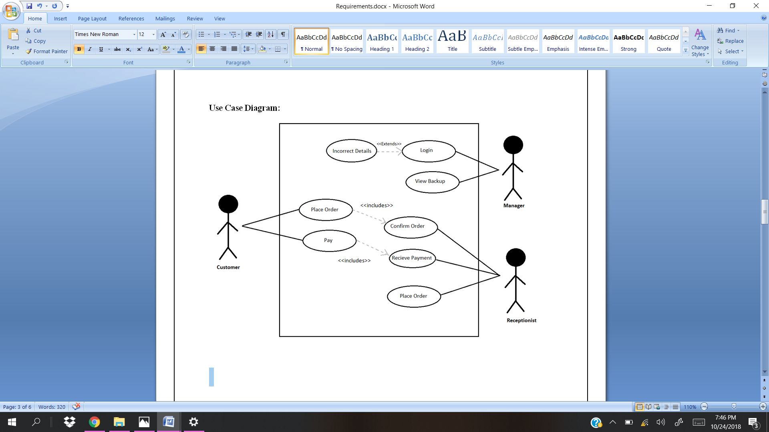**

For Delivery

**Activity Diagram:**

**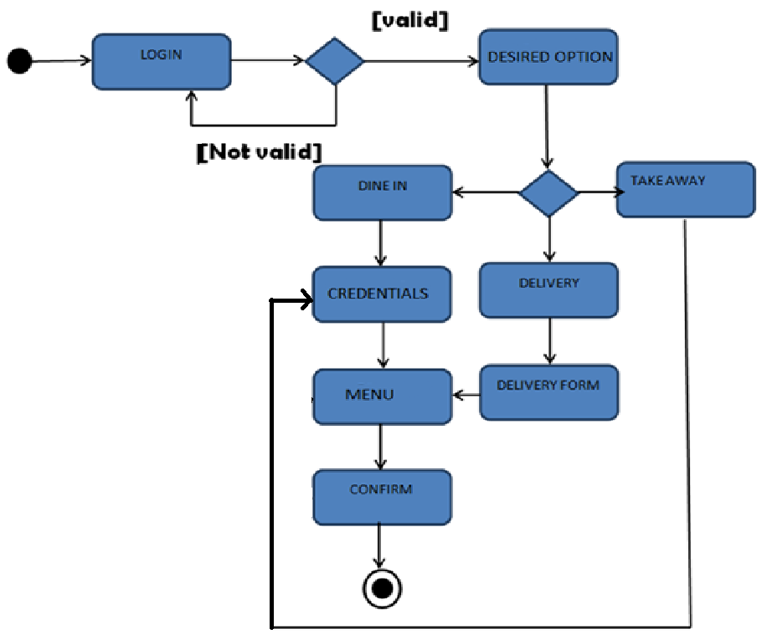**

**Class Diagram:**

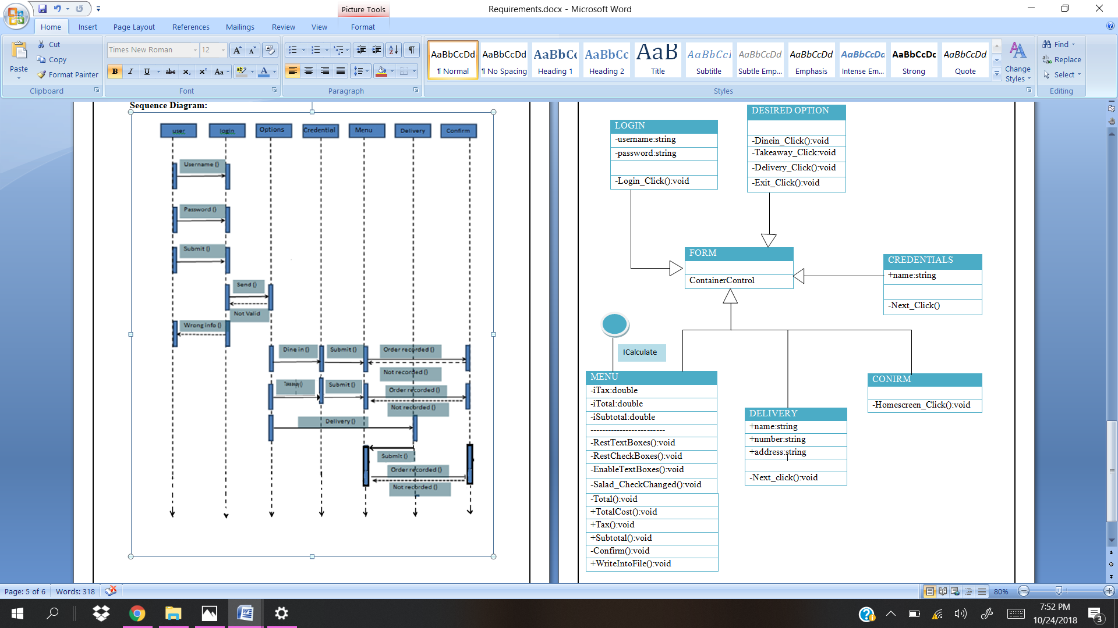

**Sequence Diagram:**

**