

Task 3 of Semester Project

Submitted by:
Ayesha habib (sp24-bcs-034)
Adeen Fatima (sp24-bcs-039)
Ayesha Zulfiqar (sp24-bcs-029)
Submitted to:
Mam Mina
Subject:
Data Structures (Lab)

Project Name:

HealthCareHub – Hospital Management System

Task A: Build Core DS Features:
- Patient Registration Using Linked List
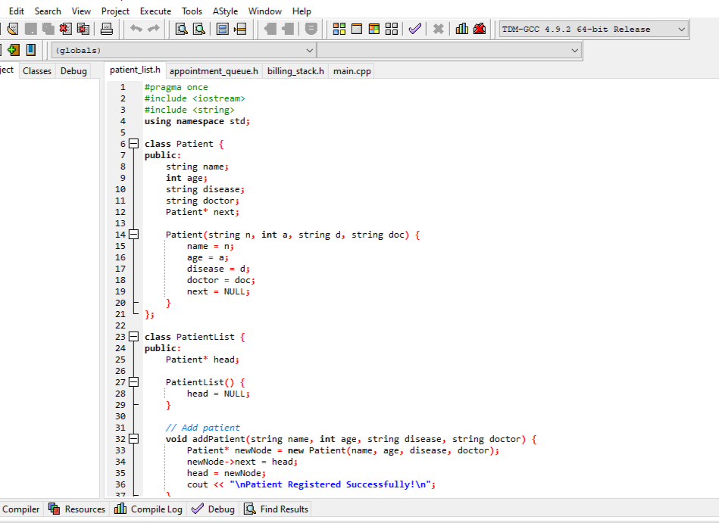
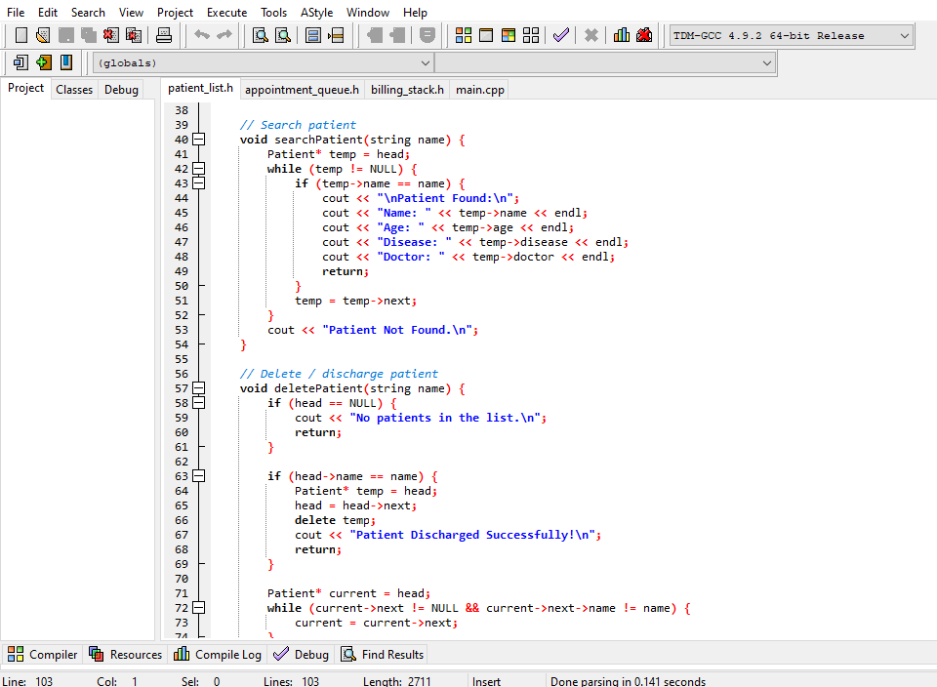
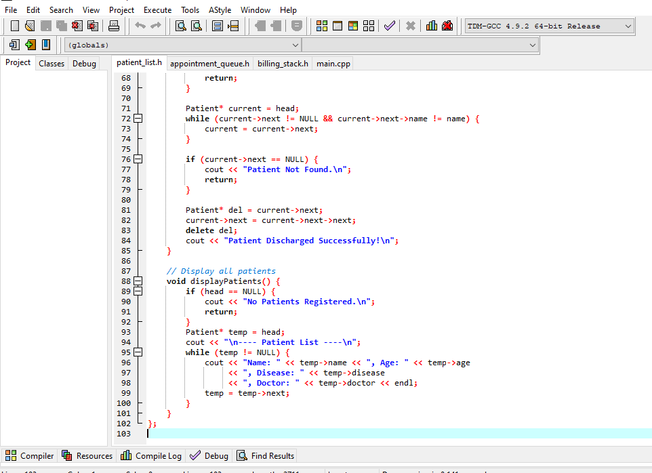
- Appointment Scheduling Using Queue
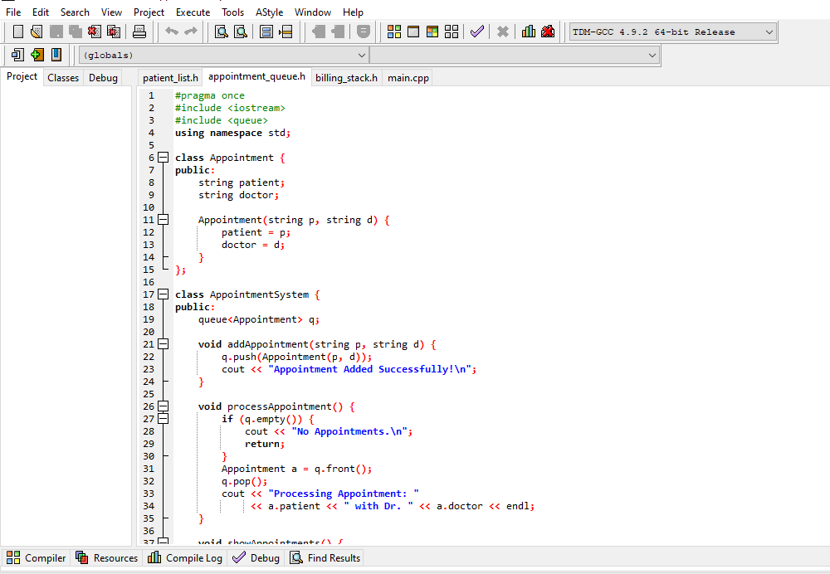
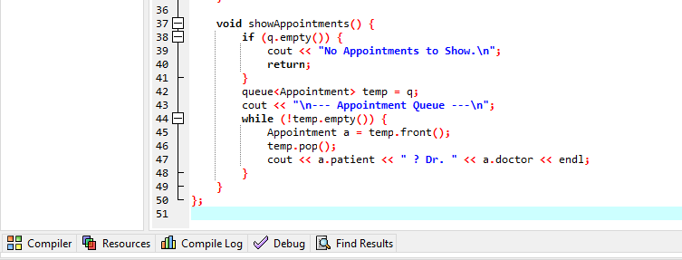
- Billing Undo/Redo System Using Stack
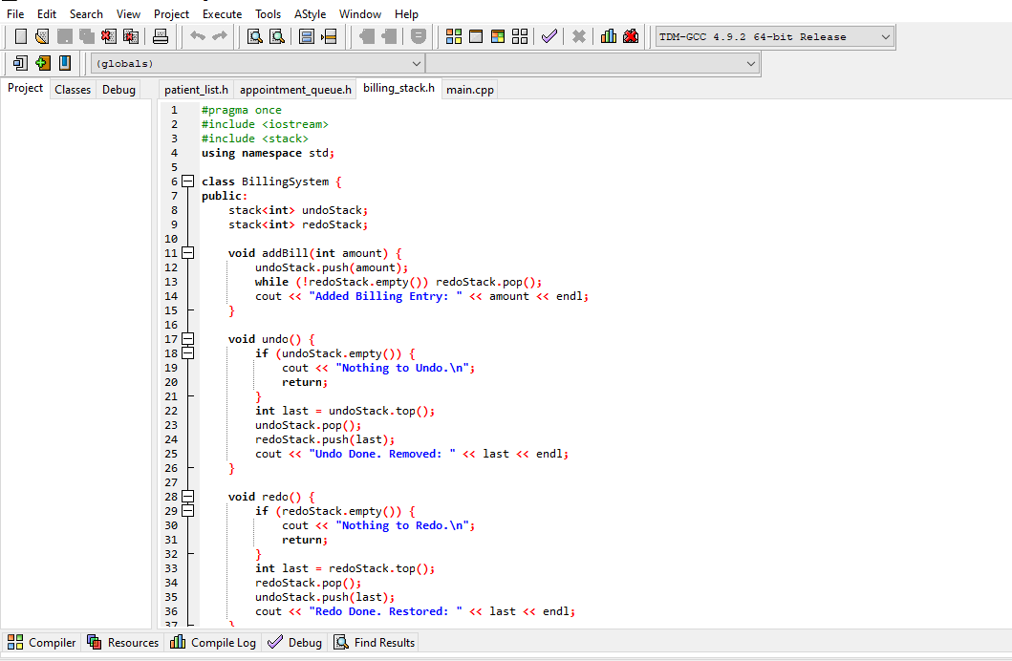
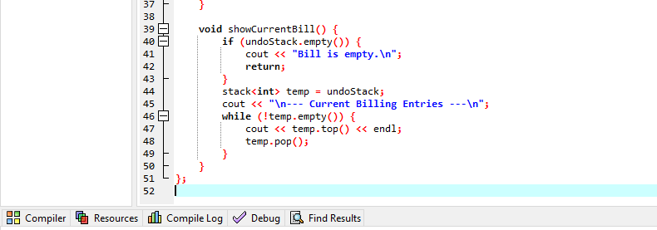
- main.cpp
