FL-01: AI Workflow Audit
Princess Adekola

1. Task Classification Audit
Task | Category | Rationale
Searching for NYSC placement options | Delegate to AI with review | AI can shortlist and draft outreach fast, but I make the final call on fit and risk.
Anthropic Academy coursework | Just me | Learning only counts if I do the actual thinking myself.
Watching YouTube videos for learning | Just me | Passive absorption there's no delegating watching to AI.
Writing/debugging backend code (personal learning) | Collaborate with AI | I write the logic, AI helps spot bugs and suggest fixes, but I need to understand every line to actually learn.
Building AI automations in n8n (personal projects) | Collaborate with AI | I design the workflow, AI helps troubleshoot node configs and logic in real time.
Writing my book on how to be funny | Delegate to AI with review | AI can expand/draft material, but comedic voice and final cut must stay mine.
Searching for freelance jobs | Delegate to AI with review | AI can filter and summarize listings, but I decide what's worth pursuing.
Researching on my final year project | Collaborate with AI | Back-and-forth exploring angles and sources, but I own the direction and conclusions.
Talking to AI about which projects to pursue next | Collaborate with AI | This is a direct thinking-partner use case by design.
Checking LinkedIn updates | Just me | Networking judgment (who to engage, how) is personal and low-value to offload.
Texting friends online | Just me | Personal relationships shouldn't be automated or delegated.
Reviewing/organizing notes from Academy courses | Fully automate | Straightforward summarizing/formatting task with no judgment call needed.

2. Claude Project Setup

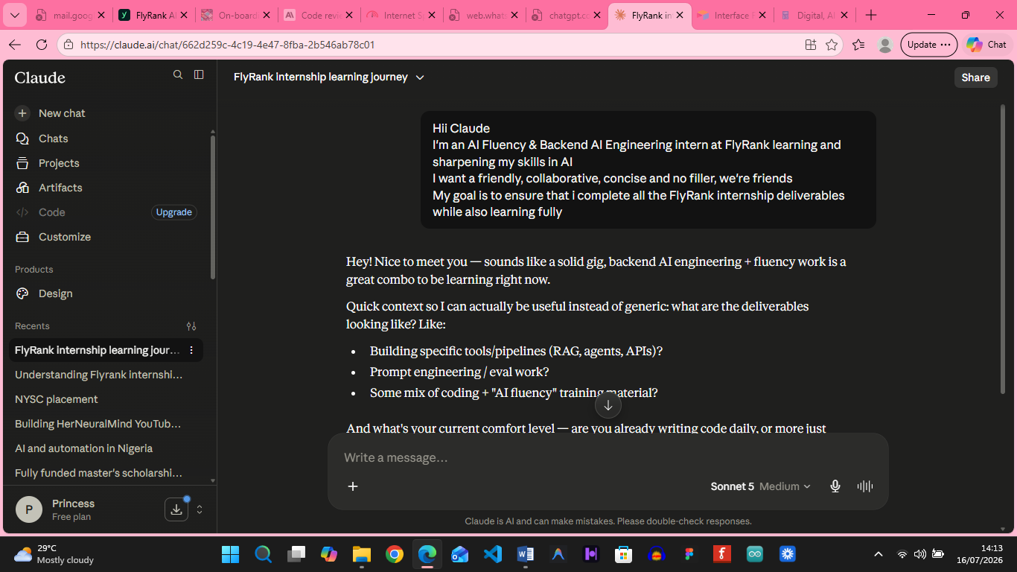

3. Three Target Tasks & Success Definitions
Target Task 1: Writing/debugging code
Success looks like AI-assisted debugging resolves at least 70% of bugs I bring to it without needing a separate search
Target Task 2: Building AI automations in n8n
Success looks like a new automation workflow goes from idea to working prototype in under 2 hours, with AI handling node-level troubleshooting.
Target Task 3: Researching on my final year project
Success looks like AI-assisted research produces at least 3 usable, correctly-cited sources per session, verified by me before use.

