|  |  |
| --- | --- |
|  | Live Area – The PFSweb Agency |
|  | Selenium Automation Suite |
|  |  |

|  |
| --- |
| Ibrahem Batta, Emad Tabib  Created: 1/28/2018  Last Modified: |

Contents

Introduction: 3

Environment setup: 3

- Eclipse 3

- testNG Eclipse plugin 3

- testNG Eclipse plugin installation 3

- Project Assets 3

- Code 3

- Execute regression 3

- TestNG result 3

- Automation Report 3

- Automation sheet 4

Code Packages: 6

1. Config file 6

o *Test environment URL*. 6

o *Report folder name and drivers path*. 6

o *Pages URLs*. 6

2. Page package 6

3. Selector package 6

4. Setup package 6

5. test_runners package 7

6. Tests packages 7

7. Util package 7

Supported mobiles in chrome emulation: 7

Data sheet documentation: 8

Users 8

Products 8

Cards 9

Addresses 9

Account Setup Regression 9

Checkout Regression 10

PDP Regression 11

Cart Regression 12

PLP Regression 13

Personal Details Regression 14

Order History Regression 15

Registration Regression 16

Address Book Regression 17

Payment Details Regression 18

Store Locator Regression 19

Email Address Regression 19

Search Regression 20

Error Pages Regression 21

Checkout Negative Cases Regression 21

Checkout B2B Regression 22

Order Details Regression 23

Password Regression 23

Mail Signup Regression 23

Quick View Regression 24

Login Regression 24

Visual Testing HP Regression 25

Visual Testing CLP Regression 25

## Introduction:

We Used selenium framework to create a generic automation code to Hybris commerce sites. We covered the full regression on the Hybris demo site. And we used TestNG to run the tests in parallel.

## Environment setup:

* Eclipse: <https://www.eclipse.org/home/index.php>
* testNG Eclipse plugin: Install TestNG in eclipse: Please use this version “<http://beust.com/eclipse-old/eclipse_6.9.12.201607091356>”
* testNG Eclipse plugin installation: To install TestNG in eclipse: Go Click on Help > Install New software. Add the link “<http://beust.com/eclipse-old/eclipse_6.9.12.201607091356>”in Work with text box. Tick the check box of TestNG. Click on Next button then Finish button.
* Project Assets: [Assets](https://drive.google.com/open?id=19F8GKKJyyd-VhhV8Iv34C3pj7wH4hjyP) to be placed on **“C” drive** ➔ “C:\SelAssets”
* Code: Import [Code](https://drive.google.com/file/d/1cZmDGqToaAU7f2Q9MQgKYNZGUlGN0tBQ/view?usp=sharing) to eclipse.
* Execute regression: Go to any xml runner in package and run it as testNG suite.
* TestNG result: Expected to have something like screenshot below
  + 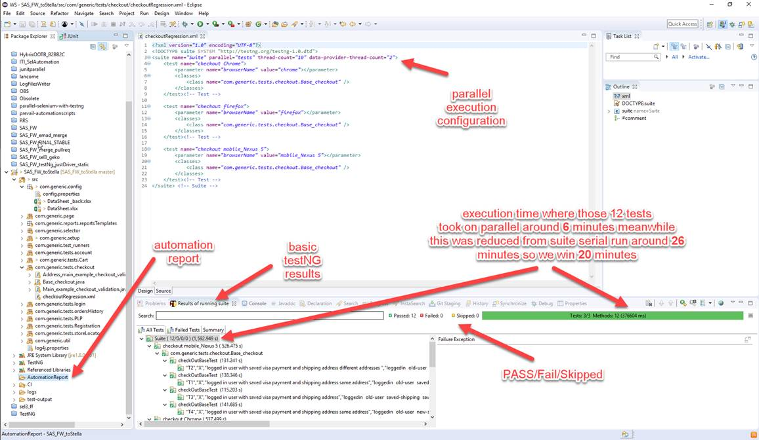
* Automation Report: Check the results from automation report from directory inside the code called **AutomationReport.**  Sample runs attached for the above run and some failures in run.
* 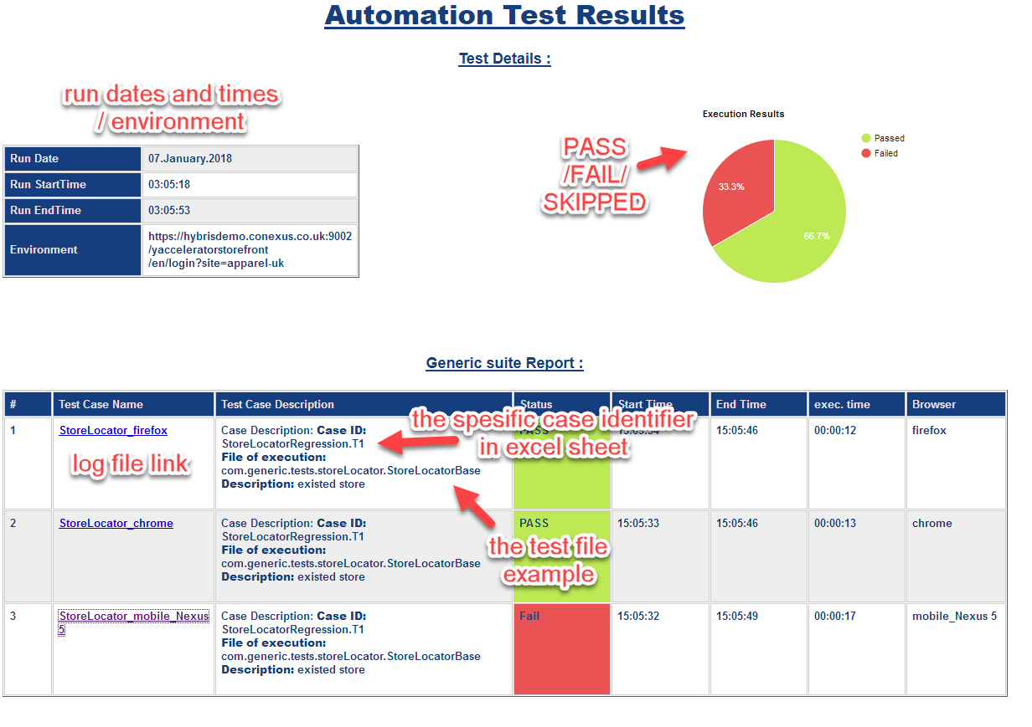
* 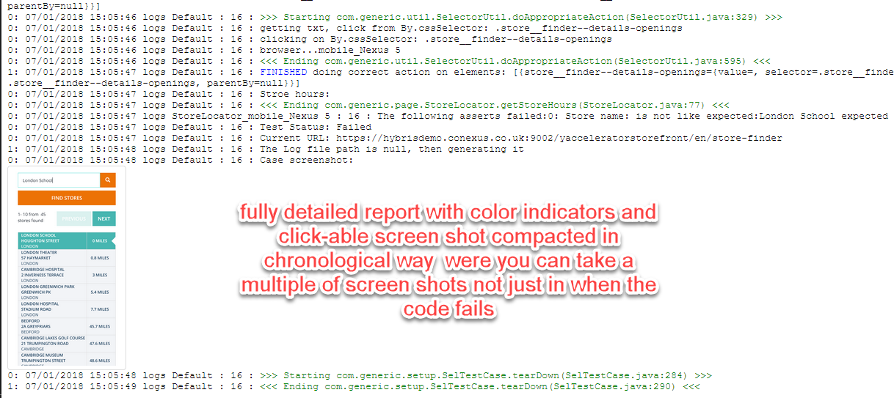
* Automation sheet: To modify the tests and test you would run you need to edit this excel sheet “\src\com\generic\config\DataSheet.xlsx”, more information please check below

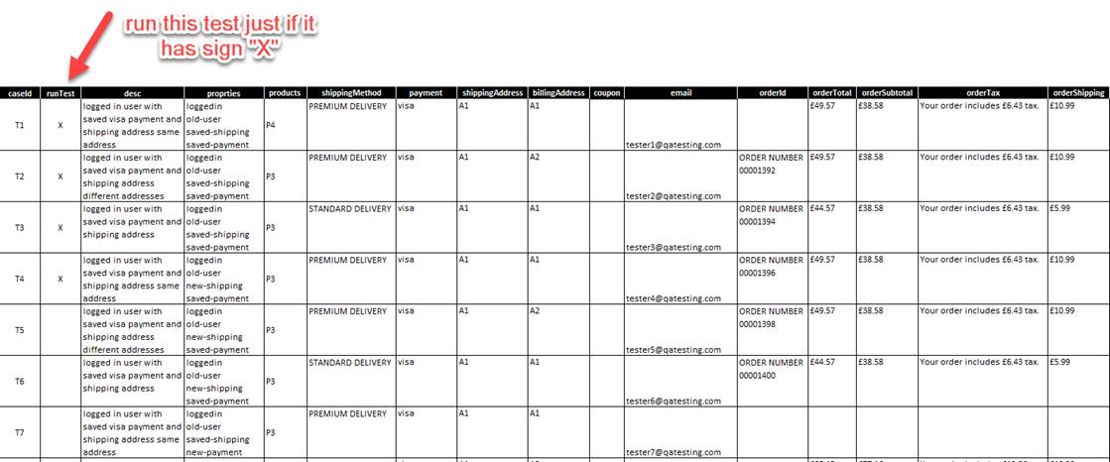

Regression tabs



## Code Packages:

1. Config file: Contains the following variables and it is located in config package:

### Test environment URL.

### Report folder name and drivers path.

### Pages URLs.

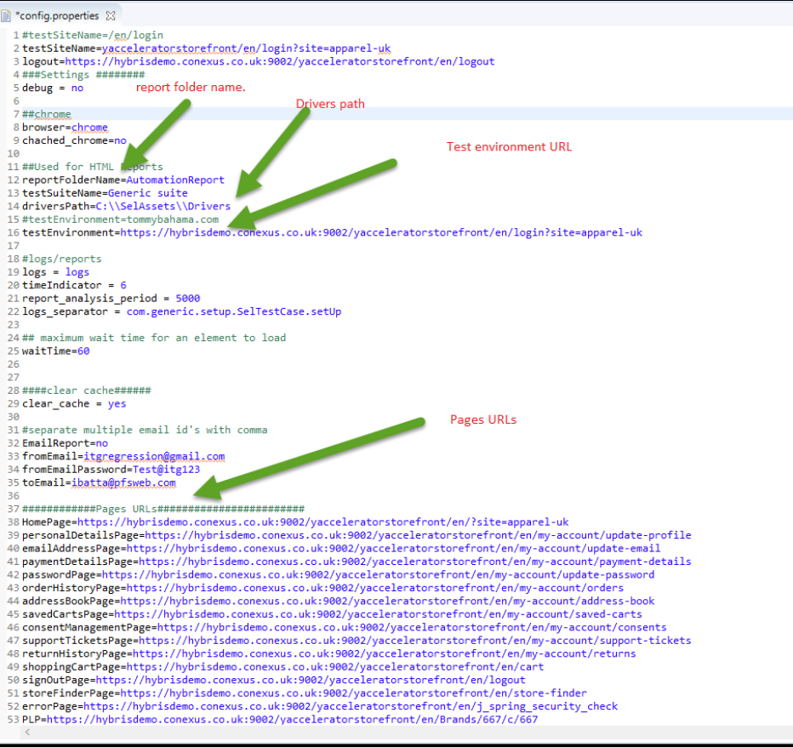

1. Page package:
   * Contains the test functions for each page.
2. Selector package:
   * Contains all element selectors for each page.
3. Setup package:
   * Action Driver class: Contains some WebDriver Commands.
   * Common class: Contains some WebDriver Commands, browser commands.
   * ExceptionMsg class: Contains all exception messages used in test packages.
   * LoggingMsg class: Contains all logging messages used in test packages.
   * Pages URLs class: Contains all page URLs.
   * SelTestCase: Initialize test report.
   * Sheet Variables: Contains all sheet names will be invoked in tests packages.
4. test_runners package: Contains all xml runner files.
5. Tests packages: Contains all validation tests class.
6. Util package: Read data from “DataSheet” file, generate random emails and names, report setup, initialize elements selectors and do the appropriate action.

## Data sheet documentation:

### Users

|  |  |
| --- | --- |
| Properties | |
| Mail | These emails are the shadow of all browser accounts. The format used for actual accounts is as follows:  Replace tester by tester_browsername.  Ex. tester1@qatesting.com -> The existing browsers accounts are: tester_chrome1@qatesting.com, tester_firefox1@qatesting.com, tester_mobile_nexus_51@qatesting.com, etc.  Note: These accounts should be already created, and they can be created by “Accounts Setup” automation test. |
| Password | The password used to create and sign in to the account |
| Last Name | Last name used to create and verify account information. |
| First Name | First name used to create and verify account information. |
| Title | Title used to create and verify account information. |
| Name (Account ID) | Used as reference for their account to be called in related sheets/ tests. However, we used the mail instead. |

### Products

|  |  |
| --- | --- |
| Properties | |
| Name | Used as reference for their product to be called in related sheets/ tests. |
| ID | Product code. |
| Title | Product title. |
| URL | Product url. Used to navigate to the product page. |
| Summary | Product summary. It will be used to verify product summary. |
| Price | Product price. It will be used to verify product price. |
| OverView | Product OverView. It will be used to verify product OverView. |
| Features | Product Features. It will be used to verify product Features. |

### Cards

|  |  |
| --- | --- |
| Properties | |
| Card (card type) | Used as reference for their card to be called in related sheets/ tests. |
| Number | The values used for the card number. |
| Name | The values used for the Cardholder Name. |
| Expire year | The values used for the expiration year. |
| Expire month | The values used for the expiration month. |
| CVCC | The values used for the code verification. |

### Addresses

|  |  |
| --- | --- |
| Properties | |
| Address code | Used as reference for their address to be called in related sheets/ tests. |
| First name | The values used for the first name of the address. |
| Last name | The values used for the last name of the address. |
| Title | The values used for the title of the address. |
| Address line | The values used for the address line of the address. |
| City | The values used for the address city. |
| Postal | The values used for the postal code of the address. |
| Country | The values used for the address country. |
| Phone | The values used in the address phone. |

### Account Setup Regression

|  |  |
| --- | --- |
| Properties | |
| Case Id | A unique identifier for each case, and it will be referenced in the test report. |
| Run test | X: To run this case in the regression.  Null: To skip this case in the regression. |
| Products  (P1 -P7) | Reference of the products listed in Products sheet. Products used in checkout. |
| Shipping method | Shipping method used in checkout. |
| Payment | Reference of the payment listed in Cards sheet. Card used in checkout. |
| Shipping address  (A1 – A4) | Reference of the address listed in address sheet. Shipping address used in checkout. |
| Billing address  ) A1 – A4( | Reference of the address listed in address sheet. Billing address used for payment. |
| Email | U-011, should be exist in users |

### Checkout Regression

|  |  |  |  |
| --- | --- | --- | --- |
| Properties | | | |
| Properties | Depend on | Variables | Description |
| logged in | old-user, fresh user | - | The user is already registered. |
| old-user | - | - | The user is already registered and has created orders before |
| saved-shipping | old-user | - | The user is already registered and has a saved shipping address. And he will checkout using it. |
| saved-payment | old-user | - | The user is already registered and has a saved payment card. And he will checkout using it. |
| new-shipping | old-user, fresh user, logging During Checkout | saveShipping | The user is already registered and will ship using a new shipping address.  saveShipping: Save your new shipping address. |
| new-payment | old-user, fresh user, logging During Checkout | saveBilling | The user is already registered and will ship using a new payment card.  saveBilling: Save your new payment card. |
| fresh user, new-user | - | - | The user has created a new account without orders yet |
| logging During Checkout | - | - | The user has an account and will log in from checkout page |
| guest | - | - | The user has no registered account. |
| Case Id | A unique identifier for each case, and it will be referenced in the test report. | | |
| Run test | X: To run this case in the regression.  Null: To skip this case in the regression. | | |
| Desc | A short description for the test case, and it will be included in the test report. | | |
| Products  (P1 – P7) | Reference of the products listed in Products sheet. Products used in checkout. | | |
| Shipping method  (PREMIUM DELIVERY) | Shipping method used in checkout. | | |
| Payment  (visa, master) | Reference of the payment listed in Cards sheet. Card used in checkout. | | |
| Shipping address  (A1 – A4) | Reference of the address listed in address sheet. Shipping address used in checkout. | | |
| Billing address  (A1 – A4) | Reference of the address listed in address sheet. Billing address used for payment. | | |
| Coupon  FREEDEL, Null(unpopulated) | If it has a value, the coupon will be added to the orders. Else no coupon will be applied.  FREEDEL: Is a valid promotion code. | | |
| Email | Reference of the email listed in user’s sheet. As we mentioned in properties column, these accounts should be already created.  **Note:** There is no need to email for the guest order because it will use a random email. | | |

### PDP Regression

|  |  |  |
| --- | --- | --- |
| Properties | | |
| Properties | **Variables** | **Description** |
| id | - | Check product code |
| title | - | Check product name |
| price | - | Check product price |
| Over view | - | Check product Over view |
| Summary | - | Check product Summary |
| Case Id | A unique identifier for each case, and it will be referenced in the test report. |  |
| Run test | X: To run this case in the regression.  Null: To skip this case in the regression. | |
| Desc | A short description for the test case, and it will be included in the test report. | |
| Products  (P1 – P7) | Reference of the products listed in Products sheet. Products used in checkout. | |
| email | Reference of the email listed in user’s sheet. As we mentioned in properties column, these accounts should be already created.  **Note:** For the guest user, it has no value. | |
| global-alerts | Verify the expected error message shown in this column. | |
|  |  | |

### Cart Regression

|  |  |
| --- | --- |
| Properties | |
| Properties | **Description** |
| Logged in | The user is logged in to the site. |
| Verify unit Price | To verify the value |
| Verify subtotal | To verify the value |
| Verify discount | To verify the value |
| Verify Promotion | To verify the value |
| Verify club Discount | To verify the value |
| Verify total | To verify the value |
| guest | The user is not logged on to the site. |
| Case Id | A unique identifier for each case, and it will be referenced in the test report. |
| Run test | X: To run this case in the regression.  Null: To skip this case in the regression. |
| Desc | A short description for the test case, and it will be included in the test report. |
| Products  )P1 – P7( | Reference of the products listed in Products sheet. Products used in checkout. |
| email | Reference of the email listed in user’s sheet. As we mentioned in properties column, these accounts should be already created.  **Note:** For the guest user, it has no value. |
| new QTY | Verify user is able to update product quantity. |
| Promotion  )FREEDEL, invalid, CHRISTMAS16( | Check coupon functionality by adding or removing valid/invalid coupons.  FREEDEL: Is a valid free delivery coupon.  invalid: Invalid coupon.  CHRISTMAS16: The coupon is no longer valid |
| global-alerts | Verify the expected error message shown in this column. |

### PLP Regression

|  |  |
| --- | --- |
| Properties | |
| Properties | **Description** |
| sort HTL | Sort products by price from highest to lowest |
| Pagination | Verify the number of products displayed in page |
| stort LTH | Sort products by price from lowest to highest |
| Case Id | A unique identifier for each case, and it will be referenced in the test report. |
| Run test | X: To run this case in the regression.  Null: To skip this case in the regression. |
| Desc | A short description for the test case, and it will be included in the test report. |

### 

### Registration Regression

|  |  |  |
| --- | --- | --- |
| Properties | | |
| Properties | **Variables** | **Description** |
| freshUser | fieldsValidation | Validate registration with positive scenario. |
| existingUser | fieldsValidation | Validate error message when attempting to register using an already registered customer. |
| emptyData | fieldsValidation | Validate error messages when attempting to register without filling data. |
| invalidUserID | fieldsValidation | Validate error message when attempting to register with invalid user ID. |
| passwordMismatch | fieldsValidation | Validate error message when attempting to register with invalid password and confirm password do not match. |
| invalidUserPassword | fieldsValidation | Validate error message when attempting to register with invalid password. |
| Case Id | A unique identifier for each case, and it will be referenced in the test report. | |
| Run test | X: To run this case in the regression.  Null (unpopulated): To skip this case in the regression. | |
| Desc | A short description for the test case, and it will be included in the test report. | |
| Fields validation | Verify the expected confirmation/error messages shown in this column based on the case mentioned in desc column. | |

### Address Book Regression

|  |  |  |
| --- | --- | --- |
| Properties | | |
| desc | **Presupposition** | **Description** |
| edit address | The user account (email) must contain a previous address. | Validate that user is able to edit an existing address from address book page. |
| address form validation. |  | Validate error messages when attempting to add a new address with missing data. |
| add new address | The user account (email) must contain a previous address. | Validate that user is able to add a new address from address book page. |
| set address as default | The user account (email) must contain a previous address. | Validate that user is able to update address from address book page |
| delete address | The user account (email) must contain a previous address. | Validate that user is able to add a new address from address book page. |
| Case Id | A unique identifier for each case, and it will be referenced in the test report. | |
| Run test | X: To run this case in the regression.  Null (unpopulated): To skip this case in the regression. | |
| Email | Reference of the email listed in user’s sheet. As we mentioned in properties column, these accounts should be already created. | |
| New address | A1-A4: Reference of the address listed in address sheet. To verify user is able to add shipping address from address book page. | |

### Payment Details Regression

|  |  |  |
| --- | --- | --- |
| Properties | | |
| Properties | **Presupposition** | **Description** |
| update default payment | The user account (email) must contain a previous payment method. | Validate the user is able to update the default payment when he has two different payments. |
| delete payment | The user account (email) must contain a previous payment method. | Validate the user is able to delete any of the saved payments. |
| Case Id | A unique identifier for each case, and it will be referenced in the test report. | |
| Run test | X: To run this case in the regression.  Null (unpopulated): To skip this case in the regression. | |
| Desc | A short description for the test case, and it will be included in the test report. | |
| Payment  (visa, master) | Reference of the payment listed in Cards sheet. Card used in checkout. In order to add a new payment. | |
| Email | Reference of the email listed in user’s sheet. As we mentioned in properties column, these accounts should be already created. | |

### Login Regression

|  |  |
| --- | --- |
| Properties | |
| Properties | **Description** |
| Success login | Verify that the registered user is able to login successfully. |
| Invalid user email | Verify the correct error message is displayed when trying to login with invalid email. |
| Invalid user password | Verify the correct error message is displayed when trying to login with invalid password. |
| Empty data | Verify the correct error message is displayed when trying to login with empty data. |
| Forgot password -Valid Email | Verify that the registered user is able to send a forgot password email. |
| Forgot password -Invalid Email | Verify the correct error message is displayed when trying to send a forgot password email with an invalid email. |
| Email | Two types of emails are used. Valid or Invalid emails based on the properties values.  Reference of the valid email is listed in user’s sheet. As we mentioned in properties column, these accounts should be already created. |
| Fields Validation | The expected error messages are added to this column. |