Lab

1

Using sed utility

1. Display the lines that contain the word “lp” in /etc/passwd file.

Screenshot from 2025-03-14 03-37-06

1. Display /etc/passwd file except the third line.

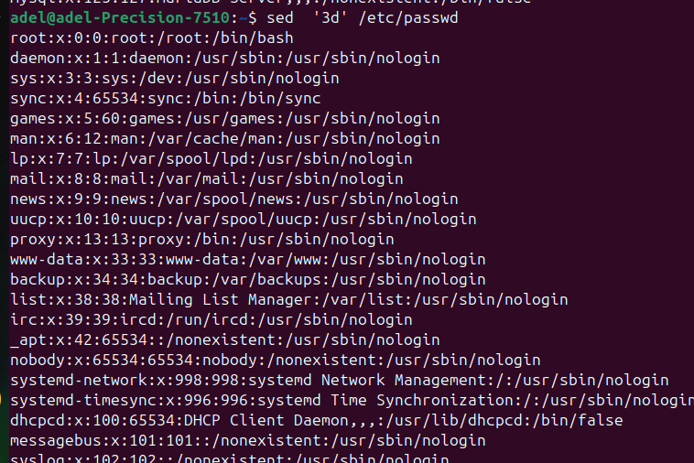

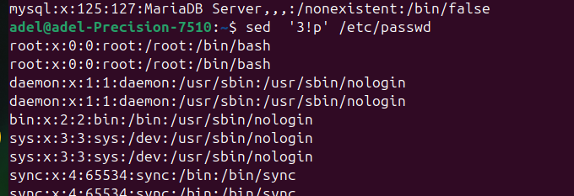

1. Display /etc/passwd file except the last line.

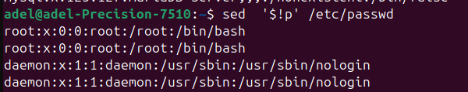

Screenshot from 2025-03-14 03-34-44

1. Display /etc/passwd file except the lines that contain the word “lp”.

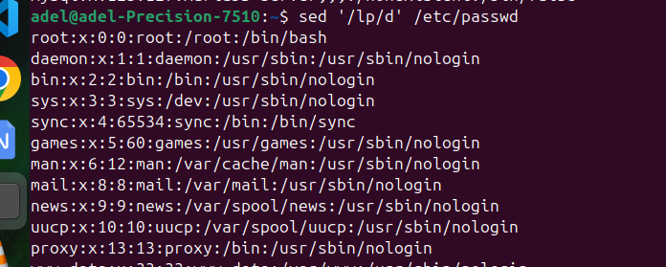

1. Substitute all the words that contain “lp” with “mylp” in /etc/passwd file.



Using awk utility

1. Print full name (comment) of all users in the system.

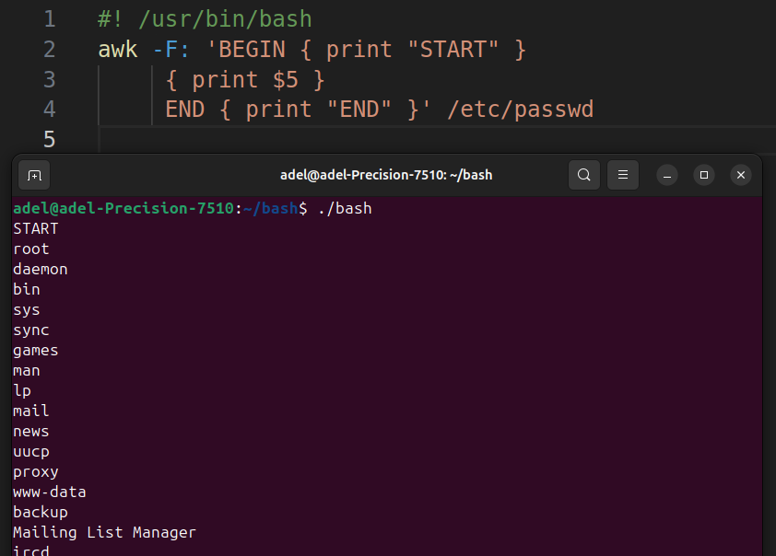

2- Print login, full name (comment) and home directory of all users.( Print each line preceded

by a line number)

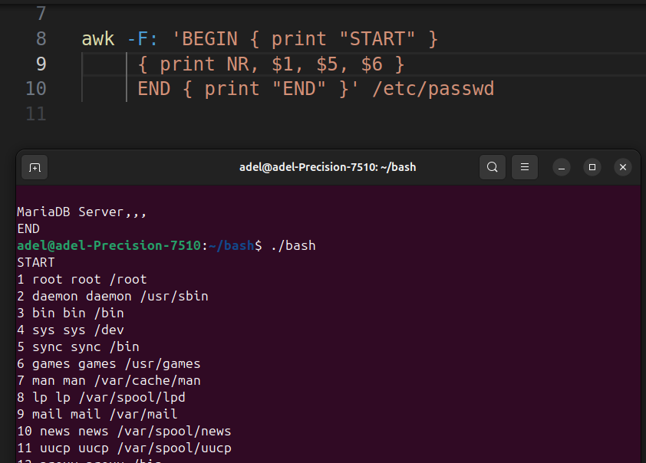3Print login, uid and full name (comment) of those uid is greater than 500

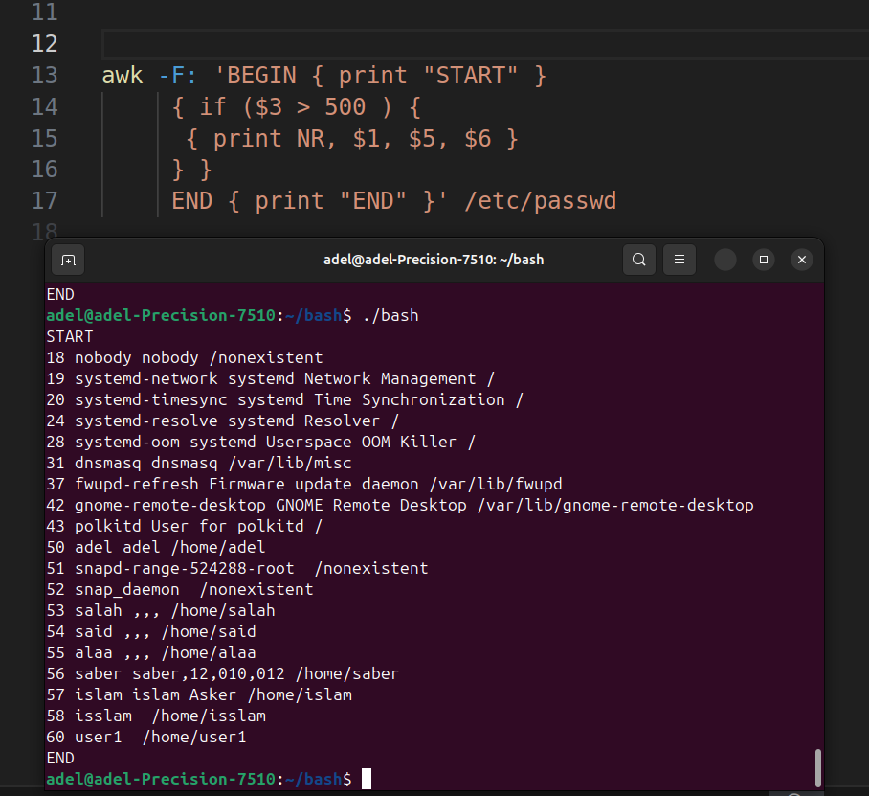

1. Print login, uid and full name (comment) of those uid is exactly 500

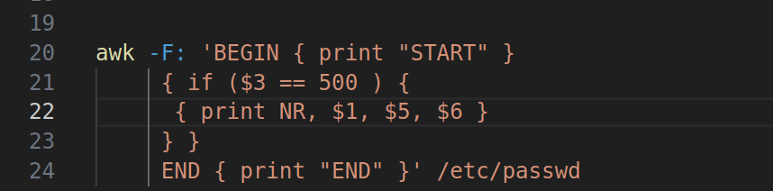

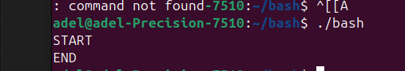

1. Print line from 5 to 15 from /etc/passwd
2. 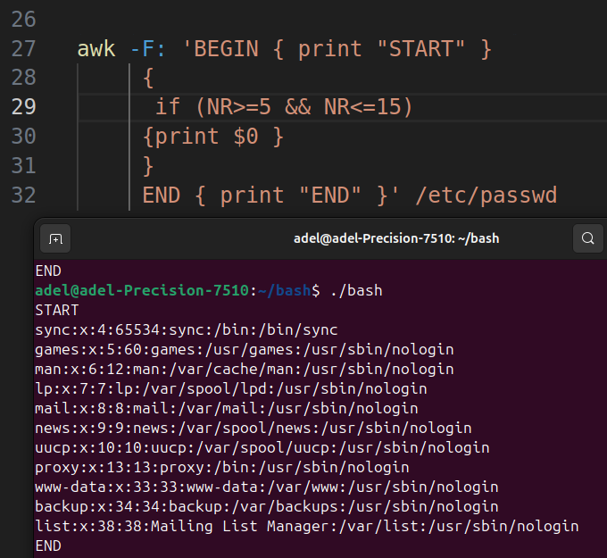

6-Change lp to mylp

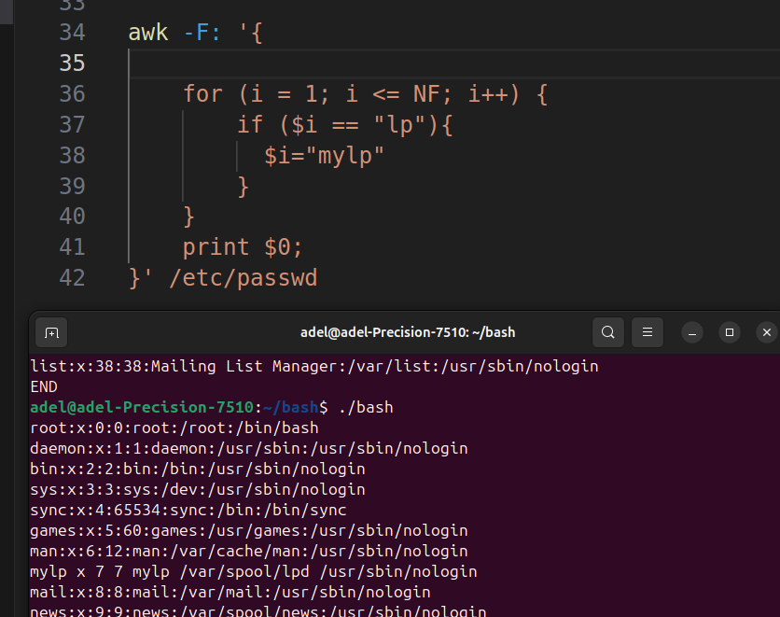7Print all information about greatest uid.

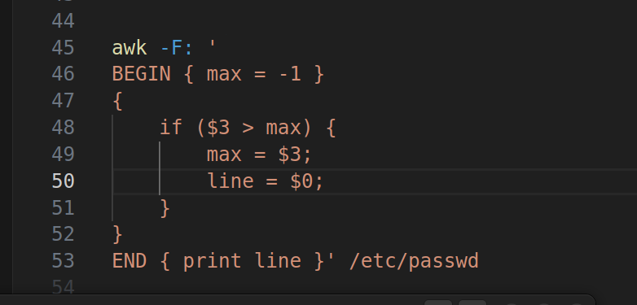

Screenshot from 2025-03-15 02-00-188Get the sum of all accounts id’s.

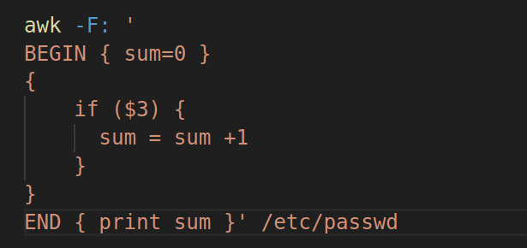

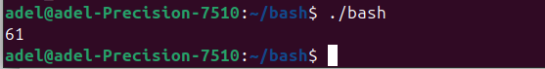

Bonus

1. Get the sum of accounts id’s that has the same group.

