Egyptian License Plate Recognition System
Project Documentation Summary

Egyptian License Plate Recognition System

Project Overview
This project presents a complete AI solution for automatic Egyptian license plate recognition. The system uses an ESP32-CAM with ultrasonic sensor to detect vehicles, captures images, processes them through a cloud-based YOLOv10 model, and displays results on a real-time dashboard.
[IMAGE: System Overview]
Caption: High-level system architecture

Problem Statement
Egyptian license plates use Arabic characters and numerals, presenting unique challenges for automated recognition:
- Right-to-left reading direction
- Arabic-Indic numerals (٠١٢٣٤٥٦٧٨٩)
- 16 possible Arabic letters specific to Egyptian plates
- Variable lighting and environmental conditions

Solution Overview
The system addresses these challenges through:
- Custom-trained YOLOv10 models for detection and OCR
- Edge-based triggering with ESP32-CAM
- Cloud processing for ML inference
- Real-time monitoring dashboard

Key Achievements
Metric | Value
Detection Precision | 95.88%
Detection Recall | 93.98%
mAP@50 | 97.50%
mAP@50-95 | 74.94%
Dataset Size | 1,800+ images

Technology Stack
Layer | Technology
Hardware | ESP32-CAM, HC-SR04 Ultrasonic
ML Framework | YOLOv10 (Ultralytics)
Backend | FastAPI (Python)
Database | PostgreSQL (Neon)
Storage | Cloudinary CDN
Frontend | React + TypeScript
Deployment | Railway

Live Deployments
- API: https://robotics-egyptian-lpr-production.up.railway.app
- Dataset: https://universe.roboflow.com/vguard-vxduz/egyptian-license-plate-detection

Dataset Preparation

Dataset Overview
Metric | Value
Total Images | 1,800+
Annotation Platform | Roboflow
Format | YOLOv10 compatible
Classes | License plate region

Images were manually collected showing Egyptian license plates in various conditions: different lighting, angles, vehicle types, and distances.

Collection Strategy
The dataset includes images from:
- Various vehicle types (cars, trucks, motorcycles)
- Different lighting conditions (daylight, shade, evening)
- Multiple angles and distances
- Urban and highway environments

Annotation Process
Each image was annotated using Roboflow with bounding boxes around the license plate region. The annotations were exported in YOLOv10-compatible format.

Model Training

Model Architecture: YOLOv10n (Nano)
YOLOv10 was selected for this project due to:
- Real-time Performance: Optimized for fast inference
- Accuracy: State-of-the-art detection accuracy
- Lightweight: Nano variant suitable for cloud deployment
- NMS-free: End-to-end design reduces complexity
Specification | Value
Parameters | ~2.3M
FLOPs | ~8.2G
Input Size | 640×640

Training Configuration
Parameter | Value
Epochs | 150
Batch Size | 8
Input Resolution | 640×640
Patience | 10 (early stopping)
Optimizer | AdamW

Augmentation Strategy
All built-in YOLOv10 augmentations were disabled. Three dataset-level augmentation versions were tested:
Augmentation | Parameters
HSV/Rotation/Scale | 0 (disabled)
Flip/Mosaic/Mixup | 0 (disabled)

Model Versions Comparison
Model Version | Precision | Recall | mAP@50 | mAP@50-95
Noise-Blur-Crop | 0.9588 | 0.9398 | 0.9750 | 0.7494
Rotation-Shear-Noise | 0.9396 | 0.9253 | 0.9664 | 0.7273
Full Augmentation | 0.9214 | 0.9081 | 0.9565 | 0.5966

Best Model: Noise-Blur-Crop achieved highest scores across all metrics. The simpler augmentation strategy outperformed aggressive augmentations, suggesting excessive transformations introduced too much variation for the dataset size.
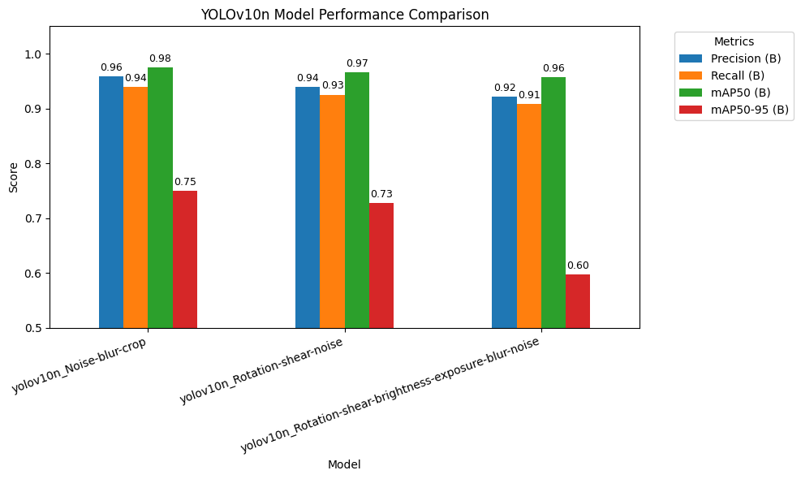
Caption: Performance metrics comparison across model versions

Arabic OCR Model

Character Classes
The OCR model recognizes 26 classes (16 Arabic letters + 10 Arabic numerals):
Arabic Letters Used on Egyptian Plates
Class | Arabic | Name
a | أ | Alef
b | ب | Ba
g | ج | Jeem
d | د | Dal
r | ر | Ra
s | س | Seen
ss | ص | Sad
tt | ط | Ta
aa | ع | Ain
f | ف | Fa
kk | ق | Qaf
l | ل | Lam
m | م | Meem
n | ن | Noon
00 | ه | Ha
w | و | Waw
y | ى | Ya

Arabic-Indic Numerals
Class | Arabic | Western
0 | ٠ | 0
1 | ١ | 1
2 | ٢ | 2
3 | ٣ | 3
4 | ٤ | 4
5 | ٥ | 5
6 | ٦ | 6
7 | ٧ | 7
8 | ٨ | 8
9 | ٩ | 9

Character Extraction Process
- Crop license plate region from detection model
- Resize to 640×640 for OCR model input
- Detect individual character bounding boxes
- Sort characters right-to-left (Arabic reading direction)
- Map Latin predictions to Arabic Unicode
- Validate 6-7 character Egyptian plate format
Egyptian plates follow a standard format with letters on the left side and numbers on the right side.

Backend API (FastAPI)

Architecture
The backend is built with FastAPI, a modern Python web framework. It handles image processing, license plate recognition, database storage, and serves data to the dashboard.
Production URL: https://robotics-egyptian-lpr-production.up.railway.app

Core Components
Component | Responsibility
FastAPI App | HTTP request handling, routing
LPR Service | License plate detection and OCR
Database Module | PostgreSQL async operations
Cloudinary Helper | Image upload to CDN

Detection Pipeline
The backend processes images through a three-stage pipeline:
Image → Plate Detection → Crop & Resize → Arabic OCR → Result
Stage 1: Plate Detection
- YOLOv10 model detects plate bounding box
- Model: yolov10_license_plate_detection.pt
Stage 2: Crop & Preprocess
- Extract plate region from image
- Resize to 640×640 for OCR input
Stage 3: Arabic OCR
- Detect individual characters
- Map to Arabic Unicode
- Sort right-to-left

API Endpoints
Endpoint | Method | Purpose
`/` | GET | Health check
`/api/recognize` | POST | Process image, return plate text
`/api/dashboard` | GET | Retrieve all detection records

Recognition Endpoint
Request: Multipart form data with image file
Response:
{
"success": true,
"plate": "أ ب ج ١ ٢ ٣",
"confidence": 0.95,
"image_url": "https://cloudinary.com/...",
"error": null
}

Dashboard Endpoint
Response:
{
"vehicles_today": 42,
"last_detection": "2024-12-24T15:30:45.123Z",
"detections": [
{
"id": 1,
"car_image": "https://cloudinary.com/car.jpg",
"lp_image": "https://cloudinary.com/plate.jpg",
"lp_number": "أ ب ج ١ ٢ ٣",
"confidence": 0.95,
"created_at": "2024-12-24T15:30:45.123Z"
}
]
}

Dependencies
Package | Purpose
fastapi | Web framework
uvicorn | ASGI server
ultralytics | YOLOv10 models
opencv-python-headless | Image processing
asyncpg | Async PostgreSQL driver
cloudinary | Image upload SDK

Dashboard (React)

Technology Stack
- Framework: React with TypeScript
- Build Tool: Vite
- Styling: Tailwind CSS
- Theme: Dark cyberpunk design

Features
- Real-time monitoring with auto-refresh every 30 seconds
- Detection cards showing:
- Vehicle image / Cropped plate image
- Arabic plate number
- Confidence percentage
- Timestamp
- Today's vehicle count display
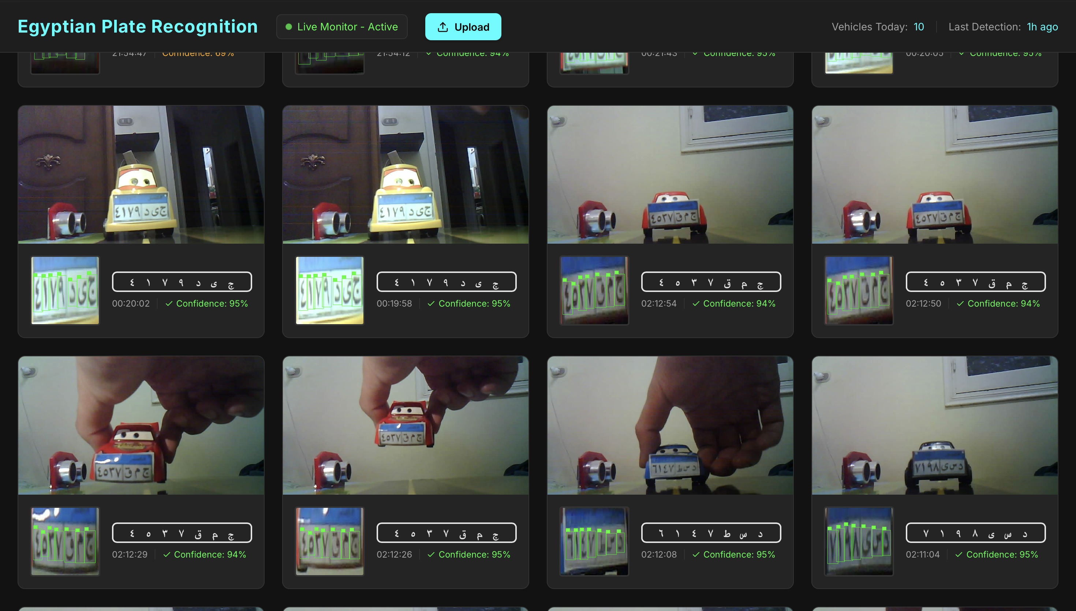
Caption: Dashboard showing detection results

Responsive Design
The dashboard uses a responsive grid layout that adapts to different screen sizes, from mobile to desktop.

Hardware Setup

Components List
Component | Specification | Quantity
Microcontroller | ESP32-CAM (AI-Thinker) | 1
Camera Module | OV2640 | 1
Distance Sensor | HC-SR04 Ultrasonic | 1
Voltage Regulator | 7805 (5V output) | 1
Batteries | 18650 Li-ion (3.7V) | 2
Resistors | 1kΩ (1/4W) | 3
FTDI Programmer | USB-to-Serial | 1

GPIO Pin Assignments
GPIO | Function | Connection
GPIO 13 | TRIG Output | HC-SR04 trigger pin
GPIO 12 | ECHO Input | HC-SR04 echo (via voltage divider)
GPIO 4 | Flash LED | Built-in LED (PWM controlled)
GPIO 0 | Boot Mode | GND for programming

Power Supply
Two 18650 batteries connected in series provide approximately 7.4V. The 7805 voltage regulator steps this down to stable 5V for the ESP32-CAM and HC-SR04.
7805 Pin | Connection
Input | Battery positive (~7.4V)
Ground | Common ground
Output | 5V to ESP32-CAM and HC-SR04

Voltage Divider Circuit
Critical: The HC-SR04 outputs 5V on ECHO, but ESP32 GPIO is 3.3V tolerant. A voltage divider is required.
ECHO (5V) ---[1kΩ]---+---[2kΩ]--- GND
|
GPIO 12 (3.3V)
Calculation:
V_out = V_in × (R2 / (R1 + R2))
V_out = 5V × (2kΩ / 3kΩ)
V_out = 3.33V ✓ (safe for ESP32)

Detection Parameters
Parameter | Value | Purpose
Trigger Distance | 15 cm | Maximum distance to trigger capture
Minimum Distance | 2 cm | Ignore noise (very close readings)
Debounce Delay | 3000 ms | Wait between captures
Camera Resolution | SVGA (800×600) | With PSRAM

Distance Calculation
The ultrasonic sensor measures time-of-flight:
Distance = (Duration × Speed of Sound) / 2
Distance = (Duration × 0.034 cm/µs) / 2
Three readings are taken and averaged for stability.

Camera Configuration
Condition | Resolution | Quality | Frame Buffers
With PSRAM | SVGA (800×600) | 10 | 2
Without PSRAM | VGA (640×480) | 12 | 1

Flash LED Control
Brightness | PWM Value
Off | 0
25% | 64
50% | 128
75% | 192
100% | 255

Deployment Architecture

Cloud Services
Service | Platform | Purpose
API Backend | Railway | Image processing, ML inference
Dashboard | Railway | Web interface
Database | Neon | PostgreSQL storage
Image Storage | Cloudinary | CDN hosting

Railway Platform
Railway provides container-based hosting with automatic deployments from Git.
API Container Configuration:
FROM python:3.11-slim
RUN apt-get update && apt-get install -y libgl1 libglib2.0-0
COPY requirements.txt .
RUN pip install --no-cache-dir -r requirements.txt
COPY api/ ./api/
COPY *.pt .
CMD uvicorn main:app --host 0.0.0.0 --port $PORT
Features:
- Auto-scaling for variable traffic
- Automatic HTTPS/SSL certificates
- Environment variable management
- Built-in logging and monitoring

Neon PostgreSQL
Serverless PostgreSQL with:
- Auto-suspend when inactive
- Auto-scaling compute
- Connection pooling
- SSL/TLS encryption

Database Schema
Field | Type | Description
id | Integer | Primary key
car_image | String | Vehicle image URL
lp_image | String | Plate crop URL
lp_number | String | Arabic plate text
confidence | Float | Detection confidence
created_at | DateTime | Timestamp (Egypt TZ)

Cloudinary CDN
Folder | Content
lpr/cars | Full vehicle images
lpr/plates | Annotated plate crops

Benefits:
- Global CDN distribution
- Automatic image optimization
- Secure HTTPS URLs

Environment Variables
Variable | Service | Description
DATABASE_URL | Neon | PostgreSQL connection string
CLOUDINARY_CLOUD_NAME | Cloudinary | Account identifier
CLOUDINARY_API_KEY | Cloudinary | API authentication
CLOUDINARY_API_SECRET | Cloudinary | API secret key
PORT | Railway | Server port (auto-set)
VITE_API_URL | Dashboard | Backend API URL

System Data Flow

Complete Data Flow Diagram
┌─────────────┐ HTTPS ┌─────────────┐
│ ESP32-CAM │───────────────▶│ Railway API │
└─────────────┘ └──────┬──────┘
│
┌──────────────────┼──────────────────┐
│ │ │
▼ ▼ ▼
┌───────────┐ ┌───────────┐ ┌───────────┐
│Cloudinary │ │ Neon │ │ Dashboard │
│ (Images) │ │(Database) │ │ (React) │
└───────────┘ └───────────┘ └───────────┘

End-to-End Process
- Vehicle Detection: Ultrasonic sensor detects object within 15cm
- Image Capture: ESP32-CAM captures JPEG image with flash
- API Request: Image sent via HTTPS POST to Railway backend
- ML Processing:
- YOLOv10 detects license plate region
- Plate cropped and resized to 640×640
- Arabic OCR extracts characters
- Characters sorted right-to-left
- Storage: Images uploaded to Cloudinary, record saved to PostgreSQL
- Dashboard: React app fetches and displays results every 30 seconds

Communication Protocols
Connection | Protocol | Security
ESP32 → API | HTTPS | TLS 1.3
API → Database | PostgreSQL | SSL
API → Cloudinary | HTTPS | API Key
Dashboard → API | HTTPS | CORS

Performance Metrics
Metric | Value
Detection Accuracy | 97.5% mAP@50
OCR Precision | 95.88%
End-to-end Latency | ~2-3 seconds
Dashboard Refresh | 30 seconds

System Architecture Diagram
┌─────────────────────────────────────────────────────────────────────────────┐
│ EGYPTIAN LICENSE PLATE RECOGNITION │
├─────────────────────────────────────────────────────────────────────────────┤
│ │
│ ┌───────────────┐ ┌───────────────┐ │
│ │ │ WiFi/Internet │ │ │
│ │ ESP32-CAM │═══════════════════════════════════▶│ Railway API │ │
│ │ + Ultrasonic │ POST /recognize │ (FastAPI) │ │
│ │ │ │ │ │
│ └───────────────┘ └───────┬───────┘ │
│ │ │ │
│ │ Camera │ │
│ │ Stream ┌───────────────┼───────┐ │
│ ▼ │ │ │ │
│ ┌───────────────┐ ┌───────▼─────┐ ┌───────▼─────┐│ │
│ │ Local Debug │ │ Cloudinary │ │ Neon ││ │
│ │ http://IP/ │ │ (CDN) │ │ PostgreSQL ││ │
│ └───────────────┘ └─────────────┘ └─────────────┘│ │
│ │ │ │ │
│ └───────────────┼───────┘ │
│ │ │
│ ┌───────▼───────┐ │
│ │ Dashboard │ │
│ │ (React) │ │
│ │ │ │
│ │ GET /dashboard│ │
│ └───────────────┘ │
│ │
└─────────────────────────────────────────────────────────────────────────────┘

Demonstration
The project is demonstrated using a miniature maket with a toy car displaying an Egyptian license plate. When the car approaches the ultrasonic sensor, the system automatically captures and processes the plate.
Demonstration Components:
- Toy car with printed Egyptian license plate
- ESP32-CAM mounted at plate level
- Ultrasonic sensor positioned to detect approaching vehicles
- Battery-powered portable operation
This allows showcasing the complete detection flow without requiring actual vehicles.
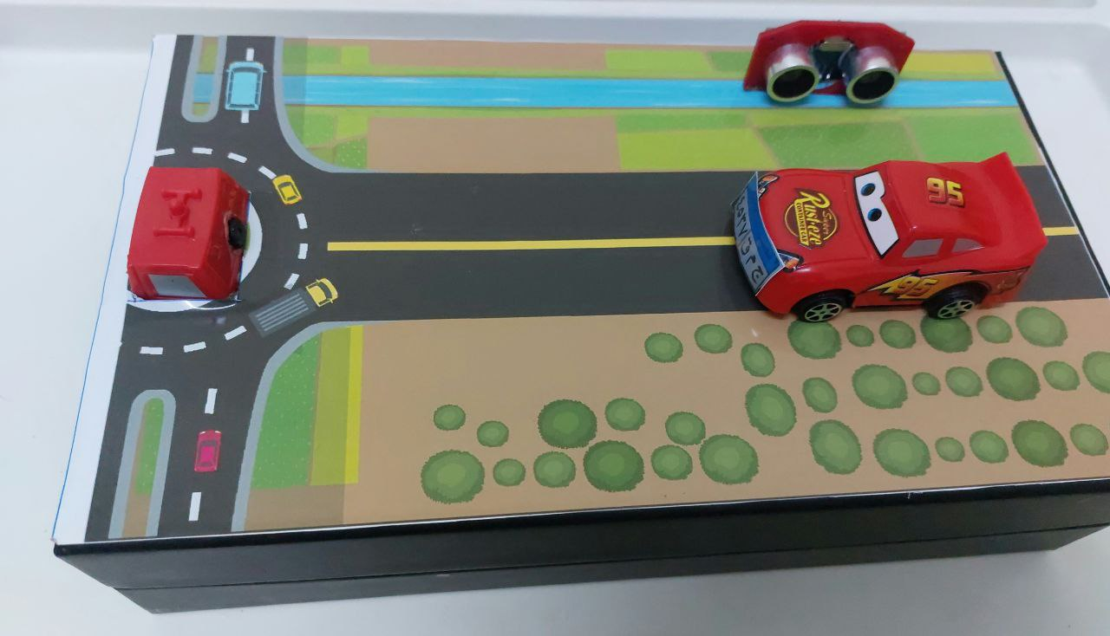
Caption: Maket demonstration showing hardware setup with toy car

Scaling Considerations

Current Resource Limits
Resource | Limit
API Memory | 512MB
Request Timeout | 60 seconds
Database Connections | 100 pooled
Image Size | 10MB max

Performance Optimizations
- Model Lazy Loading: ML models loaded on first request
- Connection Pooling: Reuse database connections
- Image Compression: JPEG quality optimization
- CDN Caching: Static assets cached globally

Reliability Features
- WiFi auto-reconnection on ESP32
- Database connection pooling
- Image fallback handling
- Error state recovery

Cost Structure
Service | Pricing Model
Railway | Usage-based (memory × time)
Neon | Free tier available, then usage-based
Cloudinary | Free tier (25GB), then storage + bandwidth

