EX 0:

a.

b. clase

Deselectare clase

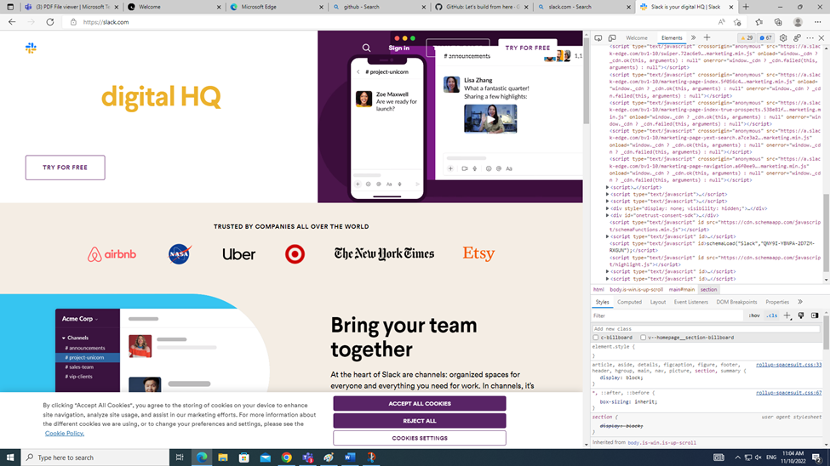

c. modificare continut

