**ASSIGNMENT #3:**

**Creating a heatmap visualization with seaborn**

import pandas as pd  
import seaborn as sns  
import matplotlib.pyplot as plt

**"""Reading in data from the csv file downloaded and saved on the computer into a Pandas DataFrame df"""**

*# The file path and name specified below (C:\Users\AmaK\Desktop\gapminder-FiveYearData.csv) must match the present location and naming of the file on the computer.*

df = pd.read_csv(**r'C:\Users\AmaK\Desktop\gapminder-FiveYearData.csv'**)  
  
*# Printing df displays an output of all the row/column data values read from the csv file.*

print(df)

**country year pop continent lifeExp gdpPercap**

**0 Afghanistan 1952 8425333.0 Asia 28.801 779.445314**

**1 Afghanistan 1957 9240934.0 Asia 30.332 820.853030**

**2 Afghanistan 1962 10267083.0 Asia 31.997 853.100710**

**3 Afghanistan 1967 11537966.0 Asia 34.020 836.197138**

**4 Afghanistan 1972 13079460.0 Asia 36.088 739.981106**

**... ... ... ... ... ... ...**

**1699 Zimbabwe 1987 9216418.0 Africa 62.351 706.157306**

**1700 Zimbabwe 1992 10704340.0 Africa 60.377 693.420786**

**1701 Zimbabwe 1997 11404948.0 Africa 46.809 792.449960**

**1702 Zimbabwe 2002 11926563.0 Africa 39.989 672.038623**

**1703 Zimbabwe 2007 12311143.0 Africa 43.487 469.709298**

**[1704 rows x 6 columns]**

**"""Creating a Pandas pivot table (heatmap_data) of 'lifeExp' values from the df DataFrame, by specifying 'continent' as row labels and 'year' as column labels; This automatically drops the remaining columns in df that were not specified."""***#The .pivot_table() function/method specifies at least the following parameters: the DataFrame, index/row, columns and values to create the 2D pivot table.*

heatmap_data = pd.pivot_table(df, index=**'continent'**, columns=**'year'**, values=**'lifeExp'**)  
  
*#Printing heatmap_data to display a 2 dimensional table with 'year' as column header/labels and 'continent' as row labels.*

print(heatmap_data)

**year 1952 1957 1962 ... 1997 2002 2007**

**continent ...**

**Africa 39.135500 41.266346 43.319442 ... 53.598269 53.325231 54.806038**

**Americas 53.279840 55.960280 58.398760 ... 71.150480 72.422040 73.608120**

**Asia 46.314394 49.318544 51.563223 ... 68.020515 69.233879 70.728485**

**Europe 64.408500 66.703067 68.539233 ... 75.505167 76.700600 77.648600**

**Oceania 69.255000 70.295000 71.085000 ... 78.190000 79.740000 80.719500**

**[5 rows x 12 columns]**

**"""Creating a basic seaborn heatmap from the pivot table heatmap_data"""***#Using the seaborn .heatmap(data_variable) method/function to create the a basic heatmap with default size and colours.*

sns.heatmap(heatmap_data)

*#Python returns:*

**<matplotlib.axes._subplots.AxesSubplot object at 0x000001ED7793ABE0>****"""Using matlablib.pyplot to plot and show a visualization of the heatmap created, showing the life expectancy data of continents over the years with 'year' as the x-axis and 'continent' as the y-axis"""***#Specifying a Title label for the plot using the .title("Title label") method/function in matlablib.pyplot*

plt.title(**"Heatmap of Life Expectancy Over the Years by Continent"**)

*#Python returns:*

**Text(0.5, 1.0, 'Heatmap of Life Expectancy Over the Years by Continent')** *#Displaying the heatmap created as an image plot using the .show() method/function in matlablib.pyplot*

plt.show()

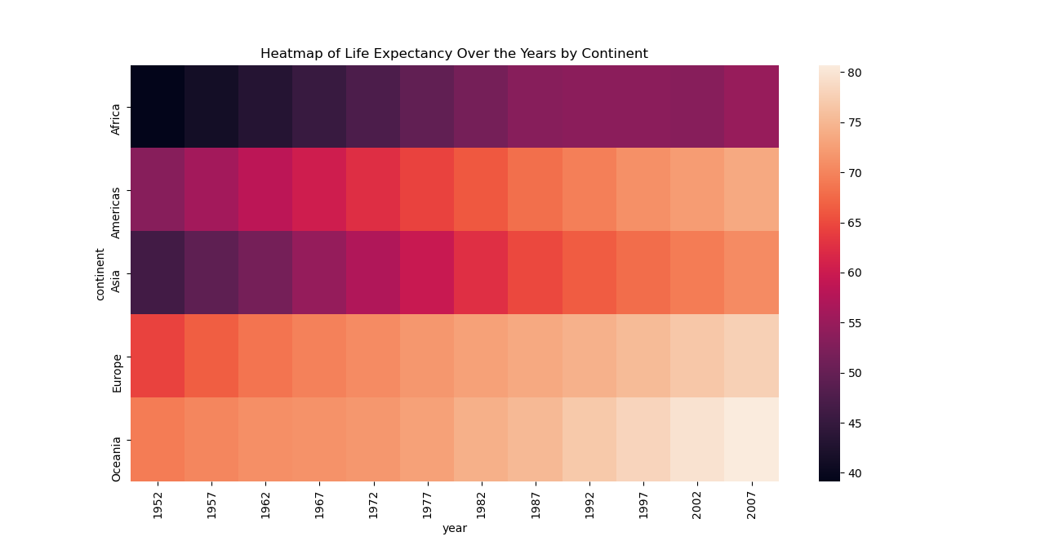

Figure 1: Heatmap Visualization of the Seaborn Heatmap created