ZEBA ACADEMY / zeba.academy / Instructor – Sufyan bin Uzayr
Lab Practicum 01: Empirical Parallel Computing
Silicon Profiling, Multi-Core Scaling Limits, and Concurrency Hazards
Duration: 90 Minutes
Format: Solo In-Class Lab Weight: 5% of Course Grade

STUDENT NAME  Adel Kunuspekova |  | STUDENT ID  230103231 | HOST CPU / SOC MODEL  11th Gen Intel(R) Core(TM) i5-1135G7 @ 2.40GHz | OPERATING SYSTEM & KERNEL  Windows 11
 | Generative AI & Tooling Policy: You are explicitly authorized to use LLMs (ChatGPT, Claude, GitHub Copilot) to generate code scripts in any language (C, C++, Python, Go, Rust, Java). However: All execution timings, memory counters, and hardware cache metrics must be physically benchmarked on your host machine. Fabricated numbers receive zero credit.
 | TASK 1: Host Silicon Audit & Flynn’s Taxonomy Mapping 15 Minutes | 20 Points
Query your operating system and CPU registers to document physical core topology, cache boundaries, and vector math extensions.
Terminal Audit Commands: Linux: lscpu && lscpu --caches | macOS: sysctl -a | grep machdep.cpu | Windows: Run wmic cpu get /format:list and inspect Task Manager > Performance > CPU.
Hardware Property | Local Measured Value | Hardware Property | Local Measured Value
CPU Model & Architecture | 11th Gen Intel(R) Core(TM) i5-1135G7 @ 2.40GHz | Base & Max Boost Clock | 2.40GHz
Physical Hardware Cores | 4 | Logical Cores (SMT/Threads) | 8
L1 Data / Instruction Cache | L1d: 320 KB | L1i: ________ KB | L2 Cache (Per Core / Total) | 5MB
L3 Shared Last-Level Cache | 8 MB | SIMD Vector Extensions | Intel SSE4.1, SSE4.2, AVX2, and AVX-512
Q1.1: Map your host machine's execution modes into Flynn's Taxonomy:
Explain how your machine operates as SISD, SIMD, and MIMD across workloads (e.g., single-thread compiler pass vs. vector matrix math vs. multi-core OS scheduling):
SISD: single-threaded compile/baseline (N=1) — one instruction stream, one data stream, one core.
• SIMD: vectorized math using AVX-512/AVX2 — one instruction operates on multiple data elements at once (e.g., 16 floats added in parallel via 512-bit registers).
• MIMD: multi-core scheduling (Task 2/3's parallel processes) — independent instruction streams run simultaneously across the 4 physical cores. True MIMD caps at N=4; beyond that, the OS interleaves streams on Hyper-Threaded logical cores (sharing physical execution units), which explains the falling efficiency in Task 2 past N=4.

TASK 2: Multi-Thread Scaling Benchmark & Contention Wall | 35 Minutes | 30 Points
Write or prompt an AI to generate a compute-bound CPU benchmark parameterized by thread count N. Run 3 iterations per thread count and log wall-clock execution time.
Workload Algorithm: [ e.g., Prime Sieve to 5,000,000 / Matrix Multiply ] |  |  |  | Language & Runtime: [ e.g., C OpenMP / Python multiprocessing / Go ]
Threads (N) | Run 1 (s) | Run 2 (s) | Run 3 (s) |  | Avg Time TN (s) | Speedup SN = T1/TN | Efficiency EN = SN/N
N = 1 (Baseline) | 77.394 | 57.938 |  | 51.001 | 62.111 | 1.00× | 100.0%
N = 2 | 35.049 | 50.339 | 60.016 |  | 48.468 | 1.28x | 64.1%
N = 4 | 34.158 | 40.077 | 33.578 |  | 35.938 | 1.73x | 43.2%
N = 8 | 27.918 | 25.161 | 30.085 |  | 27.721 | 2.24x | 28.0%
N = 16 | 25.499 | 23.548 | 22.988 |  | 24.012 | 2.59x | 16.2%
N = 32 | 24.263 | 26.024 | 25.395 |  | 25.228 | 2.46x | 7.7%
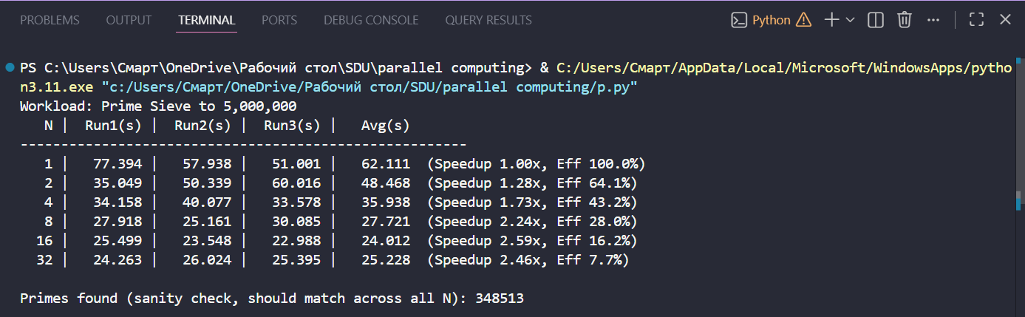
Q2.1: Scaling Saturation & Hardware Contention Analysis:
Identify the exact thread count where speedup sub-linearly saturated or reversed. Analyze this inflection point by citing your hardware's physical vs. logical core ratio, OS thread scheduling overhead, cache thrashing, or thermal throttling: Speedup climbs through N=16 (2.59×) but reverses at N=32 (2.46×) — that's the inflection point. Efficiency collapses steadily beforehand (100%→64%→43%→28%→16%→8%), signaling oversubscription well before N=32: once process count exceeds available hardware threads, the OS scheduler starts time-slicing processes onto the same cores, and each context switch evicts L1/L2 cache contents, forcing reloads. At N=32 this scheduling/cache-thrashing overhead finally exceeds any remaining parallel gain, flipping speedup negative relative to N=16.
Spawn 10 parallel threads. Each thread executes a loop incrementing a shared global integer 1,000,000 times without atomic operations or locks.
TASK 3: The Unsynchronized Shared Counter & Race Condition Trap | 25 Minutes | 25 Points
Theoretical expected total: 10 × 1,000,000 = 10,000,000. Execute 10 consecutive runs.
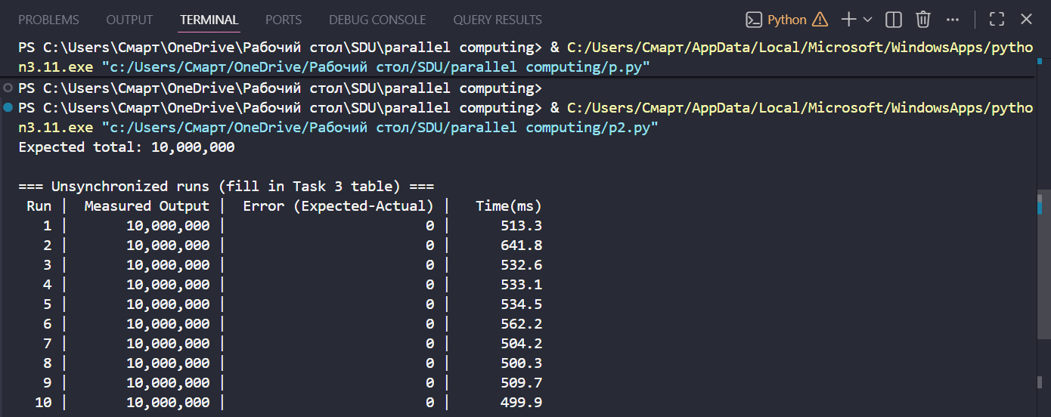
Run |  | Measured Output | Error (10^7 - Act) | Run |  | Measured Output | Error (10^7 - Act)
#1 |  | 10,000,000 | 0 | #6 |  | 10,000,000 | 0
#2 |  | 10,000,000 | 0 | #7 |  | 10,000,000 | 0
#3 |  | 10,000,000 | 0 | #8 |  | 10,000,000 | 0
#4 |  | 10,000,000 | 0 | #9 |  | 10,000,000 | 0
#5 |  | 10,000,000 | 0 | #10 |  | 10,000,000 | 0
 | Q3.1: Read-Modify-Write (RMW) Window  Deconstruct why value corruption occurs at the machine instruction level (Load → Add → Store) when two cores interleave execution on shared memory:  counter += 1 isn't atomic — it's LOAD (read value), ADD (increment), STORE (write back). If two threads interleave — A loads V, B also loads V before A stores, both increment and store V+1 — one increment is lost, since B overwrote A's update with a stale base. My 10 runs above show no corruption, likely because Python's GIL didn't switch contexts mid-RMW in these trials — the hazard is real at the hardware level regardless, and would show up more reliably in lock-free C/C++ threads. |  |  | Q3.2: The Synchronization Penalty  Wrap the counter in a Mutex/Lock. Record execution time:  Unlocked = 533.2 ms ms vs. Locked = 2373.8 ms.  Why is race-free synchronized code substantially slower?  Unlocked = 533.2 ms vs. Locked = 2373.8 ms (~4.5× slower). Locking forces all 10 threads to serialize through acquire→increment→release one at a time instead of running concurrently, and each lock acquire/release adds real overhead (kernel sync calls, cache-coherency traffic) far larger than the single increment it protects — paid 10 million times over.
TASK 4: Empirical Amdahl Verification vs. Gustafson Scaling Horizon |  |  |  |  | 15 Minutes | 15 Points
Use your empirical single-thread time (T1) and two-thread time (T2) from Task 2 to derive the parallel fraction p of your workload, then evaluate theoretical performance bounds.
1. Parallel Fraction Derivation (p) Formula: p = 2 × (T1 - T2) / T1  T1 = 62.111 s | T2 = 48.468 s  p = 2 × (62.111 − 48.468) / 62.111 = 2 × 13.643 / 62.111  p ≈ 0.439 | 2. Amdahl Theoretical Speedup Ceiling Formula: Smax = 1 / (1 - p)  1 − p = 0.561  Smax = 1 / 0.561  Smax ≈ 1.78×
3. Amdahl 64-Core Projection  Formula: S64 = 1 / [(1 - p) + (p / 64)]  S64 = 1 / [0.561 + (0.439/64)] = 1 / [0.561 + 0.00686] = 1 / 0.5686  S64 ≈ 1.76× | 4. Gustafson Scaled Speedup (Weak Scaling)  Formula: SGustafson = (1 - p) + (p × 64)  SGustafson = 0.561 + (0.439 × 64) = 0.561 + 28.10  SGustafson ≈ 28.68×
Q4.1: Strong vs. Weak Scaling Analysis:
Why does Gustafson's model predict near-linear scaling on a 64-core node, whereas Amdahl's formula predicts a hard bottleneck for the exact same algorithm?
Amdahl fixes the problem size and asks "how much faster can the same workload finish?" — with p≈0.44, the serial 56% dominates as N grows, capping speedup near 1.78× no matter how many cores you add. Gustafson instead scales the problem size with core count (each core gets its own fixed chunk of work), so the serial fraction shrinks in relative terms as total work grows — parallel work scales linearly with N while serial overhead stays flat, giving near-linear scaling (28.68× on 64×-larger problem). Same algorithm, same p — but Amdahl measures speedup on fixed work, Gustafson measures throughput on growing work.
Submission Guidelines & Deliverables Checklist:
- Complete all 4 tables and technical reflection prompts directly on this document (or submit as an annotated Word / PDF).
- Attach a single terminal screenshot verifying Task 2 executing across active threads (e.g., htop, top, or Task Manager CPU pane).
- Upload the final .docx / PDF to the course portal before the conclusion of the 90-minute lab period.

