**Web Application Description:** Group Project Team Manager

This web application will automate the process of creating student groups for projects in an academic setting, a process which is currently done manually by members of academic staff. This web application will help to eliminate the challenges experienced over the years by the lecturers (administrator) in deciding on the methodology to adopt in assigning students into groups for a project.

A look at the basic functionality of this project is to create a web platform that will describe the steps by which the system will assign project group to each student. The web app project will allocate students based on criteria set by the administrator. The administrator will be able to add students either manually by filing a form with the student’s details or will also be able to add students en-masse by uploading their data via an upload form. Students will now be divided into groups automatically based on the criteria which the administrator has provided. Once the division is done, the created groups will be visible to all and if a swap request comes from a student, the admin will have the option to accept the student’s request or not and provide a feedback.

The web application will have the option for students to register with their student id and other details so that they can login to see the groups they have been assigned to by their lecturers. A student will also be able to request to be swapped from one group to another. Group members will be able to leave comments for one another and also upload relevant academic files that will be used in their project work via the web application.

**Project Constraints**

The project (web application) will be available on GitHub and the community project will be made available via a server, csdm-webdev.

The web developer will deploy the combination of front-end and back-end. The front-end will be written in HTML and CSS while the back-end will be written in php, MySQL, and database.

There will be two (2) login systems for the user – the group and the student, needed for the administrator to access.

………………

**Feedback from the Lecturer**

Description + Constraints:(C)

- Well organised and presented report, with title page to support presentation;

- The description is very good and mostly clear;

- constraints are partially identified but incomplete e.g. file upload requirement. Note the app does appear to comply to requirements

- wireframes are supplied although mainly for login pages; a good clean layout but does not really give feel of consistent design, e.g consistent header, footer, and navigation.

Requirements: (C)

- scope of application is OK but be careful not to try too much;

-well described and organised set of functional requirements but a bit brief;

- some use of MoSCoW although virtually only MUST employed; appears to be missing student functionality e.g. on group swaps?;

- Non-functional requirements are not so well organised and very brief; although clear and measurable; PHP 7.xx would be current standard;

**Functional Requirements**

**Must Have**

1. Admin Login Screen:

* The web app administrator will login to add students
* Students will either be added manually or en-masse via an upload form.
* Admin provides an indicator to divide student into groups.
* Admin provides a feedback to notify students on the status of group creation.

1. Admin Approval Screen

* Admin accept the student’s request of an option to swap project group with others.
* Admin provides results for student on the swap request.

1. User Login Screen

* Allows a student to sign up.
* Students can register with their school detail (ID).
* Students will be allowed to view the project group assigned to each of them.
* Group members are provided with comment section to interact and upload academic files for their project work.

**Should Have:**

* School Home Page Screen

**Will Not Have:**

* Project group catalog download feature.

**Non-Functional Requirements**

* All code will be compatible with PHP Version 5.6 and MySQL Version 5.5
* The application will be developed and completed on Friday, 17th April 2020.

**Wireframe**

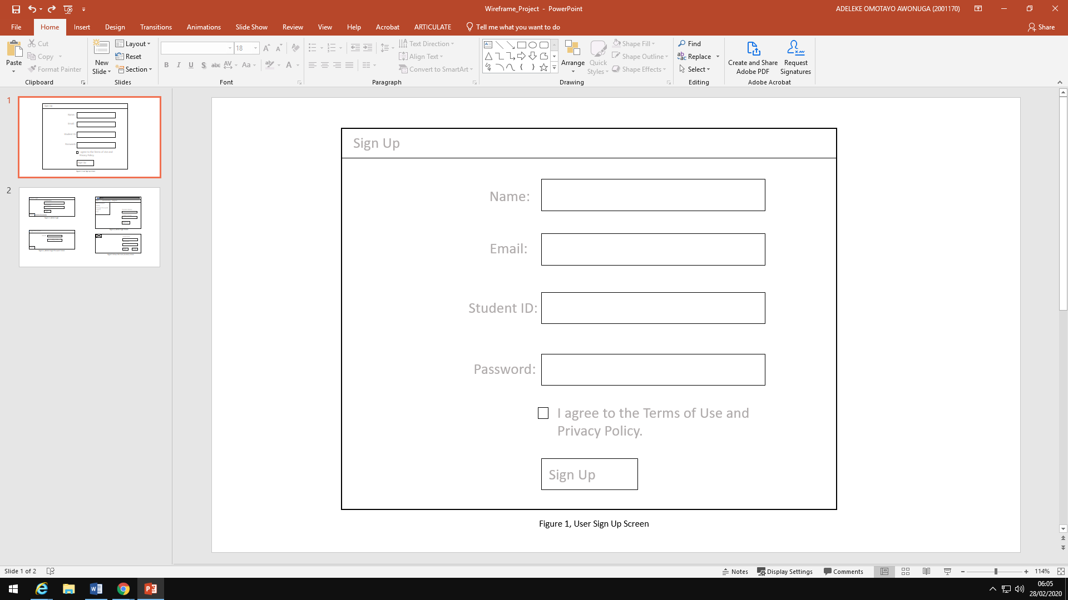

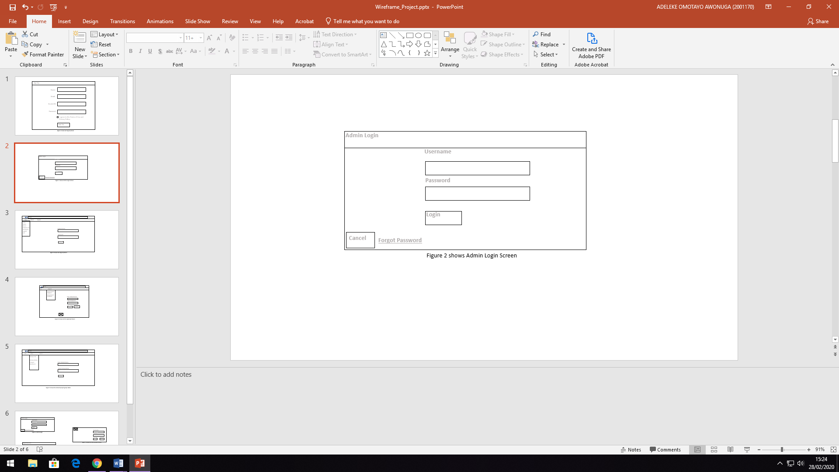

**Help**

**Report**

**www.**

**View**

**Site**

Welcome admin’s name

Website

Logout

Registered Students

Student Project Indicator

File upload Requirement

Swap Group Project Request

Swap Group Result Feedback

Processed Group Students

Enter Student Name

Enter Student ID

ADD

CANCEL

Figure 3 shows Admin Approval Screen

**Logout**

New Password

**Change Password**

Confirm New Password

Figure 4 shows the Admin change password screen

Reset your password by entering and confirming your

new password below.

Figure 5 shows file upload requirement

Upload Files

**X**

Enter Student ID

Drag files to upload

Enter Student Project Group

ADD FILE

CANCEL

filename.doc

88% done

**www.**

**Help**

**Report**

**View**

**Site**

**Student Group Project**

**Logout**

Processed Group Student

Student ID

Student Name

Student Grp Project

Swap Project Request

Swap Grp Project Feedback

CANCEL

SUBMIT

Figure 6 shows admin project feedback screen

**www.**

**Help**

**Report**

**View**

**Site**

Website

Logout

Swap Group Project Request

Swap Group Result Feedback

Processed Group Students

Group Status

Project Members

Members comment section

Add academic files

Student Group Project Assigned

**Logout**

Enter Student Name

Project Group Status

Student Group Project Assigned

Swap Group Result Feedback

CANCEL

SUBMIT

Figure 7 shows student project group status

**Help**

**www.**

**Report**

**View**

**Site**

Student Name:

**Group Members Comment Section**

Enter Comment:

Student Name:

Enter Comment:

**Submit**

**Submit**

**Comment Box**

Figure 8; comment section for group project members to interact

**Logout**

Upload Academic Files

**X**

Enter Student ID

Drag files to upload

Enter Student Project Group

ADD FILE

CANCEL

filename.doc

88% done

Figure 9; group members Upload academic files